Controversial Issue Lesson Plan

Lesson Title: Border Disputes- The Partitioning of Bomon
1
Author Name: Nicole Fagundes

Contact Information: Carson High School
nfagundes@carson.k12.nv.us
Appropriate for Grade Level(s): Secondary

Social Studies Standard(s):
H2 [9-12].25 Discuss contemporary ethnic conflicts and explain how those conflicts have changed nations.

H2 [9-12].25 Discuss major reasons for tensions and conflicts in the contemporary world and efforts that have been made to address them.

Controversial Issue: What is the best solution to border disputes and what role should the United Nations play in resolving border disputes?
Objective(s): At the end of this lesson, students will be able to…
Analyze the complex issue of border disputes, read and analyze historical maps, assess the merit of the United Nations role in resolving border disputes.
Rationale: Why Teach This Issue? (50-100 words)
The Palestine-Israeli border dispute is a complicated and challenging topic to have students evaluate. Students will grapple with the complicated issue of creating borders for a fictitious country. This is a good way to have them assume the role of a citizen in the region or the United Nations and role-play the challenge of dividing the region.

Student Readings (list):
Background to Bomon
Research on a “hot-spot” for modern border disputes

Total Time Needed: 2 class periods
Historical Background & Context (+/- 250 words):
**The Partitioning of Bomon activity is an introduction to the Palestinian-Israeli conflict
The Palestinian-Israeli conflict is essentially a modern conflict originating in the 20th century. However, the roots of the conflict – involving competing historical claims to the same stretch of land - go back thousands of years.
Jewish roots in the area began sometime between 1800 and 1500 B.C. when the Hebrew people, a Semitic group, migrated into Canaan (today’s Israel). Around 1000 B.C., their descendants formally established the kingdom of Israel with Jerusalem as its capital. Israel soon split into two kingdoms and was frequently under the control of foreign conquerors: the Assyrians, Babylonians, Persians, Greeks, and ultimately the Romans. However, despite repeated conquests, the Jews always retained their separate identity, mostly because of their distinctive religious beliefs. The fact that the Jews were monotheists (believers in one God), while their neighbors were polytheists set the Jews apart and instilled in them the idea that the territory of Israel was their “promised land.” The Jewish majority in that land was ended, however, when the Roman Empire expelled the Jewish population from Israel following a failed revolt against Roman rule in 135 AD. For the next 1,800 years, the majority of Jews lived in scattered diasporas (ethnic communities outside of their traditional homeland) throughout Europe and the Middle East.
Meanwhile, the land, which the Romans now named ‘Palaestina,’ or ‘Palestine’ in its English form, was inhabited by small groups of Jews, who had gradually returned to the area, along with other local peoples and some colonists brought in by the Romans. In the 7th century AD, Palestine came under the control of Arabs, who introduced into the region the Arabic language (a Semitic language related to Hebrew) and the religion of Islam, (a monotheistic religion related to Judaism and Christianity). Although there remained a Jewish minority in the area, comprising less than 10% of the total population, from the 7th century to the mid-20th century, the majority of the inhabitants were Arabic-speaking Palestinians. Most Palestinians are Muslims, but there is also a significant number of Palestinian Christians. Jews, Christians, and Muslims lived together relatively peacefully during the centuries that Palestine was part of the Ottoman Empire (1517-1918). However, the situation has changed over the course of the last century.
As with so many modern-day conflicts, the struggle between Jews and Palestinians developed as a product of modern nationalism, which spread throughout Europe – and eventually into the Middle East – during the 19th century. Nationalism can be a unifying force, bringing together people of all different social classes and even joining inhabitants of different countries or empires on the basis of a common language, culture, and religion. However, it can also be a disruptive force, calling for the destruction of multi-national empires and leading to discrimination against ethnic or religious minorities.
The rise of nationalism had major repercussions for the Jewish diasporas of Europe. On the one hand, Jews had an increased opportunity – even pressure - to assimilate and become members of the newly emerging ‘nations’ in which they lived, an option that brought obvious advantages but would also require them to give up their separate identity. On the other hand, nationalism fanned the flames of anti-Semitism (hostility toward the Jews), a European prejudice which had originally been based on religious feeling but which now became more intensely political as Jews were seen as ‘foreigners’ hindering the development of national unity. As attacks on Jews increased, especially in Eastern Europe, Jews responded by developing their own form of nationalism - the Zionist movement - which emerged in Europe in the 1880’s and called for the establishment of a Jewish national homeland in Palestine. Inspired by political Zionism, small groups of Jews left Europe and set up farming settlements in Palestine, which was then part of the Ottoman Empire. At first these settlements were small, and the newcomers faced little opposition from the established population. After all, as late as1917, the Jews were still less than 10% of the total population of Palestine and thus not seen as a threat by the local inhabitants. However, tensions mounted during and after the First World War.
European, particularly British, policies during World War I played a major role in bringing about a conflict between Jews and Arabs in the Middle East. Because the Ottoman Empire (of which Palestine was a part) was allied with Germany and Austria against Great Britain and its allies, the British entered into negotiations with an Arab leader planning a revolt against the Ottoman Empire. During these discussions in 1915, the British promised the Arabs an independent state after the war. Though the boundaries of the proposed state were never formally settled, Arab leaders believed that their people would be united in one large country, which would, of course, include Palestine. In the meantime, the Western powers had other ideas, secretly signing an agreement to divide most of the area into French and British-controlled ‘mandates.’ To make matters more complicated, the British courted international Jewish support by issuing the Balfour Declaration, which supported the concept of a Jewish homeland in Palestine. In essence, control of Palestine was promised to three different groups: the Arabs, British, and Jews! Thus, when the war ended and the British took charge of the Palestinian Mandate, both Arabs and Jews felt that the British had broken their promises to them.
Relations between Palestinians and Jews declined rapidly. The Balfour Declaration had alarmed Palestinians, who saw it as British favoritism toward the Jewish minority. Their fears grew as Jewish immigration increased dramatically, particularly after the rise of Hitler to power in Germany. To Jews fleeing from persecution in Europe, Palestine was one of the few places of refuge, especially as the United States and other countries closed their doors to refugees desperate to escape Nazi persecution. However, to Palestinians, the arrival of a large Jewish immigrant population altered the balance of the population, displaced many people from their land, and threatened their goal of establishing an independent Arab state in the region. Violence soon erupted between the groups.
The situation deteriorated in the immediate aftermath of World War II. Survivors of the Holocaust swelled the number of Jewish immigrants to the region, and the Allied victors, horrified by the revelation of large-scale genocide in Europe, were reluctant to stop them. As violence between Jews and Arabs grew, the British declared its Mandate over Palestine to be unworkable, turning control of the area over to the United Nations. U.N. Resolution 181 divided Palestine in two: giving 55% of the land to the Jews and 45% to the Palestinians, while putting the city of Jerusalem under a separate international authority. The Jews accepted the proposal and proclaimed the creation of the state of Israel in May 1948; the Palestinians rejected the loss of their territory. Fighting broke out in which neighboring Arab countries supported the Palestinians.
Israeli forces were victorious. (Israelis call this war “The War of Independence;” Palestinians call it “The Catastrophe.”) As a result of its victory, Israel increased its territory by 30%, and more than 700,000 Palestinian refugees fled or were driven from their homes. Many ended up in refugee camps in Lebanon, Jordan, or other areas, camps that were to become permanent places of residence. In the meantime, an additional 900,000 Jews moved to Israel over the next several years. Thus, in the first half of the 20th century, the population and balance of political power in the area underwent dramatic changes.
**The Partitioning of Bomon activity was created at a COGA (Colorado Geographic Alliance) conference in Denver, Colorado in 1995. I participated in this activity and have utilized the basic information with a few modifications. This is a good activity to get students thinking about how difficult and controversial border disputes are.

Detailed Steps of Lesson (including teaching methods/strategies that engage student participation):
Time Frame  (e.g. 15 minutes) | What is the teacher doing? | What are students doing?
10 min | Introduce the activity of Partitioning of Bomon | Read the background sheet as a group and analyze the current map
30 min | Divide students into 5 groups, based on the four ethnic groups in Bomon and a group of UN advisors  Have students work in their ethnic or UN group. Tell them to discuss their situation and their needs as a group and to talk about what they would and would not be willing to give up. UN advisors should discuss area of conflict and compromise.  Students need to take a blank map of Bomon and create boundaries that they, as a ethnic group, agree upon.  **Some students will use this time to go to other groups and make arrangements/agreements on the division of land. I always allow this but I never prompt them to do it. | Small group discussion  Create boundaries on the map. Each student must have a map identical to the one agreed upon with their ethnic group or UN group.
20min | Regroup students into groups containing one of each of the 5 roles. Give each group a map (overhead transparency or projector version). They must agree to boundaries and each member must sign the map for display. Their plan to partition Bomon is an agreement between the five members present (no other students are consulted). | Small group border division/creation
25 min | Have groups present their plans, one at a time, to the entire class. Encourage questions from other members of the class at this time.  If there is a border dispute within the group the UN can act as the mediator and ultimately the final decision maker.  Allow the class a chance to pick their favorite map and defend why they think that map would have the best results for them (either as a country or as an ethnic group). | Each group presents their plan to divide Bomon  Students pick their favorite map and defend, in a brief written summary, why this map should be used as the new borders for Bomon
10 min | Ask students to identify places in the world where border disputes have occurred historically or currently. Discuss the practicality of using similar methods to achieve compromise. | Class discussion
5 min | Closure: Have students individually write up three principles to consider when dealing with boundary disputes. | Write three principles and partner share
Homework | Have students research a “hot spot” in the world and the issues involved in the conflict. Then have them come up with possible compromises. Have students evaluate each other’s plans for the regions at the beginning of the next class. | Research and teach a partner about the issue and your solutions.  The partner will share the topic that was presented to them and their opinion on the solution rendered.

How will students reflect on their learning & understanding?
Participation in the simulation, defending their position, presenting to classmates in small and large groups, discussion, research, writing about “hot spots” and solutions and identifying three principles to consider when dealing with boundary disputes.

Attached to the following pages are all readings, primary sources, guided questions, worksheets, assignment guidelines, rubrics, etc.

The Current State of Bomon
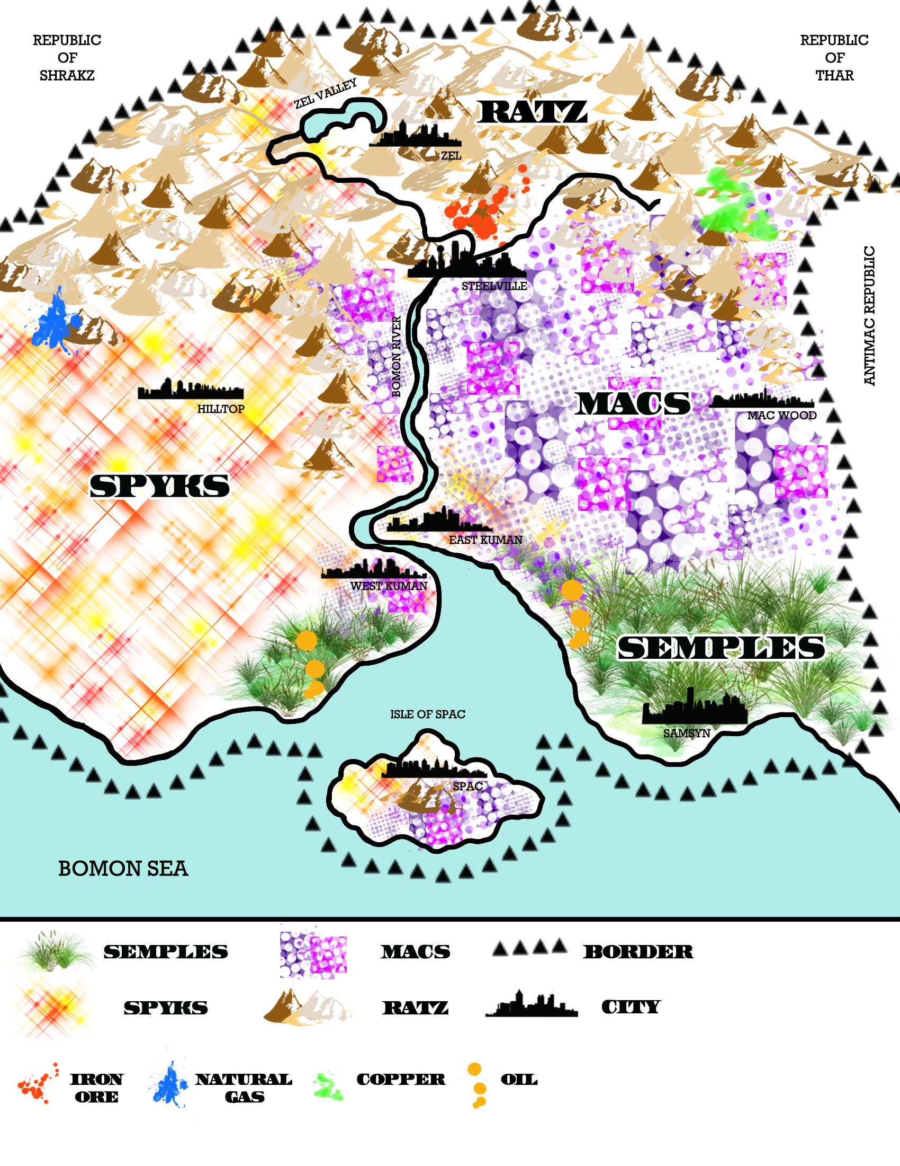

The Future State of Bomon
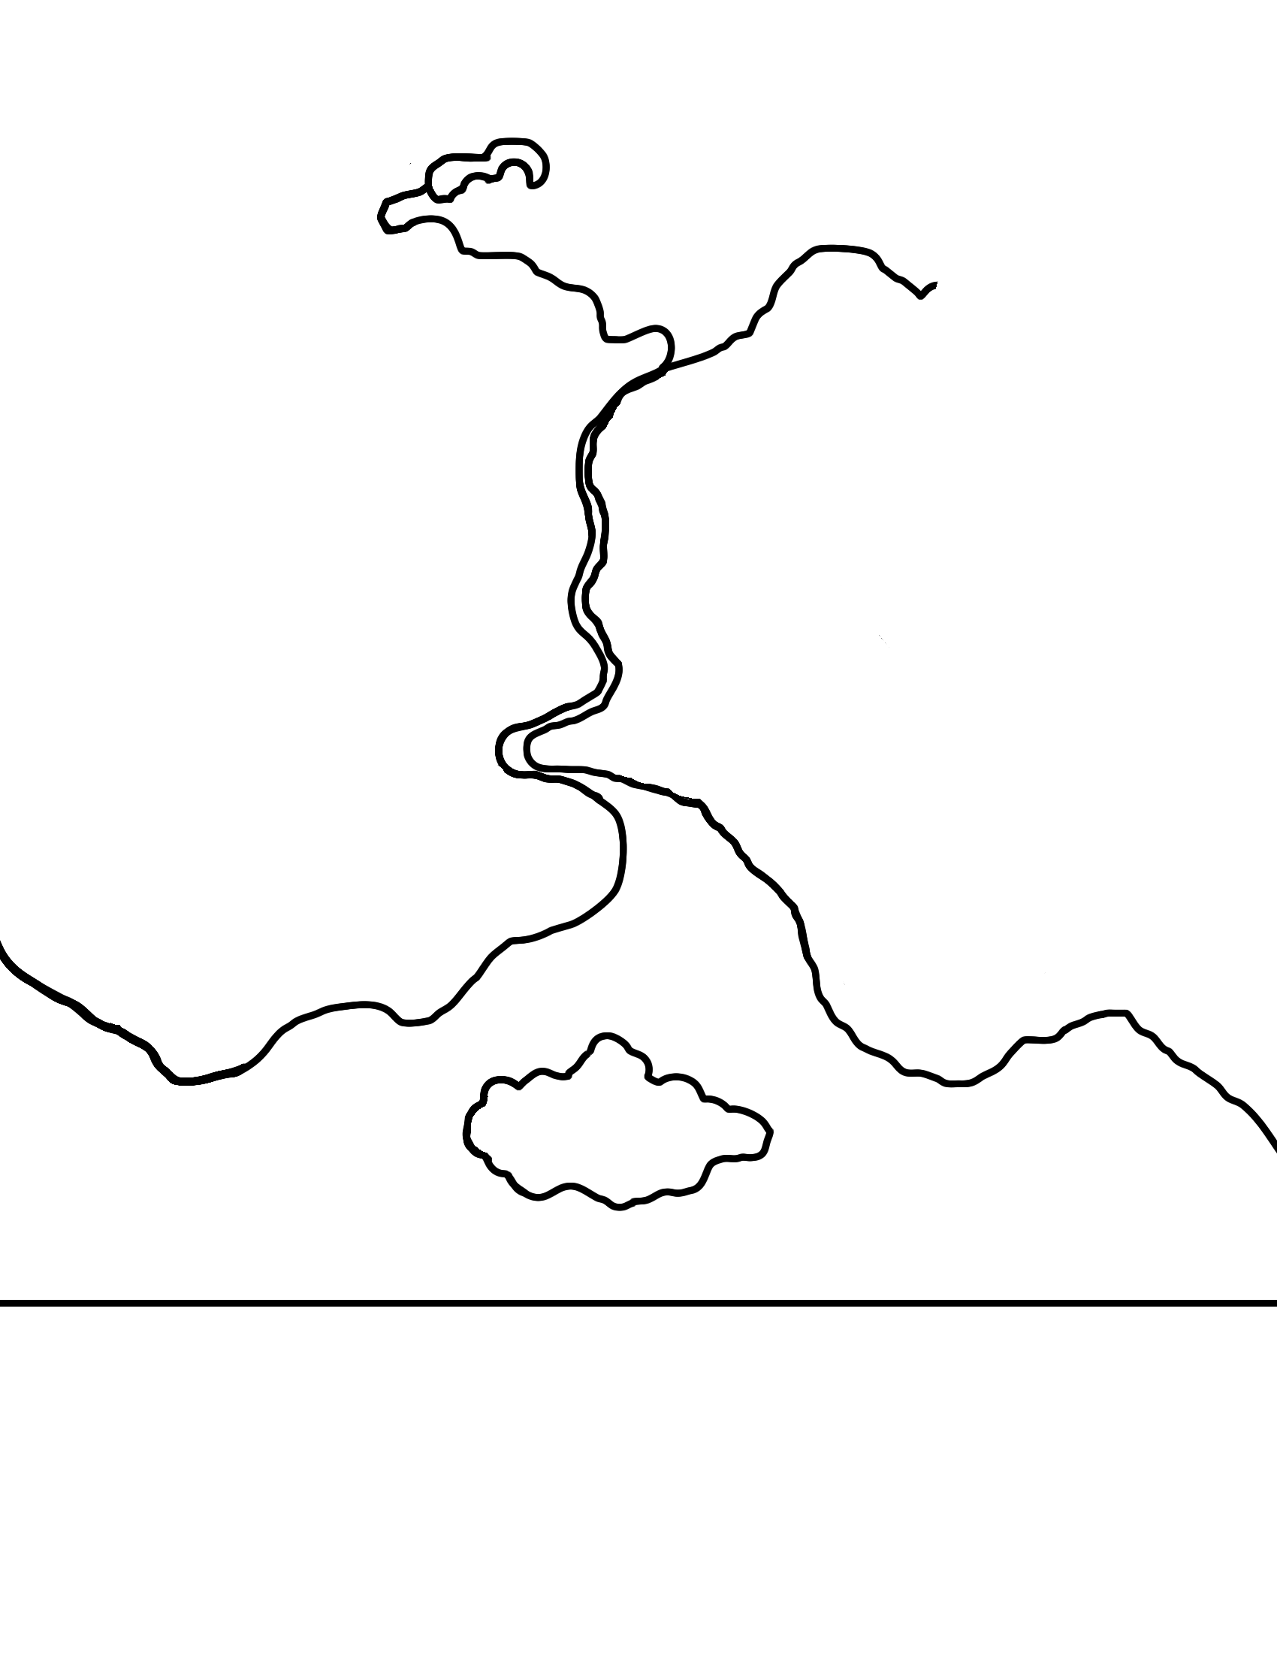

Partitioning of Bomon: Info and Background Notes
Bomon (Boh-mon); a productive but difficult to administer colony of a European power is granted its independence. Composed of diverse economic provinces and quarrelsome peoples in the Bomon River Basin, boundaries for several new countries must be drawn that will be equitable to all, defensible, and can minimize longstanding political and cultural tensions. Bomon also has much ethnic, religious, and language diversity to function as a single state, yet care must be taken not to fragment the basin into many small countries that would be powerless against antagonistic neighbors (especially the Antimac Republic). You are one of five members of the boundary commission, along with other representatives of the region’s population and a United Nations arbitrator. Please consider the following background and rules in making your decisions.
Background:
- The Bomon River is navigable most of its length, ties the region together as a trade and communication link, and is the principal water supply for the Ratz, Spyks, and Macs.
- All that is not mountain or swamp are level, fertile farmlands in full use.
- All groups in Bomon speak different languages, however, Macs and Spyks share the same religion.
- Macs and Spyks have fought each other historically.
- The Ratz, a fierce mountain people, are generally poor except for rich agricultural area in the Zel Valley that they share with the Spyks.
- Semples are proud marsh people with a distinct cultural heritage. They do not participate in the affairs of the Macs and Spyks and tend to be neutral in the regional conflicts. Historically, Semples have acted go-betweens in arbitrating disputes between the Macs and Antimacs.
- The Antimac Republic is a hostile state that repeatedly waged war with the Macs before the European era and still claims much of the land east of the Bowman River as the rightfully its own. No clear boundary separating the Anitmacs from Boman has ever been agreed upon.
- Kuman, as well as the towns of the Isle of Spac and Zel Valley, are populated equally by both ethnic groups of the immediate hinterland.
- The iron ore deposit near Steeleville is the only natural resource currently developed.
- Where two ethnic patterns overlap on the map, both peoples share the space in equal numbers and density.
Rules
- Populations cannot be moved from their present location.
- Majority rules on boundary decisions, with the United Nations advisor casting a tie-breaking vote when necessary.
* The river is given an English spelling but is derived from a Ratz word, “Bomon”, which means “life force”

