Common Core Social Studies Learning Plan Template

Lesson Title: Was Napoleon a friend or enemy to Revolutionary France?
1
Author Name: Kylie Miller

Contact Information: Kimiller@washoeschools.net

Appropriate for Grade Level(s): 10

History Standard(s)/Applicable CCSS(s) RI, W, S&L, L): H3.(9-12).24 Examine the ideals and institutions of freedom, equality, justice, and citizenship, and explain how they have changed.
Speaking and Listening #2: Integrate multiple sources of information presented in diverse formats and media in order to make informed decisions and solve problems, evaluating the credibility and accuracy of each source and noting any discrepancies among the data.
Speaking and Listening #4: Present information, findings, and supporting evidence, conveying a clear and distinct perspective, such that listeners can follow the line of reasoning, alternative or opposing perspectives are addressed, and organization, development, substance, and style are appropriate to purpose audience, and a range of formal and informal tasks.

Type of Lesson: Philosophical Chairs
Student Readings (list): Primary and Secondary Sources from packet

Total Time Needed: 200 Minutes

Lesson Outline:
Time Frame  (e.g. 15 minutes) | What is the teacher doing? | What are students doing?
10 Minutes | Introduce the topic to the students. Hold a brief discussion on what the students remember from reading the Declaration of the Rights of Man. Ask them to focus on what rights the French people were fighting for. Have the students first answer this question within their groups or partners and then ask for their answers in a couple of minutes. | (It is recommended that the students will have read The Declaration of the Rights of Man in a previous lesson).  Student will look back to their notes on the Declaration of the Rights of Man. With their groups they will quickly talk about what rights the French people fought for during the French Revolution.  After they discuss this with their groups, they will be called on by the teacher to answer.
10 Minutes | Review or introduce the rules and rubric for a Philosophical Chair (Historical Round Table) discussion. | Students will listen to the teacher as they explain the rules of philosophical chairs and the rubric that the teacher will use to grade the discussion.
5 Minutes | Introduce the documents in the document packet. Take the time to remind the students about the differences between primary and secondary sources. Remind them to think about author’s perspective and point of view when examining a primary source. | Students will be listening to the teacher go through the documents and answer questions about the differences between primary and secondary sources.
5 Minutes | Introduce the notes packet to the students. Explain that they should be attempting to find arguments that both support and oppose each document. Explain that this may not be possible with EVERY document but encourage them to do so whenever possible. | The students will listen to the teacher explain how to use the notes packet to record their findings from the documents.
80 Minutes | The teacher will monitor the students as they work through the documents and answer any questions that arise. | The students will silently work through the documents while recording arguments that they find within the documents.
Next Day | Have the room set up with the desks in a U formation. Label one side of the room Pro (Napoleon was a friend of Revolutionary France) one side Con (Napoleon was an enemy to Revolutionary France) and label the middle section neutral.
5 Minutes | When the students come in have them take out a pen or pencil, their documents packet, and their notes packet, and then put their backpacks and belongings against a designated wall. (This is to ensure they aren’t texting in under their desks or working on other assignments during the discussion. | Students will take out their work and then place the remainder of their belongings against the wall.  They can then choose a seat according to what they plan on arguing during the discussion.
5 Minutes | The teacher will go around to each student to check and make sure they have completed the prep work for the discussion. | Students will remain seated as the teacher checks to make sure their work is complete.  If a student does not complete the work they will not be allowed to participate and will have to get an alternative assignment from the teacher.
5 Minutes | The teacher will remind the students of the question up for discussion and go over a quick reminder of the rules. | Students will listen and ask any questions about the topic or rules.
60 Minutes | The teacher will keep track of how many times a student speaks as well as any comments and critiques they have about a student on a roster (class list, seating chart).  The teacher may also redirect students if the discussion starts to go in circles or begins to fall flat.  The teacher should call on students who move so that they can explain what caused them to change their minds. | The Pro side will begin the discussion and the students will follow the rules of philosophical chairs to hold a discussion on the topic. The students are allowed to use the documents and their notes at all times and are expected to follow all guidelines for behavior.  The students can move around the room according to how they feel about the topic as the discussion progresses.
10 minutes | Stop the discussion and allow both sides to meet for two minutes so that they can prepare for their closing statements. | Students will meet with their sides and make a list of what they thought were their strongest arguments.  When the two minutes are over they will pick a representative to present these arguments to the class.  The Pro side will present first.  This does not count as a talking point.
15 Minutes | Instruct the students to write down what they thought went well and what they thought could have been better about the discussion as a whole and also their own participation within the discussion.  Ask for some volunteers to share what they wrote in their reflections.  The teacher should also share what they thought went well and what they recommend the students do for next time. | Students will reflect on the discussion on the back of their notes packet.  Once they have written down a brief reflection they will be asked to share their thoughts with the class.  Students will turn in their note packets with their reflections before they leave.

Description of Lesson Assessment: Teacher should take notes during the discussion on student performance so that they can compare these notes to the rubric. The teacher will also grade the student’s notes. This will mostly be based on completion since they are allowed to add to them as the discussion proceeds.

Name: Date: Period:
The Historical Round Table
The Historical Round Table is a discussion model that we will use throughout the year to examine and debate controversial questions that history is guaranteed to provide. Every student is graded individually on their participation in these class-wide discussions. By participating in these discussions you will learn how to use evidence to back up your arguments as well as learn to articulate your arguments like a scholar!
Guidelines for Historical Round Table:
- The room will be set up in a U formation. One side will be in agreement (the dropping of the bomb was justified) the opposite side will be in disagreement (the dropping of the bomb was not justified). The section in between will be the neutral zone.
- The Pro side will begin the discussion and then it will be the Con side’s turn. A person who speaks on either side must wait until two people on their side have spoken before they can speak again.
- Students in the neutral section may move to either side based on which side of the argument they agree with, however, they must explain to the class why they have decided to take a certain side.
- Students on the Pro and Con sides may also move to other sections of the room as the discussion progresses, those students will also need to explain their reasons for doing so.
- While in the neutral section students should be taking notes on both sides of the discussion. They may also ask students on either the pro or con side to clarify their arguments.
- Students may not raise their hands to speak while someone else is speaking, they must wait until the speaker has finished.
- At the end of the discussion, each side takes 1 minute to summarize their main arguments and make a final statement.
- While another student has the floor, all other students need to remain silent.
- Arguments need to be based on evidence!
Historical Round Table Grading Rubric
30-25 Points | 24-20 Points | 19-15 Points | 14-10 Points | 9-0 Points
Student completed all work leading up to discussion.  Student spoke at least twice during discussion.  Student’s arguments were connected to the text and brought up new arguments.  Student followed all norms of the strategy. | Student completed all work leading up to discussion.  Student spoke at least twice during discussion.  Arguments were mostly connected to text.  Student followed norms regularly. | Student Completed all work leading up to discussion.  Student spoke at least once during discussion.  Arguments were mostly connected to text.  Student followed norms regularly. | Student completed at least half of the work leading up to discussion.  Student spoke at least once during discussion.  Arguments were sometimes connected to the text.  Students mostly followed norms. | Student did not complete work leading up to discussion.  Student did not speak during discussion and was given an alternate assignment.

How will students reflect on the process and their learning? They will be writing a brief reflection on their performance following the discussion.

Name: Date: Period:
Was Napoleon a friend or an enemy to Revolutionary France?
Document 1
There is thus no doubt about the interpretation to be given to the historic role of Napoleon Bonaparte. For the rest of the world, indeed, he remained the fearsome propagator of the Revolution, or the admirable instrument of reason governing: the world, of progress of the spirit in its long "discourse with time" (Hegel). But for France? . . . Bonaparte belongs to the Revolution, surely, in matters that seemed irreversible at the time— civil equality, the destruction of feudalism, the ruin of the privileged position of the Catholic Church. As for the rest, the enjoyment of liberties, the form of political institutions, there had been since 1789 so much instability, so many contradictions between grand principles and the practice of governments, so much persistent uncertainty on the outcome of the war and the unity of the nation, that the field lay open for a strong man who, on condition of preserving the essential conquests of the Revolution, would do something new in the matter of government and refuse to be embarrassed by scruples. By anchoring France securely to the shores that the Constituent Assembly had been unveiling to leave, Bonaparte accomplished somewhat late in the day that "revolution from above" of which the old monarchy had been incapable. The political trade-off was a certain number of amputations of the immediate Revolutionary inheritance, a few backward movements, and disconcerting borrowings from the Old Regime. In a sense, the dynamism of Bonaparte and his rigorous administration revived the experiment of enlightened despotism, somewhat belatedly, since in the setting of Western Europe it was already a bit out of date. . . . It was his political genius, as it is generally agreed to call it, to combine his own clear and strongly held personal ideas and convictions, reinforced by his great individual prestige, with a sure sense of the necessary and the possible in revolutionary France—after ten years of revolution. "My policy is to govern men as the great number wish to be governed. That, I think, is the way to recognize the sovereignty of the people." While implacably suppressing the most actively opposed minorities, he overcame the apathy and the wait-and-see attitude of the majority of the French. In matters of social hierarchy and the administrative system he forced upon the French, who from citizens were soon to become subjects again, a coherent construction which he intended to be permanent, and which reflected his taste for uniformity, symmetry and efficiency, the signs of a rational organization in which a single mind transmitted impulses to the most distant members. What we see as rigid or even oppressive in the survivals of the Napoleonic system were at the time the source of its strength, making of it a model to be envied, and one of unequaled modernity.
SECONDARY SOURCE: Louis Bergeron, France Under Napoleon, 1981.

Document 2
Napoleon himself believed that his work was a kind of crowning of the Revolution, and he was remarkably honest about his friendship with Robespierre's brother. He defended Robespierre from the charge of being bloodthirsty; he respected him as a man of probity. Napoleon would never have imagined that his own career could have flourished as it did without the surgery performed on French society by the Revolution. He was born in Corsica of poor, proud, petty-noble parents, and before the Revolution he could not possibly have risen above the rank of captain in the French army. Also, he had read Rousseau and sympathized with much of the Jacobin philosophy. Napoleon had two different aspects. He believed in the overthrow of the old aristocracy of privilege; on the other hand, he believed in strong government—and he learned both of these beliefs from the Revolution. He was both an authoritarian and an egalitarian. Yet, admittedly little of this seems to fit the man
SECONDARY SOURCE: Georges Rudé, 1971.

Document 3
First, women acquired the nationality of their husbands upon marriage. This made a woman's relationship to the state an indirect one because it was dependent on her husbands. Second, a woman had to reside where her husband desired. Women could not participate in lawsuits or serve as witnesses in court or as witnesses to civil acts such as births, deaths, and marriages. Such a reduction in woman's civil status enhanced that of the individual male. Moreover, the (Napoleonic) Code reduced, if not eliminated, male accountability for sexual acts and thrust it squarely on women. For example, men were no longer susceptible to paternity suits or legally responsible for the support of illegitimate children. Women were weakened economically if they bore illegitimate children, whereas men were not so affected if they fathered them. Finally, female adultery was punished by imprisonment and fines unless the husband relented and took his wife back. Men, however, suffered no such sanctions unless they brought their sexual partner into the home. The sexual behavior of women was open to scrutiny and prescribed by law, whereas that of men, almost without exception, had no criminal aspect attached to it. Thus male sexuality was accepted with few limitations, but women's was only acceptable if it remained within strict domestic boundaries. The Napoleonic Code institutionalized the republican responsibility of women to generate virtue—a term that began to acquire sexual overtones to its civic definition. The Napoleonic Code also defined the space women would occupy in the new regime as marital, maternal, and domestic—all public matters would be determined by men…In general, a woman had no control over property. Even if she was married under a contract that ensured a separate accounting of her dowry, her husband still had administrative control of funds. .. Women's wages went to their husbands, and market women and others engaged in business could not do so without permission from their husbands. .. Moreover, the husbands right to a business woman's property meant that the property passed to his descendants rather than hers. All of these provisions meant that, in the strictest sense, women could not act freely or independently. The Napoleonic Code influenced many legal systems in Europe and the New World and set the terms for the treatment of women on a widespread basis. Establishing male power by transferring autonomy and economic goods from women to men, the Code organized gender roles for more than a century.
SECONDARY SOURCE: Bonnie G. Smith, Changing Lives: Women in European History Since 1700, 1989.

Document 4
Answer: Christians owe to the princes who govern them, and we in particular owe to Napoleon I, our emperor, love, respect, obedience, fidelity, military service, and the taxes levied for the preservation and defense of the empire and of his throne. We also owe him fervent prayers for his safety and for the spiritual and temporal prosperity of the state.
Question: Why are we subject to all these duties toward our emperor?
Answer: First, because God, who has created empires and distributes them according to his will, has, by loading our emperor with gifts both in peace and in war, established him as our sovereign and made him the agent of his power and his image on earth. To honor and serve our emperor is therefore to honor and serve God himself. Secondly, because our Lord Jesus Christ himself, both by his teaching and his example, has taught us what we owe to our sovereign. Even at his very birth he obeyed the edict of Caesar Augustus; he paid the established tax; and while he commanded us to render to God those things which belong to God, he also commanded us to render unto Caesar those things which are Caesar's.
Question: Are there not special motives which should attach us more closely to Napoleon I, our emperor?
Answer: Yes, for it is he whom God has raised up in trying times to reestablish the public worship of the holy religion of our fathers and to be its protector; he has reestablished and preserved public order by his profound and active wisdom; he defends the state by his mighty arm; he has become the anointed of the Lord by the consecration which he has received from the sovereign pontiff, head of the Church universal.
Question: What must we think of those who are neglecting their duties toward our emperor?
Answer: According to the apostle Paul, they are resisting the order established by God himself, and render themselves worthy of eternal damnation.
SOURCE: An excerpt from The Imperial Catechism, April, 1806.

Document 5
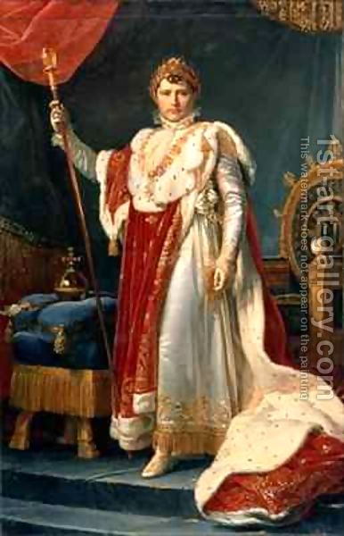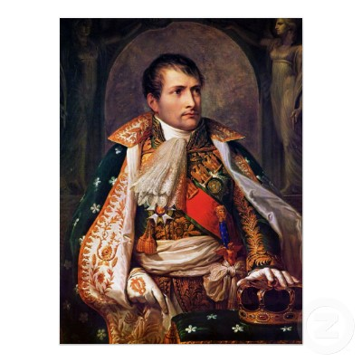
SOURCES: Napoleon I by Baron Francois Gerard, 1805. | Napoleon I, King of Italy by Andrea Apiani, 1805.

Document 6
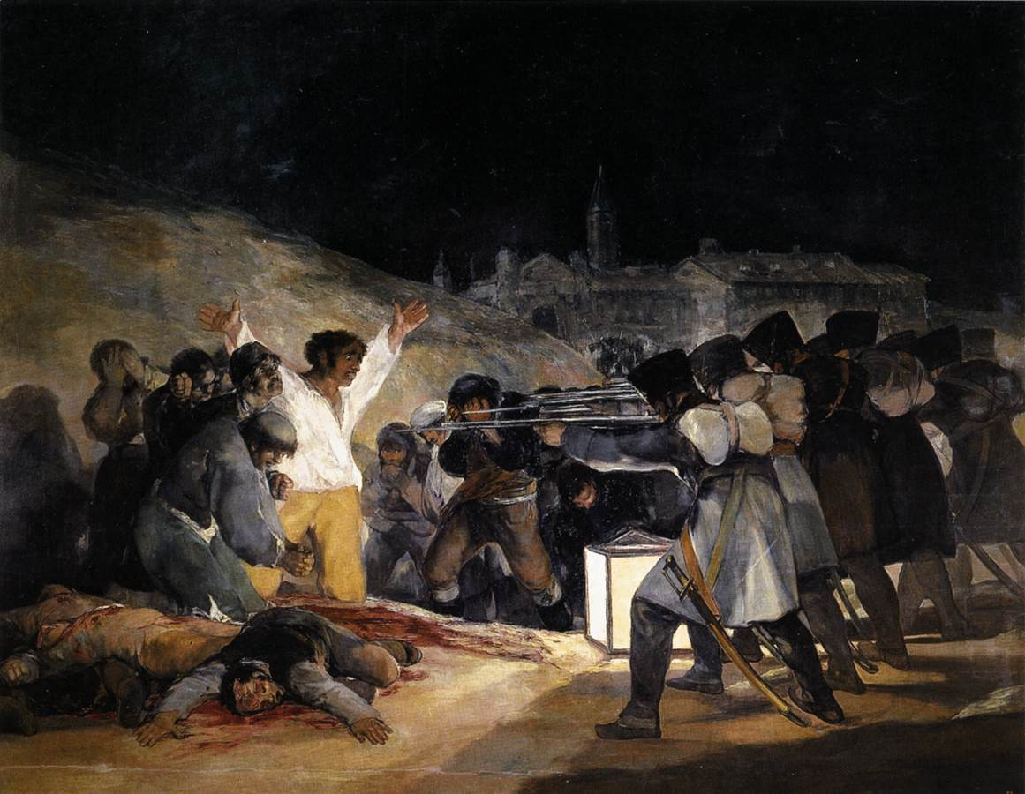
SOURCE: “The Third of May, 1808” by Francisco de Goya, 1814.

Document 7
…………….. Traitor to the Revolution? One of the accusations often leveled against Napoleon is that he "betrayed" the higher ideals of the French Revolution, retarding democratic progress in both France and Europe. People making this argument apparently forget that the revolution had its truly dark side and fell a good deal short of being an ideal society. Life was not more secure nor more prosperous. France was not friendlier to Europe under the Committee of Public Safety or the Directory than it proved to be under the Consulate or Empire. Napoleon's initial achievements are a remarkable compromise with revolutionary ideals and the requirements of a country bled white by the excesses of failed governments. He signed the Peace of Amiens, which brought an end to years of war. His enthusiastic participation in and endorsement of the codification of law embodied and certified the social revolution. He negotiated the Concordat and made peace with the Catholic Church, but on revolutionary terms, making it subordinate to the state, and the dominant faith of the French once again became a steadying and unifying influence on daily life. Yet given his singular opportunities, it is often said that he might have gone further and established a truly democratic state, a goal one might argue went against political trends both within France and on the continent. Democracies were more conceptual than actual in the era, with the American experiment still in its infancy, and it might be said that the violence of the previous decade had made the French population indifferent to the virtues of democracy. Outside France, it might also be argued that whether France was a totalitarian state or a democracy made little difference to her enemies. If there was a perceived difference, perhaps a democracy might have caused more fear among the reactionary states than the civil monarchy that actually came into being. If this was the case, perhaps Bonaparte acted more out of pragmatism than idealism, attempting to solve foreign and domestic problems by establishing a stable government that was theoretically more acceptable to everyone. He might have reasonably imagined that any man who could achieve that successful transition deserved the reins of power.

SECONDARY SOURCE: Essay by Maxwell Sewell, “Feet of Clay: An Examination of Napoleon Bonaparte” from the web site, www.NapoleonSeries,org.

Document 8
ARTICLE 1. Men are born and remain free and equal in rights. Social distinctions may be founded only upon the general good.
2. The aim of all political association is the preservation of the natural and imprescriptible rights of man. These rights are liberty, property, security, and resistance to oppressions.
3. The principle of all sovereignty (power) resides essentially in the nation. No body nor individual may exercise any authority which does not proceed directly from the nation.
6. Law is the expression of the general will. Every citizen has a right to participate personally, or through his representative, in its formation. It must be the same for all, whether it protects or punishes. All citizens, being equal in the eyes of the law, are equally eligible to all…public positions and occupations…
10. No one shall be disquieted on account of his opinions, including his religious views, provided their manifestation does not disturb the public order established by law.
13. A common contribution is essential for the maintenance of the public forces and for the cost of administration. This should be equitably distributed among all the citizens in proportion to their means.
16. A society in which the observance of the law is not assured, nor the separation of powers defined, has no constitution at all.
17. Since property is an inviolable and sacred right, no one shall be deprived thereof except where public necessity, legally determined, shall clearly demand it, and then only on condition that the owner shall have been previously and equitably indemnified.

Primary SOURCE: National Assembly of France, Declaration of the Rights of Man and of the Citizen, 1789

Document 9
8. Every Frenchmen shall enjoy civil rights.
Chapter VI: Of the Respective Rights and Duties of Married Persons
213. The husband owes protection to his wife, the wife obedience to her husband.
214. The wife is obliged to live with her husband, and to follow him every place where he may judge it convenient to reside: the husband is obliged to receive her, and to furnish her with every necessity for the wants of life, according to his means and station.
215. The wife cannot plead in her own name, without the authority of her husband, even though she should be a public trader, or noncommunicant, or separate in property.
216. The authority of the husband is not necessary when the wife is prosecuted in a criminal manner, or relating to police.
1421. The husband alone administers the property of the community. He may sell it, alienate and pledge it without the concurrence of his wife.
Primary SOURCE: Napoleon Bonaparte, The Napoleonic Code, 1804.

Document 10
By late 1799, Napoleon had established a new government, rewritten the constitution, and made himself head of state. He was the most powerful man in France, and he was only 30 years old! His military successes convinced him that he was destined to be a great leader and that the people of France looked to him to end the political chaos. In the course of the next few years, he would demonstrate that in addition to being a great military leader, he was also an enlightened monarch. As emperor of France, he would prove to be a civil executive of enormous capacity and ability. Determined to promote the growth of a modern state, he began to reorganize France completely.
Government
Napoleon instituted a strong, centralized government and simplified the court system. He also instituted universal male suffrage.
Legal System
He oversaw the development of a new system of civil laws that became known as the Napoleonic Code. That new set of laws gave permanent form to the great gains of the French Revolution. Most important, the code abolished feudalism and serfdom, provided for freedom of religion, and establishedóat least legallyóthe equality of every man before the law.
Religion
He signed an agreement called the Concordat with the pope in 1801. By the terms of the agreement, Catholicism was made the official religion of France, thereby ending the quarrel with the Catholic Church that had arisen during the revolution. Yet the next year, Napoleon limited the power of the pope to intervene in French affairs.
Infrastructure
He built canals, reservoirs, and roads. He built new parks, bridges, and quays along the Seine River.
Economy
To bolster the economy, he founded the Bank of France, thereby guaranteeing credit at a reasonable rate to French businesses. He stabilized the franc, and prosperity returned to France.
Education
All schools were controlled by a centralized system. Free public schools were envisioned. Higher education was opened to all, regardless of class or religion. Incomes were provided for eminent scholars, especially scientists.
Napoleon's empire eventually ruled 70 million Europeans. His goal was to spread his innovations throughout the empire. However, all was not well. His dictatorial rule bred discontent. At home in France, he narrowly escaped two assassination attempts and a kidnapping plot. Eventually, all of Europe was arrayed against him. In 1815, 15 years after he had begun to rule France, he was defeated by the allied forces of Great Britain, Russia, Prussia, Austria, and others; forced to abdicate; and sent into exile on an island far out in the Atlantic. He never held the reins of power again.
Napoleon I's reoganization of France." World History: The Modern Era. ABC-CLIO, 2013. Web. 10 Dec. 2013.

Document 11
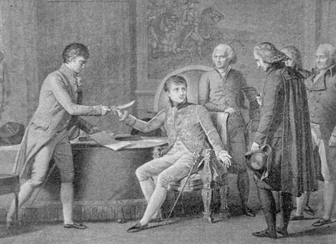

Napoleon Bonaparte signs the Concordat of 1801. In an attempt to ease the discord over the rightful control of the Catholic Church, French leader and future emperor Napoleon I signed an agreement with Pope Pius VII to reestablish the Catholic Church in France.
"Napoleon Bonaparte signs the Concordat of 1801." Image. Chaiba Media. World History: The Modern Era. ABC-CLIO, 2013. Web. 16 Dec. 2013.

Document 12
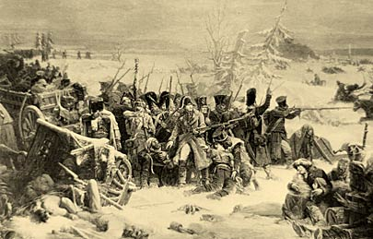

French marshal Michel Ney, musket in hand, leads the rear guard of the Grande Armée during Napoleon I's catastrophic retreat from Moscow in 1812.
"French retreat from Moscow." Image. Engraving by Henry Wolf after Adolphe Yvan from Life of Napoleon Bonaparte by William M. Sloane. New York: Century Co., 1906, vol. 4. World History: The Modern Era. ABC-CLIO, 2013. Web. 16 Dec. 2013.

Document 13
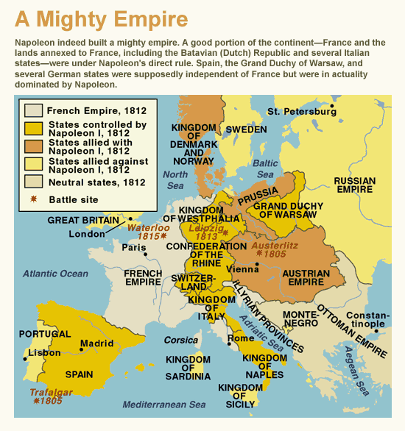
Napoleon's Empire (Visual)." World History: The Modern Era. ABC-CLIO, 2013. Web. 16 Dec. 2013.

Name: Date: Period:
Historical Round Table #2: Was Napoleon a friend or an enemy of Revolutionary France?
Directions: As you work through the documents, fill out the chart after you have studied each one. Try to find an argument for (Napoleon supported the ideals of the revolution) and against (Napoleon did not support the ideals of the revolution) in each document. This may not be possible on each, but you need to at least attempt to look at the document from both angles. The more arguments you are able to formulate, the more successful you will be in the discussion!
Documents | Arguments Supporting Napoleon | Arguments Against Napoleon
Document 1

Document 2

Document 3

Document 4

Document 5

Document 6

Document 7

Document 8

Document 9

Document 10

Document 11

Document 12

Document 13

Document 14
(Declaration of the Rights of Man)

