Open Up the Textbook (OUT)
In this OUT analysis, 10th students will study the interactions between Columbus and the Arawak people in order to better understand in what ways exploration impacted native culture. This OUT analysis provides students with documents that are meant to deliberately complicate and contest the textbook.

Source A: The Textbook – [World History, Patterns of Interaction, Beck, Black, Krieger, Naylor, & Shabaka, and page 553]

In the early hours of October 12, 1492, the long-awaited cry came. A lookout aboard the Pinta caught sight of a shoreline in the distance… By dawn, Columbus and his crew were ashore. Thinking he had successfully reached the East Indies, Columbus called the surprised inhabitants who greeted him, los indios. The term translated into ‘Indian,’ a word mistakenly applied to all the native peoples of the Americas. In his journal, Columbus recounted his first meeting with the native peoples:

“I presented them with some red caps, and strings of glass beads to wear upon the neck, and many other trifles of small value, wherewith they were much delighted, and became wonderfully attached to us. Afterwards they came swimming to the boats where we were, bringing parrots, balls of cotton thread, javelins, and many other things which they exchanged for articles we gave them…in fact they accepted anything and gave what they had with the utmost good will.” Christopher Columbus, Journal of Columbus

Columbus had miscalculated where he was. He had not reached the East Indies. Scholars believe he landed instead on an island in the Bahamas in the Caribbean Sea. The natives there were not Indians, but a group who called themselves the Taino. Nonetheless, Columbus claimed the island for Spain. He named it San Salvador, or “Holy Spirit.”
Columbus, like other explorers, was interested in gold. Finding none on San Salvador, he explored other islands, staking his claim to each one. “It was my wish to bypass no island without taking possession,” he wrote.

Source A Questions for Consideration
- Describe the relationship between Columbus and the Taino. How do you know?

- What were Columbus’ goals or interests in the Caribbean?

- Line 13 states “Columbus claimed the island for Spain.” How might the Tainos have reacted to that statement?

Source B: Secondary Source – essay – [Thomas C. Tirado, Ph.D. Professor History, Millersville University, 2000]
Setting sail from Cadiz on September 25, 1493, the second voyage was on a much larger scale; 17 ships and about 1200 colonists accompanied Columbus. Its mission was to return to La Navidad in Hispaniola to relieve the men left behind from the first voyage, settle more colonists on the islands, and conquer other islands to be discovered. This time Columbus carried a mission to bring Christianity to the Indians...
After spending two weeks discovering and naming other beautiful islands, seeing incredible lush tropics, rare sights, and indescribable flora and fauna, the fleet came upon the island of Guadalupe. The Spaniards were shocked by stories of the cruel practices of the Carib Indians who waged war on the nearby island and ate their captives. The first real battle in the New World with natives came in a skirmish with these “Cannibals” on the island of St. Croix. It should be mentioned that more than a few historians doubt that the practice of cannibalism actually existed as described in the chronicles of the sailors; nevertheless, it was believed by the Spanish explorers. Later in Spanish colonial history, it was enough to label a native “cannibal” to enslave him…
Reaching Hispaniola at the end of November, the Spanish fired a cannon to announce their arrival, but no one returned the salute. There was response, no flag waving…nothing! An ominous sign. To their horror, they discovered that the entire settlement of La Navidad had been massacred and the site burned to the ground. As they searched for any trace of their compatriots, the newcomers discovered a mass grave in which several Spaniards were buried. They discovered also that the village of Columbus’ good friend, Chief Guacanagarí, was burned and destroyed. No one will ever know for sure what happened at La Navidad, but the popular theory is that local natives destroyed the settlement out of disgust with the settlers’ greed and avarice.

Source B Questions for Consideration
- What were the goals of Columbus’ second voyage to the New World?

- What caused the first battle in the New World?

- Were the Spanish correct in their assumptions about the “Cannibals” on St. Croix? How do you know?

- What happened to the first Spanish settlement of La Navidad? Why did this occur?

- Is this author more sympathetic to the natives or to the Spanish? How do you know?

Source C: Primary Source – Letter to King Ferdinand and Queen Isabella – [Diario of Christopher Columbus, transcribed by Barolomé de Las Casas, and October 11-15, 1492]

Weapons they have none, nor are acquainted with them, for I showed them swords which they grasped by the blades, and cut themselves through ignorance. They have no iron, their javelins being without it, and nothing more than sticks, though some have fish-bones or other things at the ends. They are all of a good size and stature, and handsomely formed… It appears to me, that the people are ingenious, and would be good servants and I am of opinion that they would very readily become Christians, as they appear to have no religion. They very quickly learn such words as are spoken to them. If it please our Lord, I intend at my return to carry home six of them to your Highnesses, that they may learn our language.

…The people here are simple in war-like matters, as your Highnesses will see by those seven which I have ordered to be taken and carried to Spain in order to learn our language and return, unless your Highnesses should choose to have them all transported to Castile, or held captive in the island. I could conquer the whole of them with fifty men, and govern them as I pleased.

Tomorrow morning before we depart, I intend to land and see what can be found in the neighborhood. Here is no village, but farther within the island is one, where our Indians inform us we shall find the king, and that he has much gold. I shall penetrate so far as to reach the village and see or speak with the king, who, as they tell us, governs all these islands, and goes dressed, with a great deal of gold about him. I do not, however, give much credit to these accounts, as I understand the natives but imperfectly, and perceive them to be so poor that a trifling quantity of gold appears to them a great amount.

Source C Questions for Consideration
- What adjectives does Columbus use to describe the native people?

- Columbus takes care to mention the native’s lack of weapons and ignorance of war. Why might he include these details in his letter to Queen Isabella and King Ferdinand?

- Given the definition of ingenious, why does Columbus think the natives would make good servants?

- According to his letter, what seems to be Columbus’ main priorities in this new place?

- What evidence shows Columbus is writing for Queen Isabella and King Ferdinand? How might this influence what he writes?

Source D: Primary Source – Ship’s Log– [Ship’s Log of Christopher Columbus, October 1492]

Upon his return to Spain in 1493, Columbus presented to Queen Isabella his captain's log—the daily account of what he had observed on his voyage. The following excerpts from that document describe his impressions of the Native Americans and also reveal his attitude toward them.

Friday, 12 October 1492:
I want the natives to develop a friendly attitude toward us because I know that they are a people who can be made free and converted to our Holy Faith more by love than by force. I therefore gave red caps to some and glass beads to others. They hung the beads around their necks, along with some other things of slight value that I gave them. And they took great pleasure in this and became so friendly that it was a marvel. They traded and gave everything they had with good will, but it seems to me that they have very little and are poor in everything. I warned my men to take nothing from the people without giving something in exchange.

Saturday, 13 October 1492:
I cannot get over the fact of how docile these people are. They have so little to give but will give it all for whatever we give them, if only broken pieces of glass. One seaman gave three Portuguese ceitis (not even worth a penny!) for about 25 pounds of spun cotton. I probably should have forbidden this exchange, but I wanted to take the cotton to Your Highnesses, and it seems to be in abundance. I think the cotton is grown on San Salvador, but I cannot say for sure because I have not been here that long. Also, the gold they wear hanging from their noses comes from here, but in order not to lose time I want to go to see if I can find the island of Japan.

Source D Questions for Consideration
- What is a Captain’s log?

- How does Columbus describe the Native Americans?

- How does he treat the native peoples?

- What resources do the Taino have that Columbus notes in his log?

- How does his description of the Taino in this log compare to the letter he sent to the King and Queen of Spain (Doc C)?

Source E: Secondary Source - book – [A People’s History of the United States, Howard Zinn, and 1980]

“Now, from his base on Haiti, Columbus sent expedition after expedition into the interior. They found no gold fields, but had to fill up the ships returning to Spain with some kind of dividend. In the year 1495, they went on a great slave raid, rounded up fifteen hundred Arawak [Taino] men, women, and children, put them in pens guarded by Spaniards and dogs, then picked the best specimens to load onto ships. Of those five hundred, two hundred died en route…
But too many slaves died in captivity. And so Columbus, desperate to pay back dividends to those who had invested, had to make good his promise to fill the ships with gold. In the province of Cicao on Haiti, where he and his men imagined huge gold fields to exist, they ordered all persons fourteen years or older to collect a certain quantity of gold every three months. When they brought it, they were given copper tokens to hang around their necks. Indians found without a copper token had their hands cut off and bled to death.
The Indians had been given an impossible task. The only gold around was bits of dust garnered from the streams. So they fled, were hunted down with dogs, and were killed… In two years, through murder, mutilation, or suicide, half of the 250,000 Indians on Haiti were dead.
When it became clear that there was no gold left, the Indians were taken as slave labor on huge estates, known later as encomiendas. There were worked at a ferocious pace, and died by the thousands. By the year 1515 there were perhaps fifty thousand Indians left. By 1550, there were five hundred. A report of the year 1650 shows none of the original Arawaks or their descendants left on the island.”

Source E Questions for Consideration
- Would you describe the relationship between Columbus and the Arawaks [Taino] as strained, cooperative, or cruel? What evidence do you have of this?

- What was the ‘impossible task’ the natives had been given? What were the consequences that Columbus’ men dealt to them for not fulfilling the task?

- Why did Columbus and the Spaniards need gold? What did they do when enough gold wasn’t found?

- What were some problems Columbus faced while trying to make a profit in the Caribbean?

- How does this account of Columbus’ relationship with the Taino compare with the accounts in Documents D and A?

Source F: Primary Source - Diary – [The Devastation of the Indies: a Brief Account, Bartolomé de Las Casas, 1542]
And of all the infinite universe of humanity, these people [natives] are the most guileless, the most devoid of wickedness and duplicity, the most obedient and faithful to their native masters and to the Spanish Christians whom they serve. They are by nature the most humble, patient, and peaceable, holding no grudges, free from embroilments, neither excitable nor quarrelsome… And because they are so weak and complaisant, they are less able to endure heavy labor and soon die of no matter what malady.
Yet into this sheepfold, into this land of meek outcasts there came some Spaniards who immediately behaved…like ravening beasts, killing, terrorizing, afflicting, torturing, and destroying the native peoples, doing all this with the strangest and most varied new methods of cruelty, never seen or heard of before…
We can estimate very surely and truthfully that in the forty years that have passed, with the infernal actions of the Christians, there have been unjustly slain more than twelve million men, women, and children. In truth, I believe without trying to deceive myself that the number of the slain is more like fifteen million.
Their reason for killing and destroying … is that the Christians have an ultimate aim, which is to acquire gold, and to swell themselves with riches in a very brief time… Our Spaniards have no more consideration for them than beasts. And I say this from my own knowledge of the acts I witnessed. But I should not say "than beasts" for, thanks be to God, they have treated beasts with some respect; I should say instead like excrement on the public squares.
…The Indians began to seek ways to throw the Christians out of their lands. They took up arms, but their weapons were very weak and of little service in offense and still less in defense. (Because of this, the wars of the Indians against each other are little more than games played by children.) And the Christians, with their horses and swords and pikes began to carry out massacres and strange cruelties against them. They attacked the towns and spared neither the children nor the aged nor pregnant women nor women in childbed, not only stabbing them and dismembering them but cutting them to pieces as if dealing with sheep in the slaughter house. They laid bets as to who, with one stroke of the sword, could split a man in two or could cut off his head or spill out his entrails with a single stroke of the pike. They took infants from their mothers' breasts, snatching them by the legs and pitching them headfirst against the crags or snatched them by the arms and threw them into the rivers, roaring with laughter … With still others, all those they wanted to capture alive, they cut off their hands and hung them round the victim's neck, saying, "Go now, carry the message," meaning, take the news to the Indians who have fled to the mountains.
After the wars and the killings had ended, when usually there survived only some boys, some women, and children, these survivors were distributed among the Christians to be slaves.
Source F Questions for Consideration
- What phrases does de Las Casas use to describe the native people?

- Why does he say the Spanish are acting like “ravening beasts?”

- What was the goal of the Spanish?

- Why couldn’t the native people fight back against the Spanish? What happened when they tried?

Source G: Secondary Source – Book - [Paraphrased from “Lies My Teacher Told Me,” James Loewen, 2007]

Although not the first European to explore North America and South America, Columbus is recognized as “THE FIRST” because of the lasting impacts he made. Columbus successfully crossed the Atlantic four times. Unlike La Salle, who got lost on his second voyage, Columbus and his men were able to continuously find the same islands, which show expertise in navigation and sea travel.
Because of Columbus, and his decision to bring gold, slaves, and goods across the Atlantic, from the Caribbean to Europe, trans-Atlantic trade began. It is sometimes called the “Columbian Trade” because Columbus started this process. Part of this trans (cross)-Atlantic trade was the slave trade.
Columbus also made it a “norm” to go to an unknown place and take land, money and labor from the native people. While not a positive choice, this model of conquest was used and is still used by many today. Finally, from the point of view of the European nations who benefited from Columbus and other explorers, his trips were successful. This is because their countries grew in wealth and land. He helped add even more power to these countries.

Source H: Secondary Source – Video – [Dr. Geoffrey Symcox. Professor of History at UCLA in “Columbus’ Search for Gold” video. History Channel. 2013.]

The first day he encounters the Indians he talks about what good slaves they would make. He takes the Indians who come to him to trade and he captures them and he keeps them. Columbus was a man of his time. Like the settlers, Columbus was there to make money. He was not too particular about the ways he chose to make money because that’s the way that people behaved. There was a flourishing slave trade in Europe in the Middle Ages. Slavery was a customary product of European society. It didn’t seem in anyway unnatural for Columbus and the other settlers to do this.

Source G & H Questions for Consideration
- According to these sources, what were some of Columbus’ accomplishments?

- Dr. Geoffrey Symcox describes Columbus as “a man of his time.” What does he mean by this statement?

- How do these authors justify Columbus’ actions in the New World?

Source I: Secondary Source – Painting – [“Landing of Columbus”, John Vanderlyn, 1847. Located in the Rotunda of the U.S. Capitol Building]
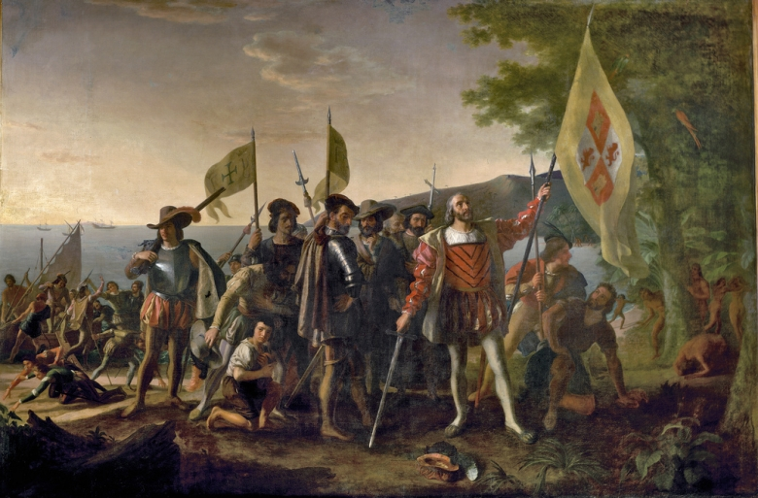

Source I Questions for Consideration
- Describe what is taking place in this scene.

- Who are the people being represented? How do you know?

- What is the artist’s claim? How do you know?

- This image was painted for the Capitol Building of the U.S. Government. How might influence this portrayal of Columbus?

Source J: Primary source – Woodcut– [The Devastation of the Indies: a Brief Account, Bartolomé de Las Casas, 1542]

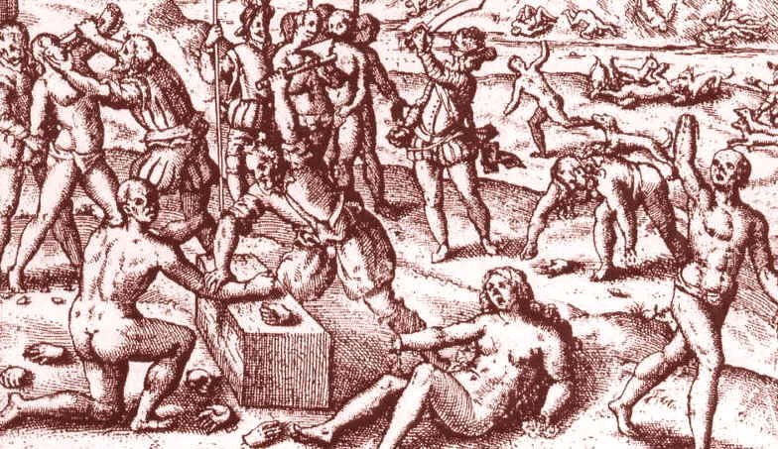
Source J Questions for Consideration
- Describe what is taking place in this scene.

- Who are the people being represented?

- Based on Sources E & F, why do you think these people are being punished?

- What did the Spanish gain from doing this?

- What is the artist’s claim? How do you know?

Writing Task

This is an argumentative writing task based on NVACS standards. Students will demonstrate their understanding of the texts as well as the ways in which the textbook was complicated and/or contested.

How should history judge the actions of Columbus? Was he a heroic explorer who helped advance his people? Or was he a cruel treasure seeker focused only on enriching himself?

- Answer the above question in approximately half a page using evidence from at least five of the texts provided.
- Write a clear claim and provide 6 pieces of evidence to support your idea. After each piece of evidence cited in a direct quote or paraphrase (your own words), please add the source letter in parentheses, for example (Source B).
- For each piece of evidence, clearly reason (explain) why this piece of evidence helps support your claim. Underline your reasoning. Reasoning can be in the same sentence or the evidence or come before or after the sentence that includes the evidence.
- Choose [4] of the important vocabulary terms from the box below to include in your writing. Add at least two context clues for each term to demonstrate your understanding. Circle your context clues for each term.
Trans-Atlantic Trade
Columbian Exchange
Trans-Atlantic Slave Trade
Enslavement
Exploit
Transport
Skirmish
Avarice
Convert
Expedition
Encomienda
Mutilation

Colony
Conquer
Conquest
Devastation
Dismember
Exploration

Arawak
Taino
Massacre
Quota
Settlement
Cruelty

Plants and animals
Spears
Clever or inventive
profit
Innocent, without trickery
Spear
Cutting off body parts

