Common Core Social Studies Learning Plan Template

Lesson Title: Jackson: King Andrew or Champion of the Common Man?
1
Author Name: Sarah Brown

Contact Information: sabrown@washoeschools.net

Appropriate for Grade Level(s): 11th AP US History or review in 11th Grade US History

History Standard(s)/Applicable CCSS(s) (RI, W, S&L, L):
US History Standards
H3.[6-8].7 Explain the struggle between states’ rights and federalism, and the impact on the national identity in the United States.
CCSS Reading Standards
RH11-12.1 Cite specific textual evidence to support analysis of primary and secondary sources, connecting insights gained from specific details to an understanding of the text as a whole.
RH11-12.2 Determine the central ideas or information of a primary or secondary source; provide an accurate summary that makes clear the relationships among the key details and ideas.
CCSS Writing Standards
WH11-12.1 Write arguments focused on discipline-specific content.
WH11-12.9 Draw evidence from informational texts to support analysis, reflection, and research.

Type of Lesson: DBQ & Philosophical Chairs Discussion

Student Readings (list): Readings /Documents were obtained from the DBQ Project

Total Time Needed: 3 Hours depending on level of students and their exposure to document analysis

Lesson Outline: *Students should have prior knowledge of Andrew Jackson and his presidency prior to beginning this lesson.
Time Frame  (e.g. 15 minutes) | What is the teacher doing? | What are students doing?
15 minutes | Teacher will instruct students to work with a partner to recall the definition of democracy and to discuss examples of democratic values in a democratic society. Ask students what makes a society democratic and what would someone who believes in democratic values support? After students have discussed with their partner, the teacher will conduct a brief whole class discussion. | Students will work with a partner to respond to the teachers questions regarding democracy. Students will next be prompted to respond to a whole class discussion.
10-15 minutes | Teacher will pass out the packet of documents.  Teacher will then ask students to read the DBQ question, “King Andrew or Champion of the Common Man; How democratic was Andrew Jackson?” and paraphrase (put it in their own words) to make sure they understand the question. At this point the teacher will discuss that some characterized Jackson as a king while others championed him as the “Common Man”. Demonstrate how these characterizations reflect opposite ends of the spectrum in regards to the DBQ question. | Students will paraphrase the DBQ question and discuss to confirm their understanding of the question.
45 – 60 minutes | Ask students to begin analyzing the documents and then complete the Preparing for Debate worksheet. | Students will work in pairs to analyze each of the documents. Teacher may model if necessary. Each student will then choose a side regarding the question and complete their Preparing for Debate worksheet individually.
5 minutes | Teacher will organize desks in a U formation following the guidelines listed on the Philosophical Chairs Rubric. Teacher will review the debate procedures and rules. | Students will choose their seat following the guidelines listed on the Philosophical Chairs Rubric.
30-45 minutes | Teacher will indicate the start of the debate and will facilitate. At the end of the debate the teacher will give each side a chance to select a spokesperson to give a 1 minute summary of their argument. After each side gives their summary students who remained undecided or moved into the undecided group will explain their position and then the debate will be over. | Students will debate following the rubric guidelines. They are expected to provide evidentiary support and speak at least twice. All students must take notes during the course of the debate on the Note Taker worksheet. At the end of the debate students will select a spokesperson and brainstorm their 1 minute summary of main arguments. The spokespersons will speak to conclude the debate.
10-15 minutes | Teacher will ask students to complete the reflection question at the end of the debate worksheet and may assign the essay portion of the DBQ. | Students will submit the debate materials or will use them to complete a written DBQ response.

Description of Lesson Assessment: Students will be assessed informally throughout the lesson as the teacher monitors and facilitates document analysis and completion of the debate preparation worksheet. Formal assessment will occur when the teacher records student participation and arguments during the debate, reviews preparation worksheet and note taker, and grades the DBQ writing assignment using the AP DBQ rubric. Students will also respond to the reflection question at the end of the debate worksheet. This will serve as an exit ticket to check for understanding.

How will students reflect on the process and their learning? Students will reflect on the content of the lesson as they write their DBQ essay afterwards. They will also reflect on their position by answering the final question on the preparation worksheet.

Preparing for Debate Name _______________________________________ Date ________ Period ________
Directions: Using your notes from your analysis of the documents and your DBQ, determine how democratic Andrew Jackson was. Prepare for the debate by brainstorming your claims, evidence, and reasoning below. Be sure to cite specific documents and examples in your brainstorm.

King Andrew or the Champion of the Common Man: How Democratic Was Andrew Jackson?
Claim –What do you intend to prove? | Evidence – What is your proof?  Cite Documents | Reasoning – How does your evidence prove your claim?

- Did your opinion about Andrew Jackson change over the course of the discussion? How? Why or why not? Provide evidence and reasoning.
Name: Date: Period:
Philosophical Chairs Debate
Philosophical Chairs Debate is a discussion model that we will use throughout the year to examine and debate controversial questions in history. Every student is graded individually on their participation in these class-wide discussions. By participating in these discussions you will learn how to use evidence to back up your arguments as well as learn to articulate your arguments like a scholar!
Guidelines for the debate:
- The room will be set up in a U formation. One side will be in agreement the opposite side will be in disagreement. The section in between will be the neutral zone.
- One side will begin the discussion and then it will be the other side’s turn. A person who speaks on either side must wait until two people on their side have spoken before they can speak again.
- Students in the neutral section may move to either side based on which side of the argument they agree with, however, they must explain to the class why they have decided to take a certain side.
- Students on the either side may also move to other sections of the room as the discussion progresses, those students will also need to explain their reasons for doing so.
- While in the neutral section students should be taking notes on both sides of the discussion. They may also ask students on either side to clarify their arguments.
- Students may not raise their hands to speak while someone else is speaking, they must wait until the speaker has finished.
- At the end of the discussion, each side takes 1 minute to summarize their main arguments and make a final statement.
- While another student has the floor, all other students need to remain silent.
- Arguments need to be based on evidence!
Philosophical Chairs Grading Rubric
35-32 Points | 31-28 Points | 27-25 Points | 24-21 Points | 20-0 Points
Student completed all work prior to discussion.  Student spoke at least twice during discussion.  Student’s arguments were connected to the text.  Student took detailed notes that informed their argument.  Student followed all norms of the strategy. | Student completed all work prior to discussion.  Student spoke at least twice during discussion.  Arguments were mostly connected to text.  Student took notes.  Student followed norms regularly. | Student completed at least half of the work prior to discussion.  Student spoke at least once during discussion.  Arguments were mostly connected to text.  Student took limited notes.  Student followed norms regularly. | Student completed less than half of the work prior to discussion.  Student spoke at least once during discussion.  Arguments were sometimes connected to the text.  Student took limited and vague notes.  Students generally followed norms. | Student did not complete work leading up to discussion.  Student did not speak during discussion or only spoke once.  Arguments were not connected to text.  No notes were taken.  Student generally did not follow norms.

Name: Date: Period:
Philosophical Chairs Debate: NOTE TAKER
Directions: As you listen and participate in debate, take notes using this note taker.
How Democratic was Andrew Jackson?
Champion of the Common Man:  Andrew Jackson was very democratic. | King Andrew:  Andrew Jackson was NOT very democratic.

Document A
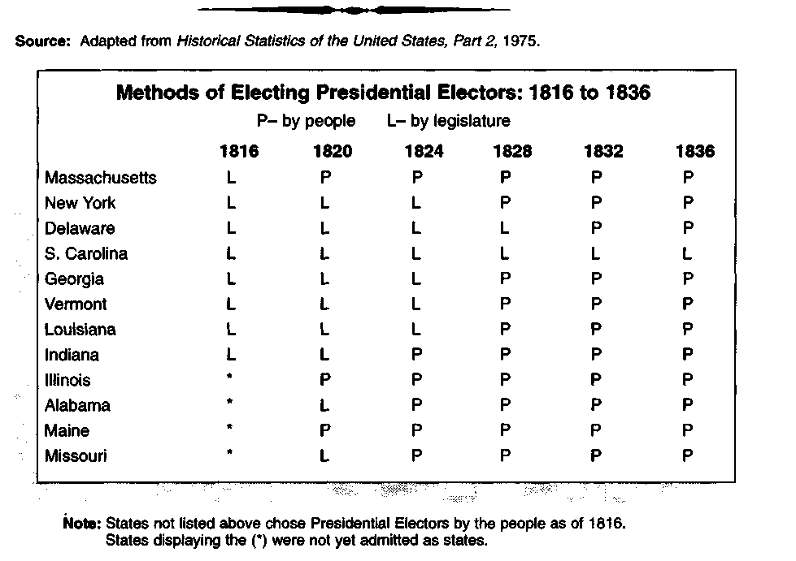

Document B
Source: Thomas Bailey and David Kennedy, The American Pageant, 1994.
...(T)he concept of a political revolution in 1828 is not completely farfetched. The increased turnout of voters proved that the common people, especially in the universal-white-manhood suffrage states, now had the vote and the will to use it for their ends....So in a broader sense the election was a "revolution" comparable to that of 1800. It was a peaceful revolution, achieved by ballots instead of bullets.... "Shall the people rule?" cried the Jacksonians. The answering roar seemed to say, "The people shall rule!" In the struggle between the poorer masses and the entrenched classes, the homespun folk scored a resounding triumph, befuddling some members of the elite establishment. "I never saw anything like it," a puzzled Daniel Webster mused about Jackson's inaugural. "Persons have come five hundred miles to see General Jackson, and they really think that the country is rescued from some dreadful danger."America hitherto had been ruled by an elite of brains and wealth, whether aristocratic Federalist shippers or aristocratic Jeffersonian planters. Jackson's victory accelerated the transfer of national power from the country house to the farmhouse, from the East to the West, from the snobs to the mobs. If Jefferson had been the hero of the gentleman farmer, Jackson was the hero of the dirt farmer. The plowholders were now ready to take over the government: their government.

Document C
Source: Reprinted by permission of P.K. Yonge Library of Florida History, University of Florida.
Hermitage August 27th, 1822
Dr. Bronough,
I had the pleasure on last evening to receive your letter of the 22nd. It affords me great pleasure to be informed of your flattering prospects of success on your election (as Florida Territory’s first delegate to the House of Representatives)….If the soldiers be admitted to vote you are safe, the army will stick by you…Under existing circumstances, it would be impolitic and unjust to make a property qualification. Residence alone, injustice to all, should be requires. This is the only rule that can be established until your land titles are adjudicated. And your vacant land, brought onto the market. Then in your constitution you can adopt such qualifications as you may think proper for the happiness, security, and prosperity of the state. Until then all freemen of six months residence should be entitled to a vote….
Andrew Jackson

Document D
Source: Robert V. Remini, Andrew Jackson and The Course of American Empire, Vol III, Copyright (c) 1984. Reprinted by permission from Harper Collins Publishers, Inc.
...(T)he General's views on office holding became even more democratic as he grew older. He proceeded from the (idea) that all offices - whether appointed or elected - must ultimately fall under the absolute control of the people. Appointed offices should be rotated, preferably every four years. Elected offices must be filled directly by the people. In keeping with this principle, Jackson tried to abolish the College of Electors in the selection of the chief executive by proposing a constitutional amendment. In addition, he said, the President should serve a single term of no more than four or six years.... Moreover, he believed that United States senators should be directly elected by the people. Also, their term should be limited to four years and they should be subject to removal.

Document E
Source: Reprinted by permission of Library of Congress, Lithograph, 1832, LC-USZ62-1562. Note: Cartoon appeared in the presidential election of 1832.

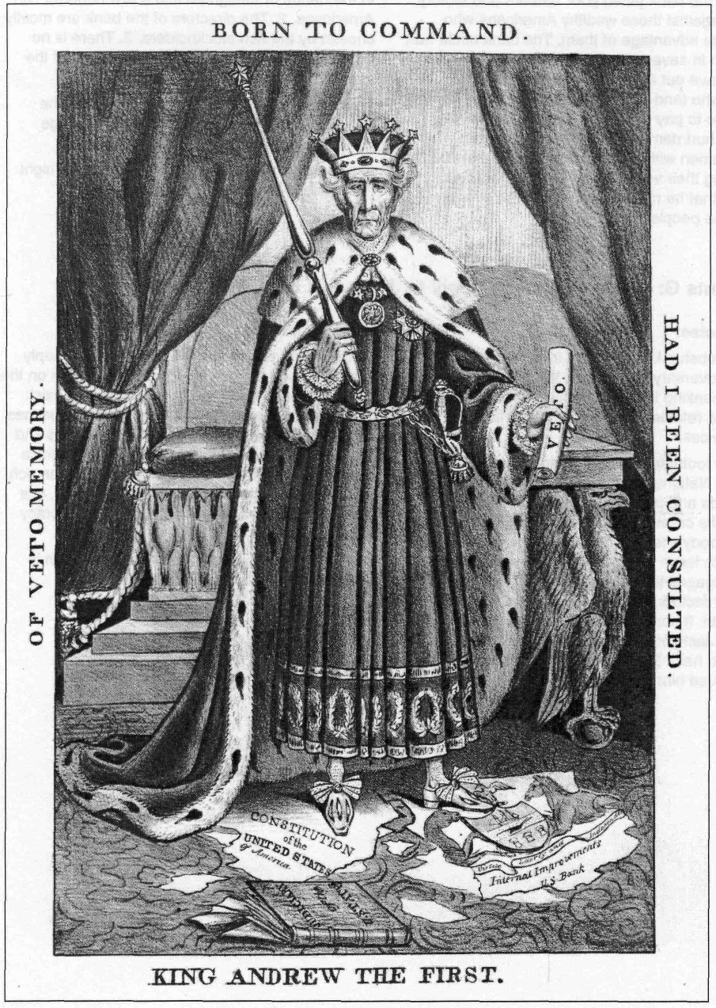

Document F
Source: James D. Richardson, A Compilation of the Messages and Papers of the Presidents, 1789-1902, 1905.
Andrew Jackson's Bank Veto Message to Congress July 10,1832
I sincerely regret that in the act before me I can perceive none of those modifications of the bank charter which are necessary, in my opinion, to make it compatible with justice, with sound policy, or with the Constitution of our country.... The present Bank of the United States...enjoys an exclusive privilege of banking,... almost a monopoly of the foreign and domestic exchange.It appears that more than a fourth part of the stock is held by foreigners and the (rest) is held by a few hundred of our own citizens, chiefly of the richest class.
Of the twenty-five directors of this bank five are chosen by the Government and twenty by the citizen stockholders.... It is easy to conceive that great evils to our country...might flow from such a concentration of power in the hands of a few men irresponsible to the people.
Is there no danger to our liberty and independence in a bank that in its nature has so little to bind it to our country?
It is to be regretted that the rich and powerful too often bend the acts of government to their selfish purposes.

Document G
Source: Daniel Webster, July 11, 1832.
Daniel Webster's Reply to Jackson's Bank Veto Message July 11,1832
(President Jackson's message) extends the grasp of (the chief executive) over every power of the government.... It sows...the seeds of jealousy and ill-will against the government of which its author is the official head. It raises a cry that liberty is in danger, at the very moment when it puts forth claims to powers heretofore unknown and unheard of.... It manifestly seeks to inflame the poor against the rich, it wantonly attacks whole classes of the people, for the purposes of turning against them the prejudices and resentments of the other classes.

Document H
Source: Senate Documents, 21st Congress, 1829-1830.
Andrew Jackson's Letter To Congress Decembers, 1829
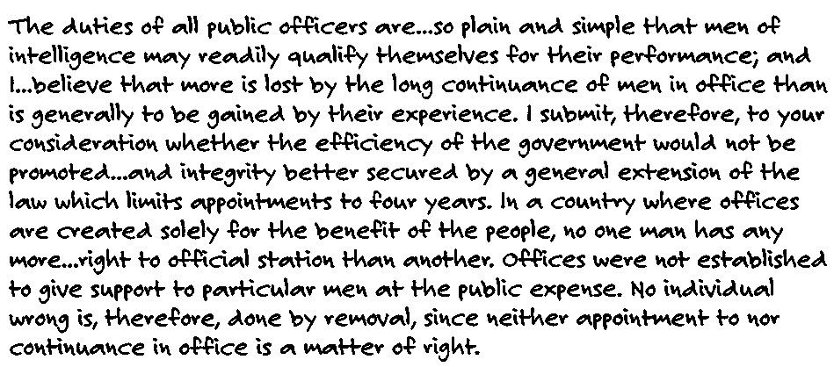

Document I
Source: Robert V. Remini, The Life of Andrew Jackson, 1988.
Reprinted by permission from Harper Collins Publishers, Inc. from The Life of Andrew Jackson, Copyright (c)1988 by Robert V. Remini.
One bit of advice (Secretary of State) Van Buren offered (Jackson) concerned the appointment of the collector of the Port of New York. This was a very sensitive and important position. Some $15 million annually passed through the collector's hands. If any post needed a man of the highest integrity it was this one. And when Van Buren learned that Jackson intended to appoint Samuel Swartwout to the office he almost collapsed. Not only did Swartwout have criminal tendencies but the Regency detested him. Van Buren alerted the President immediately and warned him that Swartwout's appointment would "not be in accordance with public sentiment, the interest of the Country or the credit of the administration." Unfortunately, Jackson refused to listen. He liked Swartwout because he had been an early supporter - unlike Van Buren - and so he went ahead with the appointment. In time, of course, Swartwout absconded with $1,222,705.09. It was a monumental theft.... Jackson was mortified.
When the scandal broke, Jackson's opponents doubled over with laughter. All the talk about rooting out corruption in government, they said, and here the greatest theft in the history of the Republic occurred in the General's own administration.... Here, then, was the bitter fruit of rotation, hooted the President's critics. Here the dreadful consequence of denying the government the service of an elite bureaucracy in order to serve some idealistic democratic principle.

Document J
Source: James D. Richardson, A Compilation of the Messages and Papers of the Presidents, 1789-1902. 1905.
Andrew Jackson's Message to Congress December 7,1829
The condition and destiny of the Indian tribes within the limits of some of our states have become objects of much interest and importance.... By persuasion and force they have been made to retire from river to river and from mountain to mountain, until some of the tribes have become extinct and others have left but remnants.... Surrounded by the whites with their arts of civilization, which, by destroying the resources of the sav age, doom him to weakness and decay, the fate of the Mohegan...is fast overcoming the Choctaw, the Cherokee, and the Creek.... Humanity and national honor demand that every effort should be made to avert so great a calamity.
...I suggest for your consideration...setting apart an ample district west of the Mississippi, and (outside) the limits of any state or territory now formed, to be guaranteed to the Indian tribes as long as they shall occupy it, each tribe having a distinct control over the portion designated for its use.... This emigration should be voluntary, for it would be as cruel as unjust to compel the aborigines to abandon the graves of their fathers and seek a home in a distant land. But they should be distinctly informed that if they remain within the limits of the states they must be subject to their laws.

Document K
Source: "Memorial of the Cherokee Nation," as reprinted in Niles Weekly Register, August 21, 1830.
We wish to remain on the land of our fathers. We have a perfect and original right to remain without interruption or molestation....
But if we are compelled to leave our country, we see nothing but ruin before us. The country west of the Arkansas territory is unknown to us.... The far greater part of that region is, beyond all controversy, badly supplied with food and water; and no Indian tribe can live as agriculturalists without these articles. All our neighbors...would speak a language totally different from ours, and practice different customs.... It contains neither the scenes of our childhood, nor the graves of our fathers....Shall we be compelled by a civilized and Christian people, with whom we have lived in perfect peace for the last forty years, and for whom we have willingly bled in war, to bid adieu to our homes, our farms, our streams and our beautiful forests? No. We are still firm.... Our consciences bear us witness that we are the invaders of no man's rights - we have robbed no man of his territory - we have usurped no man's authority, nor have we deprived any one of his unalienable privileges. How then shall we indirectly confess the right of another people to our land by leaving it forever? On the soil which contains the ashes of our beloved men we wish to live - on this soil we wish to die....

Document L
Source: Map created from various sources.
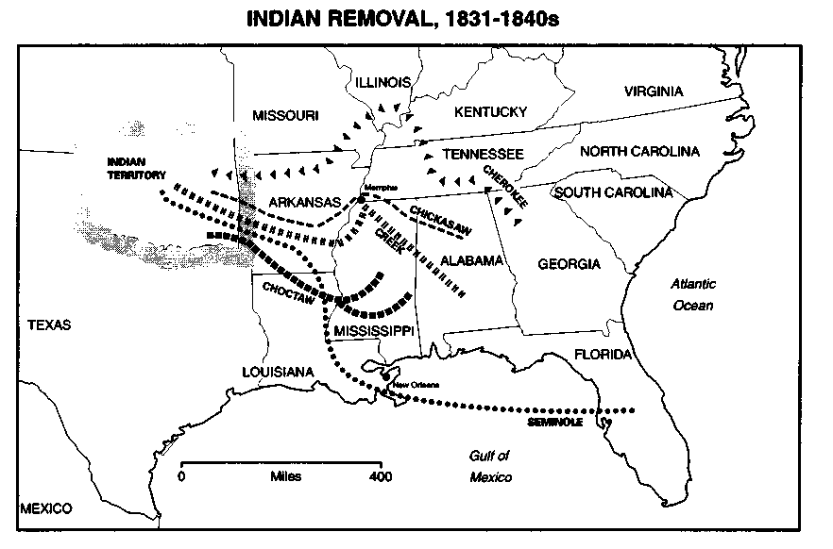
Document M
Source: John Spencer Bassett (ed.), Correspondence of Andrew Jackson, 1931. Reprinted by permission of the Carnegie Institution of Washington.
Excerpts of letters written by Andrew Jackson to his wife Rachel regarding their Creek Indian son, Lyncoya, adopted after the battle of Tallashatchie, November 13, 1813
December 19, 1813
He is the only branch of his family left, and the others when offered to them to take care of would have nothing to do with him but wanted him to be killed.... Charity and Christianity says he ought to be taken care of and I send him to my little Andrew and I hope he will adopt him as one of our family.
December 28, 1823
Tell Lyncoya to read his book and be a good boy and obey you in all things.
Note: Lyncoya died at age 14 of tuberculosis in 1827 and was buried in the family cemetery.

Document N
Source: H. Eaton, A Treatise on the Intellectual Character and Civil and Political Condition of the Colored People of the United States, 1837.
Jackson's Call "To the Free Coloured Inhabitants of Louisiana" before the Battle of New Orleans, September 21,1814
Through a mistaken policy you have heretofore been deprived of a participation in the glorious struggle for national rights, in which our country is engaged. This shall no longer exist...
To every noblehearted free man of color, volunteering to serve to the present contest with Great Britain and no longer, there will be paid the same bounty in money and lands now received by the white soldiers of the United States, viz. $124 in money, and 160 acres of land. The non-commis sioned officers and privates will also be entitled to the same monthly pay and daily rations and clothes furnished to any American soldier.
On enrolling yourselves in companies, the major general com manding will select officers for your government, from your fellow white citizens. Your non-commissioned officers will be appointed from among yourselves.
Due regard will be paid to the feelings of freemen and soldiers. You will not, by being associated with white men in the same corps, be exposed to improper comparisons or unjust sarcasm. As a distinct, indepen dent battalion or regiment, pursuing the path of glory, you will, undivided, receive the applause and gratitude of your countrymen.

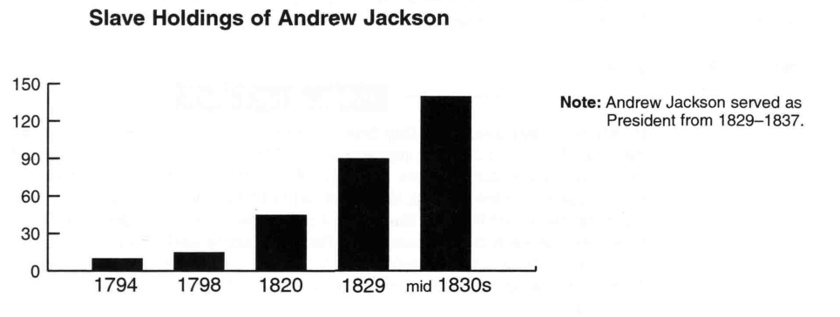
Document O
Source: Robert Remini, Life of Andrew Jackson, 1988.

