Common Core Social Studies Learning Plan Template
Lesson Title: Who was the more effective president: JFK or LBJ?
1
Author Name: Sarah Brown

Contact Information: sabrown@washoeschools.net

Appropriate for Grade Level(s): 11th Grade (designed for an AP US course)

History Standard(s)/Applicable CCSS(s) (RI, W, S&L, L):
US History Standards
H2.[9-12].13 Explain the effects of Cold War policies on U.S. involvement in Korea and Vietnam.
H2.[9-12].14 Examine the changes in the political culture of the United States during the 1960’s and 1970’s, i.e., Assassination of JFK, Watergate, Iranian Hostage Crisis.
CCSS Reading Standards
RH11-12.1 Cite specific textual evidence to support analysis of primary and secondary sources, connecting insights gained from specific details to an understanding of the text as a whole.
RH11-12.2 Determine the central ideas or information of a primary or secondary source; provide an accurate summary that makes clear the relationships among the key details and ideas.
CCSS Writing Standards
WH11-12.1 Write arguments focused on discipline-specific content.
WH11-12.9 Draw evidence from informational texts to support analysis, reflection, and research.

Type of Lesson: Document Based Question & Structured Academic Controversy Discussion Lesson

Student Readings (list): Documents are included with lesson.

Total Time Needed: 3.5 - 4 hours

Lesson Outline:
Time Frame  (e.g. 15 minutes) | What is the teacher doing? | What are students doing?
Pre - work |  | Students have read corresponding pages in textbook on JFK & LBJ. Students have taken reading notes.
90 minutes | Teacher will give a brief overview of video and then play The Century with Peter Jennings, Poisoned Dreams & Unpinned and pass out note-taking worksheet. Teacher might choose to stop and discuss during the video. | Students will take notes on the worksheet.
30 minutes | Teacher will hand out the JFK/LBJ Review worksheet and assign each pair of students either JFK or LBJ. Remind students that they should become experts on their president. | In pairs, students will complete the review worksheet. First, brainstorming what they already know about their president. Second, completing one side of the chart for their president.
15 minutes | Teacher will group one pair representing each president together to form a group of four. Instruct each pair to teach the other pair about their president. Instruct pairs to switch. | Each pair will discuss and teach the other pair about the president they were assigned. The other pair will record the information in the chart on their worksheet.
20 minutes | Regroup students so that two pairs that have the same president form a new group of four. Pass out the set of documents. Instruct the group to analyze the documents. | Students will analyze the documents. They will determine how the documents contribute to their understanding of the effectiveness of either president.
20 minutes | Pass out the SAC handout. Discuss with students what they believe the responsibilities of a president should be and what expectations they have for a president. Ask them to brainstorm and take notes on the front of the handout. Instruct groups to then work together to develop claims and cite evidence and reasoning regarding the effectiveness of their assigned president. | Students will discuss with the whole class their ideas about the responsibilities of a president and their expectations for a president. They will record thoughts on the front of their worksheet. Student will then work together to develop claims and cite evidence and reasoning to support their arguments regarding their president on the worksheet.
20-30 minutes | Regroup students back with the first group of four (one pair representing each president). Facilitate the SAC discussion. | Students will engage in the SAC discussion following the teachers lead.
10-15 minutes | Teacher will support and help students if necessary as the write introductory paragraphs that include a claim supported by arguments. | Students will work individually to write an introductory paragraph to the question that includes a claim supported by arguments.

Description of Lesson Assessment: Students will be assessed informally throughout the lesson as the teacher monitors and facilitates document analysis. Formal assessment will occur when the teacher records student participation and evaluates arguments during the SAC debate, reviews preparation worksheet and note taker from the SAC discussion, and scores/edits the introductory paragraph that includes a claim supported by arguments.

How will students reflect on the process and their learning? Students will reflect on the content of the lesson as they write wrtie their introductory parapgraphs durign the reflection post SAC discussion. They will also reflect on their position during the SAC as they listen to alternative arguments from their peers.

The Century with Peter Jennings – “Poisoned Dreams” - 1960’s Name __________________________________
Main Ideas and Q’s Period _________ Date ____________________
What was a sit-in?

What were the goals of the movement?

Who was JFK running against in the 1960 Election?

What was unique about the debates? Why did they matter?

List some characteristics of Kennedy and why he was so popular:

Why would the U.S. be fearful that Soviets sent the first man into space?

How did JFK respond to the S.U. sending the first man into space?

Why did the Soviets build the Berlin Wall?

What occurred during the 1962 Cuban Missile Crisis?

Who were Freedom Riders? What were their goals?

What was SNCC (Snick) Student Non-violent Coordinating Committee?

What role does music play in the movement?

Describe Birmingham, Alabama in the early 1960’s.

Who was George Wallace and what was his stance on segregation?

How did MLK believe civil rights would be achieved? What is the philosophy?

Who was Bull Connor and what tactics did he use to try and stop the movement?

What was the March on Washington and what was so special about this march?

What was MLK’s “Dream”? What effect did he have on the American populace?

What was the Peace Corp and why do you think it was established during the Cold War?

Why did JFK create the Green Berets (Special Forces)?

How is Vietnam an example of containment policy and the Domino Theory?

What is Kennedy’s plan for Vietnam?

Why did the U.S. support a coup to remove the South Vietnamese government in 1963?

What was the impact of first the Nuclear Test Ban Treaty?

“Unpinned”, 1960’s
LBJ – Lyndon B. Johnson(1963-1968)

What does the death of the three northern boys registering African American voters indicate about southern society in 1964?

Vietnam (North Vietnam + Viet Cong (South Vietnamese guerillas) VS. U.S. + South Vietnamese Army)
How did most young men/soldiers feel about heading to war initially?

Johnson declared an unconditional “war on poverty.” What were the goals of his Great Society plan?

What impact did Johnson’s “We Shall Overcome” speech have on the Civil Rights Movement?

Why does the split in the Civil Rights movement occur shortly after Johnson passes the 1965 Voters Rights Act?

Describe the approach/philosophy of Malcolm X.

Who were the Black Panthers? What did the advocate? What was the outcome?

Why did the Rolling Stones song “Satisfaction” become an anthem for the late 1960’s?

What contributed to the rise of the counter-culture?

What impact did the introduction of the birth control pill have an American society?

How had the civil rights movement impacted the emerging women’s rights movement?

What was the fighting in Vietnam like for U.S. soldiers that made it so hard to gain decisive victories?

Why does the American public begin to doubt the war efforts?

How was Vietnam different than WWII for the American public?

What tactics were used to protest the war?

Who protested?

What impact did the Tet Offensive have on the American perspective of the war?

How did the assassinations of MLK and Robert Kennedy affect America?

Critical Thinking Question
Why does LBJ choose NOT to run in 1968)?

Name __________________________________________________ Date _____________ Period _______
APUSH Review of Kennedy and Johnson Administrations
Task: Review JFK and LBJ by completing the comparison chart on the backside.

Objective: Prepare to discuss the effectiveness of each president next class. Think critically about what expectations the American public has regarding presidents and what makes a president effective.

Requirements: You will be working in pairs and small groups to complete this assignment. Each pair will be assigned either JFK or LBJ to focus on initially.
- Working first with your partner, take 10 min to review what you ALREADY know about the 1960’s and the president assigned to you and your partner. Ideally, you are reflecting on the text you have read and the video portion from The Century. Use your reading guides, textbook, and film notes only as a last resort. Brainstorm people, events, ideas, places, etc.

- Now complete the side of the chart for your assigned president. You and your partner will only fill out the side assigned to you during this stage of the lesson.
  - Big Picture: Create a “snapshot” of your President and his administration by including items listed in the chart and anything else you think will help give a holistic view of the president.
  - Opposition: What groups, people, etc… are in OPPOSITION to this administration? WHY?
  - Foreign Policy and International Relations vs. Domestic Policy Agenda and Events:
- Each pair will now be grouped with a pair who reviewed the other president. Each pair will discuss, and clarify questions about the president they reviewed with the other pair. Record the information on your chart.

JFK  John “Jack” Fitzgerald Kennedy | LBJ  Lyndon Baines Johnson
Big Picture
Political Party:  State of Residence (Where were they from?):  Political Philosophy:  Impact of political philosophy on decisions while in office: | Political Party:  State of Residence (Where were they from?):  Political Philosophy:  Impact of political philosophy on decisions while in office:
Opposition
Groups/people in opposition to the administration:  Why: | Groups/people in opposition to the administration:  Why:
Domestic Policy Agenda and Events
Explain JFK’s approach to domestic issues. Note successes and failures.  New Frontier:  Economy:  Civil Rights: | Explain LBJ’s approach to domestic issues. Note successes and failures.  Great Society:  Economy (War on Poverty):  Civil Rights:
Foreign Policy and International Relations
Explain JFK’s approach to domestic issues. Note successes and failures.  Cold War | Explain JFK’s approach to domestic issues. Note successes and failures.  Cold War
Doc. 1
Source: Gulf of Tonkin Resolution, 1964

Whereas the United States is assisting the peoples of southeast Asia to protest their freedom and has no territorial, military or political ambitions in that area, but desires only that these people should be left in peace to work out their destinies in their own way: Now, therefore be it
Resolved by the Senate and House of Representatives of the United States of America in Congress assembled, That the Congress approves and supports the determination of the President, as Commander in Chief, to take all necessary measures to repel any armed attack against the forces of the United States and to prevent further aggression.

Doc. 2
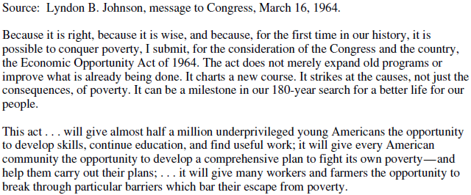
Doc. 3
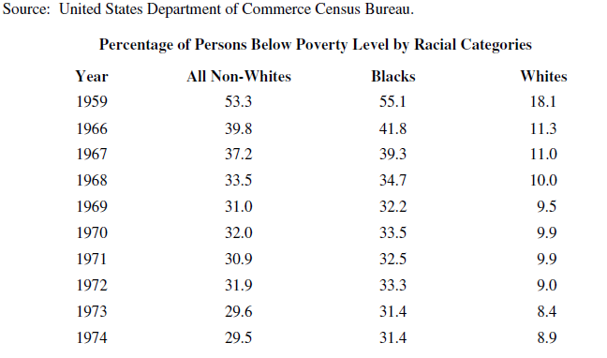

Doc. 4
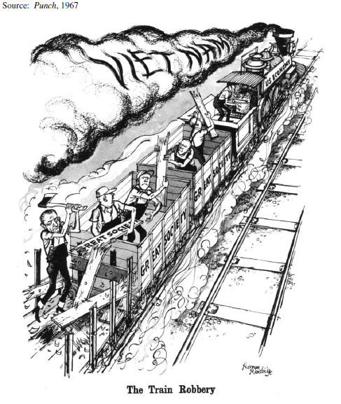
Doc. 5
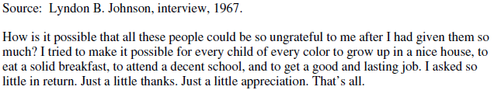
Doc 6.
Source: Voting Rights Act of 1965

SEC. 4. (a) To assure that the right of citizens of the United States to vote is not denied or abridged on account of race or color, no citizen shall be denied the right to vote in any Federal, State, or local election because of his failure to comply with any test or device in any State with respect to which the determinations have been made under subsection

Doc. 7
Source: Condoleezza Rice, My Extraordinary Family, 2012

Fortunately, though Lyndon Johnson was a southerner, he carried through on Kennedy's promise to end segregation. As a political scientist, I have read scores of academic papers on Johnson's legislative approach. Some believe that Johnson was able to do what Kennedy could not have: assemble a coalition of northern Democrats and liberal Republicans to ram through landmark legislation.

Doc. 8
Source: President Kennedy, 1961
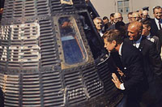

Doc. 9
Source: JFK’s Civil Rights Address, 1963

…We preach freedom around the world, and we mean it, and we cherish our freedom here at home, but are we to say to the world, and much more importantly, to each other that this is the land of the free except for the Negroes; that we have no second-class citizens except Negroes; …
We face, therefore, a moral crisis as a country and a people. It cannot be met by repressive police action. It cannot be left to increased demonstrations in the streets. It cannot be quieted by token moves or talk. It is a time to act in the Congress, in your State and local legislative body and, above all, in all of our daily lives. …. A great change is at hand, and our task, our obligation, is to make that revolution, that change, peaceful and constructive for all. Those who do nothing are inviting shame, as well as violence. Those who act boldly are recognizing right, as well as reality.

Doc. 10
Source: JFK, Address to the Nation on the Nuclear Test Ban Treaty, July 26, 1963

In an age when both sides have come to possess enough nuclear power to destroy the human race several times over, the world of communism and the world of free choice have been caught up in a vicious circle of conflicting ideology and interest. … Each increase of tension has produced an increase of arms; each increase of arms has produced an increase of tension. Yesterday a shaft of light cut into the darkness. Negotiations were concluded in Moscow on a treaty to ban all nuclear tests in the atmosphere, in outer space, and under water. For the first time, an agreement has been reached on bringing the forces of nuclear destruction under international control.

Doc. 11
Source: Senator Kennedy

October 24, 1960
How many of you who are going to be doctors, are willing to spend your days in Ghana? Technicians or engineers, how many of you are willing to work in the Foreign Service and spend your lives traveling around the world? On your willingness to do that, not merely to serve one year or two years in the service, but on your willingness to contribute part of your life to this country, I think will depend the answer whether a free society can compete. I think it can! And I think Americans are willing to contribute. But the effort must be far greater than we have ever made in the past [Peace Corp].

Doc. 12
Source: The Washington Post, Herblock Cartoon, 1962
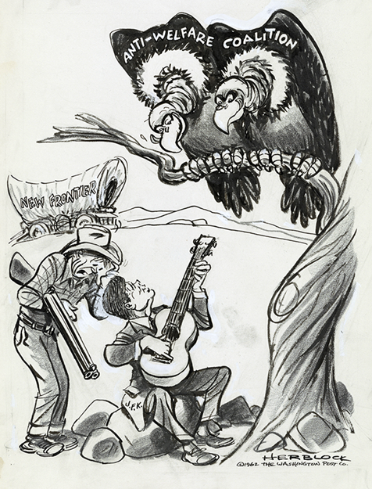

Doc. 13
Source: Political Cartoon, 1961

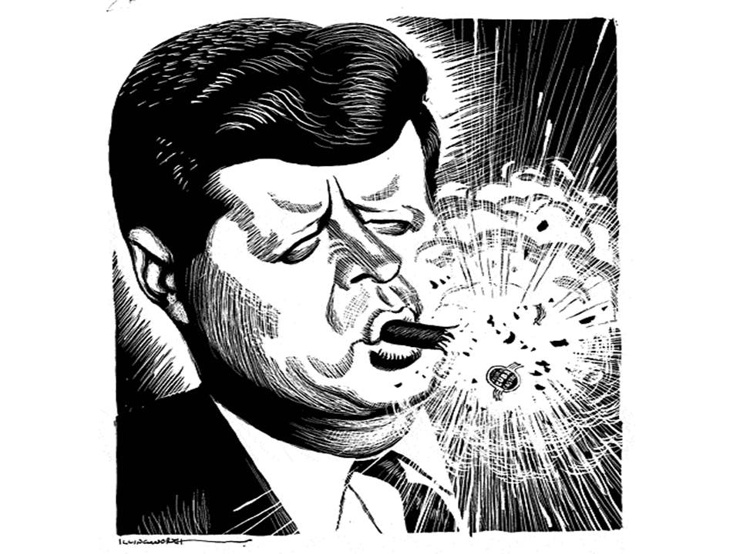
Cuban Cigar

Structured Academic Controversy Name _________________________________ Period _______

Who was the more effective president: JFK or LBJ?

- You will be placed in groups of 4.
- 2 of you will be on Team A and will discuss and provide evidence to support the opinion that JFK was more effective.
- 2 of you will be on Team B and will discuss and provide evidence to support the opinion that LBJ was more effective.
- We will first discuss what obligations and expectations we have for the executive branch.
- Next, you will work with your partner to read and analyze the documents contained in the packet.
- Then you will prepare your argument by locating historical facts and evidence to support your claims from the documents (cite specific documents), reading guides, textbook, and video notes.
- I will then guide you through the discussion. Team A will present their claims, reasons, and evidence first. Team B will then present their claims, reasons, and evidence. Short rebuttal will follow after both sides have presented. During the discussion you will both present your opinions and write down the opinions and evidence from the opposing side. You will need to cite specific documents. Every student is expected to speak.
- After both teams have presented their side of the issue you will discuss together as a whole group what you can agree on about the effectiveness and ineffectiveness of each president. You will also determine what criteria should be used to evaluate the effectiveness of a president.
- The final reflection step is to write a complete introductory paragraph with a claim supported by arguments.

What are the responsibilities of the president? What are our expectations for the president? Brainstorm a response.
I am on Team ___________ (A or B) arguing in favor of _______________ JFK or LBJ.

Preparing My Argument for the S.A.C.
My Claims (Arguments)  He was effective because… | My Evidence (Examples from the documents & reasoning or explanation about how those documents prove my claim.)

List any additional historical evidence from the textbook, Reading Guides, or video notes that might help you argue your claims.

S.A.C. Discussion: Who was the more effective president: JFK or LBJ?
The Opposing Argument
Opposing Claims | Evidence & Examples from the documents
Coming to Consensus
Can both sides agree on any examples of effectiveness for either JFK or LBJ?

Can both sides agree on any examples of ineffectiveness for either JFK or LBJ?

What criteria did your group use to determine whether or not a president was effective or ineffective?

What do you think is the most important thing to consider when determining the effectiveness of a president?

S.A.C. Discussion: Who was the more effective president: JFK or LBJ?

S.A.C. Reflection
Who was the more effective president: JFK or LBJ?
Write your introductory paragraph including a claim supported by arguments.

