Should the common citizen be able to carry a weapon?
The 2nd Amendment
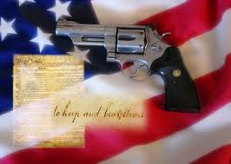
The constitution is many things to many people. Undoubtedly, it is the frame work for government in the United States. It defines three branches of, and it clearly delegates power to those branches. It also undoubtedly grants certain power to the federal government and grants others to the states; and it undoubtedly guarantees the basic rights of the people.
The constitution is short; it cannot and does not attempt to cover every eventuality. Even when it seems clear, there can be conflicting rights, and conflicting spheres of power. When disputes arise, it comes time for people, and most importantly, judges of the Judicial Branch, to interpret the Constitution. The concept of the constitutional interpretation is foreign to some countries, where the constitution makes a reasonable attempt to cover every eventuality. These constitutions are generally ridged and little changing, adapting slowly to advances in political views, popular opinion, technology, and changes in the government. The U.S. Constitution, however, has been termed a living constitution, in part because it grows and adapts to internal and external pressures, changing from one era and generation to the next.
When new situations arise, or even a new variation on an old situation, the Constitution is often looked to for guidance. It is at this point that the various interpretations of the Constitution come into play.
There is no one right way to interpret the Constitution, and people often do not always stick to one interpretation. In this project you will find an area of the Constitution that has been hotly contested. You will read through the sources, answer the questions, and create your own opinion on the 2nd amendment.
SOURCE A
VOCAB
- Militia- An army composed of ordinary citizens rather than professional soldiers. A military force that is not part of a regular army and is subject to call for service in an emergency.
- Bear- To carry from one place to another; transport

The 2nd Amendment
Right to keep and bear arms.

A well-regulated Militia, being necessary to the security of a Free State, the right of the people to keep and bear Arms, shall not be infringed. (Ratified December 15, 1791)

- List the 2 things that the 2nd amendment is guaranteeing to the people.
  - ______________________________________
  - ______________________________________
- When was the 2nd amendment ratified?
- Wright this amendment in your own words. ________________________________________________________________________________________________________________________________________________
- Discuss the pros and cons of the common citizen being able to carry a weapon? Why?
Pros | Cons
- What is your opinion? Should the common citizen be able to carry a weapon? Why?

SOURCE B
VOCAB- Unrestricted- No permit is needed to carry a gun
Shall issue- States that allow you to obtain a permit and carry a gun
May issue- May issue weapon if the states allow

SHALL ISSUE STATES

BACKGROUND- This is a map taken from the NRA website of states that allow you to carry a concealed weapon in 2010.
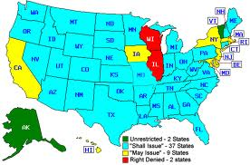
- Which states allow their residents to carry weapons if they acquire a permit? You may use the abbreviations._______________________________________________ _____________________________________________________________________
- Which states do not allow a person, under any circumstances to carry a weapon?
- What can you infer about the way the 2 states from question #2 interpret the Constitution’s 2nd amendment?

- How can you compare the different parts of the country to the different gun rights? (I.E. population, political party, etc…)
SOURCE: http://home.nra.org/#/home
SOURCE C

PRO GUNS
BACKGROUND- This is an article taken from a website called “concealedguns.procon.org/” It focuses on the benefits of concealing a weapon.
According to a 2000 study by John Lott, PhD, "shall-issue" laws have reduced homicides by 8.5%, aggravated assaults by 7%, rapes by 5% and robberies by 3%. Lott argued that if states that did not permit concealed handguns in 1992 had permitted them in 1977, 1,570 murders, 4,177 rapes, 60,000 aggravated assaults, and 12,000 robberies would have been prevented between 1977 and 1992.

- Lott argued that shall issue laws have decreased crime by as much as?
Homicide___________%
Assault______________%
Rape______________%
Robberies____________%
- According to Lott how many murders could have been prevented if hand guns had been issued in 1977?
Rapes____________________________
Assault___________________________
Robberies_________________________
- How could you explain the increase in shall issue laws and the decrease in crime?

- According to this study should citizens be allowed to carry weapons and why?

SOURCE http://concealedguns.procon.org/

SOURCE D
The Brady Law
BACKGROUND- The Brady Law was enacted in 1993, after an assassination attempt on President Ronald Reagan. Jim Brady, the press secretary of the president, was also shot during the attack. The Brady law argued that if background checks would have been in place the man would not have been able to buy the gun.
To provide for a waiting period before the purchase of a handgun, and for the establishment of the national instant criminal background check system to be contacted by firearms dealers before the transfer of any firearm.

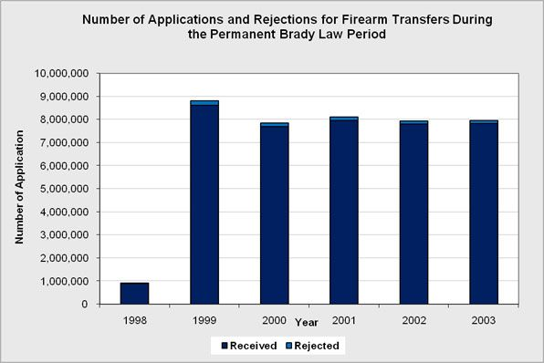
- Between 1999 and 2003, roughly how many background checks were conducted?

- Roughly how many of those were rejected?

- Infer what the problems might be with so many background checks coming back approved.

- What is one pro and one con of doing background checks for firearms?

PRO | con

- Do background checks help to deter criminals from buying weapons?

SOURCE:www.bradycampaign.org/

SOURCE E
Tendencies in Hand Gun Ownership
These graphs show gun ownership in the United States, by political party self-identification (men and women). According to author Joseph Fried, this graphic may utilize data extracted from one of two large data bases: Collected by the General Social Surveys (GSS).
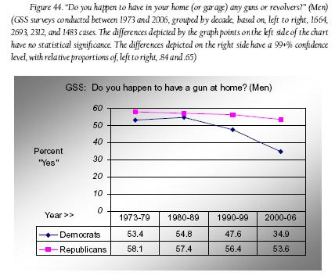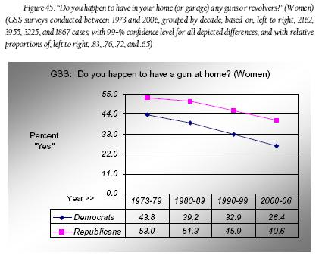
- What is the trend in gun ownership in the last 30 years?

- Who is the most likely to own a gun?

Republican Men/ Republican Women/ Liberal Men/ Liberal Women
- Why do you think that republicans are more likely to own guns?

- How would you explain the fact that men from both parties are more likely to own guns?

- Do you think that your political party might dictate whether or not you would choose to buy a gun? What about your sex?

SOURCE: www.norc.org/GSS+Website/
SOURCE F
VOCAB:
ATF- government (Bureau of) Alcohol, Tobacco, and Firearms

Higher Rates of Gun Owner Ship = Higher Rates of Crime

The American Journal of Public Health conducted a study that concluded "the United States has higher rates of firearm ownership than do other developed nations, and higher rates of homicide. Of the 233,251 people who were homicide victims in the United States between 1988 and 1997, 68% were killed with guns, of which the large majority were handguns” The ATF estimated in 1995 that the number of firearms available in the US was 223 million.

- What % of homicide victims between 1988 and 1997 were killed with guns?

- Is there a connection between higher rates of gun ownership and homicides in the United States? Explain.

- Does this article change your thoughts on whether or not people should be able to carry concealed weapons?

SOURCE: ajph.aphapublications.org/

SOURCE G
2nd Amendment Cartoons

Picture a | Picture b
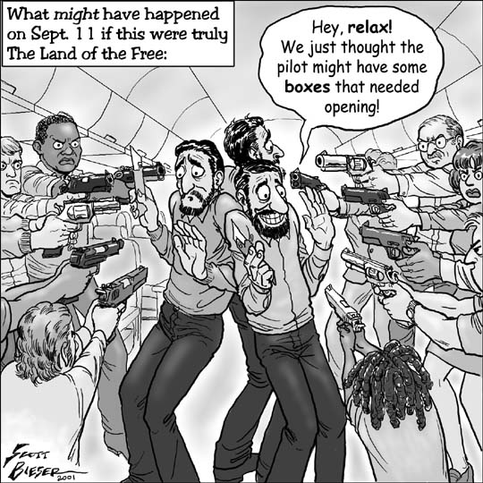 | 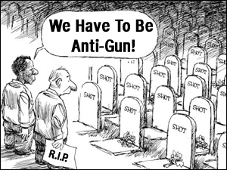

- Is Picture A pro or antigun? Picture B?

- What event in history is Picture A depicting?

- What conclusion can be drawn from Picture B?

- Do you think that these cartoons influence how people view and interpret the 2nd amendment?

SOURCES: sknvibes.com/Education/NewsDetails.cfm/9707
scottthong.wordpress.com/
Do you think that the common man should be able to carry a weapon?
_______________________________________________________________________________________________________________________________________________________________________________________________________________________________________________________________________________________________________________________________________________________________________________________________________________________________________________________________________________________________________________________________________________________________________________________________________________________________________________________________________________________________________________________________________________________________________________________________________________________________________________________________________________________________________________
2nd Amendment DBQ

One of the most hotly contested amendments is the 2nd amendment. In this unit we will look at arguments from both sides and you will have the chance to voice your opinion, not just through your writing, but through a class debate. You will be randomly chosen to argue either for or against concealed weapons. This assignment will ask you to write a paper on your personal feelings, and then debate it in class. You will use each of the sources to help you establish and defend your argument.

1 page argumentative paper______________/ 20
Argues and answers the question, should the common person be able to carry a gun.

Packet with questions completely filled out______________/20
Answered in complete sentences, with well thought out answers

Debate with rebuttals______________/20
You will be given a Post It and will receive points for each productive statement that you make during the debate

Total_____________/60

