Name ______________
Class ____ Date ______
The Death of Martha Washington
Background Information: Martha Washington passed away at Mount Vernon on May 22, 1802 at the age of 70 following an illness that lasted several weeks. At the time of her death she was surrounded by her grandchildren and great-grandchildren. Newspapers around the country eulogized her as "the worthy partner of the worthiest of men." This obituary appeared in the Augusta Herald, published in Georgia, on June 9, 1802.
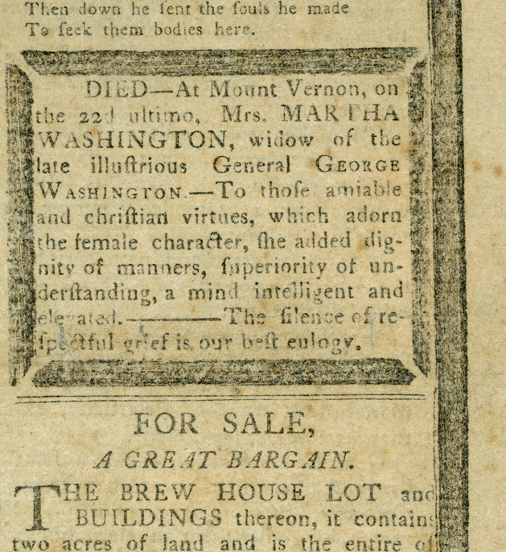
1
2
3
4
5
6
7
8
9
10
11

Source: George Washington’s Mount Vernon: http://www.mountvernon.org/education/primary-sources-2/article/martha-washingtons-obituary-june-9-1802/
Vocabulary: eulogy: a formal speech that praises a person who has died.
Contextualizing the Source:
1. When was this source created? __________________________________________________
2. Who is this text about? _________________________________________________________
3a. Is this a primary or secondary source? Explain your thinking. __________________________
___________________________________________________________________________
3b. What type of source is it? ______________________________________________________
4. Where was it created? _________________________________________________________
5. Who is the intended audience for this source? ______________________________________

After reading the text, answer the following questions:
1. Why might the names Martha Washington and General George Washington on lines
2-5 be written in all capital letters? Why did the author write the names this way?
______________________________________________________________________
______________________________________________________________________
2. Go back and reread the Background Information. Using that information, what does
the word ultimo mean in the context of this document? How do you know?
______________________________________________________________________
______________________________________________________________________
3. The Latin word amicus means friendly. How does knowing the meaning of this word
help you to understand the meaning of the word amiable on line 5? ______________
______________________________________________________________________
4a. Do you notice anything unusual with the spelling of some of the words in the
passage? If so, list the words here:
____________________ ____________________
____________________ ____________________
____________________ ____________________
____________________ ____________________
____________________
4b. In the text, each of the words that you wrote on the list above. Write what
you think the modern spelling of each word would be.

5. Annotate and underline the characteristics used to describe Martha Washington in
the above text. Which one of those characteristics, do you think, is the most
important and why? Explain your thinking. ___________________________________
______________________________________________________________________
6. What does the author say would be the “best” eulogy? _________________________
______________________________________________________________________
7. What 3 words from the text are most important to understanding the author’s tone
of the text? Explain your choices using evidence from the text. __________________
______________________________________________________________________
8. What was the author’s purpose for writing this document? _____________________
______________________________________________________________________

