Thanksgiving Proclamation of 1789
By the President of the United States of America, a Proclamation.
Whereas it is the duty of all Nations to acknowledge the providence of Almighty God, to obey his will, to be grateful for his benefits, and humbly to implore his protection and favor-- and whereas both Houses of Congress have by their joint Committee requested me to recommend to the People of the United States a day of public thanksgiving and prayer to be observed by acknowledging with grateful hearts the many signal favors of Almighty God especially by affording them an opportunity peaceably to establish a form of government for their safety and happiness.
Now therefore I do recommend and assign Thursday the 26th day of November next to be devoted by the People of these States to the service of that great and glorious Being, who is the beneficent Author of all the good that was, that is, or that will be-- That we may then all unite in rendering unto him our sincere and humble thanks--for his kind care and protection of the People of this Country previous to their becoming a Nation--for the signal and manifold mercies, and the favorable interpositions of his Providence which we experienced in the course and conclusion of the late war--for the great degree of tranquility, union, and plenty, which we have since enjoyed--for the peaceable and rational manner, in which we have been enabled to establish constitutions of government for our safety and happiness, and particularly the national One now lately instituted--for the civil and religious liberty with which we are blessed; and the means we have of acquiring and diffusing useful knowledge; and in general for all the great and various favors which he hath been pleased to confer upon us.
and also that we may then unite in most humbly offering our prayers and supplications to the great Lord and Ruler of Nations and beseech him to pardon our national and other transgressions-- to enable us all, whether in public or private stations, to perform our several and relative duties properly and punctually--to render our national government a blessing to all the people, by constantly being a Government of wise, just, and constitutional laws, discreetly and faithfully executed and obeyed--to protect and guide all Sovereigns and Nations (especially such as have shewn kindness unto us) and to bless them with good government, peace, and concord--To promote the knowledge and practice of true religion and virtue, and the encrease of science among them and us--and generally to grant unto all Mankind such a degree of temporal prosperity as he alone knows to be best.
Given under my hand at the City of New York the third day of October in the year of our Lord 1789.
Go: Washington
Source: http://www.mountvernon.org/educational-resources/primary-sources-2/article/thanksgiving-proclamation-of-1789/

Vocabulary: providence: divine direction; confer: give as a gift or honor; beseech: beg;
virtue: moral excellence
Answer the following questions using textual evidence from the passage that you just finished reading.
Be prepared to share your answers.
1. Who is the author? __________________________ When was it created? ____________________________

2. What is a proclamation and to whom was it created for?
a. letter/people b. announcement/Congress
c. announcement/people d. speech/Congress
3. The conjunction whereas on lines 3 and 4 has different meanings. It is used in two different ways in the
context of this document. What is the meaning of the word on line 3 and then line 4?
a. It being the fact that/While on the contrary b. In as much as/It being the fact that
c. It being the fact that/ While at the same time d. While at the same time/While on the contrary
4a. What did the author create in his proclamation? Underline and annotate the answer in the document.
4b. What was the given date for the previous answer? ______________________________________________
5. In lines 9-18, what reasons did the author give for creating this? Underline and annotate evidence in the text
to support your answer. _____________________________________________________________________
_________________________________________________________________________________________
_________________________________________________________________________________________
_________________________________________________________________________________________
_________________________________________________________________________________________
6. On line 10, the words “Being” and “Author” refer to the same idea and are written as proper nouns. How is
the meaning of the word “Author” on line 10 different than how the word author was used in question 4a?
_________________________________________________________________________________________
7. The author is hoping for a few things to happen in return for a day of Thanksgiving. Rank the following pieces
of evidence 1-5, (1 being the best piece of evidence -5 being the least important piece of evidence) from lines
19-27. Be ready to share your thinking with the class.
_____ to pardon our national and other transgressions
_____ to protect and guide all Sovereigns and Nations … and to bless them with good government,
peace, and concord
_____ to render our national government a blessing to all the people, by constantly being a Government
of wise, just, and constitutional laws
_____ To promote the knowledge and practice of true religion and virtue
_____ to enable us all … to perform our several and relative duties properly and punctually
8. Was this document written in a more formal or conversational style? Site specific examples from the text to
support your answer. _______________________________________________________________________
_________________________________________________________________________________________
9. So, what about the Pilgrims? How is this information different than what you already know about
Thanksgiving? _____________________________________________________________________________
_________________________________________________________________________________________
_________________________________________________________________________________________

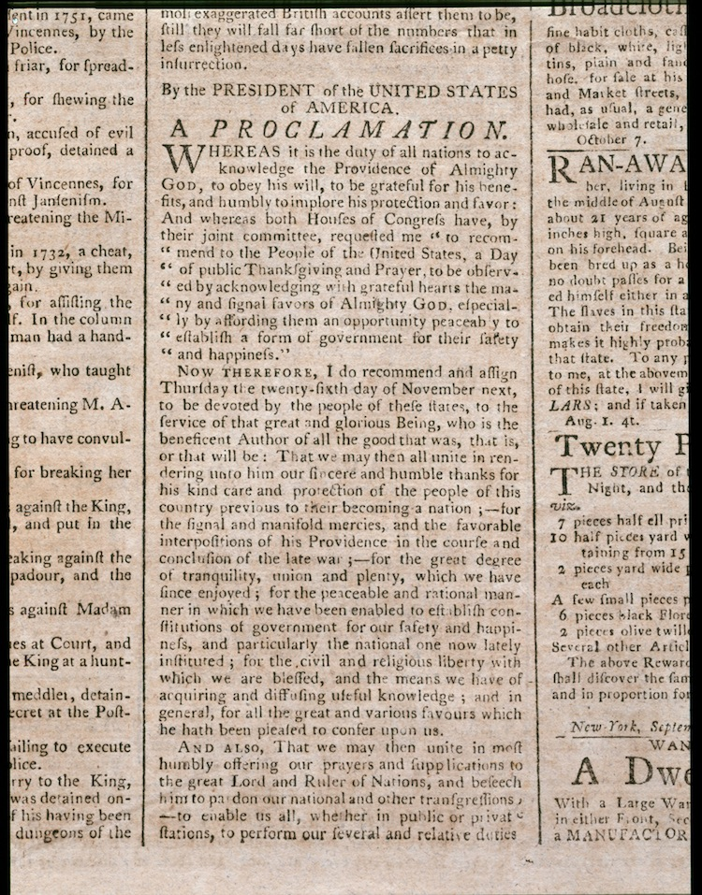
Source: http://www.mountvernon.org/research-collections/digital-encyclopedia/article/thanksgiving/

