Common Core Social Studies Learning Plan

Lesson Title: The Chinese Exclusion Act of 1882
Author Name: Marcia Motter
Contact Information: mmotter@washoeschools.net
Appropriate for Grade Level(s): 8-12
Total Time Needed: 3-4 days/ 45 minute class period
History Standard(s)/Applicable CCSS(s) (RI,W,S&L,L):
H1.[6-8].8 Describe the contributions of immigrant groups to the emerging American culture.
H.4.[6-8].9 Identify the motivations for groups coming to the Untied States and discuss U.S. political policies towards immigration.
CCSS.ELA-Literacy.RH.6-8.1 Cite specific textual evidence to support analysis of primary and secondary sources.
CCSS.ELA-Literacy.RH.6-8.2 Determine the central ideas or information of a primary or secondary source; provide an accurate summary of the source distinct from prior knowledge or opinions.
CCSS.ELA-Literacy.RH.6-8.7 Integrate visual information (e.g., in charts, graphs, photographs, videos, or maps) with other information in print and digital texts.
CCSS.ELA-Literacy.W.7.2 Write informative/explanatory texts to examine a topic and convey ideas, concepts, and information through the selection, organization, and analysis of relevant content.
CCSS.ELA-Literacy.W.7.4 Produce clear and coherent writing in which the development, organization, and style are appropriate to task, purpose, and audience.
CCSS.ELA-Literacy.SL.7.1 Engage effectively in a range of collaborative discussions (one-on-one, in groups, and teacher-led) with diverse partners on grade 7 topics, texts, and issues, building on others’ ideas and expressing their own clearly.
CCSS.ELA-Literacy.SL.7.1a Come to discussions prepared, having read or researched material under study; explicitly draw on that preparation by referring to evidence on the topic, text, or issue to probe and reflect on ideas under discussion.
CCSS.ELA-Literacy.SL.7.1d Acknowledge new information expressed by others and, when warranted, modify their own views.
Type of Lesson: Mini Q
Student Readings (list):
Chinese Exclusion Act of 1882 (excerpted), “The Only One Barred Out” Political Cartoon, “Every Dog has His Day” Political Cartoon, “Which Color is to be Tabooed Next?” Political Cartoon
Lesson Outline:
Time Frame  (e.g. 15 minutes) | What is the teacher doing? | What are students doing?
Day 1:  10 min | Place and move students into groups of 3-4.  Pass out Document Packet (Document 1-4) and focus questions.  Explain to the class that we will be reading about the Chinese Exclusion Act of 1882 and analyzing some political cartoons from the time period. We will be discussing how this law reflected Americans attitudes and beliefs towards Chinese immigration during this time period. | Students are actively listening.  Students ask questions for clarification of directions, if needed.
35 min | Ask students to read Document 1 (The Chinese Exclusion Act of 1882) with their group.  When they are done reading the document, as a group, they will answer the focus questions for Document 1.  Tell the class that if their group did not get a chance to finish with Document 1, that they need to finish answers tonight for class discussion/review tomorrow.  During discussion, I am moving among the groups, clarifying any confusion of the document, and providing support for groups. | Students are reading, discussing, and working with their small group.  Students are answering questions about the reading.  Students will be ready to share information with whole class tomorrow.
Day 2:  10 min | Whole Class Discussion: Lead the class in a discussion of the answers for Document 1. Clarify and misconceptions or point out important information that may have been missed in small group discussion. | Students are sitting with small group.  Students are sharing answers with the class.  Students are correcting any wrong answers they may have.
10 min | Ask students to read and discuss Document 2 (“The Only One Barred Out” Political Cartoon) with their group.  When they are done reading the document, as a group, they will answer the focus questions for Document 2.  During discussion, I am moving among the groups, clarifying any confusion of the document, and providing support for groups. | Students are reading, discussing, and working with their small group.  Students are answering questions about the political cartoon.  Students will be ready to share information with whole class.
5 min | Whole Class Discussion: Lead the class in a discussion of the answers for Document 2. Clarify and misconceptions or point out important information that may have been missed in small group discussion. | Students are sitting with small group.  Students are sharing answers with the class.  Students are correcting any wrong answers they may have.
10 min | Ask students to read and discuss Document 3 (“Every Dog has His Day” Political Cartoon) with their group.  When they are done reading the document, as a group, they will answer the focus questions for Document 3.  During discussion, I am moving among the groups, clarifying any confusion of the document, and providing support for groups. | Students are reading, discussing, and working with their small group.  Students are answering questions about the political cartoon.  Students will be ready to share information with whole class.
5 min | Whole Class Discussion: Lead the class in a discussion of the answers for Document 3. Clarify and misconceptions or point out important information that may have been missed in small group discussion. | Students are sitting with small group.  Students are sharing answers with the class.  Students are correcting any wrong answers they may have.
5 min | Have students read Document 4 (“Which Color is to be Tabooed Next?” Political Cartoon) tonight for homework.  Students should try their best at answering the focus questions for Document 4.  Students will have 5 minutes to share/review answers with their small group tomorrow at the beginning of class before we have a whole class discussion. | Students will read Document 4 on their own.  Students will answer the focus questions for Document 4.  Students will be prepared for class discussion of Document 4 tomorrow.
Day 3:  5 min | Have students get into their small groups and discuss Document 4.  During discussion, I am moving among the groups, clarifying any confusion of the document, and providing support for groups. | Students are reading, discussing, and working with their small group.  Students are fixing and answers about the political cartoon that they may have not understood or were wrong.  Students will be ready to share information with whole class.
5 min | Whole Class Discussion: Lead the class in a discussion of the answers for Document 4. Clarify and misconceptions or point out important information that may have been missed in small group discussion. | Students are sitting with small group.  Students are sharing answers with the class.  Students are correcting any wrong answers they may have.
35 min | Pass out the writing assignment.  Explain the writing prompt to the class.  Students will have the rest of the class period today and this evening to write their paragraphs.  Paragraphs are due at the beginning of class tomorrow.  Pass out the Foldable to any student who may need extra assistance or scaffolding with their writing. | Students will listen to and follow along as the directions for the writing assignment are explained by the teacher.  Students will write their paragraph.  For students who need some additional scaffolding, they can use the Foldable to help them organize their information. You may want to give them an extra day to turn in their paragraph.
Day 4:  if needed | Depending on class discussions and the level of students, today can be used to finish writing in class.

Description of Lesson Assessment: Students will write an argumentative paragraph when they are done analyzing all of the documents. The paragraph will be graded. Students will also earn class points for participation in small group and large group discussions of the documents.

Document 1
Chinese Exclusion Act (1882)
Background:
Enacted on May 6, 1882, the Chinese Exclusion Act placed a ban on Chinese immigrants entering the United States or being naturalized as U.S. citizens for 10 years. Originally vetoed by President Chester Arthur, the president eventually signed the law after some minor alterations. The Chinese had been entering the country in record numbers for several years previously, particularly in California, and were typically forced to work for extremely low wages and live in conditions of poverty. Many of them lived as near slaves while employed building railroad lines across the West. They were also frequently victims of attacks by workingmen and other immigrant groups, who believed the Chinese were taking jobs away from them.
Transcript of Chinese Exclusion Act (Excerpted):
An act to execute certain treaty stipulations relating to Chinese.
WHEREAS, in the opinion of the Government of the United States the coming of Chinese laborers to this country endangers the good order of certain localities within the territory thereof: Therefore,
Be it enacted by the Senate and House of Representatives of the United States of America in Congress assembled, That from and after the expiration of ninety days next after the passage of this act, and until the expiration of ten years next after the passage of this act, the coming of Chinese laborers to the United States be, and the same is hereby, suspended; and during such suspension it shall not be lawful for any Chinese laborer to come, or, having so come after the expiration of said ninety days, to remain within the United States.
Section 10. That every vessel whose master shall knowingly violate any of the provisions of this act shall be deemed forfeited to the United States, and shall be liable to seizure and condemnation in any district of the United States into which such vessel may enter or in which she may be found.
Section 12. That no Chinese person shall be permitted to enter the United States by land without producing to the proper office of customs the certificate in this act required of Chinese persons seeking to land from a vessel. And any Chinese person found unlawfully within the United States shall be caused to be removed therefrom to the country from whence he came, by direction of the President of the United States, and at the cost of the United States, after being brought before some justice, judge, or commissioner of a court of the United States and found to be one not lawfully entitled to be or remain in the United States.
Section 13. That this act shall not apply to diplomatic and other officers of the Chinese Government traveling upon the business of that government, whose credentials shall be taken as equivalent to the certificate in this act mentioned, and shall exempt them and their body and household servants from the provisions of this act as to other Chinese persons.
Section 14. That hereafter no State court or court of the United States shall admit Chinese to citizenship; and all laws in conflict with this act are hereby repealed.
Section 15. That the words "Chinese laborers," whenever used in this act, shall be construed to mean both skilled and unskilled laborers and Chinese employed in mining.
"Chinese Exclusion Act (1882)." American History. ABC-CLIO, 2013. Web. 11 Oct. 2013.

Document 2

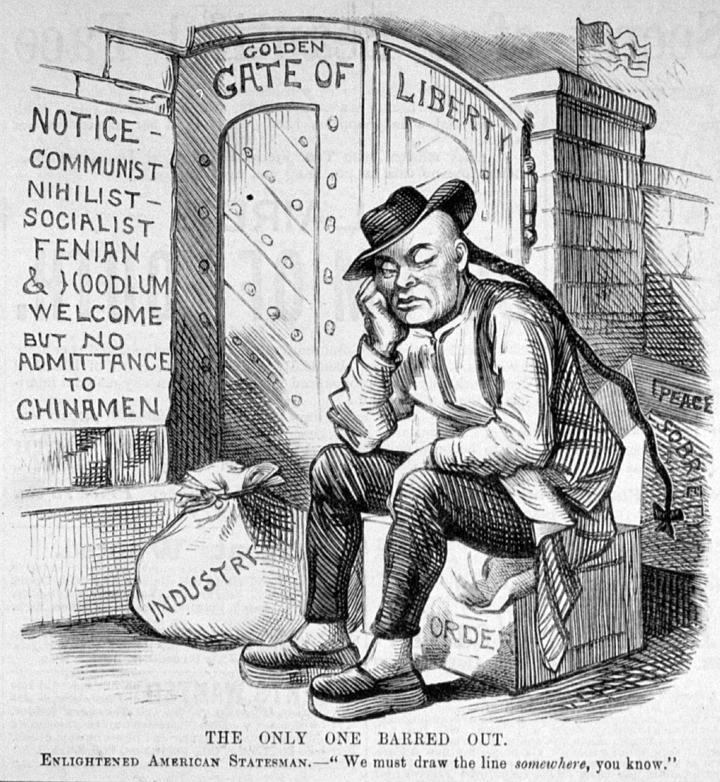

Document 3
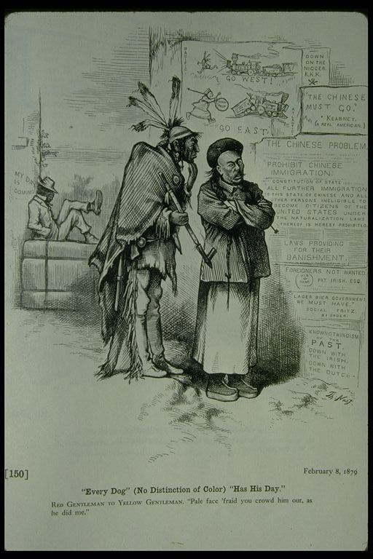

Document 4

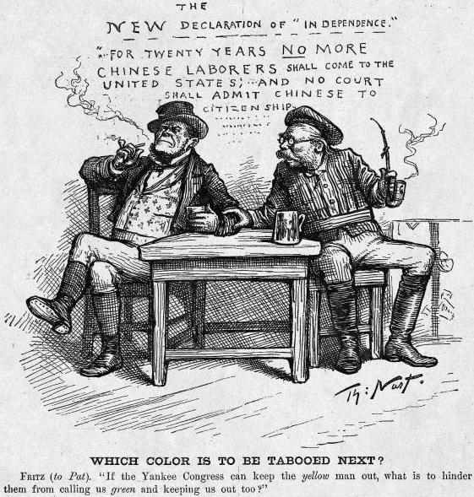

After reading each of the documents, answer the following questions:
Document 1:
When was the Chinese Exclusion Act created? __________________________________________
What words or phrases in the document help you to understand the meaning of the word Exclusion?
________________________________________________________________________________________________________________________________________________________________
The vessel in Section.10 has multiple meanings. What does the word often mean? How is it used in this context? ______________________________________________________________________
________________________________________________________________________________
What are the two things that this Act prohibits? ___________________________________________
________________________________________________________________________________________________________________________________________________________________
Who is exempt from this Act? (Who doesn’t it apply to?) _______________________________________
________________________________________________________________________________
According to this Act what is the definition of a “Chinese laborer”? ____________________________
________________________________________________________________________________________________________________________________________________________________
Why is this law important? ___________________________________________________________
________________________________________________________________________________
________________________________________________________________________________
Documents 2-4 are all examples of what type of primary source? ____________________________________________________________________
Document 2:
The caption states, “THE ONLY ONE BARRED OUT.” Who is it referring to? ___________________
What reasons are given to explain why? ________________________________________________
What country is represented in this visual? How do you know? ______________________________
________________________________________________________________________________
Who is allowed to enter this country? ___________________________________________________
________________________________________________________________________________
How are the Chinese depicted (shown) in this source? _____________________________________
________________________________________________________________________________________________________________________________________________________________
What is the message of this document? ________________________________________________
________________________________________________________________________________________________________________________________________________________________
Document 3:
When was this document created? ____________________________________________________
Which three groups are depicted in this source? __________________________________________
What do these three groups have in common? ___________________________________________
________________________________________________________________________________
Which group is being targeted in this source? How do you know? ____________________________
________________________________________________________________________________
Explain the phrase: RED GENTLEMAN TO YELLOW GENTLEMAN: “Pale face ‘fraid you crowd him out, as he did me.” _________________________________________________________________
________________________________________________________________________________________________________________________________________________________________
The caption on the source says, “Every Dog” (No Distinction of Color) “Has His Day.” What does this mean? What evidence from the document helps you to understand the meaning? _______________
________________________________________________________________________________________________________________________________________________________________________________________________________________________________________________
________________________________________________________________________________
Document 4:
Which 2 immigrant groups are depicted in this document? _________________________________
What clues in the document helped you come to this understanding?__________________________
________________________________________________________________________________________________________________________________________________________________
According to this document, what is the new Declaration of Independence?_____________________
________________________________________________________________________________
Which group has already been excluded and which group could be next? ___________________________________________________________________________
What does the word “tabooed” mean? How does this word reflect attitudes about these groups?
________________________________________________________________________________
How are the immigrant groups referenced in the document? ________________________________
What is the message of this document? ________________________________________________
________________________________________________________________________________________________________________________________________________________________
The Chinese Exclusion Act of 1882 reflects the attitudes and beliefs of many Americans on the issue of immigration in the late 1800s. Analyze and describe how this law reflected American’s attitudes towards the Chinese in the 1880s.
In a paragraph, write a claim that answers the statement above. Use 3 pieces of evidence and reasoning from the documents to support your answer. Cite the evidence correctly by using line numbers (Lines 3-4), when necessary, at the end of the sentence. Connect the evidence to the claim with reasoning that explains the evidence.
________________________________________________________________________________________________________________________________________________________________________________________________________________________________________________________________________________________________________________________________________________________________________________________________________________________________________________________________________________________________________________________________________________________________________________________________________________________________________________________________________________________________________________________________________________________________________________________________________________________________________________________________________________________________________________________________________________________________________________________________________________________________________________________________________________________________________________________________________________________________________________________________________________________________________________________________________________________________________________________________________________________________________________________________________________________________________________________________________________________________________________________________________________________________________________________________________________________________________________________________________________________________________________________________________________________________________________________________________________________________________________________________________________________________________________________________________________________________________________________________________________________________________________________________________________________________________________________________________________________________________________________________________________________________________________________________________________________________

