Common Core Social Studies Learning Plan Template

Lesson Title: Was the 1893 Overthrow of the Hawaiian Monarchy Justified?
1
Author Name: Lanette Bowen

Contact Information: lbowen@lyon.k12.nv.us

Appropriate for Grade Level(s): 7- 8

History Standard(s)/Applicable CCSS(s) (RI, W, S&L, L):
Reading: Writing: Listening & Speaking: History: Geography: Civics:
1 & 2 1 & 8 1 & 4 H1.6 & H2.15 G6.7 & G6.4 C.13.9; C16.3 &16.4

Type of Lesson: Document based Questions

Total Time Needed: 5 – 45-50 minute class periods

Lesson Outline: Was the 1893 Overthrow of the Hawaii’s Monarchy Justified?
Time Frame  (e.g. 15 minutes) | What is the teacher doing? | What are students doing?
Day 1  10 min. | Introduction : Vocabulary - abdicate, annexation, expansion, imperialism, monarchy, provisional government, overthrow, immigration | Use with word wheel- write word/ definition/ picture
35-40 min. | Use reading to introduce lesson  Project Petition to Annex Hawaii , from the Fifty-fifth Congress, Second Session on December 6, 1897.( First paragraph, read to students then model annotating; comments; questions(?); using highliters)  One copy per group: Queen Lili'uokalani letter to the House of Representatives. | Read in partners(2)/ annotate in margins. Answer questions about the document (see document assessment questions)  Closure: Discuss findings.
Day 2 | Groups assigned book chapters
5 min | Computers checked out ( 1 per pair)
45 min. | Go over directions on note taking  Take first page of Ch. 1 read and model expectations to students.  Divide class into eight groups, with each group having a chapter from Hawaii’s Story, by Hawaii’s Queen . Lili’uokalani.  http://digital.library.upenn.edu/women/liliuokalani/hawaii/hawaii.html  With 2 sets of students at each table, each group will divide the chapter in half, using their note taker | Students “draw” for chapter:  1. Hawaiians Plead for a New Constitution 2. The Crimes I am Charged 3. Overthrow of the Monarchy 4. Attempt to Restore the Monarchy 5. I am Placed under Arrest 6. Imprisonment 7. Brought to Trial 8. Sentenced
Day 3 | Students present information from their readings to classmates. | Using the note takers from yesterday to present
20 min. | Presentations: Each table will present their part of the chapter | Students will use a storyboard
 |  | to keep a chronologic order to the events that occurred.
40 min. | Model the process of analyzing document  Students will Jigsaw 8 documents, in small groups, and add comments to the chart paper. Most are political cartoons from the time period. | Write comments. Put a check by the ones you agree with, but must write additional comments.
Day 4 | Debrief each document by using charts from yesterday. | Students have their note takers to review
10 min. | Make a claim: The overthrow of ….was not justified, or the overthrow was justified…Model an example of the brace map | Students pick their claim
40 min  At lunch | Using documents and notes, write a 3-5 paragraph essay answering the question:  “Was the 1893 Overthrow of the Hawaiian Monarchy Justified?”  If students want to come in and watch the 2004 American Experience film, “Hawaii’s Last Queen”, it will be shown during 2 lunch periods. | Use brace map (3-5 pieces of text evidence) organizer to write claims and evidence, for documents and notes.
Day 5 | Finish essays | Finish essays

Description of Lesson Assessment:
A. Document Assessment
- What type of document is it?
- Who wrote the document?
- To whom was it written?
- What is the date of the document?
- What was the purpose of the document?
B. Class discussion of vocabulary terms and group responses to questions.
C. Observation of group work.
D. Final essay.
How will students reflect on the process and their learning?
Their final writing piece will reflect their learning and processing of the information.

Sources:
Pitzer, Pat, “The Overthrow of the Monarchy”.''Spirit of Aloha.'' May, 1994.
http://www.hawaii-nation.org/index.html
http://www.freehawaii.org/timeline.html
Silva, Noenoe K. Aloha Betrayed: Native Hawaiian Resistance to American Colonialism.. Durham: Duke University Press, 2004, pages 123-163.
The 1897 Petition Against The Annexation of HawaiiPage 6 of Men's Petition Against Annexation of Hawaii September 11, 1897 www.archives.gov
Queen Liliuokalani - University of Illinois at Chicago
www.uic.edu/depts/owa/history/liliuokalani.html
The Overthrow of Queen Lili‘uokalani www.pbslearningmedia.org/resource/ha06.ush.ind.overthrow
Was the 1893 Overthrow of Hawaii’s Monarchy Legal?
The first known settlers of the Hawaiian Islands were Polynesians who voyaged, historians believe, from the South Pacific, sometime in the 8th century, landing on the southern most tip of the island of Hawaii.
By the early 18th century, American traders came to the Islands for sandalwood, which was valued in China, and for the whaling industry. In the 1830s, sugar plants were introduced and became well established by the mid 1800’s. This brought great changes to the Islands politically, culturally, and economically. The Islander’s religious life also changed due to the American Christian missionaries who came to the region.
Several corporations, known in Hawaii as ”The Big Five”, controlled the sugar industry which were owned and operated by former missionary families. Together, they gained control over other aspects of the Hawaiian economy including banking, warehousing, shipping, and importing. The Hawaiian monarchy had close ties with missionaries, who took advantage of capital investments, cheap land, cheap labor, and increased global trade, which allowed them to become very wealthy. These businessmen had perfected a wage-earning labor force dependent upon plantation goods and services.
By 1890, ethnic Hawaiians were already a minority in the Kingdom. Between 1890 and 1900 the primary immigration from Asia reduced the ethnic Hawaiian population. The explosion of Asian population in Hawaii was partly due to King Kalakaua's trip to Japan in 1881 and his invitation for Japanese laborers for the Hawaii sugar plantations.
Following Kalakaua's death in 1891, his sister became the new queen. “Zin”, the traditional tour of the islands, the new queen, "heard the cries of her people" and received petitions for a new constitution. Lili'uokalani was a very astute, political operator. She may have sent an advance party to organize the petition drive in which "her people" would beg for a new constitution that would give the queen much stronger powers.
The 1893 overthrow of Queen Lili'uokalani was caused by her publicly announced intention to proclaim a new constitution, which violated the existing constitution she had sworn to uphold. Her new constitution would have restored strong powers to the monarch, including undoing the reforms of the earlier constitution of her brother. Some received this as an act of treason and it triggered a cause for her overthrow.
In January 1893, a group called the "Committee of Safety," made up of 13 long-time residents of Hawaii who were registered as Hawaii voters -- 5 Americans, 3 Hawaiians, 3 Germans, 1 English, 1 Scottish. - were all in favor of annexation to the United States. Sanford B. Dole, who helped stage the coup against Queen Lili’uokalani, organized this; He put himself in charge with the support of the United States and the U.S.S. Boston which arrived in Honolulu the day before the coup. The Boston received news about the political unrest which was communicated the ship's officers. Pleas were received from Americans asking for troops to be landed to protect American life and property. It was clear there would be a coup by armed militias to overthrow the monarchy. Troops were sent ashore, some being Marines and the rest members of the ship's crew totaling about 160 men.
On February 1, Minister John Stevens recognized Dole's new government on his own authority and proclaimed Hawaii a U.S. protectorate. Dole submitted a Treaty of Annexation to the U.S. Senate, but most Democrats opposed it, especially after it was revealed that most Hawaiians did not want annexation.
President Grover Cleveland sent a new U.S. Minister to Hawaii to restore Queen Lili’uokalani to the throne under the 1887 constitution, but Dole refused to step aside. Instead he proclaimed the “Independent Republic of Hawaii”. Cleveland was unwilling to overthrow the government by force, and his successor, President William McKinley, negotiated a treaty with the Republic of Hawaii in 1897.
In 1898, the Spanish-American War broke out, and the use of the naval base at Pearl Harbor during the war convinced Congress to approve formal annexation. Two years later, Hawaii was organized into a formal U.S. territory and in 1959 entered the United States as the 50th state.

Textual Evidence

Supporting Detail #1
___________________________
___________________________
___________________________

Central Idea or Inference

Supporting Detail #2
___________________________
___________________________
___________________________

___________________________
Supporting Detail #3
___________________________
___________________________

Joint Resolution to Provide for Annexing the Hawaiian Islands to the United States (1898)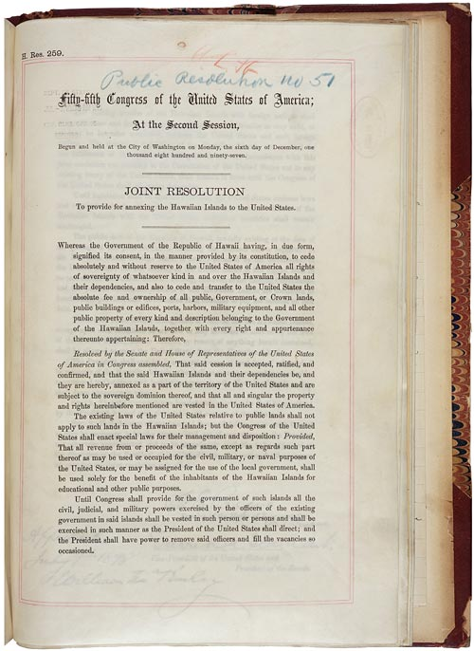

www.ourdocument.com
(Project this as well as printing out. Read to class)

Letter of protest from Queen Liliuokalani of Hawaii to the United States House of Representatives
www.ourdocuments.com

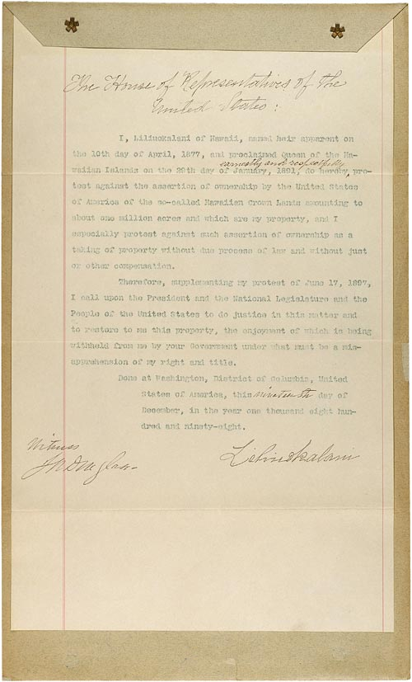
(Project this as well as printing it out. Read to class)
Document 1:
An Annexation Time-Line
Here, we present a time-line of the events which swept Hawai`i into annexation by the United States during that crucial period 1897-98.
March 1897: Grover Cleveland leaves office having served two terms. William McKinley, having won over William Jennings Bryan, becomes President.
A McKinley campaign plank: “The Hawaiian Islands should be controlled by the United States and no foreign power should be permitted to interfere with them." - Stolen Kingdom, Budnick, p. 170
June 16, 1897: Treaty of Annexation of Hawai`i to the United States signed and forwarded to U.S. Senate for ratification, where it was rejected. See page 6342 of the Congressional Record - Senate
September 9, 1897: The Provincial Government (occupying force) Senate Ratifies
September 14: U.S. Senator John T. Morgan of Alabama, Chairman of the Committee on Foreign Relations, appeared in Hawai`i, leading a contingent of fellow annexationist of the U.S. Congress (Congressmen Joseph G. Cannon of Illinois, James A. Tawney of Minnesota, Henry C. Loudenslager of New Jersey, and Albert S. Berry of Kentucky). Morgan was author of the Morgan report of early 1894 - an attempt to refute the findings of President Cleveland's Special Commissioner to Hawai`i, James Blount. Special Commissioner Blount had uncovered a multitude of violations of international law and of American foreign policy in the U.S. conduct in Hawai`i during the events of the overthrow. Morgan insisted that the U.S. conduct was appropriate. Now for the first time in Hawai`i, Morgan was trying to boost the annexation attempt on-going in the Congress. Arriving on September 14, he engaged in public speeches and newspaper interviews. He tried persuading native Hawaiians that their status as American citizens would be an improvement in their condition, assuring them that the Americans wanted only to "secure you from aggression from foreign powers “
October 8, 1897: Hawaiian loyalists gathered by the thousands to protest the expected annexation to the United States. The gathering was held at Palace Square, today, the area fronting the U.S. Main Post Office and the old Federal Building, directly opposite the coronation stand on `Iolani Palace grounds. This mass meeting was the largest organized protest by Hawaiians against the activities of the Republic of Hawai`i and the United States in taking Hawai`i.
In a written request, Hawaiian citizens, both aboriginal and foreign born, pointed out they were "held in subjection by the armed forces of the Provisional Government of the Hawaiian Islands, and of its successor, the Republic of Hawaii; and have never yielded,"
Contained within this protest was an "appeal to the President, the Congress and the People of the United States, to refrain from further participating in the wrong" and invoked the spirit of "the Declaration of American Independence; and especially the truth therein expressed, that Governments derive their just powers from the consent of the governed."
U.S. Senate debated the treaty in secret. The Senate was not open to the public or the press! U.S. House of Representatives also debated the treaty although they had no authority in the matter.
By early December, it was obvious that the treaty was stalled in the Senate.
December 1897; the U.S. Battleship Maine was sent to Havana Harbor to "protect U.S. citizens and property."
By February, 1898, a head count showed that the Senate was not able to pass the Hawai`i annexation treaty. Discussion now moves to a joint resolution of Congress, [new tactic] might be a way to bring Hawai`i in!
15 February 1898, the battleship Maine explodes and sinks, killing 260 aboard. Sabotage by the Spanish is suggested.
Gavan Daw's Shoal of Time; Rich Budnick, Stolen Kingdom, William Russ, Jr.: The Hawaiian Republic (1894-98), Congressional Records, Howard Zinn's A people's History of the United States (1990), Helena G. Allen, The Betrayal of LILI`UOKALANI, 1982
1. The protest in October included what population?
2. The Senate, by law, approves treaties. Why would these hearings not be open to the public?
3. Why would the information about the Maine be of interest to the people of Hawaii?
4. Do you think bringing Hawaii in, as a state would have been popular at this time? Why or why not.

Document 2: Queen Liliuokalani.
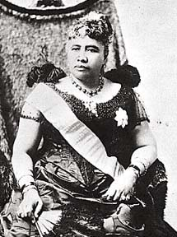
Examine the photograph of the Queen Liliuokalani and describe from what you see .

Document 3
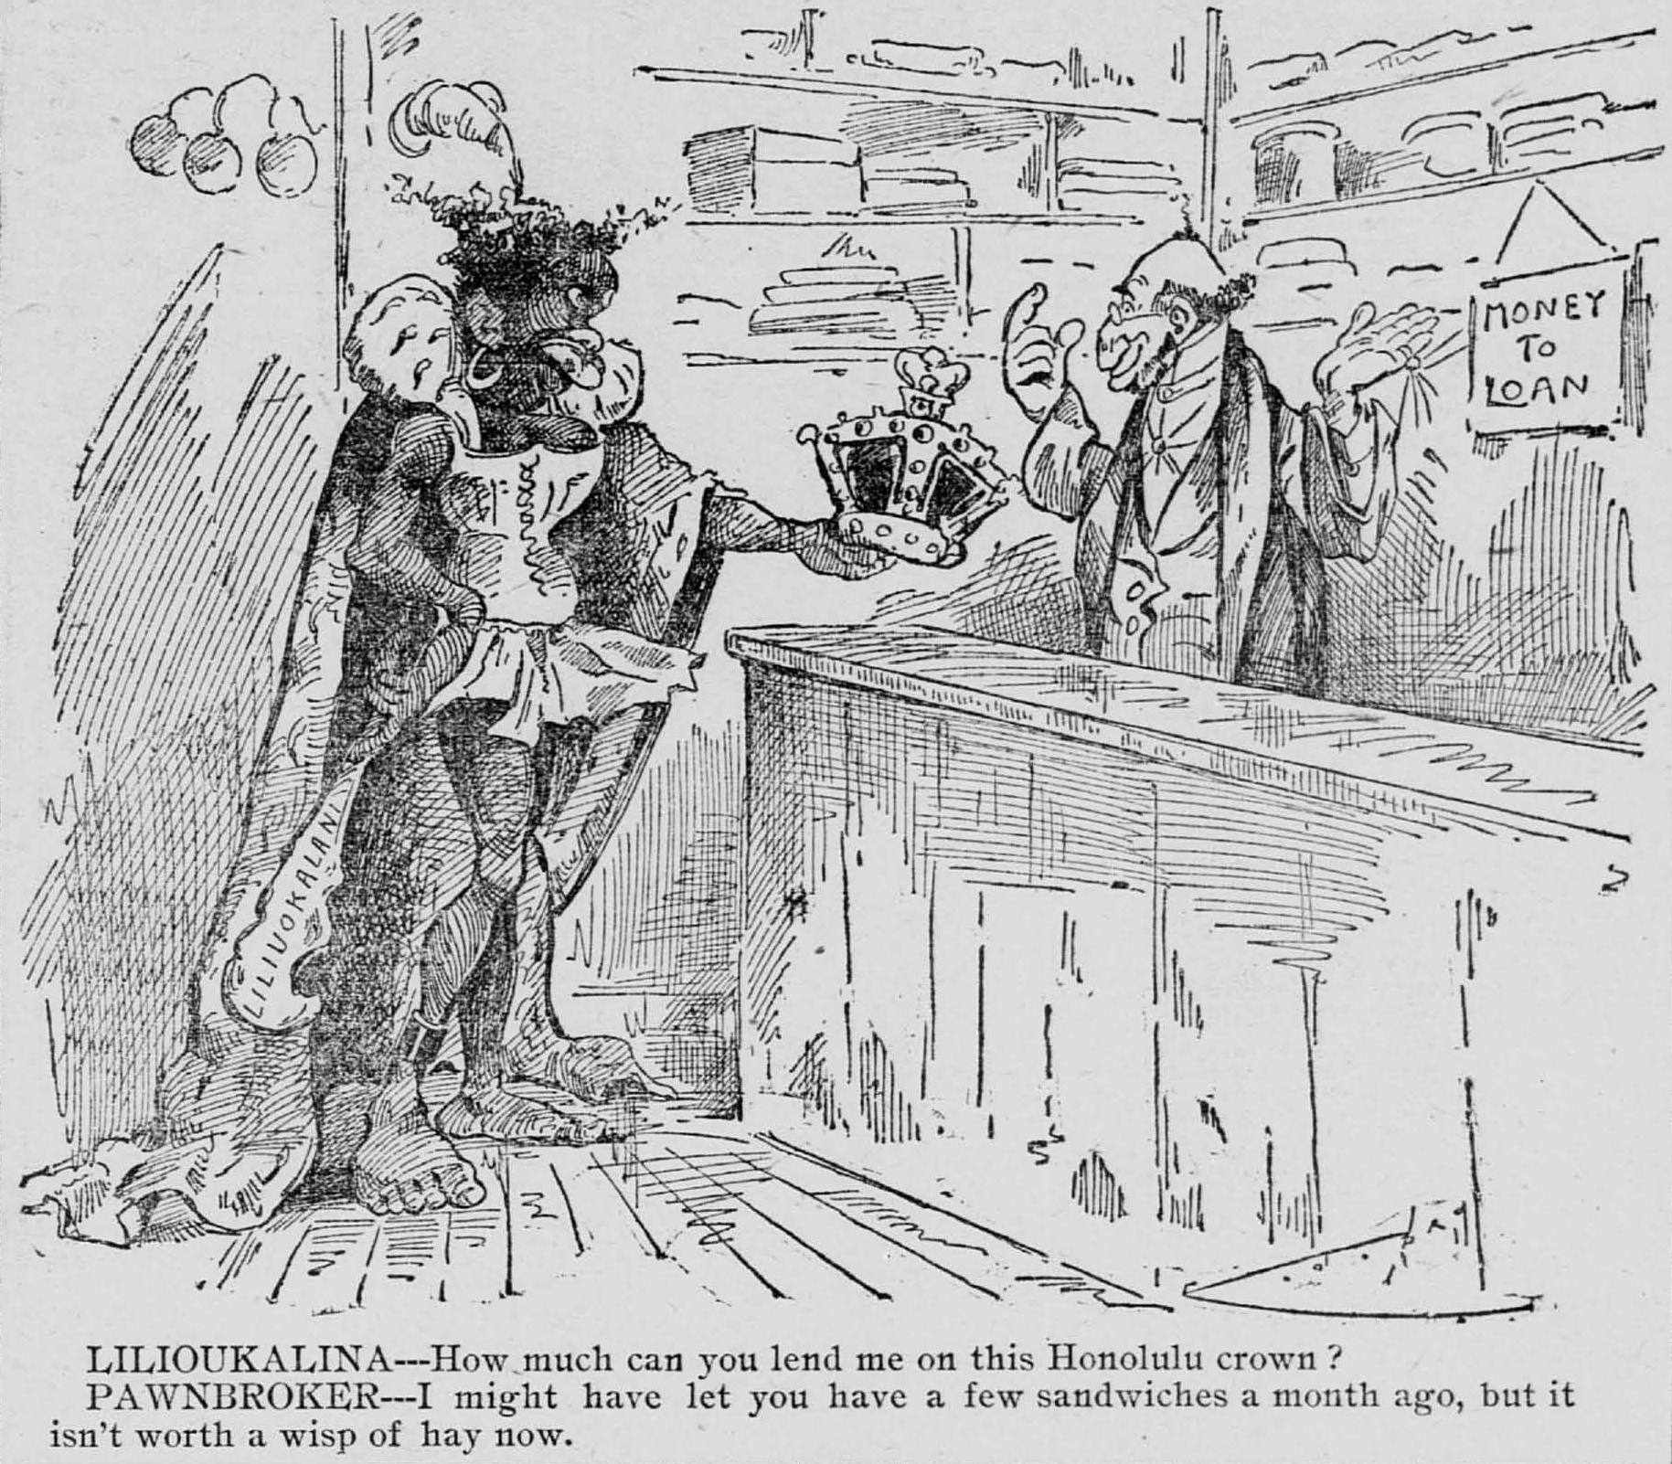
St. Paul Daily Globe., February 03, 1893
1. From the way she is dressed, how does the press perceive her?
2. What do you think the phrase, “Isn’t worth a wisp of hay” means?
3. What type of store might this be?
4. Give an explanation in a paragraph or two, of what was happening between 1892-1893. Apply these facts to the cartoon.
Document 4: Lowering the Hawaiian Flag from Iolani Palace; Annexation Ceremony
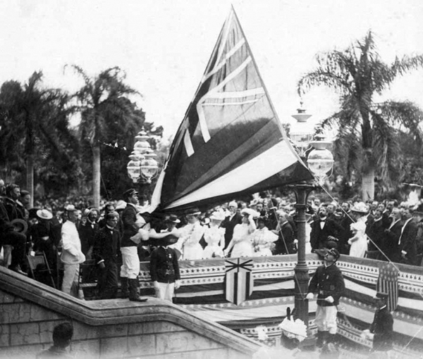
August 12, 1898. Photograph from Hawai‘i State Archives
1. Looking at the crowd, what can you tell about them?
2. What nationality is lowering the flag?
3. What mood is the crowd in?

Document 5: Petition Against Annexation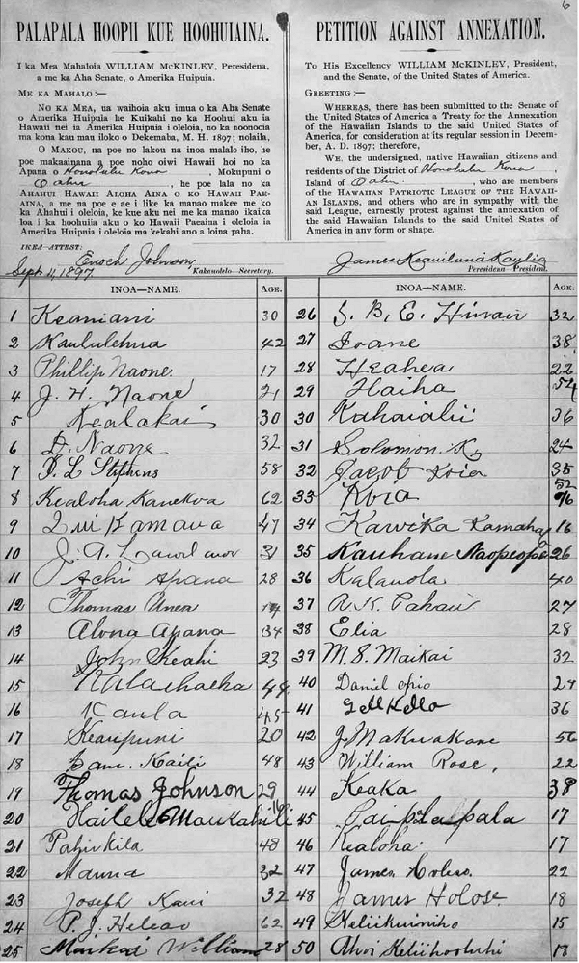
1. What was the year and who was the petition addressed?
2. Who wrote the petition?
3. Were these men or women, or both?

Document 6: Compare the two cartoons. How is the Queen perceived? Explain the importance of sugar barrel.
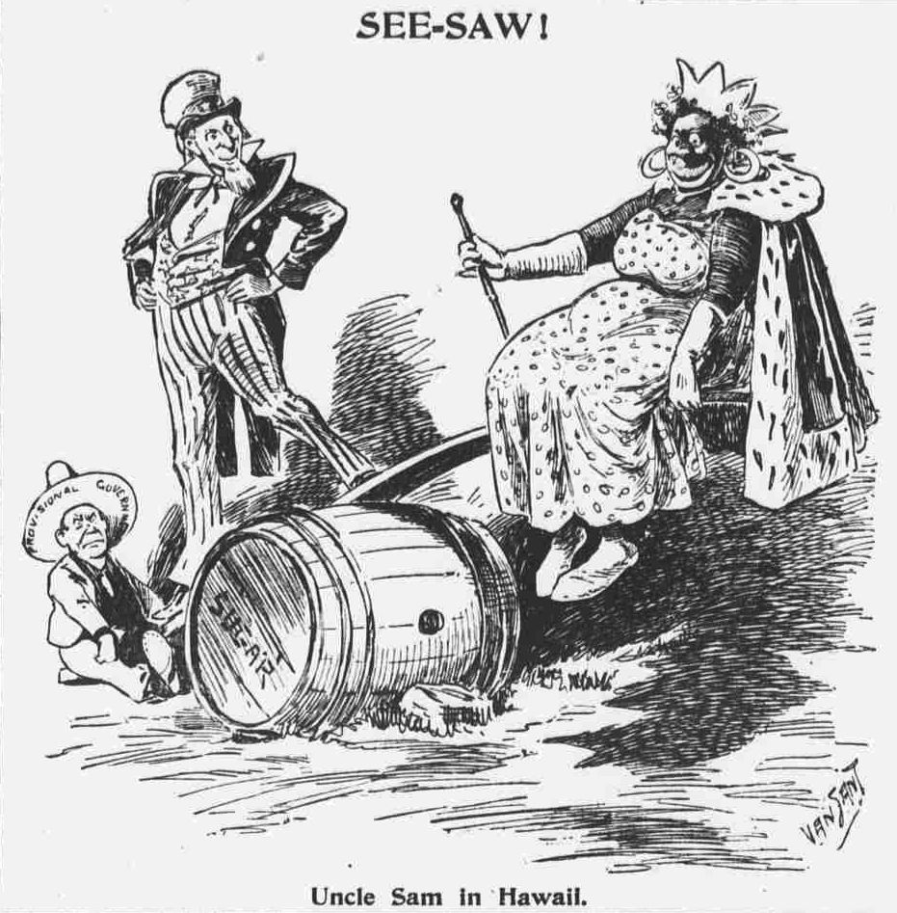Who are the actors? Over what issue are they debating? On what side is Uncle Sam?
Text: "See-saw! Uncle Sam in Hawaii" The Evening World, November 14, 1893, BROOKLYN
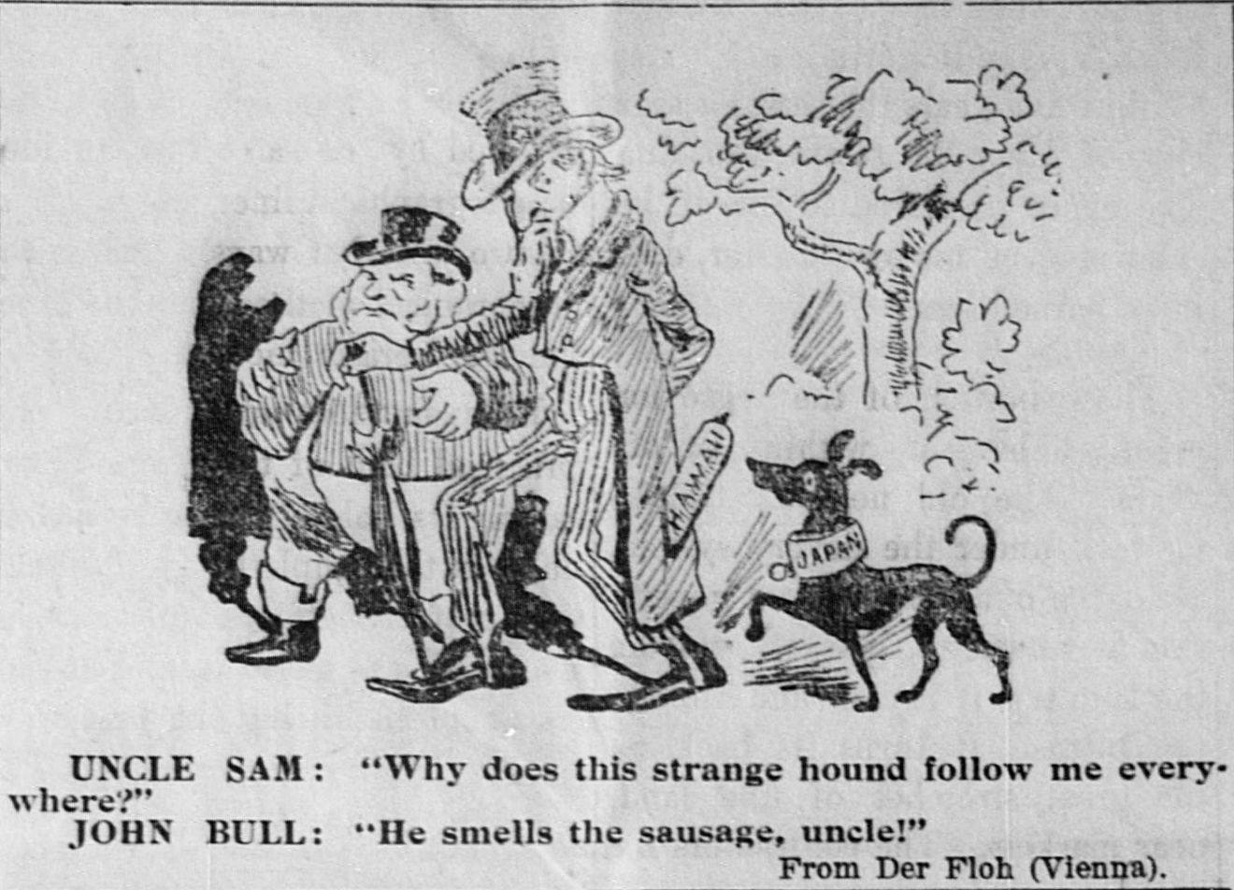John Bull is a representative of England.
Uncle Sam: "Why does this strange hound follow me everywhere?" John Bull: "He smells the sausage, uncle!" From Der Fish (Vienna) The Hawaiian gazette., August 20, 1897, Page 3
How is Hawaii portrayed? What is Uncle Sam’s concern? Who else would want the “sausage”? What does the sausage represent? How is Japan represented.
- What type of document is it?
- Who wrote the document?
- To whom was it written?
- What is the date of the document?
- What was the purpose of the document?
Use these questions with all the documents or the Analysis sheet with the photographs/cartoons
Visual Art Analysis Worksheet
Step 1- Evidence: “What I see”
- Study the photograph for two minutes. Form an overall impression of the photograph and then examine individual items.

- Use the chart to list examples of evidence you observe: people, objects, and activities in the image.
People | Objects | Activities
Step 2- Claims: “What I Think.”
- Based on the evidence you collected, write three statements you believe about this image.
- ___________________________________________________________________________
- ___________________________________________________________________________
- ___________________________________________________________________________

Step 3- Reasoning: “How I know.”
- For each claim, list the evidence that supports your idea and a sentence that explains your thinking.
1. ____________________________________________________________________________

______________________________________________________________________________

2. ___________________________________________________________________________

_____________________________________________________________________________

3. ___________________________________________________________________________

_____________________________________________________________________________

