Trail of Tears
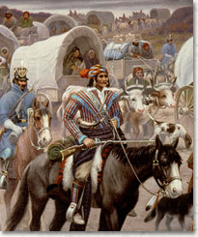
Document Based
Questions

Mr. Inskeep
What factors eventually led to the Cherokee removal and the Trail of Tears? Was the United States justified in removing the Cherokees from their land?

Source #1

Vocabulary -
Exterminate - To get rid of entirely, as by killing, wipeout
Genocide - A program of action intended to destroy a whole national or ethnic group.
Integration - Bringing different racial or ethnic groups together equally.

“The distinguished scholar of Native American history Francis Paul Prucha has argued that four courses of action were available to the government in ending the everlasting white/red crisis. And four courses only. First, genocide. Exterminate the race. But one in his right mind seriously proposed such a solution, certainly not Jackson or any other responsible official in the government. Second, integrate the two societies. But Native Americans had no desire to become cultural white men. They had their own customs, laws, language, religion, government, and leaders and wanted to keep them. …Nor did whites favor integration. As racists they feared that integration with red people would ultimately lead to integration with blacks. And that possibility horrified them. Third, protect the natives where they lived by enforcing existing treaties. …There was not army enough o keep squatters from invading the Indian country. …Fourth, removal. This was the course Jackson knew would work and therefore adopted. No other alternatives existed if Indians were to survive.”

Source: Robert V. Remini, Andrew Jackson and his Indian Wars, 2001

Questions-
1) In your own words, what were the four courses of action the author felt were available to President Jackson?

2) Why is genocide an option?

3) Why would white settlers be opposed to integration?

4) Why would the Native Americans not want to integrate with white people?

5) What attitudes and perceptions separated white people from Native Americans?

6) Which of the four choices would you have picked, and why?
What factors eventually led to the Cherokee removal and the Trail of Tears? Was the United States justified in removing the Cherokees from their land?
Source #2
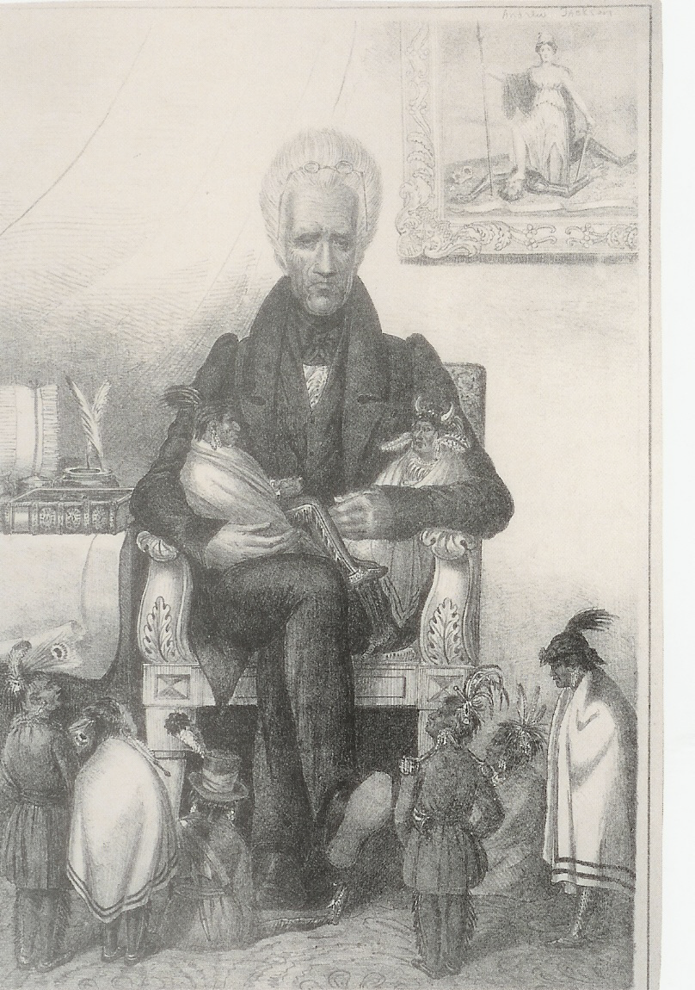

1) Who is depicted in this political cartoon?

2) How are Native Americans portrayed in this illustration?

3) What is the relationship between President Andrew Jackson and the native Americans?

4) What other parts of the illustration show conflict?

5) What attitude toward Native Americans does this cartoon imply?

6) If you were a Native American how would you feel about this political cartoon?
What factors eventually led to the Cherokee removal and the Trail of Tears? Was the United States justified in removing the Cherokees from their land?

Source #3

Vocabulary -
Liable - Legally responsible or obligated.
Intoxication - To become drunk or cause loss of control.

President Andrew Jackson speaks to the Cherokee delegation at the White House. March 1835
“You are now placed in the midst of the white population….You are now subject to the same laws which govern the citizens of Georgia and Alabama. You are liable to prosecutions for offenses, and to the civil actions for a breach of any of your contracts. Most of your people are uneducated, and are liable to be brought into collision at all times with your white neighbors. Your young men are acquiring habits of intoxication. With strong passions…they are frequently driven to excesses which must eventually terminate in their ruin. The game has disappeared among you, and you must depend upon agriculture and the mechanic arts for support. And yet, a large portion of your people have acquired little or no property in the soil itself….How, under the circumstances, can you live in the country you now occupy? Your condition must become worse and worse, and you will ultimately disappear, as so many tribes have done before you?”

Source: Jackson’s talk, March 1835, Jackson Papers, LC.

1) What are the situations that Jackson describes for the Cherokees?

2) What states will be in conflict with the Cherokees?

3) What skills does Jackson think the Cherokees have to adapt to the new environment?

4) What negative habit does Jackson say the Cherokees are acquiring?

5) Does Jackson think that the Cherokees will be successful living with the whites?

6) What could the Cherokees do to be successful in white society?
What factors eventually led to the Cherokee removal and the Trail of Tears? Was the United States justified in removing the Cherokees from their land?

Source #4

Vocabulary -
Sabbath - Holy days, usually Sunday for Christians.
Swine - Pigs.
Cultivate - To prepare or use the soil or land for growing crops.

“I will tell you about the Cherokees. I think they improve,” a young Cherokee girl wrote a New England clergyman in 1828. “They have a printing press and print a paper called the Cherokee Phoenix. They come to meeting on the Sabbath days. They wear clothes which they have made themselves. Some though rude, have shoes and stockings. They keep horses, cows, sheep, and swine. Some have oxen. They cultivate fields….I hope this nation will soon become civilized and enlightened.”

Source: Sally M. Reese to Reverend Daniel Campbell, July 25, 1828, John Howard Payne Papers, Newberry Library, Chicago.
From: Thelda Perdue and Michael Green, The Cherokee Nation and the Trail of Tears, 2007.

1) Who is describing the Cherokees?

2) What do the words rude and stockings mean in this context?

3) Why would it be important to mention that they raise farm animals?

4) What white culture institutions have the Cherokees assumed?

5) Why does the speaker think that the Cherokees will become “civilized and enlightened”?

6) How does the speakers view of the Cherokees differ from the perception that most white people had of the Cherokees?
What factors eventually led to the Cherokee removal and the Trail of Tears? Was the United States justified in removing the Cherokees from their land?

Source #5

Vocabulary -
Ga. - Georgia
Approvation - The approval of.
Neutrality - Not taking part in either side of a dispute or quarrel.

“The clouds may gather, thunders roar & lightning flash from the acts of Ga. Under the approvation of Genl. Jackson’s neutrality, but the Cherokees with an honest patriotism & love of country will still remain peaceably and quietly in their own soil.”

Source: John Ross to Jeremaih Evarts, July 24,1830, Gary Moulton, ed, The Papers of Chief John Ross (2 v., Norman University of Oklahoma Press 1985), 1: 195-196.
From: Thelda Perdue and Michael Green, The Cherokee Nation and the Trail of Tears, 2007.

1) What mood does the author show for the “acts of Ga.”?

2) What does General Jackson’s “neutrality” mean?

3) Was the neutrality of General Jackson good or bad for the Cherokees? Defend or support your answer.

4) How do the Cherokees describe themselves?

5) How does the author describe the difference between how the state of Georgia and the Cherokees are handling the situation?

6) How does the author describe how the Cherokees will confront the situation?
What factors eventually led to the Cherokee removal and the Trail of Tears? Was the United States justified in removing the Cherokees from their land?

Source #6

Vocabulary -
Repugnant - Contradictory, opposed, or disagreeable to.
Favour - Favor, to support.
Assent - Approval of.
Intercourse - Communication or dealings between people or countries.
Vested - To put in control of.

“On the ground of its being repugnant to the Constitution, treaties, and laws of the United States, and the decision is in favour of its validity."

“The Cherokee nation, then, is a distinct community, occupying its own territory, with boundaries accurately described, in which the laws of Georgia can have no force, and which the citizens of Georgia have no right to enter but with the assent of the Cherokees themselves, or in conformity with treaties and with the acts of Congress. The whole intercourse between the United States and this nation is, by our Constitution and laws, vested in the Government of the United States.”

Source: Samuel A. Worcester v. The State of Georgia, January Term, 1832.

1) According to this Supreme Court decision who has control here, Georgia or the Government of the United States?

2) Who does this excerpt of the Supreme Court decision seem to favor?

3) According to this decision should Georgia have been allowed to continue to take land from the Cherokees?

4) What do you think the reaction was from the Cherokee Nation to this decision?

5) Based on this decision why should the Cherokees have been allowed to stay in Georgia? Explain why or why not?

