Lewis and Clark Structured Academic Controversy
This Lesson is from the Stanford History Education Group: Reading Like A Historian

Lesson Title: Were Lewis and Clark respectful to the Native Americans they encountered on their
journey?

Author Name: Marcia Motter

Contact Information:

Appropriate for Grade Level: 5-12

US History Standard(s)/Applicable CCSS(s):

H2.[6-8].16 Define the concept of Manifest Destiny and explain the events that led to the expansion of the United States.
H.2.[6-8].17 Discuss and analyze the interactions between pioneers and Native Americans during the westward expansion.

CCSS RH1: Cite specific textual evidence to support analysis of primary and secondary sources.

CCSS RH2: Determine the central ideas or information of a primary or secondary source; provide an accurate summary of the source distinct from prior knowledge or opinions.

CCSS WHST.6-8.1a: Introduce a claim(s) about a topic or issue, acknowledge and distinguish the claim(s) from alternate or opposing claims, and organize the reasons and evidence logically.
CCSS WHST.6-8.1b: Support claim(s) with logical reasoning and relevant, accurate data and evidence that demonstrate an understanding of the topic or text, using credible sources.
CCSS WHST.6-8.1e: provide a concluding statement or section that follows from and supports the argument presented.

CCSS.ELA-Literacy.SL.7.1: engage effectively in a range of collaborative discussions with diverse partners on grade 7 topics, texts, and issues, building on other’s ideas and expressing their own clearly.

CCSS.ELA-Literacy.SL.7.1a: Come to discussion prepared, having read or researched material under study; explicitly draw on that preparation by referring to evidence on the topic, text, or issue to probe and reflect on ideas under discussion.

CCSS.ELA-Literacy.SL.7.1d: Acknowledge new information expressed by others and, when warranted, modify their own views.

Discussion Questions: Students will discuss the Central Historical Question: Were Lewis and Clark respectful to the Native Americans they encountered on their journey? Supplemental Questions: Should Lewis and Clark be judged for what happened to Native Americans after their trip? Can we judge people by our standards?

Engagement Strategy: Structured Academic Controversy.
1. Students will read the primary and secondary source documents. Depending on their level, they
can either read them individually, with a partner, or in groups. They will answer the guided
questions and then complete the note taker that is provided.

2. Place the students into groups of 4. Then have 2 of the students be on Team A and 2 of the
students be on Team B.
Team A will argue that Lewis and Clark were respectful.
Team B will argue that Lewis and Clark were not respectful.

Teams will use the graphic organizer (Organizing Evidence) to collect data for their side.

3. Team A will present their evidence to Team B. Team B will repeat arguments back to Team A, until
Team A is satisfied with their responses.

4. Team B will present their evidence to Team A. Team A will repeat arguments back to Team B,
until Team B is satisfied with their responses.

5. The team will reach a consensus.

6. The team will write their group consensus on the Coming to Consensus page. The team will need
to include a claim, evidence and a counterclaim for their response.

7. If there is time, groups may share their responses to the class.

Student Readings:
Document A: Jefferson’s Letter to Meriwether Lewis
Document B: Time Magazine Article
Document C: Diary entries of William Clark
Document D: The Mandan Buffalo Dance

Stanford History Education Group: Reading Like A Historian: The original lesson can be found on this website. If you have an account with SHEG log in and download the lesson plan. The original documents can be found there. If you do not have an account, go to this website and print the lesson: http://sheg.stanford.edu/upload/Lessons/Unit%204_Expansion%20and%20Slavery/Lewis%20and%20Clark%20SAC1.pdf
The questions for the documents have been modified to make them more text-specific. Also, the original Document B was a bit inappropriate for middle school students. If you are teaching high school, Document B may be fine. The documents are ordered differently in this lesson plan. The original Document B was replaced by Document D, The Mandan Buffalo Dance. Students can still understand the importance of the ritual with this replacement.

Total Time Needed: 4 days; 50 minute class periods

Lesson Outline:

Time Frame | What is the teacher doing? | What are the students doing?
Day 1:  5 min | Tell the class that they will be starting a Structured Academic Controversy (SAC) today. (If this is the first time doing this discussion activity in your classroom, share and discuss the powerpoint provided by SHEG) The question that students will be discussing is Were Lewis and Clark respectful to the Native Americans they encountered on their journey? | Students will actively listen to the teacher.
Day 1:  10-12 min | Pass out the primary source readings to the class. Have students read, discuss and answer the questions for Document A.  Have students go back into the text to find the answer(s) to the question. All answers need to be evidence based.  Depending on their level, students may read individually, work with a partner or be placed into group of 3 or 4.  (For this part of the lesson, I would have students read with a partner or small group.) | Students will read the primary source documents.  Students are discussing the evidence that they have found.  Students are referring to the line numbers on the left side of the text when discussing their answers.  Students are annotating their text.  Students are being assessed formatively while the teacher watches them work in their small groups. The teacher provides probing questions as needed.
Day 1:  10 min | Bring the students back to a whole class discussion.  Ask different students in different groups to share their answers. There are multiple answers to the question.  Ask enough students the question to make sure that they have enough support and evidence for the answer. | Students are actively listening to the whole group discussion.  Students are sharing their answers/evidence with the class.  Students are annotating their text as needed.  Students are being given probing questions as needed.
Day 1:  10-12 min | Have students read, discuss and answer the questions for Document B.  Have students go back into the text to find the answer(s) to the question. All answers need to be evidence based. | Students will read the primary source documents.  Students are discussing the evidence that they have found.  Students are referring to the line numbers on the left side of the text when discussing their answers.  Students are annotating their text.  Students are being assessed formatively while the teacher watches them work in their small groups. The teacher provides probing questions as needed.
Day 1:  10 min | Bring the students back to a whole class discussion.  Ask different students in different groups to share their answers. There are multiple answers to the question.  Ask enough students the question to make sure that they have enough support and evidence for the answer. | Students are actively listening to the whole group discussion.  Students are sharing their answers/evidence with the class.  Students are annotating their text as needed.  Students are being given probing questions as needed.
Day 2:  40 min | Today students will work on Documents C and D.  Repeat the same steps as yesterday for Documents A and B | The student expectations for classroom reading and discussion are the same today.
Day 2:  10 min | For homework tonight, students need to prepare for the group discussion tomorrow. They will need to fill out the graphic organizer Were Lewis and Clark respectful to the Native Americans they encountered on their journey?  They will fill out answers for both sides of the question. | Students will complete the graphic organizer Were Lewis and Clark respectful to the Native Americans they encountered on their journey?  This will be preparation for the Structured Academic Controversy tomorrow.
Day 3:  25 min | Place the students into groups of 4. Then have 2 students be on Team A and 2 students be on Team B. Team A will argue: Lewis and Clark were respectful to the Native Americans. Team B will argue: Lewis and Clark were not respectful to the Native Americans.  Give the teams 25 minutes with their partner to find 4 pieces of evidence which will support their side. | Once students are in their groups, have them pick 2 members for Team A and 2 members for Team B. Students will read through the documents for their side of the argument. They will fill out the Organizing Evidence graphic organizer for their side.
Day 3:  10 min | Give the following directions to the class: Team A will now present their evidence to Team B. Team B will write down the evidence presented to them on the graphic organizer. | Team A will read their evidence to Team B.  Team B will write down the evidence on the graphic organizer.
Day 3:  10 min | Give the following directions to the class: Team A will now present their evidence to Team B. Team B will write down the evidence presented to them on the graphic organizer. | Team B will read their evidence to Team A.  Team A will write down the evidence on the graphic organizer.
Day 4:  10 min | Have the students get into their teams.  Tell the teams that they will have 7 minutes to come to a consensus on the question: Were Lewis and Clark respectful to the Native Americans they encountered on their journey?  All members of the group must come to an agreement. | Students will come to a consensus on the question. All students must come to an agreement.
Day 4:  30 min | As a group, students will answer the question. They will give a claim, 3 pieces of evidence and include a counterclaim to the argument. | As a group, students will write an answer to the question. They will give a claim, 3 pieces of evidence and include a counterclaim to the argument.
Day 4:  10 min | Have students turn in their group writing.  Discuss the process with the class. | Turn in group writing.  Participate in group discussion.

Description of Lesson Assessment: Students will turn in their group writing. The assessment will be their group consensus. If there is time at the end of class, groups can present their positions to the class.

Were Lewis and Clark respectful to the Native Americans they
encountered on their journey?

Prepare for our class discussion on the question: Were Lewis and Clark respectful to the Native Americans they encountered on their journey? Fill out the graphic organizer with as many reasons as you can. Include the document and line number with the reason for class discussion.

Lewis and Clark were respectful to the Native Americans. | Lewis and Clark were not respectful to the Native Americans.

Structured Academic Controversy:
Were Lewis and Clark respectful to the Native Americans they
encountered on their journey?

During class today, you will work as part of a team. You will discuss whether or not Lewis and Clark were respectful to the Native Americans they met on their journey. Your goals for today should include looking at all of parts of the issue, seeing both sides, and finding a common ground.

SAC Question: Were Lewis and Clark respectful to the Native Americans they encountered on their journey?

Team A will argue: Yes, Lewis and Clark were respectful to the Native Americans.

Team B will argue: No, Lewis and Clark were not respectful to the Native Americans.

Procedure:
Day 1:
25 minutes: With your teammate, read the documents in the packet. Find 3 pieces of
evidence which support your side

10 minutes: Team A presents. BOTH PARTNERS MUST PRESENT! Team B writes
down Team A’s arguments and then repeats them back to Team A.

10 minutes: Team B presents. BOTH PARTNERS MUST PRESENT! Team A writes
down Team B’s arguments and then repeats them back to Team B.

Day 2:
10 minutes: Everyone can abandon their positions. As a group of four, you must
come to an agreement on the question being discussed. Everyone in
the group must agree!

30 minutes: The group will have 30 minutes to write an answer to the question: Were
Were Lewis and Clark respectful to the Native Americans they
encountered on their journey?

The response must include a claim, evidence, reasoning and a counterclaim.

Name ____________________
Class ______ Date _________

Organizing the Evidence

Use this graphic organizer to write your evidence (main points) and the evidence made by the other side.

Lewis and Clark were respectful to the Native Americans: List the 3 main points/evidence that support this side.

1) From Document _____:

2) From Document _____:

3) From Document _____:

Lewis and Clark were not respectful to the Native Americans: List the 3 main points/evidence that support this side.

1) From Document _____:

2) From Document _____:

3) From Document _____:

Name __________________
Name __________________
Name __________________
Name __________________
Class ______ Date _______

Coming to Consensus

Starting now, you may abandon your assigned position and argue for either side. Your group must come to a consensus on the question. Everyone in your group must agree on your position.

Use the space below to write a paragraph on your group’s position. You must include a claim, 3 pieces of evidence, reasoning and a counterclaim.

________________________________________________________________________________________________________________________________________________________________________________________________________________________________________________________________________________________________________________________________________________________________________________________________________________________________________________________________________________________________________________________________________________________________________________________________________________________________________________________________________________________________________________________________________________________________________________________________________________________________________________________________________________________________________________________________________________________________________________________________________________________________________________________________________________________________________________________________________________________________________________________________________________________________________________________________________________________________________________________________________________________________________________________________________________________________________________________________________________________________________________________________________________________________________________________________________________________________________________________________________________________________________________________________________________________________________________________________________________________________________________________________________________________________________________________________________________________________________________________________________________________________________________________________________________
Grading Rubric for SAC: Were Lewis and Clark respectful to the Native Americans they encountered on their journey?

Name of student: ______________________________________________

 | 0 | 1 | 3 | 5
Claim:  Points:________ | A claim was not written. | An attempt to write a claim was included in the paragraph. | A claim was included in the paragraph. The reader was confused about the side being argued. | The claim was written correctly, arguing one side of the question. The reader knew which side was being argued.
Evidence:  Points:________ | Evidence that answered the questions was not provided. Or  The evidence in the document was not cited. | The paragraph had only 1 piece of evidence. Or An attempt was made to cite evidence. It was not done correctly. | 2 pieces of evidence were included in the paragraph. Or  An attempt was made to cite evidence, it was somewhat correct. | 3 pieces of evidence were included in the paragraph. The evidence was cited correctly, including who the source was and the document it came from.
Reasoning:  Points:________ | There was not any reasoning included in the document linking the evidence back to the claim. | Minimal reasoning was included in the document linking the evidence back to the claim. | There was some reasoning linking the evidence back to the claim. Some of the reasoning made sense. | There was reasoning explaining all of the evidence. The reasoning made sense to the reader.
Counterclaim:  Points:________ | A counterclaim was not included. | A counterclaim was included in the paragraph. | A counterclaim was included in the paragraph. It made an attempt to argue the other position with reasoning or evidence. | A counterclaim was included in the paragraph. It argued the other position with evidence and reasoning.
Conventions:  Points:________ | The paragraph had excessive spelling, grammar, and mistakes in punctuation. It made the paragraph difficult to read. | The paragraph had many mistakes in spelling, grammar, or punctuation. | The paragraph has some mistakes in spelling, grammar, or punctuation. | The paragraph was well written with few mistakes in spelling, grammar or punctuation.

______/25
Document A: Jefferson’s Letter to Meriwether Lewis (Modified)

To Captain Meriwether Lewis,
In all your interactions with the natives, treat them in the most friendly and peaceful manner. Assure them that the purpose of your journey is innocent, that the U.S. wishes to be neighborly, friendly, and useful to them. Tell them we wish to trade peacefully with them, and find out what articles would be most desirable for both of us to trade.
If a few of their chiefs wish to visit us, arrange such a visit for them. If any of them wish to have some of their young people schooled by us and taught things that might be useful to them, we will receive, instruct and take care of them.
Carry with you some smallpox medicine and explain to them how to use it and encourage them to use it, especially in the winter.
Thomas Jefferson, President of USA

Source: The passage above is from a letter written by Thomas Jefferson to Meriwether Lewis on June 20, 1803. The letter gives detailed instructions on how Lewis and Clark should treat Native Americans.

Lewis and Clark

Document B: Time Magazine Article (Modified)

For more than a century, the history of Lewis and Clark’s encounters with the 58 tribes along the trail has been defined by the white men’s journals. The Mandan, who fed them, danced with them over the bitterly cold winter of 1804-5, were described as good neighbors. . . .
Today Indians are looking to their own oral histories, as well as reading between the lines of the journals, to re-interpret what happened.
The President of the Western American Indian Chamber in Denver said: “[History books make] Lewis and Clark as friendly protectors of the Indians, but that’s baloney.”
The real truth is that when Clark became the Governor of the Missouri Territory and Superintendent of Indian Affairs, he was in charge of Jefferson’s land-grab policy, which some historians have called “cultural genocide” and “ethnic cleansing.”
Whites brought diseases that killed as many as 90% of some tribes’ members. Most of the tribes Lewis and Clark encountered were forced off their land and herded onto reservations with poor soil.

Source: The passage above comes from an article published in Time Magazine in July 2002.

Lewis and Clark

Document C: Diary entries of William Clark (Modified)

May 11, 1806
The tribe surrounded us in the lodge. When the chief arrived, we gave him a small medal and spoke to the Indians through Sacagawea. We informed them who we were, where we came from, and our friendly intentions towards them, which pleased them very much.
August 17, 1806
We said goodbye to our interpreters (Shabono and his wife, Sacagawea), who accompanied us on our route to the Pacific Ocean. I offered to take his little son, a beautiful, promising child who is 19months old. They agreed and said that in one year the boy would be sufficiently old to leave his mother and he would then take him to me. I agreed to raise the child as my own, in such a manner as I thought proper.

Source: Many people have heard the name of Sacagawea, the Native American woman who (with her husband and newborn baby) accompanied Lewis and Clark on their journey and served as a translator. Above are Clark’s diary entries about Sacagawea.

Lewis and Clark

Document D: The Mandan Buffalo Dance
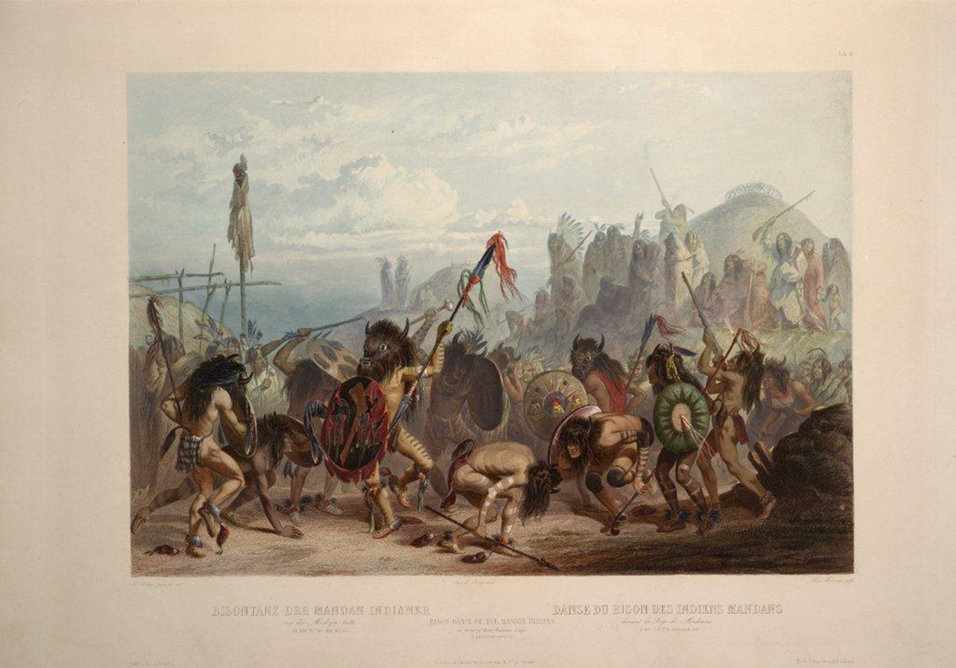
The dances continued each day through January 5th, the Mandans believing that the buffalo dance would attract herds to be hunted. Within days a herd of buffalo showed up. Of the dance, Sergeant John Ordway wrote:
“January 1st, 1805- We …went up to the 1st village of Mandans to dance as it had been their request. carried with us a fiddle & a Tambereen & a Sounden horn. as we arrived at the entrence of the vil[lage] we fired one round. then the music played. loaded again. then marched to the center of the village [and] fired again. then commenced dancing. a frenchman danced on his head and all danced round him for a short time. then went in to a lodge & danced a while, which pleased them verry much. they then brought vectules from different lodges…& Some buffalow Robes which they made us a present off. So we danced in different lodges untill late in the afternoon. then a part of the men returned to the fort. The remainder stayed all night in the village.”
(http://dorgan.senate.gov/lewis_and_clark/dance.html)

Lewis and Clark

Name __________________
Class _____ Date _________

Were Lewis and Clark respectful to the Native Americans they encountered on their journey?
Guiding Questions:
Document A:
1. According to Thomas Jefferson, how should Lewis and Clark treat the Native Americans they
meet?

2. In paragraph 2, why would Thomas Jefferson make such an invitation?

3. What does Thomas Jefferson want from the Native Americans?

4. What is the purpose of this letter?

Document B:
1. According to this article, why has the history of Lewis and Clark been one-sided?

2. Who do the oral histories belong to?

3. Who do the journals belong to?

4. Which could be considered a more reliable source, an oral history or a journal? Explain why?

5. What were some of the long-term outcomes of Lewis and Clark’s journey on Native Americans?

Document C:
1. Based on these two paragraphs, how would you describe the relationship between Sacagawea’s
family and Lewis and Clark?

2. Why would Sacagawea want to give up her son to William Clark?

3. What questions do you still have after reading the diary entries?

Document D:
Using both primary sources, answer the following questions:
1. What is the purpose of the Buffalo Dance?

2. Who participated in the Buffalo Dance?

3. How did the men on the journey participate in the Dance?

4. How did Lewis and Clark’s men honor the Native American custom or ritual of the Buffalo Dance?

