Hyperlinking Inquiry Resource Documents through Dropbox and From the Web.
- Create an account on www.dropbox.com
- In the column on the right, select New Folder.
- Name the folder “Hyperlinked Documents.”
Saving A Document In Dropox:
- To save resources into dropbox, open the “Hyperlinked Documents” folder and select upload files from the right hand column.
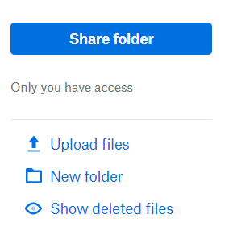
- Find and select resource you want to upload from your computer. Select it. Save it into dropbox.
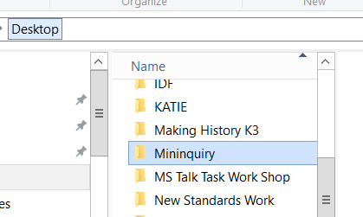

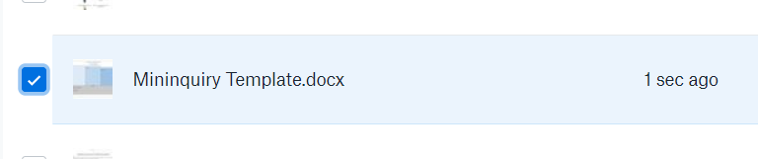

Inserting A Hyperlink from Dropbox into an Inquiry:

- In your inquiry lesson, select the words or phrases that will represent the hyperlink (the words that will appear blue to click on). It will be the title, some portion of the title of the resource, or “(see instructions)”.

- While highlighted, right click, and choose Hyperlink. A window will open.
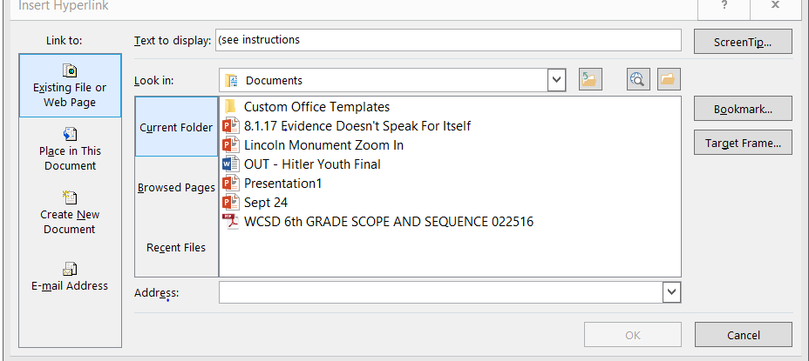

- Keep that window open and go back to your dropbox.

- From the dropbox folder, hover over the document you want to link in your inquiry. A Share button will appear to the right of the document title. Select Share. Select Create a link. Select Copy link. The link will copy to your clipboard.
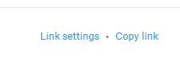

- Go back to the Hyperlink window open in your Inquiry lesson document. Paste the link into the space provided at the bottom of the window. Select Okay.
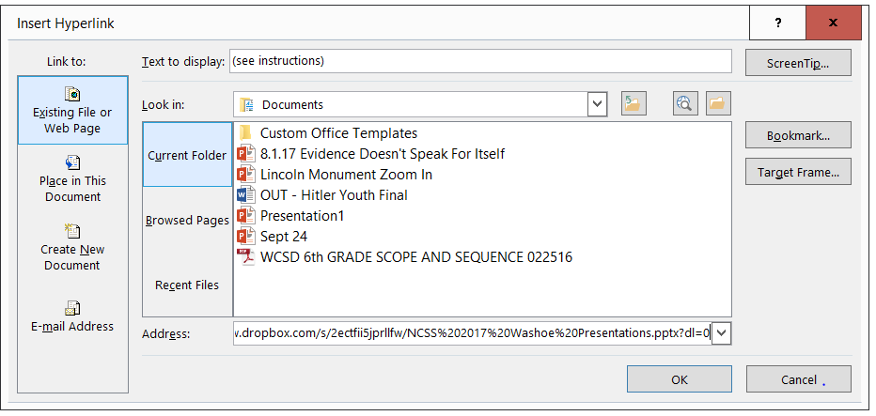

- Yay! The link in your inquiry lesson should be blue. Good job! You did it. Complete steps 4-11 for each resource you will be making available through dropbox in your inquiry lesson.
Hyperlinks Links Straight from the Internet:
- In your inquiry lesson, select the words or phrases that will represent the hyperlink (the words that will appear blue when the lesson is viewed from the internet). It will be the title, or some portion of the title of the resource, or the name of the web page.

- While selected, right click, and choose Hyperlink. A window will open.

- Keep that window open and go back to the webpage.

- Copy the entire link from web address by selecting it, right clicking, and copying it.

- Go back to the Hyperlink window open in your Inquiry lesson document. Copy the link into the space provided at the bottom of the window. Select Okay.

- Yay! You did it! Complete steps 13- 17 for each web resource you will be making available in your inquiry lesson.

