In this 19th-century illustration, travelers in the Andes Mountains take refuge in a stone structure. The Incan people created an extensive network of roads through the Andes' valleys and high passes; along these roads they built rest houses, known as *tambos.*

Andes Mountains

[Felipe Guaman Poma de Ayala]

Incan emperor Atahualpa was killed by the Spanish on August 29, 1533, and the Inca Empire soon collapsed. Atahualpa was strangled, instead of being burned at the stake, at his advisers' request.

[Charles & Josette Lenars/Corbis]

A sculpture depicting a jaguar covers ruins at Chavín de Huántar in Peru. Chavín de Huántar, a temple complex built high in the Andes Mountains, was the center of Chavín civilization.

map

[Robert Weller]

Agricultural terraces built by the Inca at Moray, near Cuzco, Peru. Crops including wheat and quinoa were grown on the terraces, which included a built-in irrigation system.

[Jay I. Kislak Collection, Rare Book and Special Collections Division, Library of Congress]

View of Cuzco, Peru, the capital city of the Inca Empire. The representation shows the square bordered by the Inca palace, the great temple, and the homes of senior dignitaries, from which four roads led to the most remote corners of the Inca Empire. From *Civitates Orbis Terrarum* (1572), the first systematic city atlas, which depicts cities from around the world.

[Ben Ferguson]

View of the Patallacta ruins from the Inca Trail in present-day Peru. The Patallacta ruins are one of many Incan ruins along the route that connected Machu Picchu to Quito (in present-day Ecuador).

[Werner Forman/Corbis]

A quipu, the knotted cord device used by the Incas for keeping accounts, from Peru, about 1430–1532.

[Instructional Resources Corporation]

Golden Inca vase from about 1500 CE, found in Peru. The Incas believed that their emperor was descended from the sun and that gold was his symbol. His temple in Cuzco had walls covered with gold, a garden of golden corn plants, and a golden llama

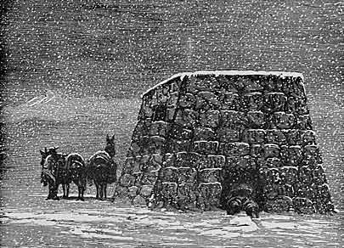

[Rfoxphoto/Dreamstime]

Angled cut stones make up an Incan wall in Cuzco, Peru.

[Instructional Resources Corporation]

Illustration of Incas sharing coca leaf. The Andean Indians, particularly those who lived in the higher elevations, customarily chewed coca leaves to help them adapt to the thinner air. Coca bags like the one shown here have been found in sites dating from 1400 CE.

[David Owens/iStockPhoto]

Ruins of Machu Picchu, an Incan city high in the Andes Mountains. It is believed to have been built by Pachacuti Inca Yupanqui in the mid-15th century. It was abandoned prior to the Spanish conquest of the Inca and rediscovered in 1911 by Hiram Bingham.

[Corel]

Looking up a steep, terraced hillside at Machu Picchu in Peru. Some archaeologists believe that there are many more terraces than necessary to support the ancient population of Machu Picchu, leading to theories of agricultural export or experimentation.

[Corel]

The Intihuatana, a huge carved stone, occupies a high point in Machu Picchu. Because the Incas left no written records, it is unclear what purpose this stone served. It may have been an astronomical calendar or the site of mountain worship of the sun.

[Ben Ferguson]

The Incas never moved massive rocks or other natural features; instead, they built around them as in this photo. The stonework itself is an example of the more refined, carved style the Incas used for temples and the base of important structures.

[Getty Images]

Portrait of Manco Capac, founder of Cuzco and first ruler of the Inca.

[Ben Ferguson]

The circular Temple of the Sun at Machu Picchu in Peru is known for featuring the best stonework at the site. The temple is built above a cave that served as a royal tomb.

[Corbis]

Eighteenth-century portrait of Pachacuti Inca Yupanqui, ninth emperor of the Inca. Under Pachacuti's rule, the Inca Empire expanded to become the most powerful empire in the New World.

[Ben Ferguson]

Stone steps lead upward on the Inca Trail in present-day Peru. The Inca Trail was built more than 500 years ago and connected Machu Picchu to the southern Inca capital, Cuzco, and the northern capital, Quito (in present-day Ecuador).

[Corel]

Ruins of an Incan fortress near Pisac, Peru. The fortress is located in the Urubamba Valley, about 20 miles from the Incan capital of Cuzco.

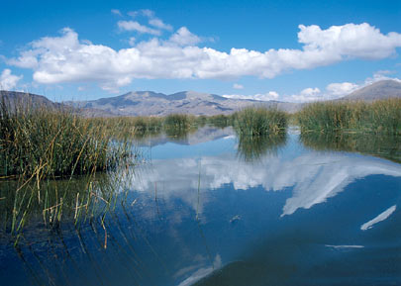

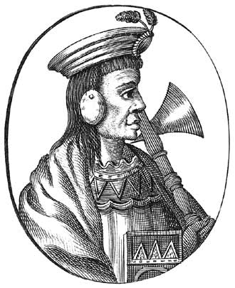

[Travel Pictures Gallery]

Lake Titicaca in present-day Peru, almost 13,000 feet above sea level, is an area steeped in folklore and the center of Incan creation myths. The area was among those conquered by Pachacuti Inca Yupanqui when he became emperor of the Inca Empire.

Inca surgeons in ancient Peru commonly and successfully removed small portions of patients' skulls to treat head injuries, according to a new study. The surgical procedure—known as trepanation—was most often performed on adult men, likely to treat injuries suffered during combat, researchers say.

Three Inca mummies found near the lofty summit of [Volcán Llullaillaco](http://volcano.oregonstate.edu/oldroot/CVZ/llullaillaco/) in Argentina were so well preserved that they put a human face on the ancient ritual of *capacocha—*which ended with their sacrifice. Tests revealed that this sacrificed 13-year-old used coca at a high level during the last year of her life, but her alcohol use surged only in her last weeks.

Mummies of deceased Inca rulers are offered a ceremonial drink of chicha by their attendants

Employing a shrewd combination of dipomacy, intermarriage, and military coercion the Inca cnqured a vast realm extending 2,500 miles along the mountainous spine of South America. At their height they rules as many as 12 million people who spoke at least 20 languages. This fractious conglomeration quickly fell apart after the Spanish conquest in 1532

This well-preserved mummy was removed from an ancient Inca cemetery located just outside Peru's capital, Lima. The site, adjacent to Puruchuco-Huaquerones, the largest Inca cemetery ever found, yielded dozens of human remains and artifacts dating back more than 500 years. The mummies were bundled in textile cocoons containing one or more adults or children.

[Holger Mette]

Salcantay, a peak in the Andes Mountains of Peru that may have had cosmological significance for the Incas of Machu Picchu.

Three figurines festooned with colorful feathers and woven garments were found alongside the bodies three Inca children were left to freeze to death as a sacrifice to the gods. Anthropologist J. Reinhard told National Geographic News in 2005. "They were being sacrificed to enter into the realm of the gods. It was considered a great honor.

[Philip Baird/www.anthroarcheart.org]

Ruins of the ancient city of Pachacamac in present-day Peru. The Huari people built Pachacamac largely between 200 BCE and 600 CE, with the Inca adding later construction.