Table of Contents
INTRO. Introductory Materials | Angela Orr & Katie Anderson
- Nevada Symbols and Nicknames (p. 10-12)  From Chapter 1 “History Close to Home” | Heather Bowman & Cherie Kuykendall
- The Spirit Cave Mummy (p. 48-49)  From Chapter 3 “The First People” | Rachel Holmes, Amy Kappel, & Mary Lamont
- Homes of Nevada’s Native People (p. 60)  From Chapter 3 “The First People” | Jacqueline Backlund, Christine Smart &  Brandi Vigen
- Reservation Life: Native Americans (p. 64-65)  From Chapter 3 “The First People” | Holly Blackson, Jamie Nelson, Kris Stosic,  Heidi Schreiber, Janelle Turnier, & Jodie Westmont
- Explorers Come West (p. 78)  From Chapter 4 “Discovering Nevada” | Debbie Galati, Cheryl Hensley, Anna Burnett,  Melissa Sullivan, & Melissa Pruyn
- Mountain Men of Nevada (p. 74-79)  From Chapter 4 “Discovering Nevada” | Angela Orr
- Wagon Trains & the Forty-Mile Desert (p. 87-88)  From Chapter 5 “Go West” | Lisa Smith, Lisa Stover, Bree Evans, Geri Moore,  Erica Pienkoski, Johnna Ramos,  & Michael Raybourn
- Chinese Prospectors (p.141-142)  From Chapter 6 “Making a Place in Nevada” | Jennifer Fick, Lynn Autino, Joe Lowery,  & Jennifer Noland
- Basque Culture In Nevada (p 138-39)  From Chapter 7 “A Time of Growth and Change” | Virginia Briggs
- Chinese & Railroads in Nevada (p.141-142)  From Chapter 7 “A Time of Growth and Change” | Melinda Dacus & Sally D’Ault
- Stewart Indian School  From Chapter 7 “A Time of Growth and Change” | Sylvia Sisto & Holly Tretten
- Constructing Hoover Dam (p.173)  From Chapter 8 “Entering a New Century” | Aaron Grossman
- Industries in Nevada (p.244)  From Chapter 11 “Making a Living in Nevada” | Kelly Lorenzetti, Julie Martin,  & Christi Wilson
- Nevada’s Unique Scenery and Tourism (p.245)  From Chapter 11 “Making a Living in Nevada” | Sara Davis & Christy Aker-Minetto
- Mining and the Environment (p.246)  From Chapter 11 “Making a Living in Nevada” | Tracy Chew, Adam Farnsworth, Revae Henry, & Kitty Gillette
- Mining and Taxation (p.246)  From Chapter 11 “Making a Living in Nevada” | Tammi Crowther, Diane Longoni,  & Sandi Speirer
Introduction to 4th Grade Nevada History OUTs
What is an OUT?
OUT stands for Open up the Textbook. Textbooks often offer a single, linear, and detail-void narrative of history. In order to bring history alive and encourage critical historical thinking, teachers are encouraged to help students vivify, enlarge, complicate, and contest the textbook narrative with primary and secondary sources. OUTs begin with a short section of the textbook and then require students to analyze and synthesize a variety of sources on the same topic by answering text-specific questions, grappling with complex Tier 2 and Tier 3 vocabulary, discussing ideas with their peers, and engaging in a writing task based on textual evidence.
How were they created?
Beginning in July, 2014 in a partnership between WCSD, the Nevada Museum of Art, NWRPDP, and TMCC, 49 4th grade teachers came together as the Nevada History & Art Cohort. The Cohort met for 50 hours over the course of the 2014-2015 school year and engaged in graduate level study of Nevada history, social studies literacy, and visual literacy. This first-rate group of educators was humbly led by Angela Orr and Katie Anderson of WCSD Curriculum & Instruction and supported by guest historian, Dr. John Reid, visual literacy education specialist, Colin Robertson, and literacy specialists Aaron Grossman, Nicolette Smith, Kristin Campbell, and Stacy Drum.
Nearly ten hours of small group Professional Learning Community time was dedicated to building these OUTs as teachers learned more about social studies literacy and historical thinking. The work required a great deal of research and understanding of the Instructional Shifts necessary to implement the standards. The development of this curricular resource also required true collaboration amongst peers.
The OUTs were edited by a team and have been published for use in 4th grade classrooms. We are extremely proud of the materials and the teacher learning which developed as a result of their creation, and we hope they will be useful to teachers around the state. But these materials are not perfect. They will be living documents, available on our website www.projecttahoe.org and we know that with teacher use and feedback to us, the OUTs will change and become better over time. Make sure that you pull up the color copies of each of these OUTs on the website and project color images for students, where appropriate.
How might these OUTs become a staple in your 4th grade social studies curriculum?
We encourage teachers to plan for social studies instruction using the Instructional Practice Guides available on www.acheivethecore.org. Social studies instruction should include regular use of rich and complex, content-rich texts along with questions and tasks that are text-dependent and specific and which require students to tackle tough vocabulary and syntax. In addition, teachers should encourage students to engage in the historical thinking skills of sourcing, contextualization, corroboration, and close reading. Most importantly, any social studies classroom should be discussion-rich and student-centered. The OUTs themselves should always be implemented with students in small, heterogeneous groups and student dialogue should center on the ways in which sources conflict or offer multiple perspectives. The OUTs are not worksheets. They represent opportunities for conversations about source bias and reliability, about point of view and diversity, and about ways to best evaluate and synthesize evidence.
No teacher should consider implementing all of these OUTs. First and foremost, social studies instruction should be varied and offer a wide-range of learning experiences. Secondly, there will not be time to implement each OUT. Teachers should review the different learning experiences in each and then choose three to eight that best meet the needs of their students and incorporate them as meaningful learning experiences throughout the year. We suggest that teachers also use some of the primary sources from OUTs not implemented in their entirety to provide students opportunities to practice historical thinking and analysis.
2014-2015 Nevada History & Art Cohort

Angela Orr, K-12 Social Studies Coordinator Katie Anderson, Content Literacy
Dr. John Reid, Nevada Historian, TMCC Colin Robertson, Curator of Education, NMA
Aaron Grossman, Curriculum & Instruction Stacy Drum, Striving Readers
Nicolette Smith, RPDP Kristin Campbell, RPDP

Christy Aker, Winnemucca Elementary Wendy Autino, Taylor Elementary
Jacqueline Backlund, Silver Lake Elementary Holly Blackson, Sun Valley Elementary
Heather Bowman, Cannan Elementary Virginia Briggs, Mt. Rose Academy
Anna Burnett, Van Gorder Elementary Tracy Chew, Westergard Elementary
Tammi Crowther, Melton Elementary Melinda Dacus, Dodson Elementary
Sally D’Ault, Dodson Elementary Sara Davis, Winnemucca Elementary
Bree Evans, Sepulveda Elementary Adam Farnsworth, Westergard Elementary
Jennifer Fick, Taylor Elementary Debbie Galati, Van Gorder Elementary
Kitty Gillette, Westergard Elementary Revae Henry, Westergard Elementary
Cheryl Hensley, Van Gorder Elementary Rachel Holmes, Sierra Nevada Academy
Amy Kappel, Sierra Nevada Academy Angie Klinger, Van Gorder Elementary
Cherie Kuykendall, Cannan Elementary Mary Lamont, Smith Elementary
Diane Longoni, Melton Elementary Kelly Lorenzetti, Hunsberger Elementary
Joe Lowery, Taylor Elementary Julie Martin, Hunsberger Elementary
Geri Moore, Whitehead Elementary Jamie Nelson, Sun Valley Elementary
Jennifer Noland, Palmer Elementary Erica Pienkowski, Sepulveda Elementary
Melissa Pruyn, Sepulveda Elementary Johnna Ramos, Whitehead Elementary
Michael Raybourn, Sepulveda Elementary Heidi Schreiber, Sun Valley Elementary
Silvia Sisto, Drake Elementary Christine Smart, Silver Lake Elementary
Lisa Smith, Dunn Elementary Sandra Speirer, Melton Elementary
Kris Stosic, Loder Elementary Amy Stover, Sepulveda Elementary
Melissa Sullivan, Van Gorder Elementary Holly Tretten, Drake Elementary
Janelle Turnier, Sun Valley Elementary Brandi Vigen, Silver Lake Elementary
Jodie Westmont, Sun Valley Elementary Amy Williams, Silver Lake Elementary
Christi Wilson, Hunsberger Elementary

ENLARGE:  include unrepresented groups; hear voices of silenced people and groups | 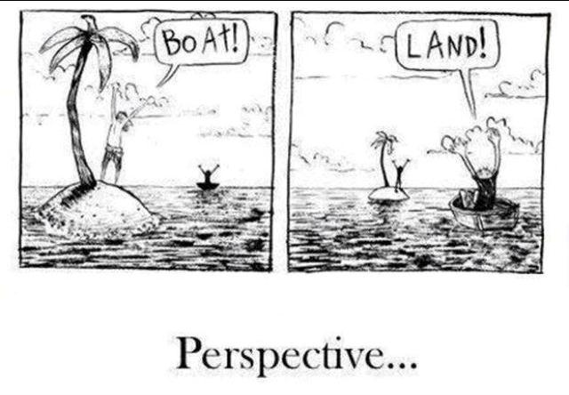
COMPLICATE:  offer a different point of view that makes a piece of the text seem more complex | 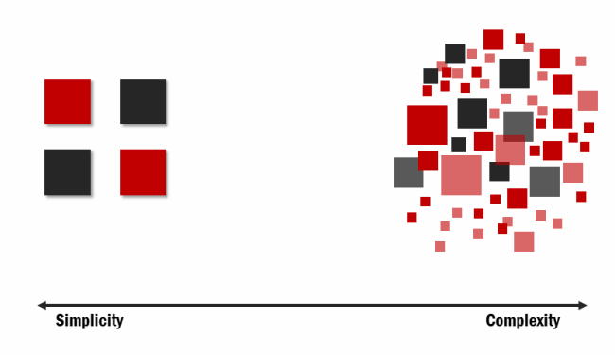
CONTEST:
build knowledge from primary sources that challenge the facts of the textbook
VIVIFY:  breathe life into the textbook version with rich details; make the history come alive | 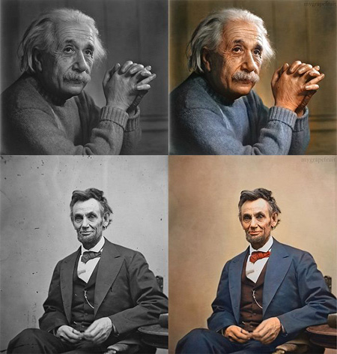

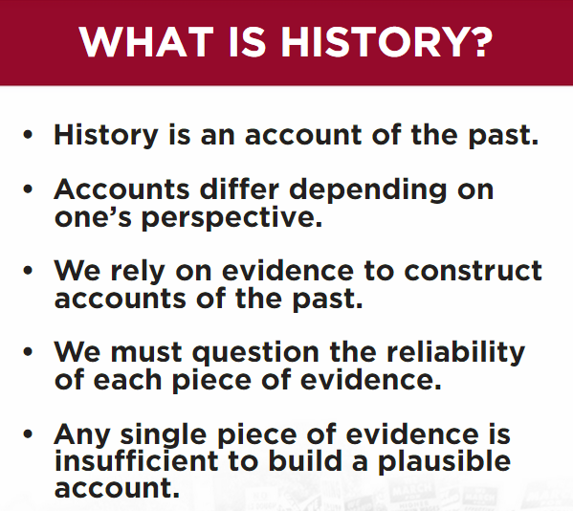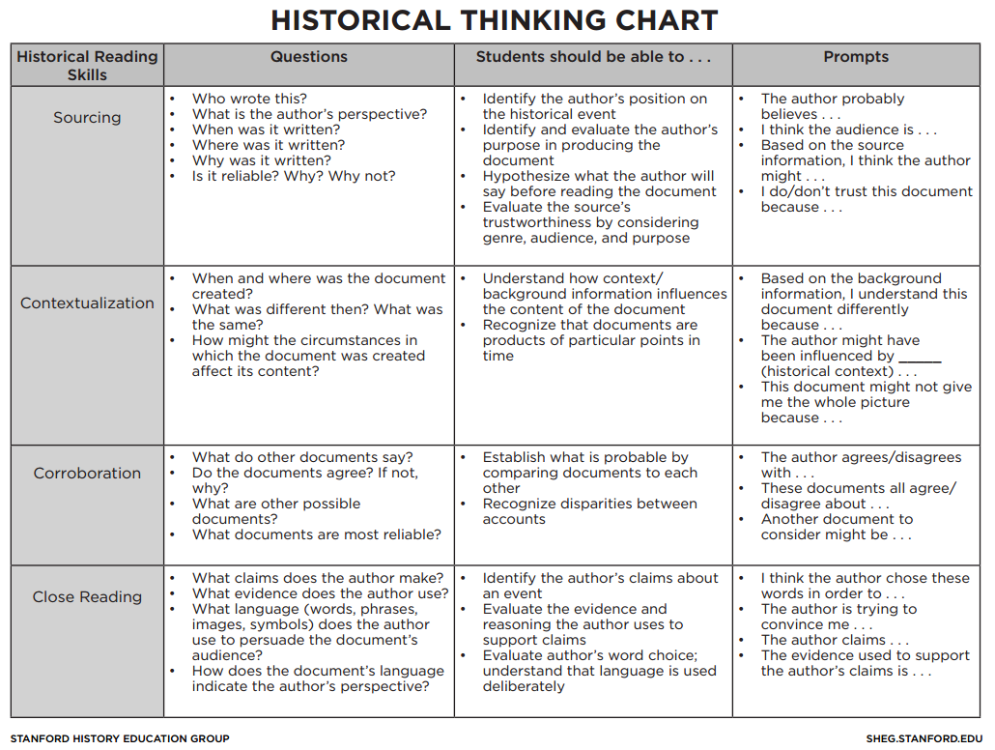

Students who are College and Career Ready in Reading, Writing, Speaking, Listening, & Language
(From the Common Core State Standards Introduction, pg. 7)
They demonstrate independence.
Students can, without significant scaffolding, comprehend and evaluate complex texts across a range of types and disciplines, and they can construct effective arguments and convey intricate or multifaceted information. Likewise, students are independently able to discern a speaker’s key points, request clarification, and ask relevant questions. They build on others’ ideas, articulate their own ideas, and confirm they have been understood. Without prompting, they demonstrate command of Standard English and acquire and use a wide-ranging vocabulary. More broadly, they become self-directed learners, effectively seeking out and using resources to assist them, including teachers, peers, and print and digital reference materials.
They build strong content knowledge.
Students establish a base of knowledge across a wide range of subject matter by engaging with works of quality and substance. They become proficient in new areas through research and study. They read purposefully and listen attentively to gain both general knowledge and discipline-specific expertise. They refine and share their knowledge through writing and speaking.
They respond to the varying demands of audience, task, purpose, and discipline.
Students adapt their communication in relation to audience, task, purpose, and discipline. They set and adjust purpose for reading, writing, speaking, listening, and language use as warranted by the task. They appreciate nuances, such as how the composition of an audience should affect tone when speaking and how the connotations of words affect meaning. They also know that different disciplines call for different types of evidence (e.g., documentary evidence in history, experimental evidence in science).
They comprehend as well as critique.
Students are engaged and open-minded—but discerning—readers and listeners. They work diligently to understand precisely what an author or speaker is saying, but they also question an author’s or speaker’s assumptions and premises and assess the veracity of claims and the soundness of reasoning.
They value evidence.
Students cite specific evidence when offering an oral or written interpretation of a text. They use relevant evidence when supporting their own points in writing and speaking, making their reasoning clear to the reader or listener, and they constructively evaluate others’ use of evidence.
They use technology and digital media strategically and capably.
Students employ technology thoughtfully to enhance their reading, writing, speaking, listening, and language use. They tailor their searches online to acquire useful information efficiently, and they integrate what they learn using technology with what they learn offline. They are familiar with the strengths and limitations of various technological tools and mediums and can select and use those best suited to their communication goals.
They come to understand other perspectives and cultures.
Students appreciate that the twenty-first-century classroom and workplace are settings in which people from often widely divergent cultures and who represent diverse experiences and perspectives must learn and work together. Students actively seek to understand other perspectives and cultures through reading and listening, and they are able to communicate effectively with people of varied backgrounds. They evaluate other points of view critically and constructively. Through reading great classic and contemporary works of literature representative of a variety of periods, cultures, and worldviews, students can vicariously inhabit worlds and have experiences much different than their own.

