**PERSIA Learning Buddies**

Make an appointment with 6 different people in class. Be sure to write the appointments on both of your clocks. Only make the appointment if there is an open slot at that spot on both of your papers.

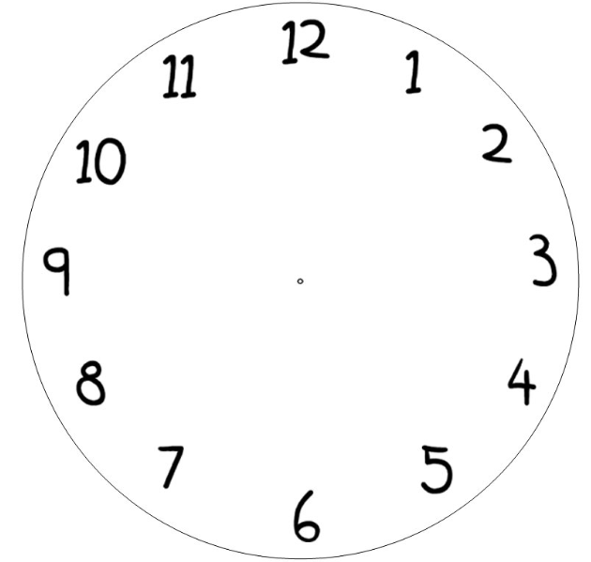

Area  


Political  


Economic  


Intellectual  
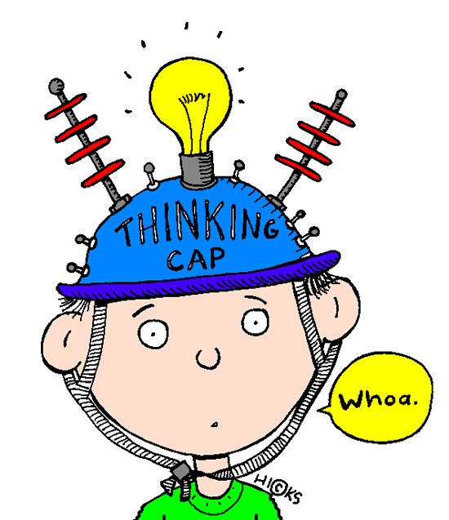

Religion  


Social  


Tape this paper inside a notebook, or something that you bring to class each day.