Open Up the Textbook (OUT)
The Boston Massacre
Enlarge Complicate Contest Vivify

Author: Marcia Motter
In this OUT analysis, 5th grade students will study an event, in Boston, that contributed to colonial resentment toward England in order to better understand the following essential questions:
- What are the causes of the American Revolution?
- What are key events that led up to the American Revolution?

This OUT analysis provides students with documents that are meant to deliberately complicate and vivify the textbook.
This strategy is implemented most effectively when students collaborate to analyze the texts in small, heterogeneous groups or when document analysis is modeled by the teacher with the whole class. The texts that accompany the textbook are complex and often include difficult vocabulary and syntax. (For a few words that are likely unknown to students and unidentifiable based upon context clues, helpful synonyms are provided in the footnotes.) Students should first annotate each text and then collaborate to answer the text dependent and specific questions that follow. Questions will highlight sourcing and perspective of the author, close reading of key details from the document that enlarge, complicate, contest, or vivify the textbook, as well as questions that help students corroborate (or not) the accuracy of individual documents. The writing task that follows is an independent activity wherein students will employ evidence from multiple sources to justify their analysis, synthesis, and evaluation.

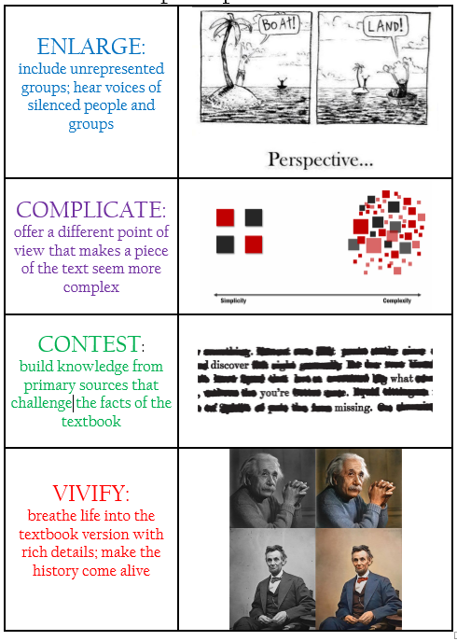
Teacher Tips:

- Model document analysis with students.

- Ensure that students stay on task in their small groups. Stop regularly to check for understanding and have groups report out on their findings.

      - At the end of each document analysis, have students answer the question: Does this document enlarge, complicate, contest, or vivify the textbook? How?
      - There are 7 documents included in this OUT. Not all of the documents need to be used. Use teacher discretion to decide which documents to use. Document A – The Textbook should always be included.

Source A: The Textbook –

The Boston Massacre
Tensions had been rising in Boston since the British soldiers first arrived in 1768. Fist fights between soldiers and colonists were a common sight in the streets. So on the night of March 5, 1770, the city was ready to explode. When angry colonists surrounded Hugh White and his fellow soldiers, the soldiers panicked. They fired into the crowd killing five people.
The event became known as the Boston Massacre. A massacre is the killing of many people who cannot defend themselves.
One of the victims was Crispus Attucks. Born into slavery, Attucks escaped slavery at age 27 and began working as a sailor. On the night of the shooting he had led a group of sailors to the scene of the protest.
The British soldiers were put on trial for murder in Boston. They were defended in court by John Adams, a cousin of Samuel Adams. Like Samuel, John Adams opposed British taxes and did not like having British soldiers in Boston. Still, he felt the soldiers deserved a fair trial. The court ruled that the soldiers were not guilty of murder.
Source A Questions for Consideration:
When did the Boston Massacre take place? _________________________________________
According to the text, what is a massacre? __________________________________________
_____________________________________________________________________________
Who was involved in the Boston Massacre? _________________________________________
How many people were killed in the Boston Massacre? ________________________________
How was Crispus Attucks involved in the Boston Massacre? ____________________________
_____________________________________________________________________________
According to this text, who is responsible for the Boston Massacre? _____________________
____________________________________________________________________________
Was the Boston Massacre really a massacre? Explain your thinking. ______________________
_____________________________________________________________________________
_____________________________________________________________________________
What is a question you still have after reading this text? _______________________________
_____________________________________________________________________________

Source B: Primary Source – The Boston Massacre of March 5, 1770: Primary Document Teaching Kit (http://www.bostonhistory.org/pdf/Boston%20MassacreDocuments.pdf)
Excerpt from the Boston Gazette article from March 12, 1770
... Thirty or forty persons, mostly lads, being by this means gathered in King Street, Capt. Preston with a party of men with charged bayonets, came from the main guard to the commissioner’s house, the soldiers pushing their bayonets, crying, make way! They took place by the custom house and, continuing to push to drive the people off pricked some in several places, on which they were clamorous and, it is said, threw snow balls. On this, the Captain commanded them to fire; and more snow balls coming, he again said, damn you, fire, be the consequence what it will! One soldier then fired, and a townsman with a cudgel struck him over the hands with such force that he dropped his firelock; and, rushing forward, aimed a blow at the Captain’s head which grazed his hat and fell pretty heavy upon his arm. However, the soldiers continued the fire successively till seven or eight or, as some say, eleven guns were discharged.
Source B Questions for Consideration:
What type of primary source is this? _______________________________________________
When was it written? ___________________________________________________________
Who is the intended audience? ___________________________________________________
The word party on line 5 has multiple meanings. What does this word often mean? How is it used differently in this context? How do you know? ___________________________________
_____________________________________________________________________________
Who threw the snowballs? Circle any words that help to support your answer. _____________
According to this text, why did the Captain order the soldiers to fire their guns? ____________
_____________________________________________________________________________
According to this text, how many shots were fired? ___________________________________
How does this text expand your understanding of the events that happened that day? _______
_____________________________________________________________________________
_____________________________________________________________________________

Source C: Primary Source – Paul Revere’s Engraving (from www.digitalhistory.uh.edu/active_learning /explorations/revolution/revolution_art.cfm)
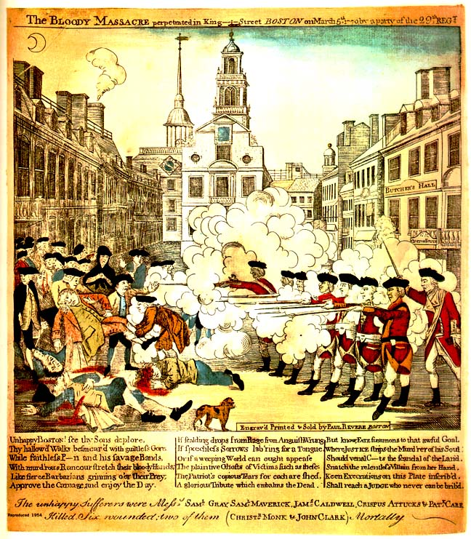
Background: An engraving was a method of producing images on paper in printmaking. This engraving was created 3 weeks after the event took place.
The text at the top of the engraving states: Paul Revere, The Bloody Massacre perpetrated in King Street Boston on March 5th 1770 by a party of the 29th Regt.
Source C Questions for Consideration:
Who created the engraving? _____________________________________________________
When was it created? __________________________________________________________
Describe the colonists. What are they doing? How are they shown? ______________________
_____________________________________________________________________________
_____________________________________________________________________________
Referring back to the previous texts, what are the colonists missing in this engraving? _______
_____________________________________________________________________________
Describe the soldiers. What are they doing? How are they shown? ______________________
_____________________________________________________________________________
_____________________________________________________________________________
Are the soldiers happy or scared? Provide evidence from the engraving to support your answer. ______________________________________________________________________
Is this a reliable source? Explain your thinking. _______________________________________
_____________________________________________________________________________
_____________________________________________________________________________
How does this source vivify the Boston Massacre? ____________________________________
_____________________________________________________________________________
_____________________________________________________________________________

Source D: Primary Source – Boston Massacre Historical Society (from http://www.bostonmassacre.net/ trial/acct-preston2.htm)
Captain Thomas Preston's Account of the Boston Massacre
On Monday night about 8 o'clock two soldiers were attacked and beat… About 9 some of the guard came to and informed me the town inhabitants were assembling to attack the troops… In my way there I saw the people in great commotion, and heard them use the most cruel and horrid threats against the troops… about 100 people passed… towards the custom house where the king's money is lodged. They immediately surrounded the sentry posted there, and with clubs and other weapons threatened to execute their vengeance on him… he assured me he heard the mob declare they would murder him. This I feared might be a prelude to their plundering the king’s chest. I immediately sent a non-commissioned officer and 12 men to protect both the sentry and the king's money, and very soon followed myself to prevent, if possible, all disorder, fearing lest the officer and soldiers, by the insults and provocations of the rioters, should be thrown off their guard and commit some rash act.
They soon rushed through the people, and by charging their bayonets in half-circles, kept them at a little distance… the unhappy affair took place without any loading in their pieces; nor did I ever give orders for loading them… The mob still increased and were more outrageous, striking their clubs or bludgeons one against another, and calling out, come on you rascals, you bloody backs, you lobster scoundrels, fire if you dare, G-d damn you, fire and be damned, we know you dare not, and much more such language was used. At this time I was between the soldiers and the mob, parleying with, and endeavouring all in my power to persuade them to retire peaceably, but to no purpose. They advanced to the points of the bayonets, struck some of them and even the muzzles of the pieces… some well behaved persons asked me if the guns were charged. I replied yes. They then asked me if I intended to order the men to fire. I answered no, by no means, observing to them that I was advanced before the muzzles of the men's pieces [he was standing in front of the guns] and must fall a sacrifice if they fired; that the soldiers were upon the half cock and charged bayonets, and my giving the word fire under those circumstances would prove me to be no officer. While I was thus speaking, one of the soldiers having received a severe blow with a stick, stepped a little on one side and instantly fired, on which turning to and asking him why he fired without orders, I was struck with a club on my arm, which for some time deprived me of the use of it, which blow had it been placed on my head, most probably would have destroyed me.
On this a general attack was made on the men by a great number of heavy clubs and snowballs being thrown… by which all our lives were in imminent danger… Instantly three or four of the soldiers fired, one after another, and directly after three more in the same confusion and hurry. The mob then ran away, except three unhappy men who instantly expired… On my asking the soldiers why they fired without orders, they said they heard the word fire and supposed it came from me. This might be the case as many of the mob called out fire, fire, but I assured the men that I gave no such order.
Vocabulary: sentry: a soldier posted as a guard; vengeance: to punish or hurt someone for
revenge; endeavouring: trying

Source D Questions for Consideration:
Who gave this account? ________________________________________________________
The word lodged on line 8 has multiple meanings. What does this word often mean? How is it used differently in this context? How do you know? ___________________________________
_____________________________________________________________________________
Why were more soldiers ordered to help the sentry? __________________________________
_____________________________________________________________________________
Describe the mob. How were they behaving? What was the mood of the mob? ____________
_____________________________________________________________________________
_____________________________________________________________________________
According to Captain Prescott, die he intend for the soldiers to fire? Underline evidence in the text to support your answer. _____________________________________________________
Is this a reliable source? Explain your thinking. _______________________________________
_____________________________________________________________________________
How does this account contest or challenge the information in Sources B and C?
Provide 3 specific examples in your answer.
Source B or C | Source D: Captain Prescott
Source ____ said, | However, Captain Prescott said,
Source _____ said, | However, Captain Prescott said,
Source _____ said, | However, Captain Prescott said,

Source E: Primary Source – The Colonial Williamsburg Foundation (http://www.history.org/History/teaching/enewsletter/volume8/sept09/images/sept09/multiple_perspectives_psactivity.pdf)

Testimony from Bostonian William Tant

… I saw a party of soldiers come from the main guard, and draw themselves up in a line from the corner of the Customs-house to the sentry-box; the people still continued in the street, crying “fire, fire, and be damned,” and hove some more snow balls; whereupon I heard a musket go off, and in the space of two or three seconds, I heard the word “Fire” given, but by whom I do not know, and instantly the soldiers fired one after another. I then stood between the sentry-box and the Custom-house and the Custom-house door. And further I know not.
Source E Questions for Consideration:

Who was the author of this primary source? _________________________________________

How is he different from the other sources? _________________________________________

Is he a reliable source? Explain your thinking. ________________________________________
_____________________________________________________________________________

Does this testimony complicate the texts you have read previously? _____________________
__________________________________________________________________________________________________________________________________________________________

Source F: Secondary Source – Africans in America
(http://www.pbs.org/wgbh/aia/part2/2p24.html)
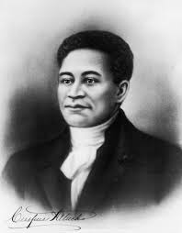

Crispus Attucks
In 1770, Crispus Attucks, a black man, became the
first casualty of the American Revolution when he
was shot and killed in what became known as the
Boston Massacre. Although Attucks was credited
as the leader and instigator of the event, debate
raged for over as century as to whether he was a
hero and a patriot, or a rabble-rousing villain.
In the murder trial of the soldiers who fired the fatal
shots, John Adams, serving as a lawyer for the crown, reviled the "mad behavior" of Attucks, "whose very looks was enough to terrify any person."
Twenty years earlier, an advertisement placed by William Brown in the Boston Gazette and Weekly Journal provided a more detailed description of Attucks, a runaway: "A Mulatto fellow, about 27 Years of Age, named Crispus, 6 feet 2 inches high, short cur'l hair, his knees nearer together than common."…
Brown offered a reward for the man's return, and ended with the following admonition: "And all Matters of Vessels and others, are hereby cautioned against concealing or carrying off said Servant on Penalty of Law. " Despite Brown's warning, Attucks was carried off on a vessel many times over the next twenty years; he became a sailor, working on a whaling crew that sailed out of Boston harbor. At other times he worked as a ropemaker in Boston.
Attucks' occupation made him particularly vulnerable to the presence of the British. As a seaman, he felt the ever-present danger of impressment into the British navy. As a laborer, he felt the competition from British troops, who often took part-time jobs during their off-duty hours and worked for lower wages. A fight between Boston ropemakers and three British soldiers on Friday, March 2, 1770 set the stage for a later confrontation. That following Monday night, tensions escalated when a soldier entered a pub to look for work, and instead found a group of angry seamen that included Attucks.
That evening a group of about thirty, described by John Adams as "a motley rabble of saucy boys, negroes and molattoes, Irish teagues and outlandish jack tarrs," began taunting the guard at the custom house with snowballs, sticks and insults. Seven other redcoats came to the lone soldier's rescue, and Attucks was one of five men killed when they opened fire…
Source F Questions for Consideration:
Is this text a primary or secondary source? __________________________________________
At the time of the Boston Massacre, was Crispus Attucks an enslaved person? Underline any evidence that supports your answer. __________________________________________________________________________________________________________________________________________________________
What types of jobs did Mr. Attucks have during his lifetime? ____________________________
_____________________________________________________________________________
List two reasons Crispus Attucks did not like the British. _______________________________
_____________________________________________________________________________
_____________________________________________________________________________
After reading this text, do you think that Crispus Attucks was a hero and a patriot or a rabble-rousing villain? Explain your thinking. ______________________________________________
_____________________________________________________________________________
_____________________________________________________________________________
_____________________________________________________________________________
How does this passage complicate what the textbook said about Crispus Attucks? __________
__________________________________________________________________________________________________________________________________________________________

Source G: Secondary Source – Boston Massacre Historical Society (from www.bostonmassacre.net/ alternative.htm)

Alternative View on the Event
The Boston Massacre was not really a massacre, but more like a riot. In fact only five people died.
One of the most common myths is that the Boston Massacre was the event that led to the Revolutionary War. In fact, many important events led up to the massacre. It was called a massacre by the use of propaganda. It was mainly started by the British who were trying to enforce laws.
British Soldiers were sent to America to enforce the Proclamation and to maintain order but their presence just made matter worse…
The purpose of the Boston Massacre was to try to make liberal and moderate people become radicals. It was really an accident and the radicals tried to use propaganda and turn something small into something big. The British soldiers were accused of murder and manslaughter. To represent them was John Adams, a relative of Samuel Adams. Adams wanted the trial to get over and didn’t want the truth to come out. The Boston Massacre and misleading visual representation by Paul Revere could have been one cause of a later war.
The Boston Massacre increased the hatred between the Americans and the British. The radical people tried to use this minor event as propaganda. Paul Revere and Samuel Adams were happy that a few colonists died because they used it as propaganda so the colonist would get mad at the British.
Vocabulary: propaganda: information or material whose purpose is to influence people to think in a
certain way; liberal: a person who is open to new ideas and ways of thinking;
moderate: a person who is opposed to extreme or radical views; radical: a person
who favors extreme views and change.
Source G Questions for Consideration:
According to this text, was the Boston Massacre really a massacre? Explain your thinking. __________________________________________________________________________________________________________________________________________________________
What misleading visual representation did Paul Revere create? _________________________
In lines 10-15, which two people do you think could be referred to as radicals? _____________
_____________________________________________________________________________
The soldiers were put on trial for what after the Boston Massacre? ______________________
_____________________________________________________________________________
What was a result of the Boston Massacre? _________________________________________
_____________________________________________________________________________
How was the Boston Massacre used as propaganda by the colonists? _____________________
__________________________________________________________________________________________________________________________________________________________
_____________________________________________________________________________
How does this source complicate what you read in the textbook entry? ___________________
_____________________________________________________________________________
_____________________________________________________________________________
_____________________________________________________________________________

Writing Task This is an informational writing task based on NVACS standards R 5.1; R5.4; R5.7; L5.4; W5.2; W5.9. Students will demonstrate their understanding of the texts as well as the ways in which the textbook was complicated and vivified.

The Boston Massacre was an event which increased hostilities between the colonists and the British. This event, along with others, led up to the American Revolution. Through the use of propaganda, the Boston Massacre was turned from a minor event into a major event. In a paragraph, explain how the use of propaganda turned the Boston Massacre into an event that led to the start of the American Revolution. Include at least 1 important person who was involved in the event in your paragraph.
- Answer the above question in approximately one paragraph, using evidence from three of the texts provided.
- Write a clear thesis and provide 3 pieces of evidence to support your idea. After each piece of evidence cited in a direct quote or paraphrase (your own words), please add the source letter in parentheses, for example (Source B).
- For each piece of evidence, clearly reason (explain) why this piece of evidence helps support your claim Underline your reasoning. Reasoning can be in the same sentence as the evidence or come before or after the sentence that includes the evidence.
- Choose 3 of the important vocabulary terms from the box below to include in your writing.

massacre, propaganda, colonists, British, vengeance, radical

