How Did the rules of Victorian Society Shape the Social Culture of Antebellum America?
Discussion and Writing Option #2
Primary Source Documents that go with Lesson

NOTE: Please refer to the Seneca Falls Declaration excerpted document and the Men/Women/Child document packets for this alternate lesson.

NOTE 2: Please use the Informative writing checklist from the Middle School SLO to grade the argument paragraphs.

Directions: Read through the original lesson. When you get to the directions for Jigsaw, skip them and have students complete the mini-lessons on
- Summarization with expanding sentence kernels and
- But, So and Because sentences.

Next organize students in groups of three (one from each research group- men, women, children) for the discussion. They will complete the two-sided discussion note taker. This is modified from the Pro Se Court model. (I made sure the students added “Big Idea #1” and “Big Idea #2”, etc. to help them organize their thoughts for the section Most important information for answering the DBQ.

Finally, students will work alone to write an informational paragraph on their expert section: men, women or children.

Extensions: Students may write a multi-paragraph essay and include all groups (men, women and children). This would require students to have all three document packets in case the students in their triads didn’t do a good job of teaching the information. They could also turn their individual paragraphs into a multi paragraph essay and together write an introduction and conclusion.

Antebellum/Victorian Era
SUMMARIZATION WITH EXPANDING SENTENCE KERNELS

- Work with a partner to find relevant information to answer the questions that follow the kernel.
- Collaboratively construct a complex or a compound/complex sentence that includes all of the necessary information using textual evidence.
- Check to make sure that your sentence is clear, concise, and specific.

KERNEL:
The Victorian Era was a difficult time period to live in.
OR
The Victorian Era was a wonderful time period to live in.

Who? (pick the one you have been studying – men, women, or children)

What?

Where?

Why?

When?

How?

Complex Sentence: _______________________________________________________________________________________________________________________________________________________________________________________________________________________________________________________________________________________________________________________________________________________________________________________________________________________________________________________________________
Antebellum/Victorian Era
SUMMARIZATION WITH BUT, BECAUSE, SO SENTENCES

- Choose one kernel sentence below to expand
- Work with a partner to develop three sentences that expand upon the Kernel Sentence below.
You can add details before the ‘but’ , ‘because’, or ‘so’.
- Make sure your sentences include different details from the text (Documents A, B, and C) In other words, your “because” sentence should not have the same details as your “so” or “and” sentence.

KERNEL:
Victorians valued manners.
OR
Victorian behavior expectations were too strict.

BUT: ______________________________________________________________________________________ _______________________________________________________________________________________________________________________________________________________________________________________________________________________________________________________________________________________________________________________________________________________________________________________________________________________________________________________________________

BECAUSE:__________________________________________________________________________________________________________________________________________________________________________________________________________________________________________________________________________________________________________________________________________________________________________________________________________________________________________________________________________________________________________________________________________________________

SO: _______________________________________________________________________________________ _______________________________________________________________________________________________________________________________________________________________________________________________________________________________________________________________________________________________________________________________________________________________________________________________________________________________________________________________________

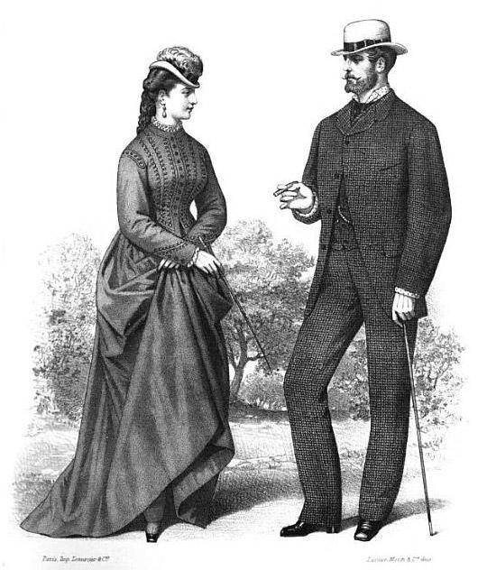

How Did the Rules of Victorian Society Shape the Social Culture of Antebellum America?
The name of the discussion leader:
I am the (circle one) Man/ Woman/ Child in this discussion.
The Man’s, __________________________ (name of Man), most important information pieces are:
A.__________________________________________________________________________________________
B.__________________________________________________________________________________________
C.__________________________________________________________________________________________
The Woman’s, ________________________ (name of Woman), most important information pieces are:
A._______________________________________________________________________________________
B._______________________________________________________________________________________
C._______________________________________________________________________________________
The Child’s, (name of Child), most important information pieces are:
A._______________________________________________________________________________________
B._______________________________________________________________________________________
C. _______________
Best evidence to answer the question: How did the rules of Victorian Society Shape the Social Culture of Antebellum America? _______________________________________________________ __________________________________________________________________________________________________________________________________________ ____________

How Did the Rules of Victorian Society Shape the Social Culture of Antebellum America?

Collaborative Group Notes
List facts you learned from your packet of documents, other documents or videos:

Most Important evidence with reasoning for answering the question: How did the rules of Victorian Society Shape the Social Culture of Antebellum America?

What important vocabulary can I use?

