Why are we all working so much?

By Dylan Matthews , August 23, 2012
Fun fact: we’re more than twice as productive as we were in 1964. That means that we could work less than half as much as we did then and still have 1964-style living standards. We could then use the rest of the time to hang out with friends and family, relax, read or watch TV and movies, bang on our drum all day, and so forth.
Sounds nice, doesn’t it? Indeed, John Maynard Keynes thought it sounded so nice that in 1931 he predicted that his grandchildren would only work 15 hours a week, exploiting their greater productivity not to make more money but to have more leisure time. Instead of working, he floridly wrote, people could “cultivate into a fuller perfection the art of life itself.” Obviously, that hasn’t happened (and not just because Keynes didn’t have any kids or grandkids). As Robert and Edward Skidelsky document in their new book How Much Is Enough?, working hours in developed countries have declined over the past few decades, but not by nearly as much as Keynes thought:

This has happened despite global growth actually exceeding Keynes’ forecast:

So how did Keynes get it so wrong? The Skidelskys argue that we don’t have the right policies to encourage people to kick back and work less. If we gave everyone a guaranteed income, or changed the tax code to penalize consumption, they argue, things would change. But U.S. Appeals Court Judge Richard Posner, who reviewed the Skidelskys’ book in the New York Times the other day, doesn’t think that’s what’s up. The big issue, Posner argues, is that people don’t just want leisure, they want expensive leisure. Going on cruise ships and to movie theater and to bars with your friends is pricey, and people want to make more money to pay for it. People today, he reasons, “have less leisure time than if their preferred form of leisure were lying in a hammock, but on balance they obtain more pleasure.”
But how pricey is our preferred leisure, actually? The best data on this comes from the American Time Use survey, conducted annually by the Bureau of Labor Statistics. The most recent survey found that Americans spent an average of 5.72 hours a day on general leisure, religious and other organizational activities, and communicating on the phone or e-mail in 2011. But averages can be misleading.
The survey’s micro-data lets you break things down by employment status. Surprisingly, on a typical weekday employed and unemployed people and those outside the workforce (such as retired people, students and homemakers) each enjoyed about seven hours of leisure, travel and other relaxation activities, in spite of the fact that full-time workers average seven-and-a-half hours of work a day to unemployed peoples’, well, zero. Part of the reason is that unemployed people and those outside the workforce spend much more time on household chores (3 hours and 50 minutes to employed peoples’ 2 hours) and average an extra eighty minutes more sleep every night
I further broke down leisure into free leisure (relaxing, going to church/mosque/temple, volunteering, socializing, etc.) and leisure that costs money (going to movies or museums, watching TV, watching/playing sports, travel). Here’s how that looks for each employment category on weekends, when most leisure happens:
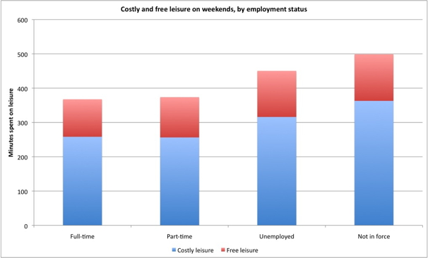
So Posner is right — most leisure these days costs money. But not as much of it as you might expect, and a lot of costly leisure involves going to movies and watching TV, which aren’t super-expensive. This data has its limitations; I didn’t include time spent eating, since one can’t easily separate out eating to socialize and eating to not die, and meals often have business purposes, but that is a major leisure category for most people. But it does suggest that the good life, while hardly free, is often cheap.

