 | A  Authority & Power | M  Media &  Public Opinion
 | - GOVERNMENT OFFICIALS  - LAWS  - PEOPLE’S VOICE  - STATES V. FEDERAL  - SEPARATION OF POWERS  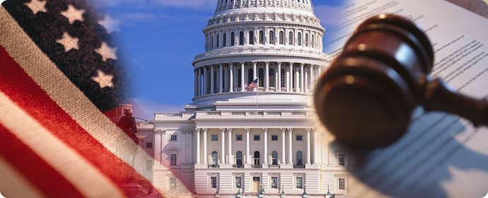 | - POLLING  - LEAKS  - 4TH BRANCH/ESTATE  - SOCIAL V. TRADITIONAL  - FACT V. OPINION

E  Economics | R  Rights & Responsibilities | I  International
- IMPORTS/EXPORTS  - TRADE TREATIES  - LIBERAL/CONSERVATIVE  - CAPITALISM  - RESOURCES | - VOTING  - CIVIC DUTIES  - FEDERALISM  - SOCIAL CONTRACT  - EQUAL RIGHTS  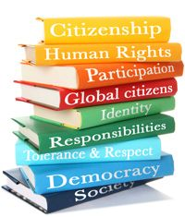 | - TREATIES  - WAR & CONFLICT  - UNITED NATIONS & NATO  - SUPER POWERS  - DIPLOMACY  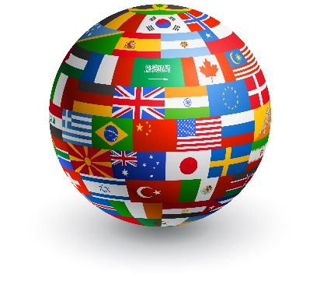

C  Constitution &  Laws | A  Area &  Region
- BILL OF RIGHTS  - COURT SYSTEM  - JUDICIAL REVIEW  - PRECEDENTS  - BALANCE OF POWER | - DEMOGRAPHICS  - AFFILITATIONS  - RELIGION  - ECONOMICS  - RESOURCES  