OUT: Open Up the Textbook
ENLARGE:  include unrepresented groups; hear voices of silenced people and groups | 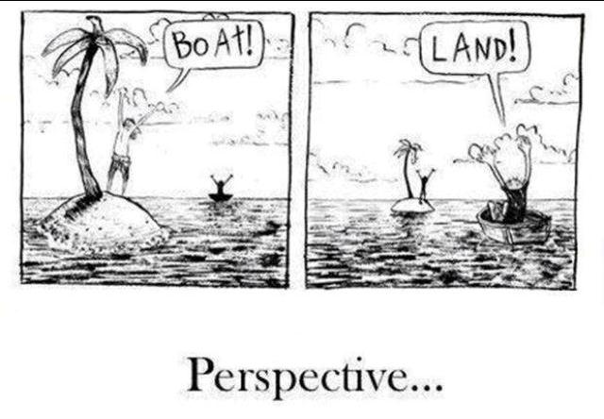
COMPLICATE:  offer a different point of view that makes a piece of the text seem more complex | 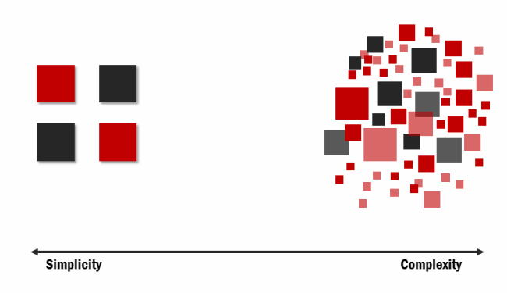
CONTEST:
build knowledge from primary sources that challenges the facts of the textbook

VIVIFY:  breathe life into the textbook version with rich details; make the history come alive | 