First Grade DBQ – Core Knowledge – Different Lands, Similar Stories
A DBQ (Document Based Question) is an authentic assessment where students interact with historical texts. Document Based Questions were first used in high school AP classes. But after several years of using DBQs in grades 4-12 in WCSD for all students, it was determined that the same skills could be practiced with students in K-3. A DBQ asks students to read and analyze historical records, gather information and fill in short scaffolding response questions, assimilate and synthesize information from several documents, and then respond in writing to an assigned task, by using information gleaned from the documents, as well as, their own knowledge. For grades K-3, these tasks have been refined to include pictures and text from the Core Knowledge units of study. In this way, students who have been immersed in a unit of literacy study are able to demonstrate their knowledge of the unit while also practicing the skills used in social studies in later grades with a DBQ.
This DBQ is aligned with the Core Knowledge Listening and Learning domain, Early World Civilizations. It is meant to follow the unit so that students have already been exposed to the knowledge and vocabulary gained from the read alouds. You may need to take some time to build an understanding of the important components of a civilization.
With prompting, scaffolding, and support, the students will review the series of pictures and text to determine the important components of early world civilizations. After reviewing the documents, students will write to the prompt independently.
Helpful Vocabulary:
setting characters action clever
conflict adventure folktale dwelling
problem fiction foreign extravagance

Writing Task:
Using evidence found in the documents, your knowledge of the read alouds and at least one vocabulary word from above in each sentence, explain one way that Tom Thumb and Thumbelina’s adventures were similar/the same. Explain one way that Tom Thumb and Thumbelina’s adventures were different.

Teacher Notes:
- Review Documents A.1 & A.2 as a whole group and discuss each character and their adventures. What is unique to their individual adventures? What is similar about each story? Using a discussion technique such as think-pair-share may be helpful as well as a T-Chart graphic organizer. Allow students to retell the stories with their partners, each taking turns sharing a detail. For example, one partner may can retell the adventure and the other can add a detail. Partners can switch roles to allow each the opportunity to retell and share a detail. Encourage the use of transition words such as, “next, then, after,” etc.
With teacher support as needed, engage in a whole group discussion about the effects of Tom Thumb and Thumbelina being so small and how that impacted their adventures. Use sentence starters such as, “Even though he was very small, Tom Thumb…”
- Engage in whole class discussion about what a conflict is. Ask students to share their own personal experiences, such as when they have had to face a conflict of their own. Next, allow students to work in small groups as they review Documents B.1 and B.2 and discuss and uncover the conflict for both Tom Thumb and Thumbelina. How might they solve the conflict if they were them? How are they similar? How are they different?
- Review what the setting of a story is. Have students work in groups to complete the chart in the document. Ask students to think about and discuss how the different setting of each story contributes to the different adventures of the character. Please note: Provide additional scaffolding for students who need assistance identifying key elements of the picture.
- Engage in whole group discussion to determine the final outcome of each character’s story. It may be helpful to discuss ways in which the stories have similar and different endings. Create a whole group T-Chart or process grid to document ideas and information from students.
- These activities lead to the culminating writing task. Writing activities may vary greatly depending on student developmental writing level as well as what point in the school year you have chosen to complete this domain. While some students may be able to complete this task on an independent level, other students may benefit from small group support with the teacher. Please scaffold/extend as needed. In addition, depending on student writing level, you may wish to modify the culminating writing task by asking for a picture with labels to show student response to the prompt in addition to two complete sentences.

Name _____________________

First Grade DBQ – Core Knowledge – Different Lands, Similar Stories

Helpful Vocabulary:
setting characters action clever
conflict adventure folktale dwelling
problem fiction foreign extravagance

Writing Task:
Using evidence found in the documents, your knowledge of the read alouds and at least one vocabulary word from above in each sentence, explain one way that Tom Thumb and Thumbelina’s adventures were similar/the same. Explain one way that Tom Thumb and Thumbelina’s adventures were different.

Document A.1
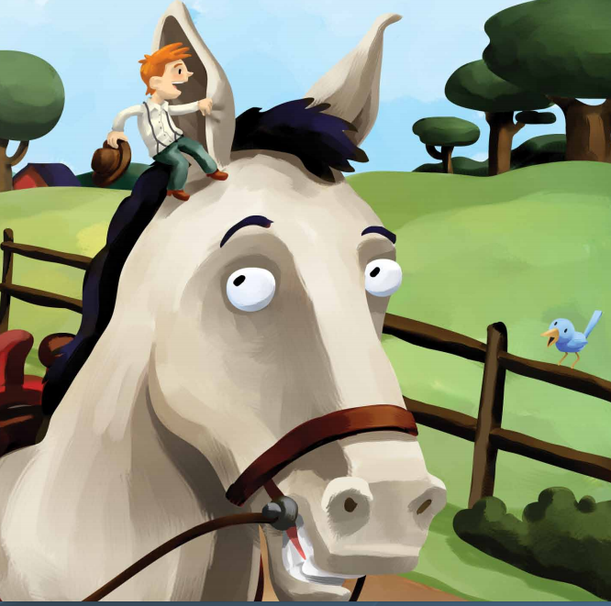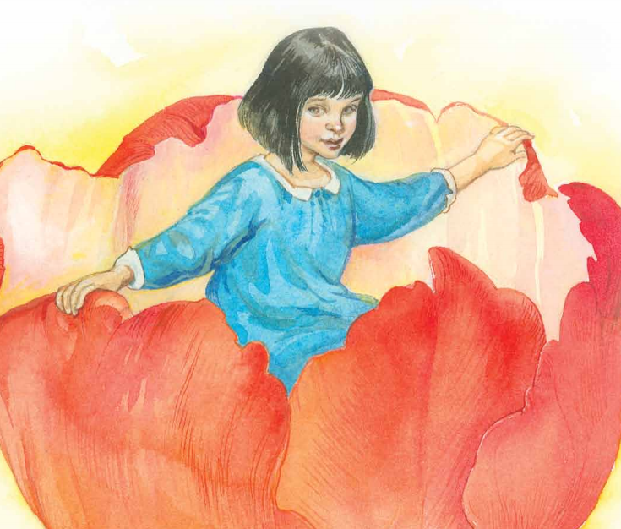
Document A.2
A folktale is a fictional story that has been read over and over again and can include many adventures for the main character. Both Tom Thumb and Thumbelina are characters that are no bigger than a thumb, but were still able to accomplish many great things.

- Using the picture above and what you’ve heard in the story, describe what adventure Thumbelina is taking part in.

- Using the picture above and what you’ve heard in the story, describe what adventure Tom Thumb is taking part in.

- Although Thumbelina was small, she was still a great help to others. How was Tom Thumb able to help others?
Document B.1
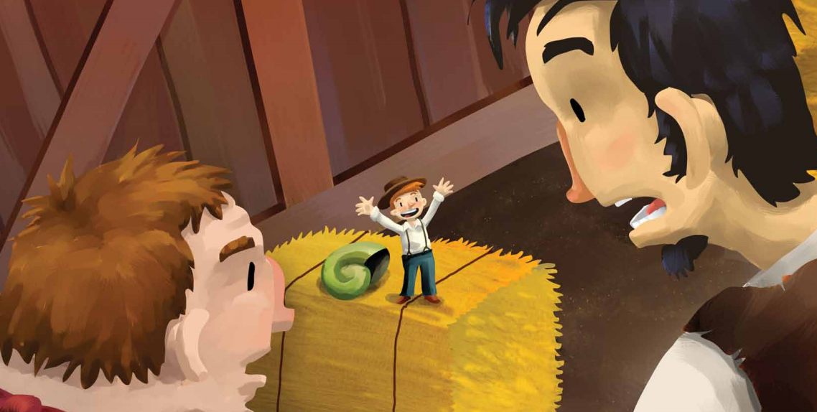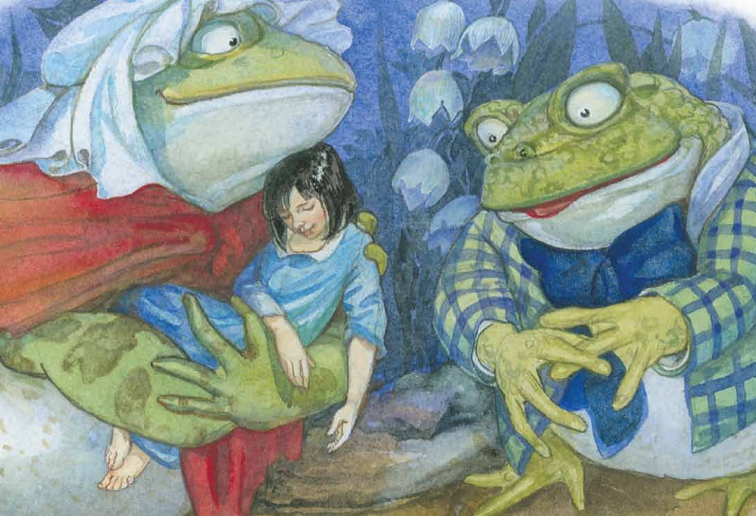
Document B.2
Both Tom Thumb and Thumbelina have problems that they must solve during their adventures. Both characters are put in dangerous situations that they must think through in order to solve. A conflict is the problem the characters face. Tom Thumb and Thumbelina may have similar conflicts, or problems, that they must deal with.
- Using the pictures above and what you know from the read alouds to describe the conflict for each character and the actions they took to solve.

Character | Conflict | Action
Thumbelina
Thumbelina
Tom Thumb
Tom Thumb

- Based on Documents B.1 and B.2, what is a conflict?
Document C.1

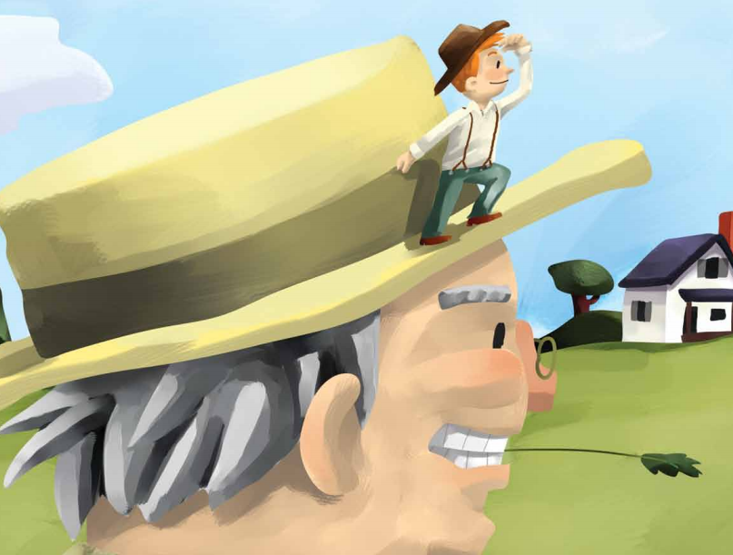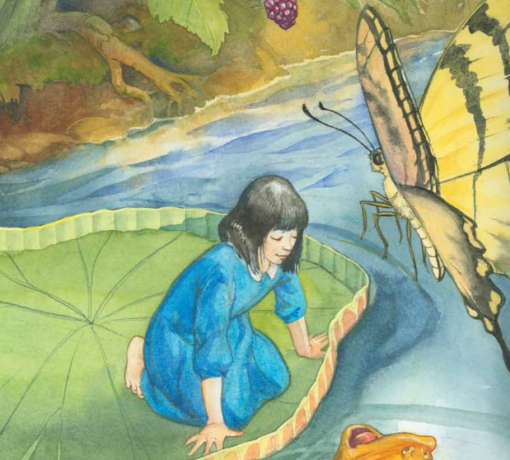
Document C.2
In the stories Tom Thumb and Thumbelina, the characters adventures take place in different settings. The setting of a story is where a story takes place.
- Describe the setting for each picture.
Image | Setting Description
- Think about what you have heard in the read aloud Tom Thumb. What are some other settings that Tom’s adventures take place in?

- Think about what you have heard in the read aloud Thumbelina. What are some other settings that Tom’s adventures take place in?

- How does the setting make each story different?
Document D.1
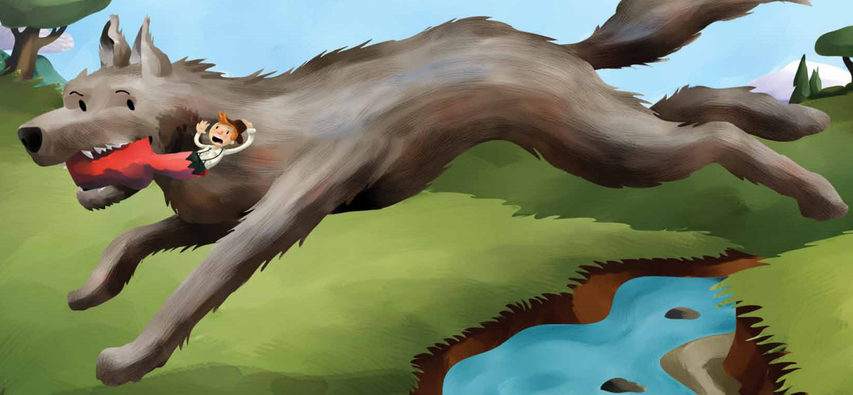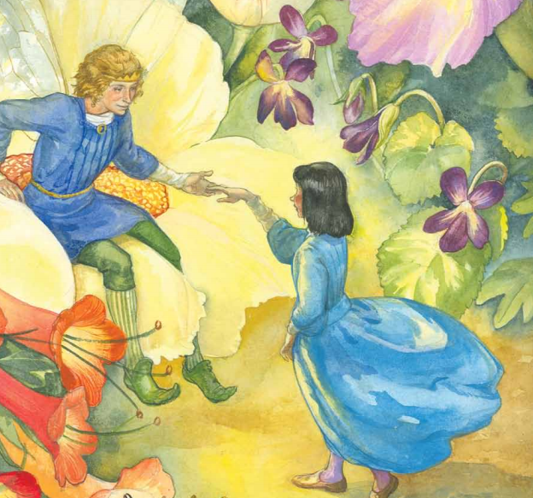
Document D.2
In Image 4A-8, Tom leads the wolf back to his family home where the wolf ate until he was full. In Image 5A-13, Thumbelina meets the king of the fairy people.

- What happens to Tom Thumb at the end of the story?

- What happens to Thumbelina at the end of the story?

- What similarities can you see in the ending of each story?

- What differences can you see in the ending of each story?

Name: _________________________________________________

Writing Task: Using complete sentences, explain one way that Tom Thumb and Thumbelina’s adventures are similar/the same. Explain one way that Tom Thumb and Thumbelina’s adventures were different.
- Use at least one piece of evidence from each document in this packet. For example, one from A, one from B, one from C, one from D. After each piece of evidence, write the document letter in parenthesis. For example, “Tom Thumb is the main character in the folktale Tom Thumb (Doc. B.2).”
- Correctly use at least one of the vocabulary terms from this DBQ in each of your complete sentences.
____________________________________________________________________________________________________________________________________________________________________________________________________________________________________________________________________________________________________________________________________________________________________________________________________________________________________________________________________________________________________________________________________________________________________________________________________________________________________
________________________________________________________________________________________________________________________________________________________________________________________________________________________________________________________________________________________________________________________________________________________________________________________________________________________________________________________________________________________________________________________

