Second Grade DBQ – Core Knowledge – Ancient Greek Civilizations

A Document Based Question (DBQ) is an authentic assessment whereby students interact with historical texts. A DBQ asks students to read and analyze historical records, gather information and fill in short scaffolding response questions, assimilate and synthesize information from several documents, and then respond (usually as a written essay) to an assigned task, by using information gleaned from the documents as well as their own outside information.
This DBQ is aligned with the Core Knowledge Listening and Learning domain, Ancient Greek Civilizations. It is meant to follow the unit so that students have already been exposed to the knowledge and vocabulary gained from the read alouds.
With prompting, scaffolding, and support, the students will review the series of pictures and text to determine what challenges the Ancient Greeks faced, and how they worked together to overcome these challenges. After reviewing the documents with partners and whole group, students will write to the prompt independently.
Helpful Vocabulary:
rugged | contributions | invader | massive
boundaries | independently | retreat | determination
unique | city-states | mission | democracy

Writing Task:
Using evidence found in the following documents, your knowledge of our readings, and at least four of the vocabulary words from above, explain the challenges the ancient Greeks faced, and then describe how they worked together to overcome these challenges.
Teacher Notes:
- Students should be given the opportunity to discuss the documents with partners and/or small groups. Students should not be expected to work through the documents independently. The teacher should monitor their understanding of the documents through whole group discussion before moving on to the independent writing task.
- As a teacher, you know your students and where they are on the developmental spectrum in writing. After the students have a solid understanding of the documents, the students are expected to tackle the writing piece independently. However, please scaffold and support this writing as needed by your students. For example, you could provide additional support through shared writing beforehand as an example, or provide additional graphic organizers as needed.
- Allow for several class sessions to complete this DBQ.

Name _____________________

Second Grade DBQ – Core Knowledge – Ancient Greek Civilizations

Helpful Vocabulary:

rugged | contributions | invader | massive
boundaries | independently | retreat | determination
unique | city-states | mission | democracy
Writing Task:
Using evidence found in the following documents, your knowledge of our readings, and at least four of the vocabulary words from above, explain the challenges the ancient Greeks faced, and then describe how they worked together to overcome these challenges.

Document A
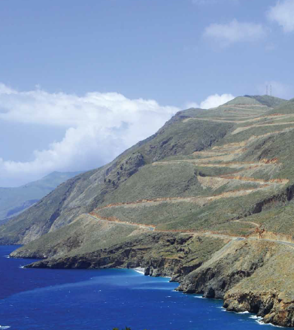
Greece is a land of high, rugged mountains, and in many parts, farming for the Greeks was a struggle. The mountains made it difficult for people to move place to place. They created independent city-states around Greece, and each city-state ruled itself by its own government.
- Make a list of what you see in the picture.

- What does the caption tell you?

- What challenges does this document show that the Greeks faced?

- How does this document show how the Greeks worked together to overcome a challenge?

Document B
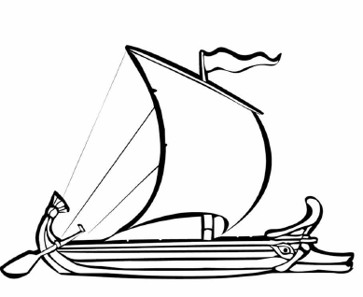
Because they were surrounded by water, some Greeks built harbors near the seas, and many became expert fishermen or sailors, who traded goods with people from other lands or communicated with other city states, using boats like this one.

- Describe the boat you see in the image.

- What does the caption tell you?

- What connections can you make between this document and document A?

- What challenge does this document show that the Greeks faced?

- How does this document show how the Greeks worked together to overcome a challenge?

Document C
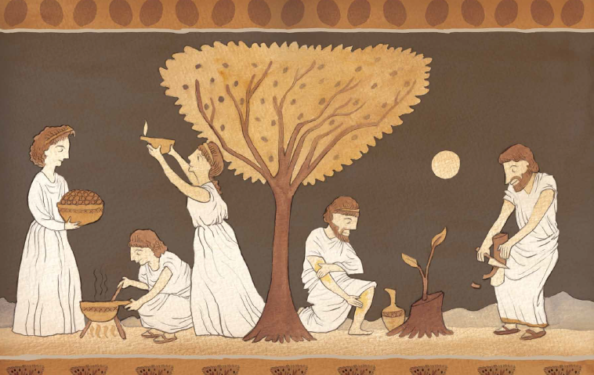
Athena smiled and said, “From these olive trees will come the wealth of your city, for they will grow in the rocky hills that are hard to farm. You will eat the fruit you pick and never go hungry. The oil you squeeze from the fruit will be delicious and improve the flavor of anything you cook with it. Fill a lamp with the oil and you will have light in the darkest of night. You can ship it to other lands far and near, and they will want to have the blessings of the oil themselves.”

- Make a list of everything you see in the picture.
People | Objects | Actions

- What benefits or gifts did the Greeks get from the olive trees?

- What connections can you make about this document and document A?

- What challenge does this document show that the Greeks faced?

- How does this document show how the Greeks worked together to overcome a challenge?

\
Document D
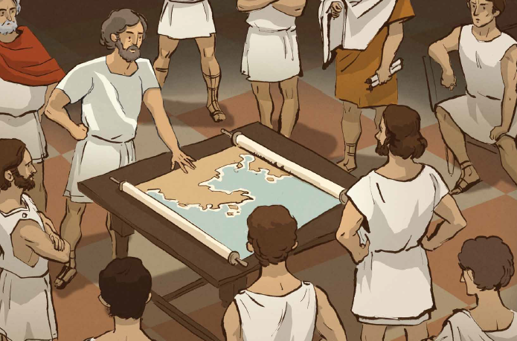
Each city-state was a democracy and had its own government and laws, but in times of emergency, they would work together for all of Greece. When the Persians came to invade Greece, the generals came together to create a plan of defense. They sent for the Spartan army to help them with the invaders.
- Make a list of everything you see in this picture.
People | Objects | Actions

- What does the caption tell you?

- Based on what you know about Greece, why are the men looking at the map?

- What challenge does this document show that the Greeks faced?

- How does this document show how the Greeks worked together to overcome a challenge?

Document E
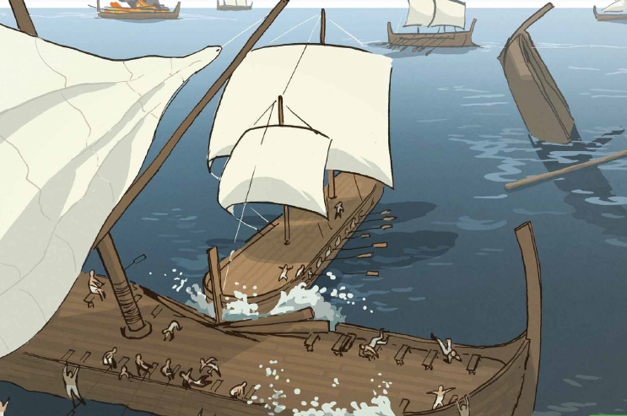
When the Persians arrived to Athens, they were surprised to see the city deserted. Themistocles had sent all of the Athenian citizens away to hide in the hills. When the much larger Persian army sent their ships to attack, Themistocles had all of the Greek ships hide and wait. Then the smaller, faster Greek ships were able to surprise the Persians and smash their ships with metal battering rams.
- Make a list of everything you see in this picture.
People | Objects | Actions

- What does the caption tell you?

- Who are the two sides that are fighting each other on these ships?

- Read the caption carefully. What were the two ways the Greeks were able to surprise the Persians?

- What challenge does this document show that the Greeks faced?

- How does this document show how the Greeks worked together to overcome a challenge?

Name: _______________________________________
Writing Task: Explain the challenges the ancient Greeks faced, and then describe how they worked together to overcome these challenges.
Remember to use an introductory sentence.
- Look back at your notes.
- Use at least one piece of evidence from each of the documents about the heroes you have chosen. After a piece of evidence from a document, put the document letter in parentheses. For example, “George Washington was the top army general for the Continental Army (Doc. B).”
- Correctly use at least four of the vocabulary terms from this DBQ in your paragraph.
______________________________________________________________________________________________________________________________________________________________________________________________________________________________________________________________________________________________________________________________________________________________________________________________________________________________________________________________________________________________________________________________________________________________________________________________________________________________________________________________________
__________________________________________________________________________________________________________________________________________________________________________________________________________________________________________________________________________________________________________________________________________________________________________________________________________________________________________________________________________________________________________________________________________________________________________________________

