Second Grade DBQ – Core Knowledge – Early Asian Civilizations

A Document Based Question (DBQ) is an authentic assessment whereby students interact with historical texts. A DBQ asks students to read and analyze historical records, gather information and fill in short scaffolding response questions, assimilate and synthesize information from several documents, and then respond (usually as a written essay) to an assigned task, by using information gleaned from the documents as well as their own outside information.
This DBQ is aligned with the Core Knowledge Listening and Learning domain, Early Asian Civilizations. It is meant to follow the unit so that students have already been exposed to the knowledge and vocabulary gained from the read alouds.
With prompting, scaffolding, and support, the students will review the series of pictures and text to determine how water was important to early Asian civilizations. After reviewing the documents, students will write to the prompt independently.
Helpful Vocabulary:
fertile | irrigation canals | Indus River | trade
cultivate | sacred | Yangtze River | transport
source | Hinduism | Yellow River | Himalayan Mountains

Writing Task:
Using evidence found in the following documents, your knowledge of our readings, and at least four of the vocabulary words from above, please describe how water was important to early Asian civilizations.
Teacher Notes:
- Students should be given the opportunity to discuss the documents with partners and/or small groups. Students should not be expected to work through the documents independently. The teacher should monitor their understanding of the documents through whole group discussion before moving on to the independent writing task.
- As a teacher, you know your students and where they are on the developmental spectrum in writing. After the students have a solid understanding of the documents, the students are expected to tackle the writing piece independently. However, please scaffold and support this writing as needed by your students. For example, you could provide additional support through shared writing beforehand as an example, or provide additional graphic organizers as needed.
- Allow for several class sessions to complete this DBQ.

Name _____________________

Second Grade DBQ – Core Knowledge – Early Asian Civilizations

Helpful Vocabulary:
fertile | irrigation canals | Indus River | trade
cultivate | sacred | Yangtze River | transport
source | Hinduism | Yellow River | Himalayan Mountains

Writing Task:
Using evidence found in the following documents, your knowledge of our readings, and at least four of the vocabulary words from above, please describe how water was important to early Asian Civilizations.

Document A
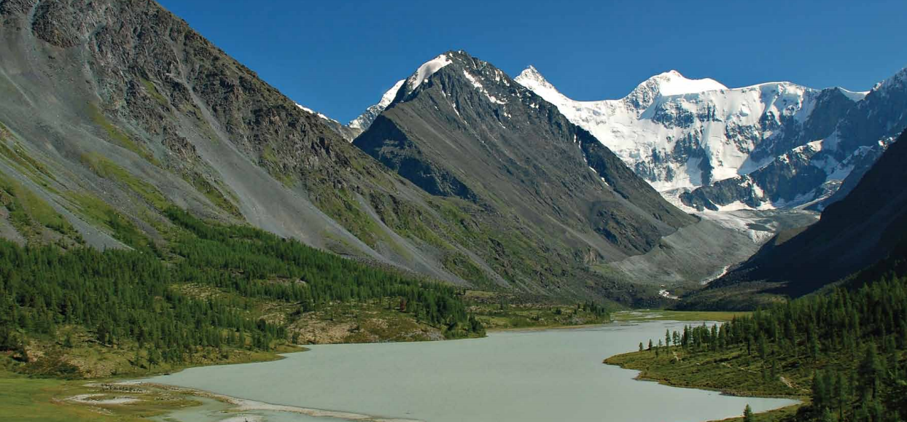
The Himalayan Mountains
- Make a list of everything you see in the picture.

- What do you notice at the top of the mountains?

- How did the river form in the valley?

- How are the trees able to grow in the valley?

- How does this document help to explain how water was important to early Asian civilizations?

Document B

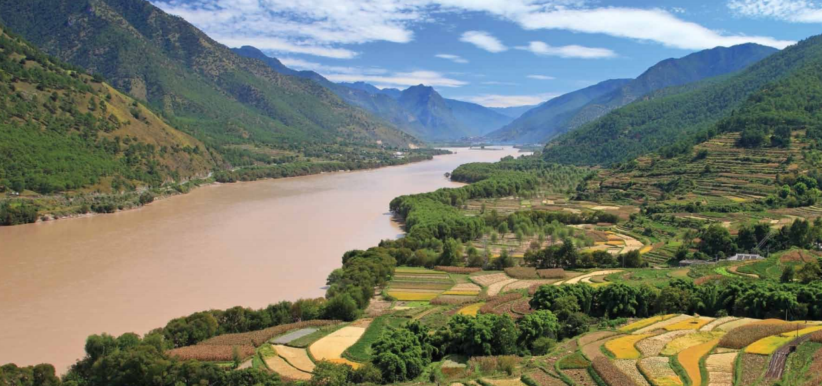

Yangtze River and rice fields
Make a list of everything you see in the picture.

- Look carefully at the picture and read the caption. What are the colored rectangular shapes in the bottom right part of the picture?

- How are those crops able to grow there?

- What connection can you find between Document A and Document B?

- How does this document help to explain how water was important to early Asian civilizations?
Document C
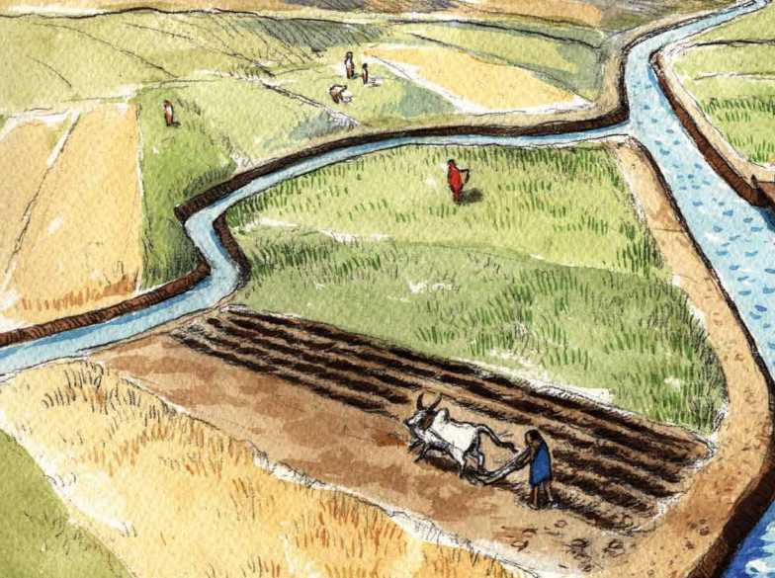
Irrigation canals on the Yangtze River
- Make a list of everything you see in the picture.
People | Objects | Actions

- Based on the picture and the caption, how were these bodies of water formed?

- How did these bodies of water help the people during this time period?

- Can you make any connections between this document and documents A and B?

- How does this document help to explain how water was important to early Asian civilizations?
Document D
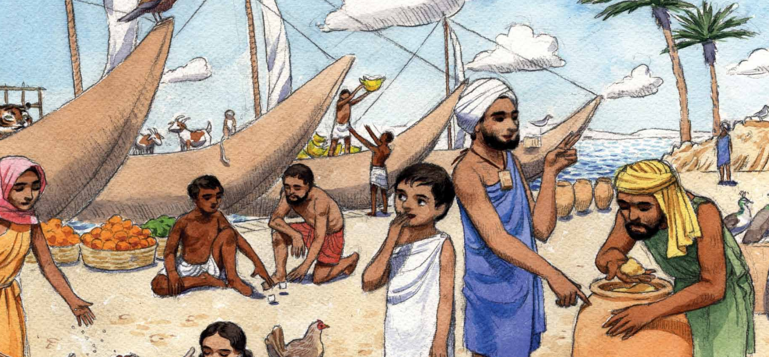Sanjay and his father at the port
- Make a list of everything you see.
People | Objects | Actions

- Describe what the boats are being used for.

- Why are the people meeting by the river?

- When Sanjay and his father went to the port to trade their goods, Sanjay’s father says, “O, Great River, Mother of the People, Provider of Life, we thank you.” Why did he describe the river this way?

- How does this document help to explain how water was important to early Asian civilizations?

Document E

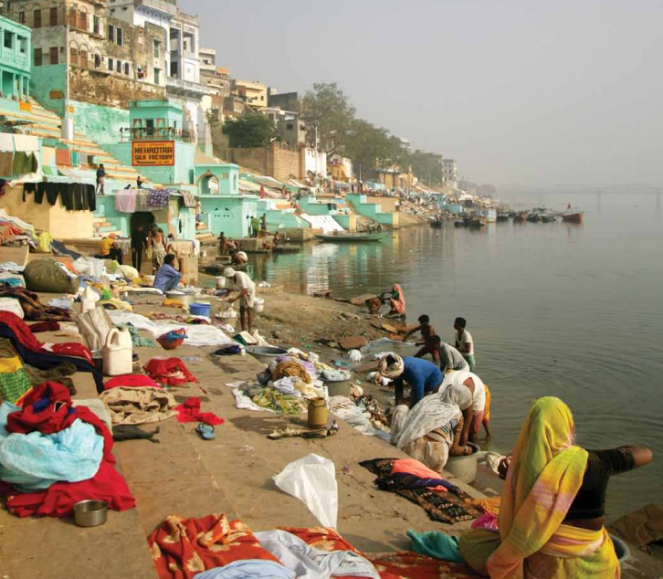
Hindus gathering at the Ganges River
- Make a list of everything you see in the picture.
People | Objects | Actions

- Based on what you know about the Hindu people, why might the people be gathering at the river?

- How is this document different from the other documents?

- How does this document help to explain how water was important to early Asian civilizations?

Name: _______________________________________
Writing Task: In one paragraph, describe how water was important to early Asian civilizations.
Remember to use an introductory sentence.
- Use at least one piece of evidence from each document. After a piece of evidence from a document, put the document letter in parentheses. For example, “George Washington was the top army general for the Continental Army (Doc. B).”
- Correctly use at least four of the vocabulary terms from this DBQ in your paragraph.
______________________________________________________________________________________________________________________________________________________________________________________________________________________________________________________________________________________________________________________________________________________________________________________________________________________________________________________________________________________________________________________________________________________________________________________________________________________________________________________________________
______________________________________________________________________________________________________________________________________________________________________________________________________________________________________________________________________________________________________________________________________________________________________________________________________________________________________________________________________________________________________________________________________________________________________________________________________________________________________________________________________
__________________________________________________________________________________________________________________

