Second Grade DBQ – Core Knowledge – The Civil War

A Document Based Question (DBQ) is an authentic assessment whereby students interact with historical texts. A DBQ asks students to read and analyze historical records, gather information and fill in short scaffolding response questions, assimilate and synthesize information from several documents, and then respond (usually as a written essay) to an assigned task, by using information gleaned from the documents as well as their own outside information.
This DBQ is aligned with the Core Knowledge Listening and Learning domain, The Civil War. It is meant to follow the unit so that students have already been exposed to the knowledge and vocabulary gained from the read alouds.
With prompting, scaffolding, and support, the students will review the series of pictures and text to determine why certain leaders of the Civil War were heroes. After reviewing the documents with partners and whole group, students will write to the prompt independently.
Helpful Vocabulary:
slavery | rebel | abolitionist | plantation
Confederacy | Union | wounded | emancipation
proclamation | general | civil war | Underground Railroad

Writing Task:
A hero is a person who is admired for courage and achievements that help others. Using evidence found in the following documents, your knowledge of our readings, and at least four of the vocabulary words from above, rank all of these people in order from least heroic to most heroic. Then, write about your top three most heroic choices. Make sure to use details to support your reasoning for why these people are heroic.
Teacher Notes:
- It may be a good idea to have the class brainstorm qualities of heroes. These qualities will assist them in producing reasoning based on evidence in their writing. It might also help them clarify this concept. For instance, does a hero have to sacrifice to help others? Is a hero always a leader?
- Students should be given the opportunity to discuss the documents with partners and/or small groups. Students should not be expected to work through the documents independently. The teacher should monitor their understanding of the documents through whole group discussion before moving on to the independent writing task.
- As a teacher, you know your students and where they are on the developmental spectrum in writing. After the students have a solid understanding of the documents, the students are expected to tackle the writing piece independently. However, please scaffold and support this writing as needed by your students. For example, you could provide additional support through shared writing beforehand as an example, or provide additional graphic organizers as needed.
- Allow for several class sessions to complete this DBQ.

Name _____________________

Second Grade DBQ – Core Knowledge – The Civil War
Helpful Vocabulary:
slavery | rebel |  | abolitionist |  | plantation
Confederacy | Union |  | wounded |  | emancipation
proclamation | general |  | civil war |  | Underground Railroad
Writing Task: A hero is a person who is admired for courage and achievements that help others. Using evidence found in the following documents, your knowledge of our readings, and at least four of the vocabulary words from above, rank all of these people in order from least heroic to most heroic. Then, write about your top three most heroic choices. Make sure to use details to support your reasoning for why these people are heroic.

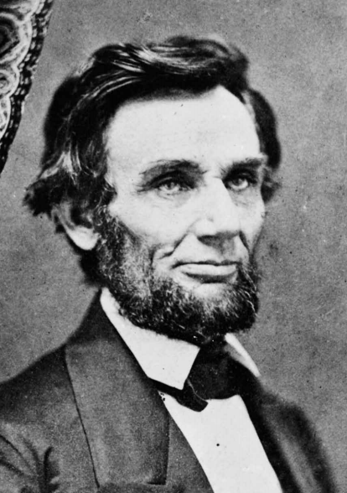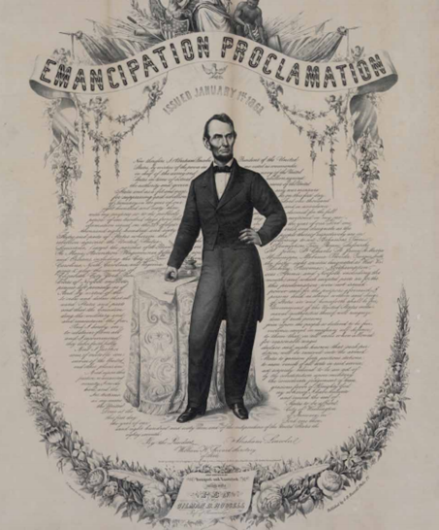
Document A
Abraham Lincoln only went to school for a year or two as a child. He spent his days working on a farm and teaching himself how to read and write. He eventually taught himself about law and became a well-known lawyer in Illinois. In 1858 he debated Stephen Douglas while running for the Senate. In these debates, he said that the U.S. government had a right to prevent the spread of slavery to new parts of the country. He wondered how America could continue to be one united nation if it allowed slavery to spread to new states. He said, “A house divided against itself cannot stand.” He lost this election but was elected to be president in 1860. Then several southern states seceded from the Union, and the Civil War began to keep the country united. During the war, President Lincoln wrote the Emancipation Proclamation. This proclamation stated that the slaves living in states that had seceded from the Union should be free. It allowed the freed slaves to fight for the Union. Some people thought the Emancipation Proclamation was not a good idea, but Lincoln did what he knew was the right thing to do.

- Describe what Abraham Lincoln was like as a young man.

- What did Lincoln say about slavery during the debates with Stephen Douglas?

- Abraham Lincoln said, “A house divided itself cannot stand.” What word could he have said instead of house?

- Explain what the Emancipation Proclamation said.

- What heroic qualities did Abraham Lincoln have? What details support this?

Document B.1 Document B.2 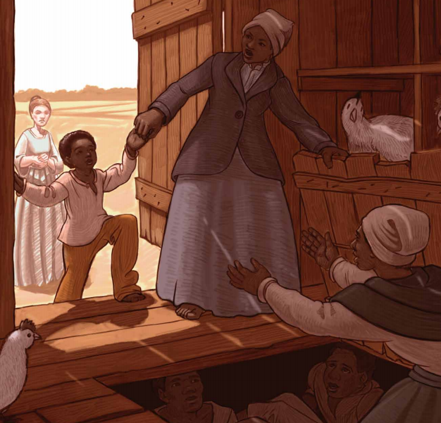 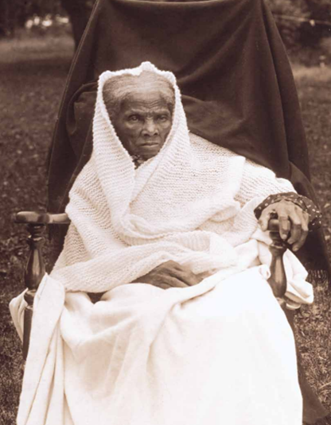
Document B.3
Harriet Tubman grew up as a slave living on a plantation. She was a bit rebellious; she always did things her way. So, she was sent to work in the fields-plowing and digging, cutting hay and tobacco, and chopping would instead of working in the big house. She became strong and tough and ran away from her life in slavery. She used the Underground Railroad to reach freedom. The Underground Railroad was a system of secret routes and hiding places to help enslaved people escape from slavery in the South to freedom in the North. Once Harriet became free, she missed her friends and family and wanted to help them become free, too. So, she became a conductor on the Underground Railroad. A conductor guided runaway slaves, leading them through secret paths and taking them to safe houses. She returned to the South nineteen times, helping many enslaved Africans escape to freedom. She also worked as a nurse and sometimes as a spy for the Union Army. Because she knew all of the roads and secret trails, she was able to spy on the Confederate Army, telling Union generals which direction they were going and how many men they had. After the war, Harriet Tubman moved to Washington D.C., helping newly freed African Americans find jobs and homes and worked for women’s rights to vote.
- Describe what Harriet was like as a young girl.

- What did Harriet Tubman decide to do after she became a free woman? Why did she do that?

- Look carefully at Document B 1. Describe the people that you see. What are the people doing in that picture?

- Besides being a conductor on the Underground Railroad, what else did Harriet Tubman do during the Civil War?

- What heroic qualities did Harriet Tubman have? What details support this?

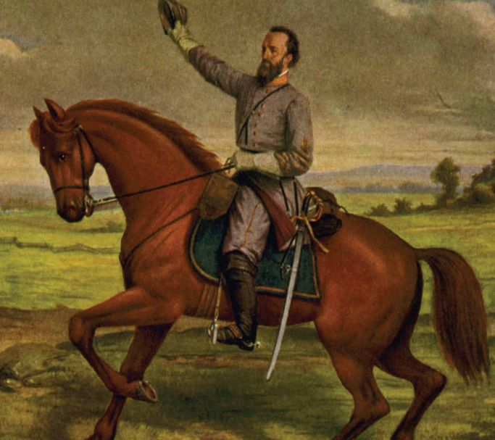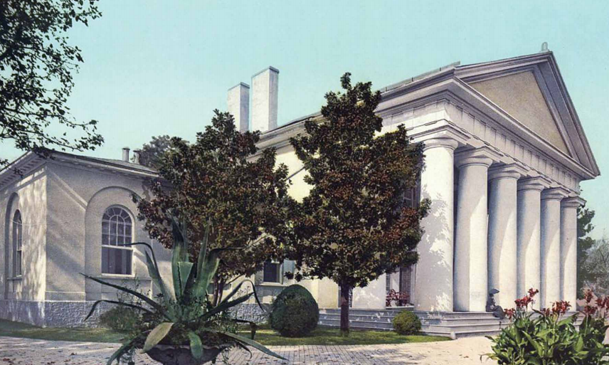
Document C
Robert E. Lee was the son of a hero from the Revolutionary War who had fought bravely alongside George Washington. Robert E. Lee was born and raised in Virginia. He joined the army at age seventeen and fought in the Mexican-American War. He lived in a plantation home in Virginia, a Confederate state, with his wife, Mary. He did not think that the South should secede from the Union, and at first refused to join the Confederate Army, even when President Jefferson Davis asked him to. But, after Virginia seceded from the Union, he became Commander of the Army of Northern Virginia because he hated the thought of fighting against his home state. All of his soldiers loved him and called him “Old Man” out of respect. His men would cheer and wave their hats whenever Lee rode past to greet them. He tried to keep their spirits high. General Lee won many battles during the Civil War, but eventually surrendered by offering his sword to Ulysses S. Grant. After the war, he moved back to Virginia, but was never the same again. He died five years later, sad and regretful, haunted by all the things he could have or should have done differently during the war, but was still proud to have fought for Virginia.

- Describe Robert E. Lee’s youth.

- What happened when President Jefferson Davis asked Lee to join the Civil War?

- Why did Lee eventually join the war?

- How did General Lee’s men feel about him? How can you tell?

- Explain what happened to Lee after the Civil War ended.

- What heroic qualities did Robert E. Lee have? What details support this?

Document D.1 Document D.2
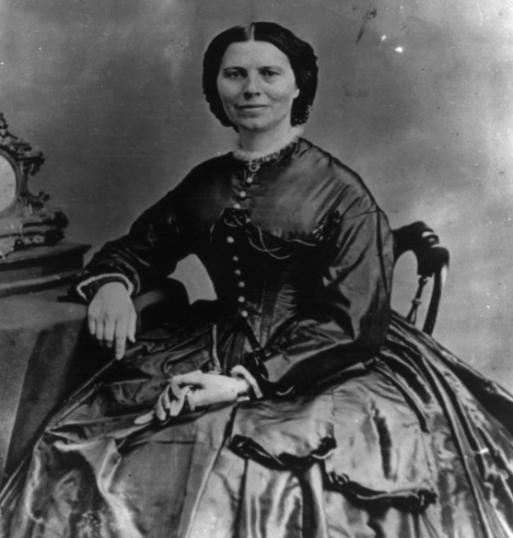
\
Document D.3
Clara Barton was a schoolteacher from Massachusetts and had always been known as a loving, compassionate person, meaning that she cared for other people and wanted to make their lives better. She was in Washington D.C. after the First Battle of Manassas. Hundreds of Union soldiers were wounded, and the hospitals in the city were quickly overcrowded. Clara Barton immediately went around the city knocking on doors and collecting bandages and medicine from people’s homes. She recognized a problem that while the generals were figuring out how to build their armies and win battles, nobody had thought about taking care of the wounded. She began writing letters, visiting doctors, and collecting money and medical supplies for the wounded. She then began to follow the Union Army with her wagonloads full of supplies, making sure the doctors had everything they needed. She made food for the sick and wounded, brought them water, comforted them, and fixed their bandages. Women were not allowed to go onto the battlefields at this time, but Clara Barton kept asking and insisting, and finally she was given permission. She became known as the “Angel of the Battlefield” to soldiers and doctors who were always glad to see her calm face. Once a bullet tore right through her sleeve, but she did not let her fear stop her from doing what she needed to do. After the war, she traveled to Europe and worked as a nurse in wars over there. In 1881, she returned to America and founded the American Red Cross to provide medical supplies, food and other aid during natural disasters such as floods and earthquakes.
- What did Clara Barton do before the Civil War began?

- Describe what Clara Barton did after the First Battle of Manassas.

- Why was she known as the “Angel of the Battlefield”?

- Look carefully at Document D.2. What are the people doing in that picture? What does this document have to do with Clara Barton?

- What heroic qualities did Clara Barton have? What details support this?
Document E.1 Document E.2
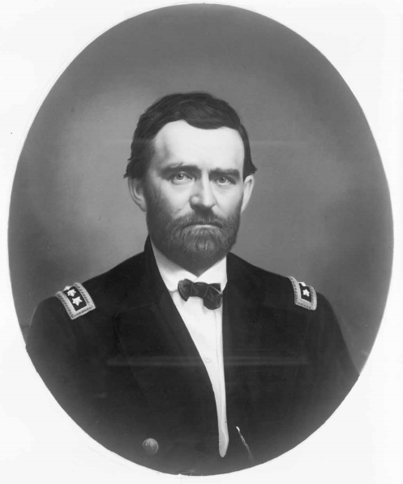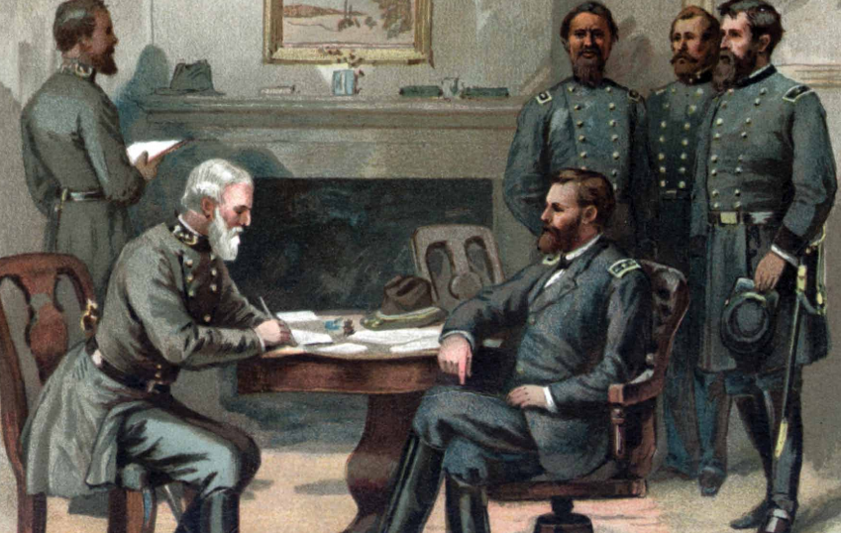

Document E.3
Ulysses S. Grant was the commander of the Union Army. The only person who ranked higher than General Grant was President Lincoln. Grant took orders from Lincoln, and everyone else took orders from Grant. General Grant had served in the army for over twenty-five years, staring when he was just seventeen years old. He had already fought in another war. General Grant had spent the first three years of the Civil War fighting farther west, away from the action in Virginia. His most impressive victory came at Vicksburg. General Grant won the Battle of Vicksburg after two long, hard months. This victory gave the Union final control over the entire Mississippi River, which made it easier for the Union to take over the rest of the South. The Mississippi River was important because the Union could use it to send troops and supplies from the North to the South. Many generals in the Civil War made mistakes and were not forceful enough. But Grant was different. He won the long Battle of Vicksburg because he was stubborn and unafraid; he kept fighting and attacking until the enemy surrendered. He chased General Lee and his men all over Virginia and did not stop until the war was finished. Robert E. Lee surrendered to General Grant in a small farmhouse in the village of Appomattox Court House, Virginia. After the war, General Grant was a hero throughout the North. He went on to become president of the United States in 1869.
- What was Ulysses S. Grant’s job during the Civil War?

- Why was the Battle of Vicksburg important during the Civil War?

- What made Ulysses S. Grant a successful general?

- Look carefully at Document E.3. Based on what you know about this time period, who are the men in the picture? Describe what the men are doing in that picture.

- What heroic qualities did Ulysses S. Grant have? What details support this?
Name: _______________________________________
Writing Task: A hero is a person who is admired for courage and achievements. Look back at your documents. Rank the people in order from the least to the most heroic here:
1. ____________________________________________________(least)
2. ________________________________________________________
3. ________________________________________________________
4. _______________________________________________________
5. ___________________________________________________(most)
Now write about your top three choices. Make sure to use details to support your reasoning for why these people are heroic. Look back at your notes.
- Use at least one piece of evidence from each of the documents about the heroes you have chosen. After a piece of evidence from a document, put the document letter in parentheses. For example, “George Washington was the top army general for the Continental Army (Doc. B).”
- Correctly use at least four of the vocabulary terms from this DBQ in your paragraph.
______________________________________________________________________________________________________________________________________________________________________________________________________________________________________________________________________________________________________________________________________________________________________________________________________________________________________________________________________________________________________________________________________________________________________________________________________________________________________________________________________
__________________________________________________________________________________________________________________________________________________________________________________________________________________________________________________________________________________________________________________________________________________________________________________________________________________________________________________________________________________________________________________________________________________________________________________________

