3RD Grade DBQ - Classic Tales-The Wind in the Willows
A DBQ (Document Based Question) is an authentic assessment where students interact with historical texts. A DBQ asks students to read and analyze historical records, gather information and fill in short scaffolding response questions, assimilate and synthesize information from several documents, and then respond in writing to an assigned task, by using information gleaned from the documents, as well as, their own outside information.
This early level DBQ is aligned with the Nevada Academic Content Standards. It is meant to follow the completion of the unit on Classic Tales\, so that students have already been exposed to the knowledge and vocabulary gained from the read-alouds. The specific standards that are supported in this DBQ are RL3.3, RL.3.7, RL.3.9, RI.3.7, W.3.8, SL.3.1A, SL.3.1B, SL.3.1C, SL.3.1D, SL.3.3, SL.3.4, SL.3.6, L.3.3A, L.3.4C, and L.3.6. These standards are met through teacher led document discussions. Our recommendation is to lead and complete one document with your class per day. Only the culminating writing task is done independently.
With prompting and consistent teacher support through the whole process, students will review the series of pictures and think about the characters and themes throughout the story. The teacher will show the images, ask the accompanying questions and allow pairs to discuss their answers (these do not need to be answered in writing). After reviewing the documents, in teacher led discussion, students will write to the task independently.

Teacher Notes:
- Students should be given the opportunity to discuss the documents with partners and/or small groups. Students should not be expected to work through the documents independently. The teacher should monitor their understanding of the documents through whole group discussion and individual group monitoring before moving on to the independent writing task.
- As a teacher, you know your students and where they are on the developmental spectrum in writing. After the students have a solid understanding of the documents, the students are expected to tackle the writing piece independently. However, please scaffold and support this writing as needed by your students. For example, you could provide additional support through shared writing beforehand as an example, or provide additional graphic organizers as needed.
- Allow for several class sessions to complete this DBQ.

Name _______________# _____

Third Grade DBQ-Core Knowledge- Classic Tales
The Wind in the Willows
Helpful Vocabulary:
interferes dejected conceited sensible deprive recklessly
startled modest evasively escorted heartily distress dismally
revenge settle motor car despondent

Writing Task:
Using evidence found in the following documents, your knowledge of our readings, and at least 6 of the vocabulary words from above: Identify a theme in the story (friendship/loyalty, responsibility and irresponsibility, hospitality). Compare and contrast how two different characters’ actions illustrate this theme. How are they alike and different in relation to this theme?
One paragraph will compare the characters for ways they are similar in relation to the theme.
One paragraph will contrast the characters and show how they are different in relation to the theme.

Document A
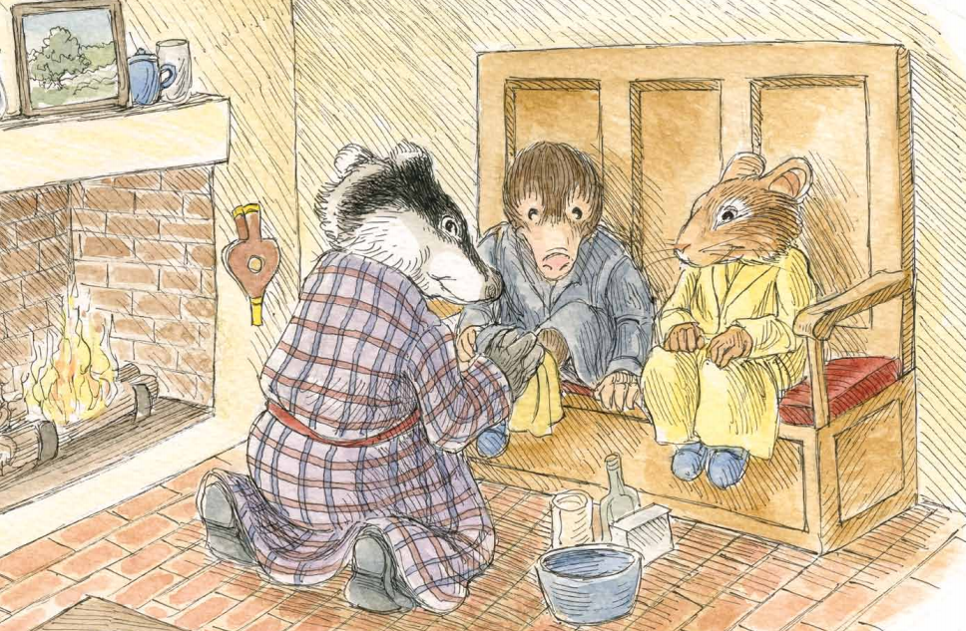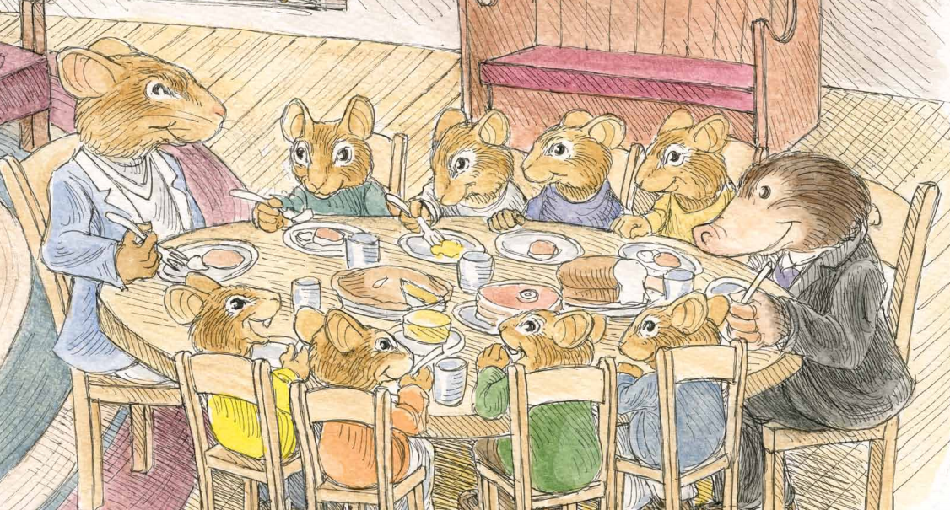
1. Look at the pictures and make a list of everything you see.
Characters | Objects | Actions/Expressions

- Describe how the guests are being treated in the first and second picture.

- What connection can you find between the pictures?

- What examples of the theme “hospitality” do you see in these pictures and from the chart above?

Document B.1 and 2
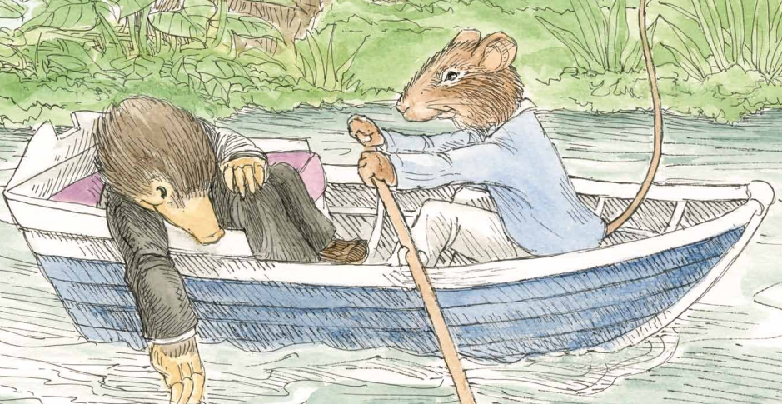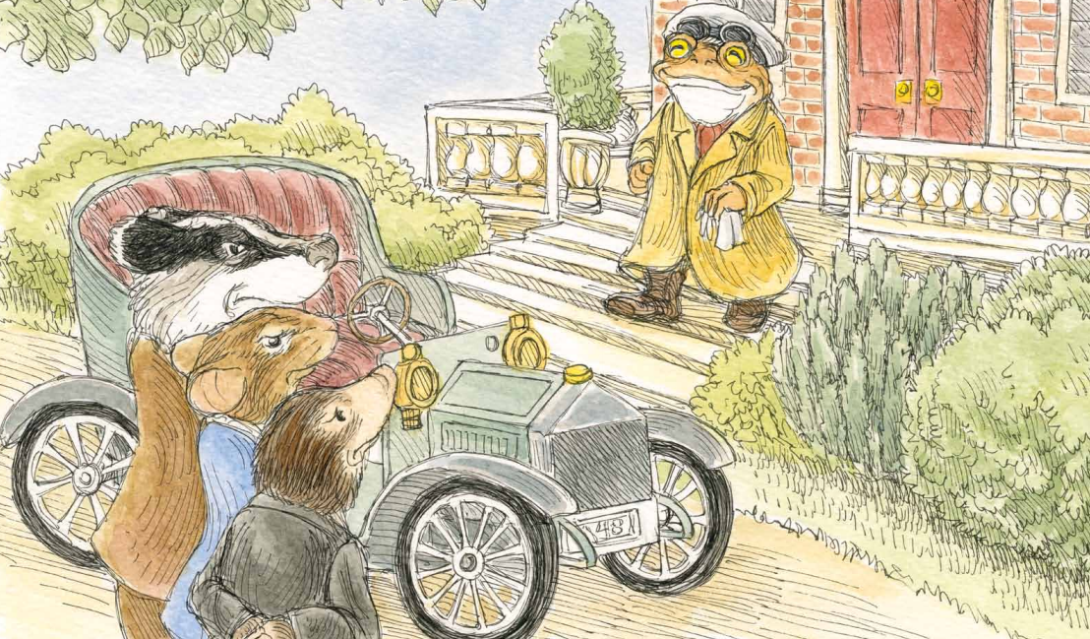

Document B.3
The Mole did not hear a word he said. He was already absorbed in the new life he was entering upon. He trailed a paw in the water and dreamed long waking dreams. The Water Rat, like the good little fellow he was, sculled steadily on and did not disturb him.

- Look closely at the pictures and make a list of everything you see.

Characters | Objects | Actions/Expressions

- Based on what you know from the reading, describe the relationship between Mole and Rat in the first picture.

- Based on what you see in the second picture, describe what is happening between the four characters.

- What examples of the theme “friendship” do you see in these documents?

Document C
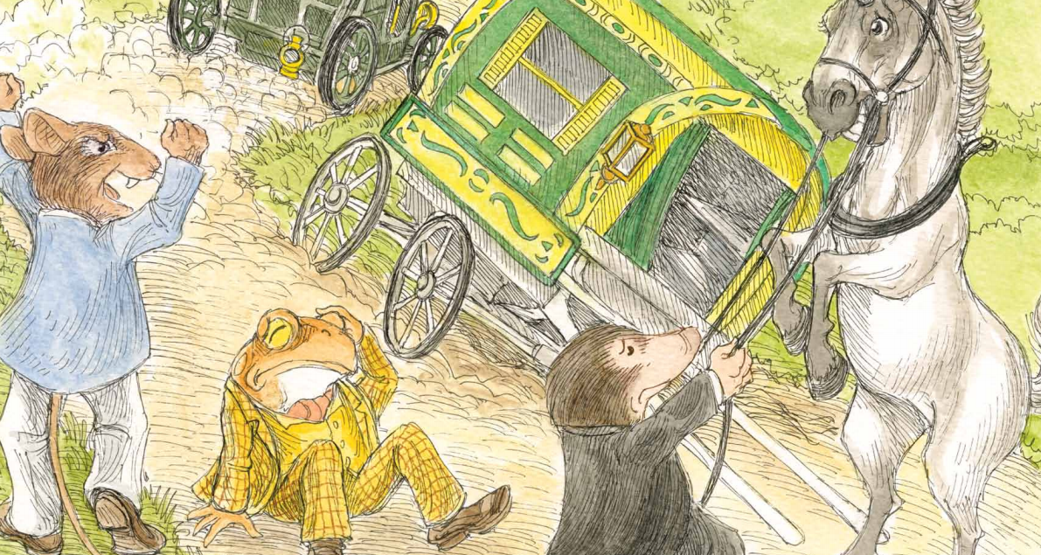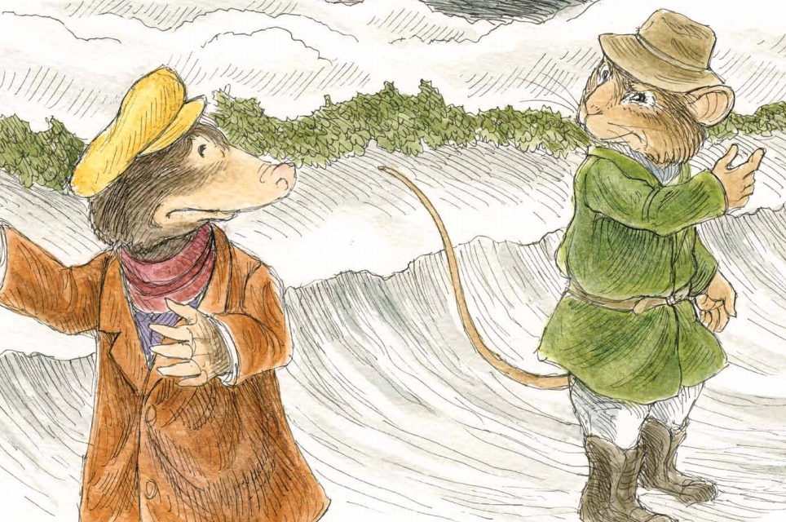

- Look closely at the pictures and make a list of everything you see.
Characters | Objects | Actions/Expressions

- Describe the differences between the events in the first picture and the second picture.

- What connection can you find between the two pictures?

- Based on what you have learned about these characters, who is demonstrating the theme of “irresponsibility” in these pictures? Who is demonstrating “responsibility”? What words and phrases point you to that theme?

Document D
- The kindly Badger guided them to one of the settles, and bade them to remove their wet coats and boots. Then he fetched them dressing gowns and slippers. He bathed the Moles’ shin with warm water and dressed the cut. When they were thoroughly warm, the Badger summoned them to the table to eat a delicious meal.

- Over went the boat, and Mole found himself struggling in the river. O my, how cold the water was, and O, how very wet it felt. How it sang in his ears as he went down, down, down! How bright and welcome the sun looked as he rose to the surface coughing and spluttering! How black was his despair when he felt himself sinking again! Then a firm paw gripped him by the back of his neck. It was the Rat, and he was laughing. The Rat got hold of a scull and shoved it under the Mole’s arm. Then he did the same by the other side of him and, swimming behind, propelled the helpless animal to shore.

- They inspected the wagon and found that it would no longer travel. Once wheel had been broken into bits. “Come on!” said the Rat. “We’ll have to walk. It’s five or six miles to the nearest town. The sooner we get started the better.” “But what about Toad?” asked Mole. “We can’t leave him here, sitting in the middle of the road by himself! It’s not safe. What if another…thing…were to come along?”

- As he tramped along, he thought of his adventures, and how when things seemed at their worst, he had always found a way out. Toad’s pride and conceit began to swell within him. “Ho, ho!” he said to himself, “What a clever Toad I am!” He got so puffed up with conceit that he made up a song as he walked in praise of himself, and sang it at the top of his voice, though there was no one to hear it but him. He sang as he walked, and go more inflated every minute. But his pride was shortly to have a severe fall.

- The four paragraphs above each display a different theme from the story. Which paragraph is an example of friendship and loyalty? How do you know?

- Which paragraph is an example of hospitality? How do you know?

- Which paragraph is an example of responsibility? How do you know?

- Which paragraph is an example of irresponsibility? How do you know?

Name:_________________________________ #________
WRITING TASK
Writing Task: Identify a theme in the story (friendship/loyalty, responsibility and irresponsibility, hospitality). Compare and contrast how two different characters’ actions illustrate this theme. How are they alike and different in relation to this theme?
One paragraph will compare the characters for ways they are similar in relation to the theme.
One paragraph will contrast the characters and show how they are different in relation to the theme.
- Use at least one piece of evidence from each document to compare and contrast the characters and themes in this story. After using a piece of evidence from a document, put the document letter in parentheses. For example, “Badger treated the animals kindly, when he invited them to his home.” (Doc A).
- Correctly use at least 6 of the vocabulary words from this DBQ in your paragraph.
___________________________________________________________________________________________________________________________________________________________________________________________________________________________________________________________________________________________________________________________________________________________________________________________________________________________________________________________________________________________________________________________________________________________________________________________________________________________________________________________________________________________________________________________________________________________________________________________________________________________________________________________________________________________________________________________________________________________________________________________________________________________________________________________________________________________________________________________________________________________________________________________________________________________________________________________________________________

