3RD Grade DBQ – The Viking Age
A DBQ (Document Based Question) is an authentic assessment where students interact with historical texts. Document Based Questions were first used in high school AP classes. But after several years of using DBQs in grades 4-12 in WCSD for all students, it was determined that the same skills could be practiced with students in K-3. A DBQ asks students to read and analyze historical records, gather information and fill in short scaffolding response questions, assimilate and synthesize information from several documents, and then respond in writing to an assigned task, by using information gleaned from the documents, as well as, their own outside information. For grades K-3, these skills and tasks have been refined to include pictures and text from the Core Knowledge units of study. In this way, students who have been immersed in a unit of literacy study are able to demonstrate their knowledge of the unit while also practicing the skills used in social studies in later grades with a DBQ.
This DBQ is aligned with the Nevada Academic Content Standards for Listening and Learning Domain. It is meant to follow the completion of the unit, so that students have already been exposed to the knowledge and vocabulary gained from the read-alouds. The specific standards that are supported in this DBQ are RI.3.1, RI.3.4, RI.3.7, W.3.4, SL.3.1A, SL.3.1B, SL.3.1C, SL.3.1D, SL.3.3, SL.3.4, SL.3.6, and L.3.4A. These standards are met through teacher led document discussions. Our recommendation is to lead and complete one document with your class per day. Only the culminating writing task is done independently.
With prompting and consistent teacher support through the whole process, students will review a series of pictures and information and think about the life as a Viking. The teacher will show the images, ask the accompanying questions and allow pairs to discuss their answers (these do not need to be answered in writing). After reviewing the documents in teacher led discussion, students will write to the task independently.

Teacher Notes:
- Students should be given the opportunity to discuss the documents with partners and/or small groups. Students should not be expected to work through the documents independently. The teacher should monitor their understanding of the documents through whole group discussion and individual group monitoring before moving on to the independent writing task.
- As a teacher, you know your students and where they are on the developmental spectrum in writing. After the students have a solid understanding of the documents, the students are expected to tackle the writing piece independently. However, please scaffold and support this writing as needed by your students. For example, you could provide additional support through shared writing beforehand as an example, or provide additional graphic organizers as needed.
- Allow for several class sessions to complete this DBQ.

Name _______________# _____
Third Grade DBQ-Core Knowledge- The Viking Age
Helpful Vocabulary:
banished ferocious plundered raids reliable
imposing raucous reluctantly extracted sagas
longship (drekar) conquer cargo ship (knar) enable rowboat (faering)

Writing Task:
In your first paragraph, describe the Viking people and culture with at least three vocabulary words and two pieces of text evidence. Then, in a second paragraph, choose one aspect of the Viking’s legacy: sailing, raiding, or trading, and describe the Viking legacy of this way of life using three vocabulary words and at least two pieces of text evidence.

Document A
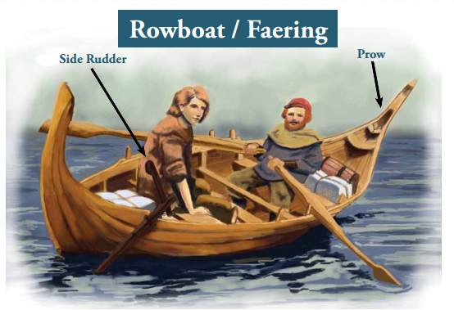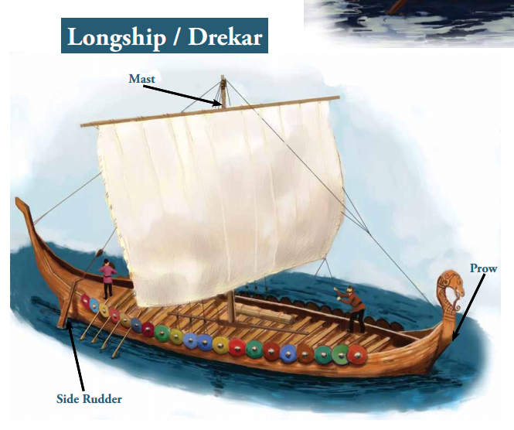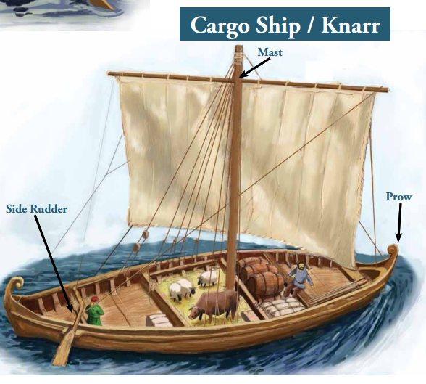
- Look at the pictures and make a list of everything you see.

Characters | Objects | Actions/Expressions

- What differences do you see between the three ships?

- What similarities do you see between the three ships?

Document B.1 and B.2

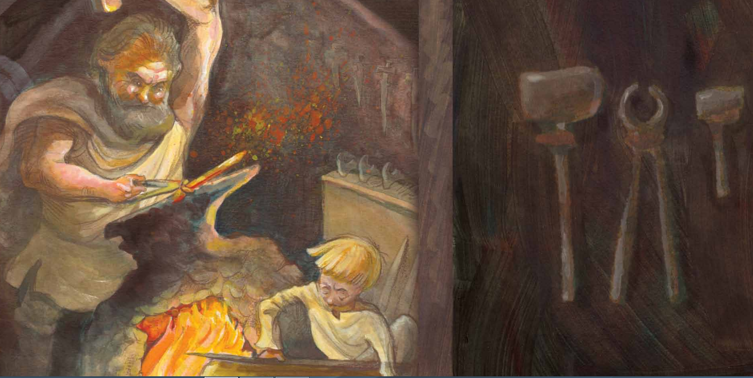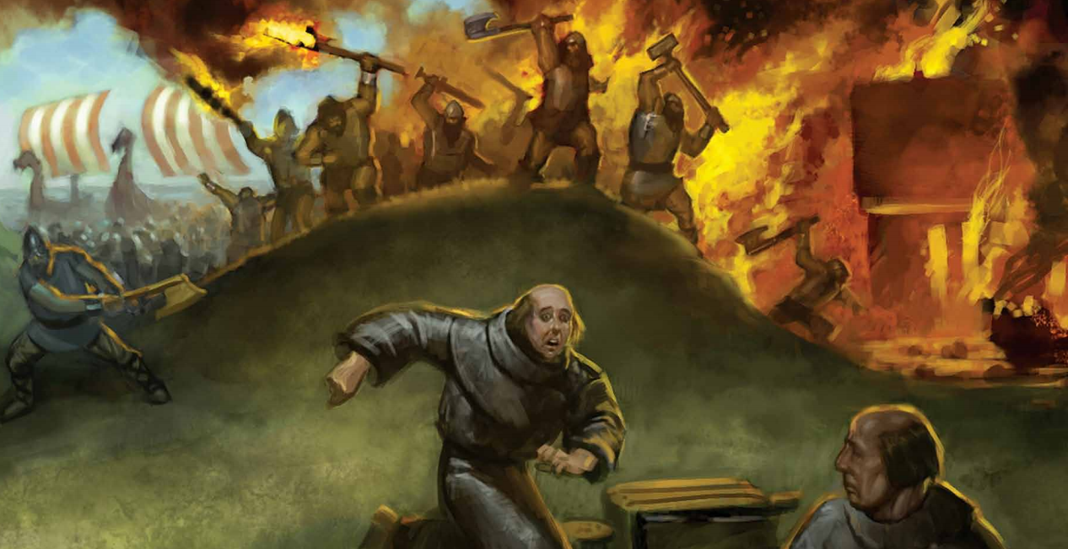

Document B.3 and B.4

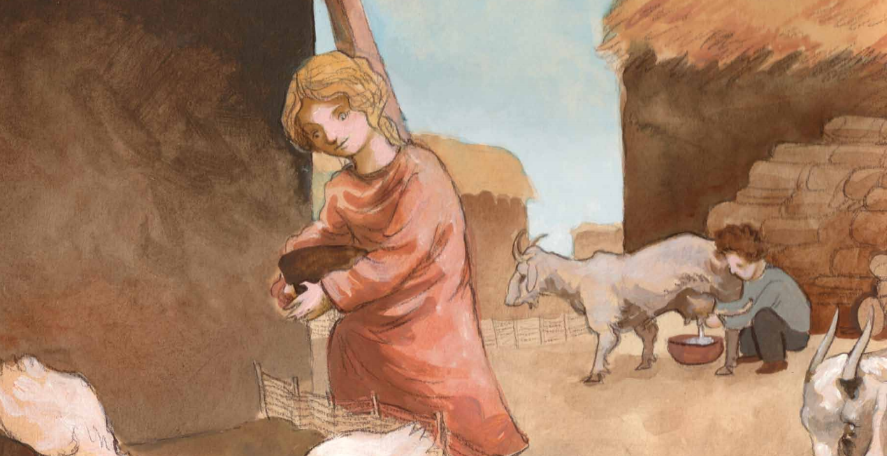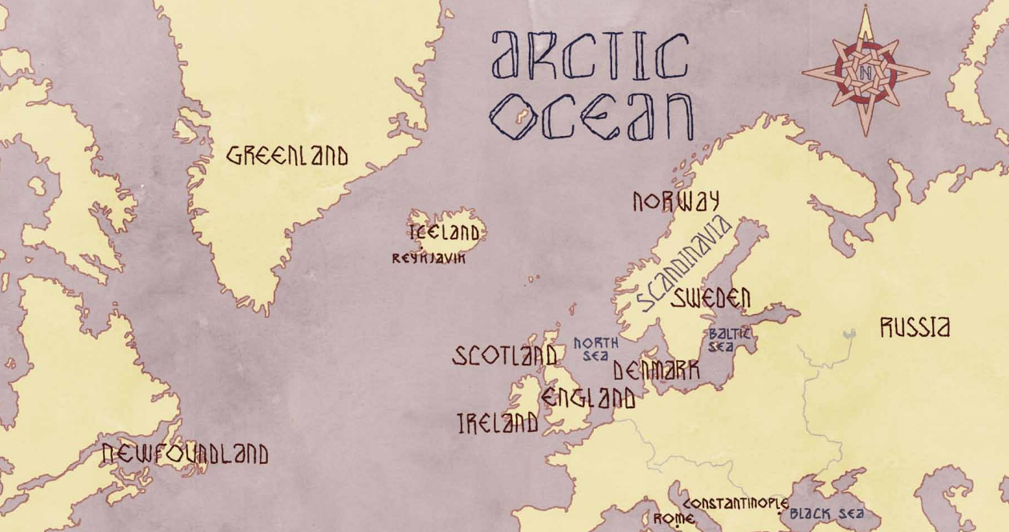

- Using your knowledge and Documents B.1-B.4, fill in the blank spots in the following chart about the different groups of people in the Viking society. Underline vocabulary words used.
Culture | Daily Life | Occupations/Jobs | Explorations | Cultural Practices
Norse men and women |  |  |  | -Skalds told the history of the Viking people  -Worshipped multiple gods and goddesses
Viking Warriors |  | -Raid/Loot  -Sailing the longships  -Conquered other lands
Children |  |  | -Stayed near the home until teenagehood  -Teenage boys left for a voyage, to become successful farmers or Warriors

Document C
A long time ago, more than one thousand years in the past, the Vikings were the lords of the seas. Vikings were famous as ferocious warriors who were feared by people because of their seaborne raids. Viking were an important part of a Norse civilization that also had farmers, traders, explorers, settlers, and poets. The Vikings traveled westward across the Atlantic Ocean to North America and eastward to Russia and beyond. They left a deep imprint on many parts of Europe and surrounding islands, and they established settlements in Iceland, Greenland, and Vinland (which is now called Newfoundland).
Viking expansion was made possible by their magnificent longships. The longships are the icons of the Viking Age. The sight of a longship struck fear into the hearts of others, but they were highly valued by the Vikings, who celebrated the ships in poetry, gave them as gifts, and even used them in funeral rituals. They used their magnificent ships to explore, trade, raid, and invade new lands.
Vikings were also called Norsemen, which means Northmen. This name came from people they raided who were living in England and other parts of Europe. The Vikings, or Norsemen, began regular raids on Ireland, England, Spain, France, Germany, and Russia. Viking warriors were known to kill without mercy, and would steal anything of value, including people who could be used as slaves.
The Vikings didn’t just raid and steal; they also traded. Their cargo ships-carrying items from their home like fish, furs, timber, walrus ivory and hides, and woolen cloth-sailed on major rivers across Europe and into Russia. They traded these items for silver or for things they did not have in their homeland.
Expectations for what a girl and a boy would do as part of growing up during the Viking Age were different. Boys, for example, might have been expected to travel on raids or become apprentices, farmers, or fishermen; whereas girls, might assume more responsibility in household chores. As adults, the people of that time relied on farming, trading and fishing for their survival. Viking people were not one group who lived under the rule of one king; they traveled to and settled in many different places.
Much of what we know about the Vikings was handed down to each generation in the form of sagas, or narratives, told by poets called skalds. Vikings also believed in the power of magic. They believed in gods, giants, ghosts, zombies, dwarfs, elves, trolls and dragons. They believed in good spirits and bad spirits. The Viking Age lasted around five hundred years, and over time came to an end as they went on fewer and fewer raids to other lands. Even though the Viking Age ended, the Norse people continued on and still exist today. They are known as Danes, Swedes, Norwegians, Icelanders and Greenlanders.
- What does the word Norsemen mean? Where did that name come from?

- Besides raiding other places, what other things did the Viking people do?

3. What countries did the Viking people raid? Where did they settle?

4. What are some reasons why the Viking Age came to an end?

Name:_________________________________ #________
WRITING TASK
Writing Task:
In your first paragraph, describe the Viking people and culture with at least three vocabulary words and two pieces of text evidence. Then, in a second paragraph, choose one aspect of the Viking’s legacy: sailing, raiding, or trading, and describe the Viking legacy of this way of life using three vocabulary words and at least two pieces of text evidence.
* After using a piece of evidence from a document, put the document letter in parentheses. For example, “Their cargo ships sailed on major rivers, across Europe into Russia.” (Doc A).
____________________________________________________________________________________________________________________________________________________________________________________________________________________________________________________________________________________________________________________________________________________________________________________________________________________________________________________________________________________________________________________________________________________________________________________________________________________________________________________________________________________________________________________________________________________________________________________________________________________________________________________________________________________________________________________________________________________________________________________________________________________________________________________________________________________________________________________________________________________________________________________________________________________________________________________________________________________________________________________________________________________________________________________________________________________________________________________________________________________________________________________________________________________________________________________________________________________________________________________________________________________________________________________________________________________________________________________________________________________________________________________________________________________________________________________________________________________________________________________________________________________________________________________________________________________________________________________________________________________________________________________________________________________________________________________________________________________________________________________________________________________________________________________________________________________________________________________________________________________________________________________________________________________________________________________________________________________________________________________________________________________________________________________________________________________________________

