Kindergarten DBQ – Core Knowledge: Columbus and the Pilgrims
A DBQ (Document Based Question) is an authentic assessment where students interact with historical texts. Document Based Questions were first used in high school AP classes. But after several years of using DBQs in grades 4-12 in WCSD for all students, it was determined that the same skills could be practiced with students in K-3. A DBQ asks students to read and analyze historical records, gather information and fill in short scaffolding response questions, assimilate and synthesize information from several documents, and then respond in writing to an assigned task, by using information gleaned from the documents, as well as, their own outside information. For grades K-3, these skills and tasks have been refined to include pictures and text from the Core Knowledge units of study. In this way, students who have been immersed in a unit of literacy study are able to demonstrate their knowledge of the unit while also practicing the skills used in social studies in later grades with a DBQ.
This DBQ is aligned with the Core Knowledge Listening and Learning domain, Columbus and the Pilgrims and supports NVACS H1.K.1, H1.K.3, H2.K.1, H3.K.2, W.K.2, W.K.5, SL.K.1, SL.K.2, SL.K.3, SL.K.6 and RI.K.1, RI.K.3, RI.K.7. It is meant to follow the Core Knowledge unit so that students have already been exposed to the knowledge and vocabulary gained from the read alouds.
With prompting and support, the students will review the series of pictures and text to determine: What were some similarities and differences between the two voyages of Columbus and the Pilgrims? (Essential Question)
After reviewing the document, students will write to the prompt with support and/or independently. The teacher will show the images, ask the accompanying questions and allow pairs to discuss their answers (these do not need to be answered in writing). After reviewing all of the documents, students will write to complete the task independently. This series of questioning will take place over a span of 3-5 days.
Helpful Vocabulary to Post During DBQ and Refer To For Writing Task:
journey | natives | adventures | sailors
explorers | ships | religion | feast

Writing Task:
Using evidence found in the following documents, your knowledge of our readings, and at least 3 of the vocabulary words from above explain: What were some similarities and differences between the two voyages of Columbus and the Pilgrims?
Teacher Notes:
- When guiding students in pairs to discuss the documents, you should project them on the board as well as allow the students to have the image in front of them (if applicable). If you find that students are struggling in their discussion, you might provide sentence starters or stems (e.g. I see ____________________ in the image.).
- As a teacher, you know your students and where they are on the developmental spectrum in writing. If your students have practice writing sentences, the writing task pushes them a bit further to include evidence from text and specific vocabulary. If your students need further scaffolding, consider using sentence stems or providing fill in the blank opportunities (example below).
This is __________ and I think that because _________.

- Importantly, the outcome in this exercise is retrieving evidence and synthesizing information from documents (not necessarily demonstrating writing competency). Where appropriate take dictation of student responses.
- Students should be provided appropriate kindergarten paper for the writing opportunity.
Document A Document B
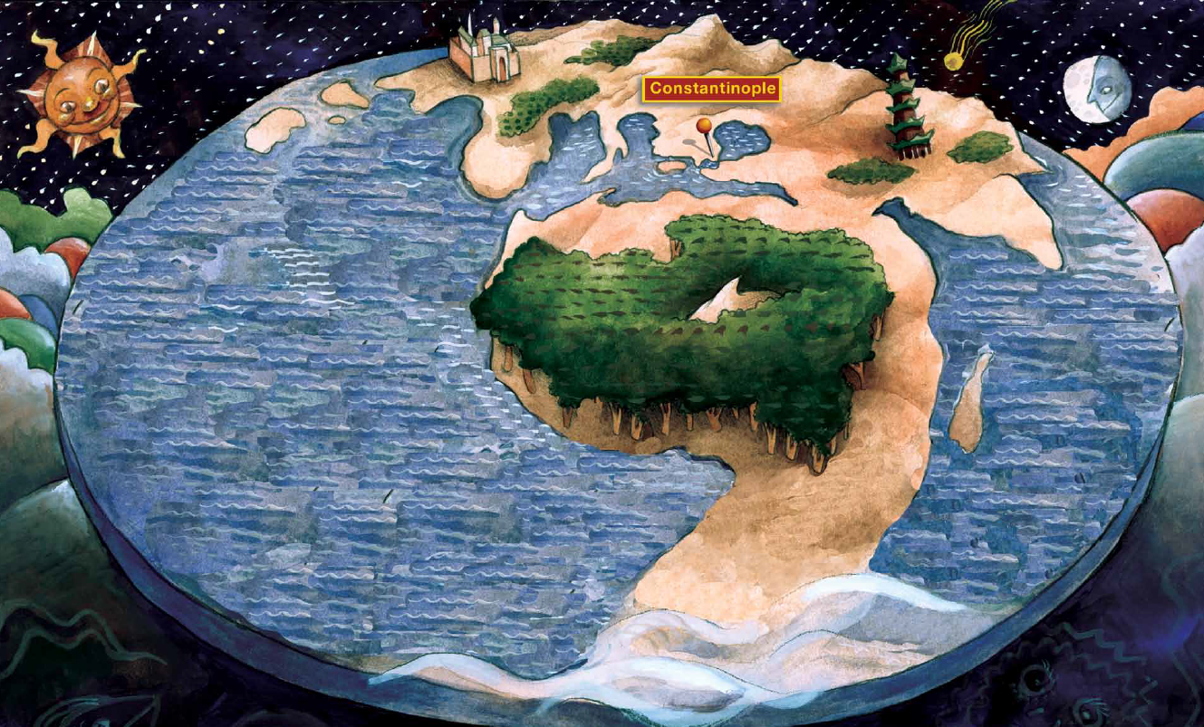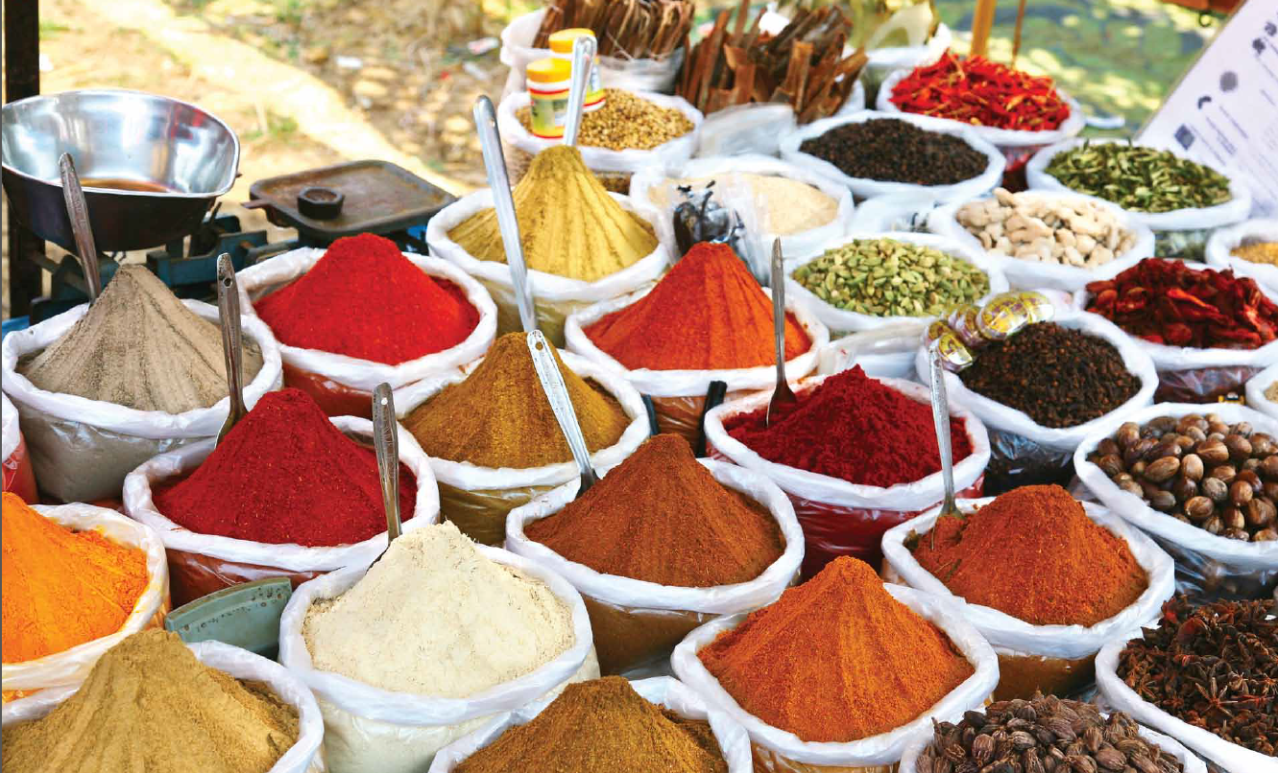
Students respond orally to a partner and to the class to the following:
- Look at document A and make a list of everything you see. What do you notice about Document A?
- Looking at Document A what other way could people from Italy travel to the spice lands other than by land?
- What do you see in Document B?
- Why were spices important during this time in history?

Document C
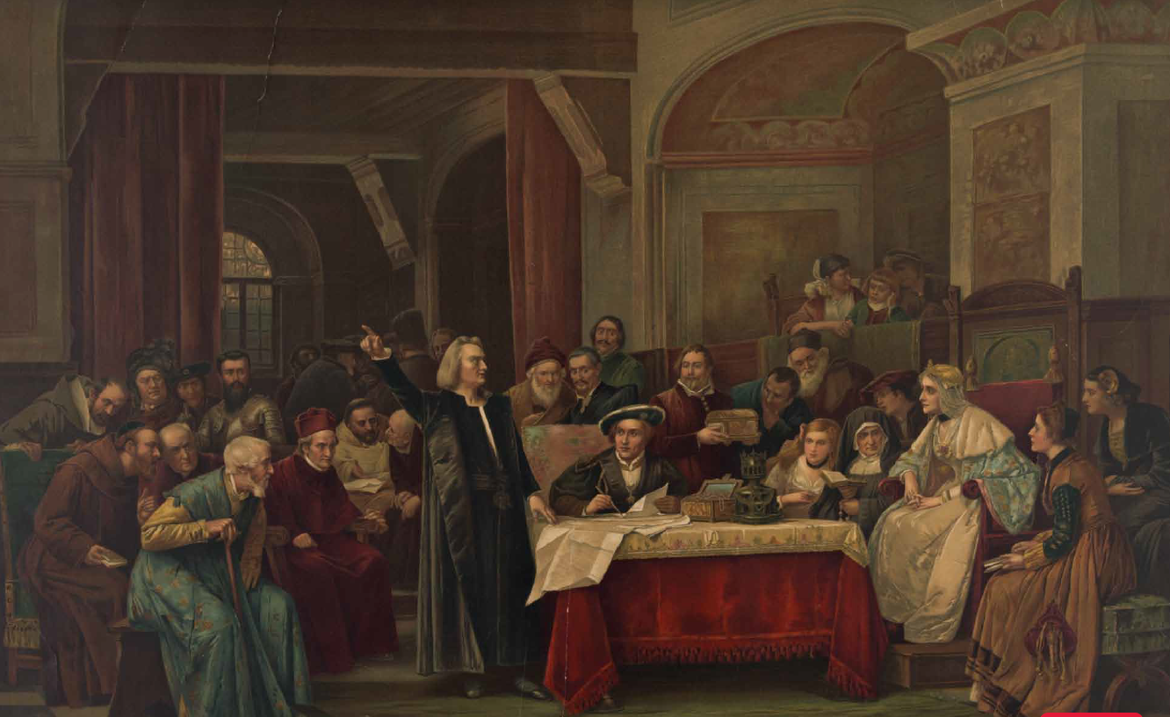
Students respond orally to a partner and to the class to the following:
- What do you see in this image?
- Based on your knowledge (what you heard) from the domain read aloud what is Columbus asking for?
- What evidence from the image supports your answer?
- Why did Columbus want to make his journey?

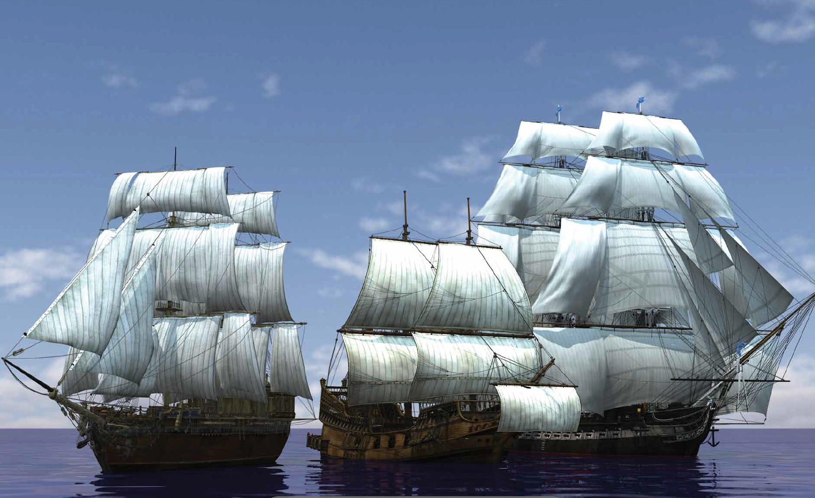
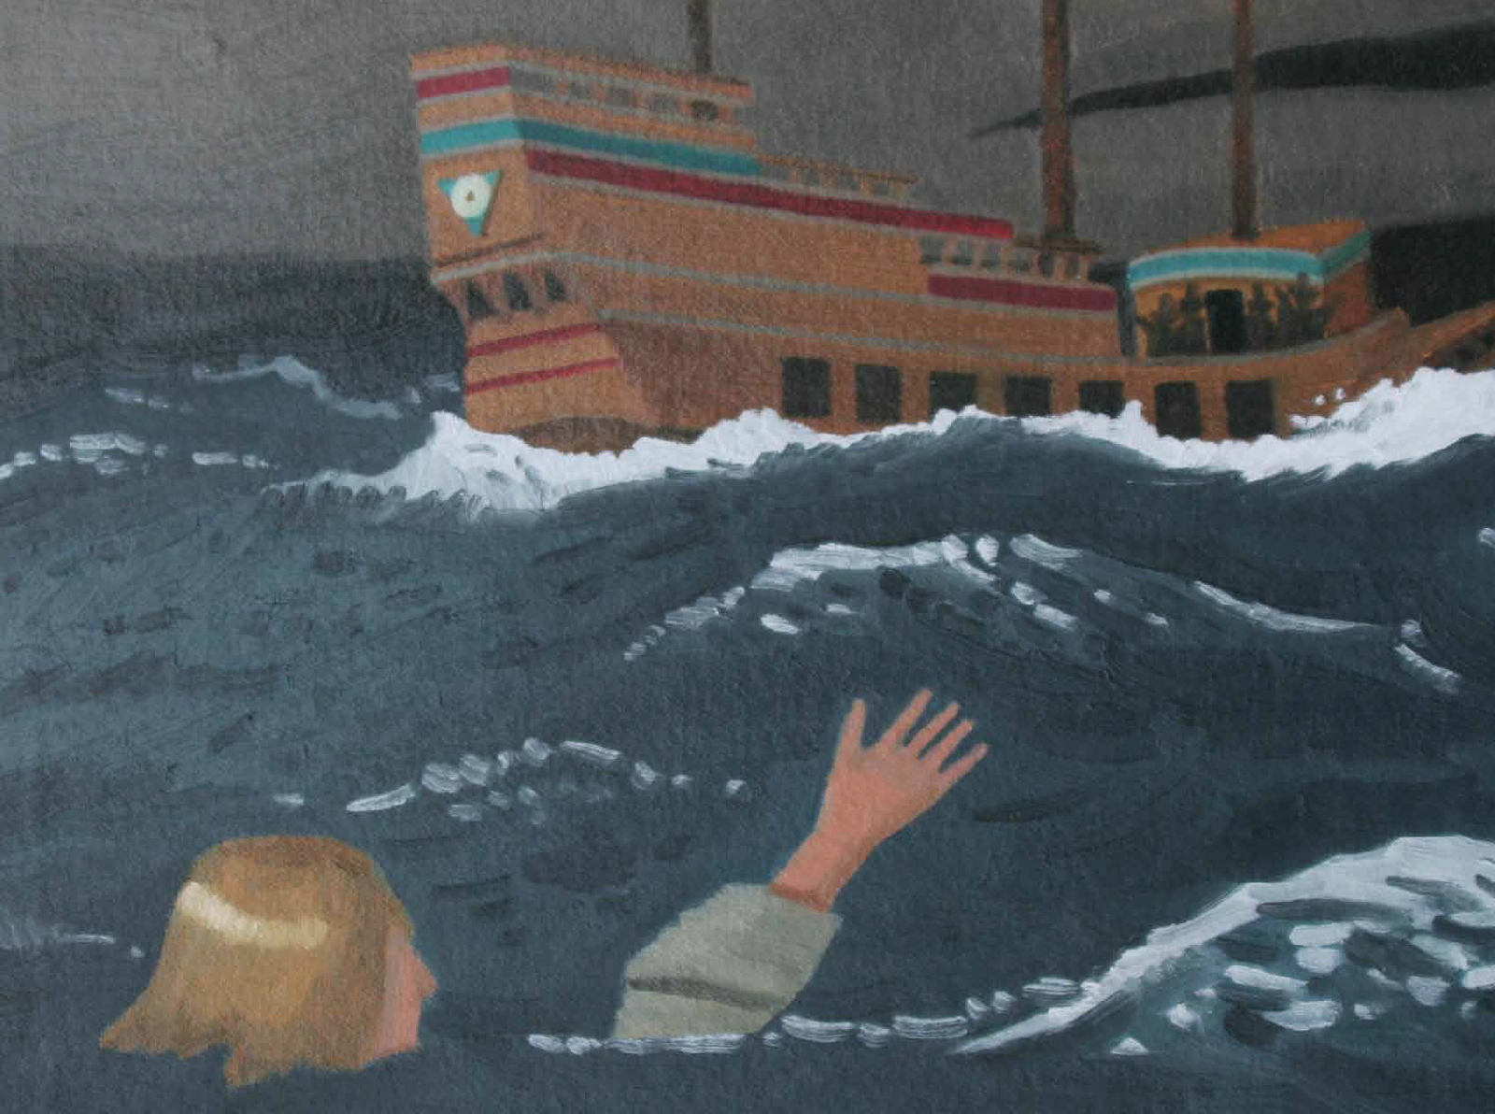
Document D Document E

Students respond orally to a partner and to the class to the following:
- Look closely at document D what do you notice about the ships? (if prompting is needed ask what do they notice about the ocean too)
- Based on this document and the domain read alouds what difficulties did Columbus and his crew face on their journey?
- What is happening in document E?
- How are the Pilgrim’s difficulties during their journey similar to Columbus’?

Document F Document G
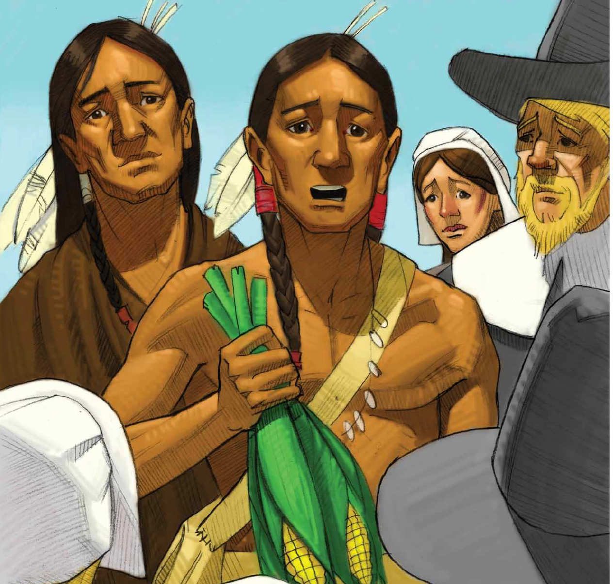
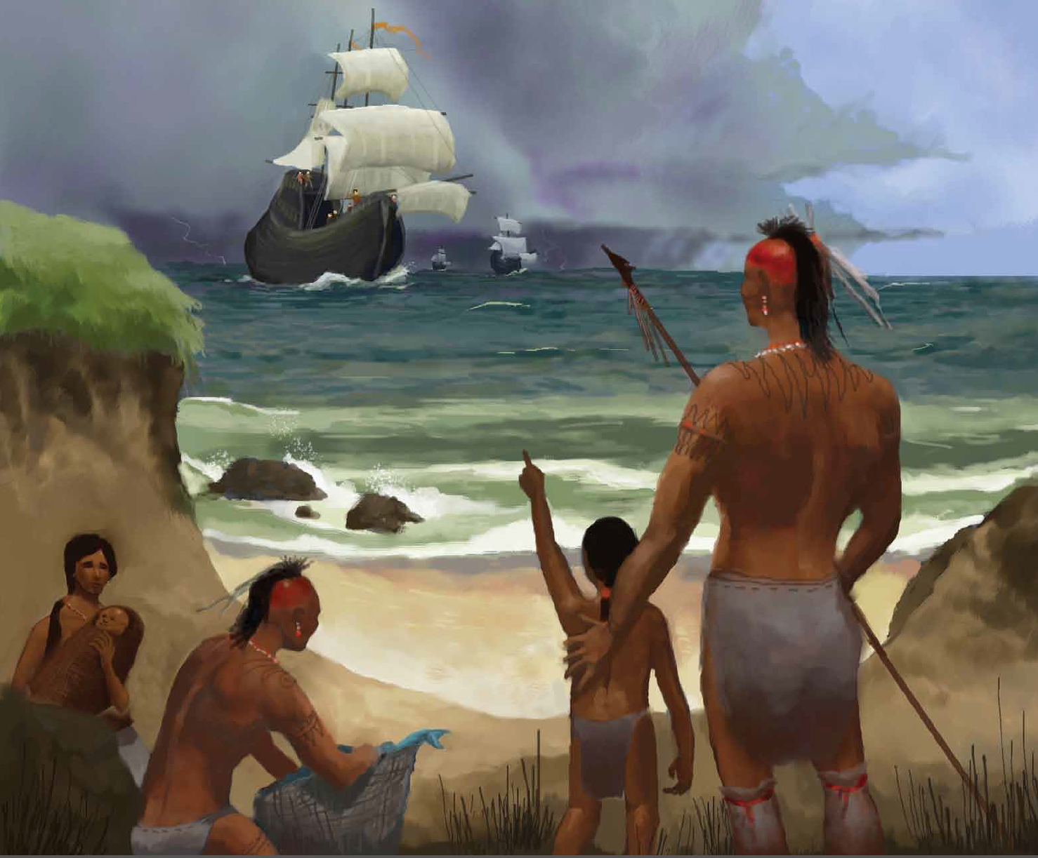

Students respond orally to a partner and to the class to the following:
- Tell a partner everything you notice about document F and document G?
- How is the man with the corn in document G similar to the people in document F?
- What are the people called who live in a certain place for a long time?
- Using evidence from the text how did the native people help Columbus? (you can reread this portion of the domain)
- Based on document G and the text how did the native people help the Pilgrims?
- With a partner discuss the similarities and difference of Columbus and the Pilgrim’s encounter (or meeting) of the Natives.

Document H Document I
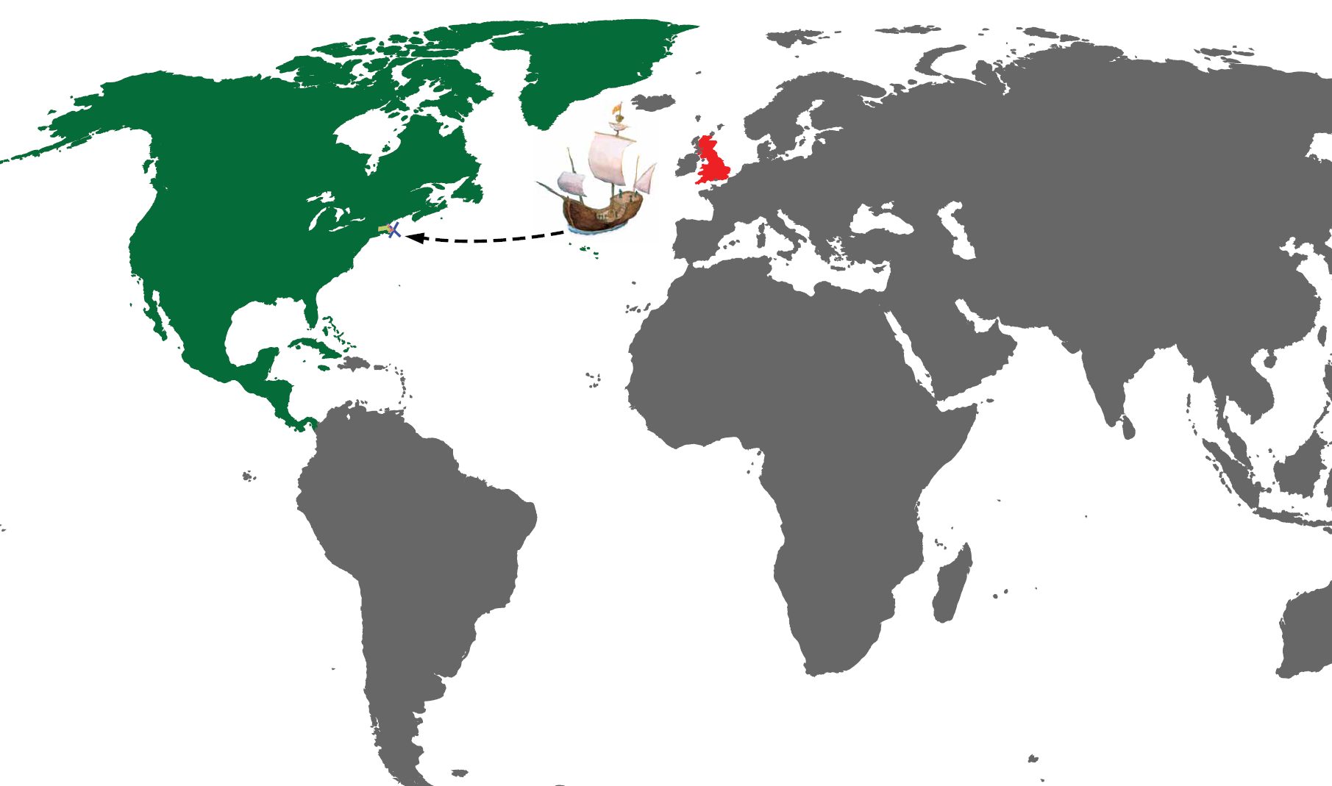
(Remind students that the voyage took 2 months and 9 days)
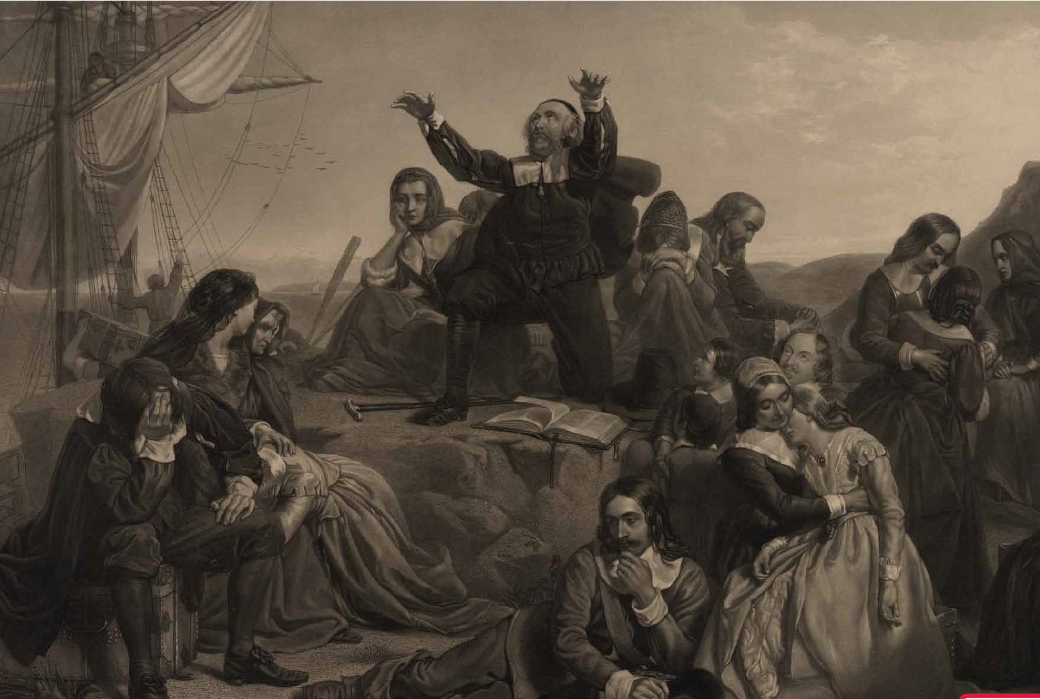

Students respond orally to a partner and to the class to the following:
- What is shown in document H?
- Look closely at document I and tell a partner everything you notice. What did you notice (whole group share).
- Who are the people in the document?
- Using evidence from the read alouds explain where the Pilgrims are going and why? (If students say Separatists remind them that once they began their journey they were known as Pilgrims)

Additional discussion opportunity: Discuss the motives that prompted both Columbus’s and the Pilgrim’s voyages. (Gold and spices for Columbus and freedom for the Pilgrims)
Writing Opportunity: With prompting and support, dictate, draw or write to answer the question: What were the similarities and differences between the two voyages of Columbus and the Pilgrims? (Essential Question)

Use at least two document sources and three vocabulary words.
(Note to teacher: use whatever writing paper is appropriate for your students at this time of the year. If a student provides a picture only, teacher should write dictation under the picture.)

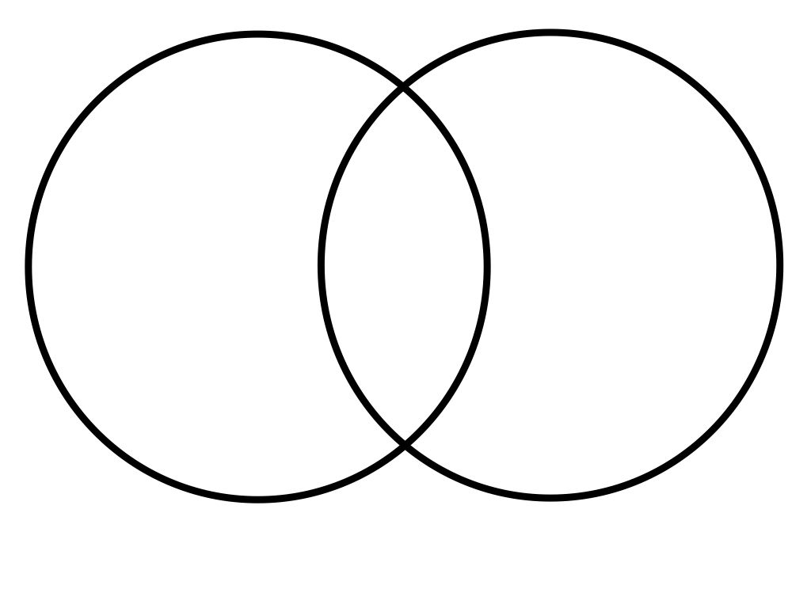
Similar (Same)
Pilgrims
Columbus
Modification ideas:
- Students could write/draw some responses on white boards
- Students write/draw responses in their Core Knowledge notebooks (if you do teacher made notebooks)
- Teacher could go back and reread sections of the text to scaffold answering questions
- Use the venn diagram (or other graphic organizer) to chart discussions and similarities and differences s as they are cited
- Have students act out when Columbus/Pilgrims met the natives

