The Jacobins and the Reign of Terror
By 1793, the French Revolution had been in place for four years when a fearsome madness gripped the government and the mob it seemed to represent. It was at that time that the Jacobins, the radical arm of the revolutionary movement, seized control of the government from the more moderate Girondins. Led by Maximilien Robespierre, the Jacobin Committee of Public Safety soon became the instrument of the most senseless bloody period in a revolution that was initiated to reform a corrupt royalist government and create a republican state based on the equality of all men…
The Jacobins started out as a fairly moderate group favoring a constitutional monarchy. Over time, however, their membership changed to include more fiery revolutionaries, and the thrust of the organization changed. They devolved from protectors of the ideals of the revolution to dictatorial predators who perpetrated terrorism in the name of those same ideals.
In 1793, the Jacobins took the opportunity of political struggles in the French National Convention to snatch the reins of government. They began a policy of systematic terror that was designed to keep the radical Jacobins in power through the steady elimination of anyone whom they might have considered "counter-revolutionary." In practice, "counter-revolutionary" often meant those who disagreed with any part whatsoever of the Jacobin platform.
Liberty, Equality, Brotherhood . . . and Death
The Reign of Terror lasted for slightly over a year—a year in which the sheer number of people beheaded in gruesome public executions sometimes caused small streams of blood from the guillotine to run through the streets of Paris. The Jacobins decreed that executions were educational and should be attended by all patriotic people. Women were encouraged to practice the feminine art of knitting while attending trials and beheadings. Despite the egalitarian approach, however, the Reign of Terror proved to be nothing more than the exercise of uncontrolled and distorted authority unleashed against the very people for whom the revolution had been initiated—the common individual.
" . . . and never heads enough . . . "
Everyone was suspect. The civil liberties for which the revolution had ostensibly been fought were summarily suspended. Utter a word of criticism against the actions of the Committee of Public Safety and you might find yourself and your entire family headed for the guillotine. Witnesses to your guilt were not required; an accusation was often the only evidence needed. By July 1794, the Revolutionary Tribunal had ordered the execution of 2,400 people. From June 1793 to July 1794, approximately 17,000 people lost their lives. Eventually, like all fatal diseases, the Reign of Terror ran its course, feeding on itself along the way.
Vocabulary: ostensibly: apparently

Source: "The Jacobins and the Reign of Terror (Overview)." World History: The Modern Era. ABC-CLIO, 2014. Web. 21 July 2014.

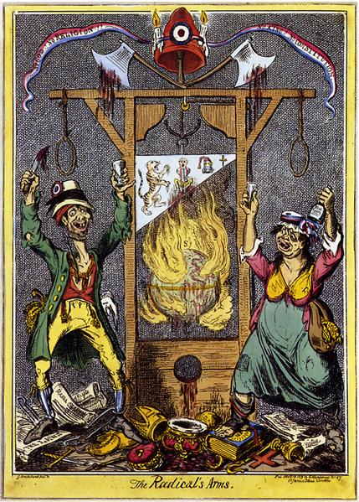
Tricolor ribbon inscription: “ No God! No Religion! No King! No Constitution!”
Source: The Radical’s Arms, caricature by George Cruikshank

1. Who were the Jacobins? What part did they play in the French Revolution? Find multiple pieces of
evidence from the text to support your answer. __________________________________________
__________________________________________________________________________________
__________________________________________________________________________________
2. The word radical first appears on line 3. It has multiple meanings. What is the meaning of the word
in the context of this document?
a. extreme; a change from traditional forms b. of or going to the root of origin
c. favoring drastic political reforms d. forming a foundation
3. Why was this period of time called the Reign of Terror? ____________________________________
_________________________________________________________________________________
_________________________________________________________________________________
4. Who was the target of punishment under the Jacobins? Did the accused have any rights? Provide
evidence from the document to support your answer. ____________________________________
________________________________________________________________________________
________________________________________________________________________________
5. What words and phrases in lines 29-34 help you to better understand the meaning of the word
summarily on line 29? _____________________________________________________________
________________________________________________________________________________
________________________________________________________________________________
6. In the political cartoon, who is the target of the guillotine? Provide evidence from the cartoon to
support your answer. _______________________________________________________________
_________________________________________________________________________________
_________________________________________________________________________________
7. What is the message of this visual? How do you know? Provide evidence in your answer. ________
________________________________________________________________________________
________________________________________________________________________________
8. Compare both sources and find two ways in which they are similar. _________________________
________________________________________________________________________________
________________________________________________________________________________

