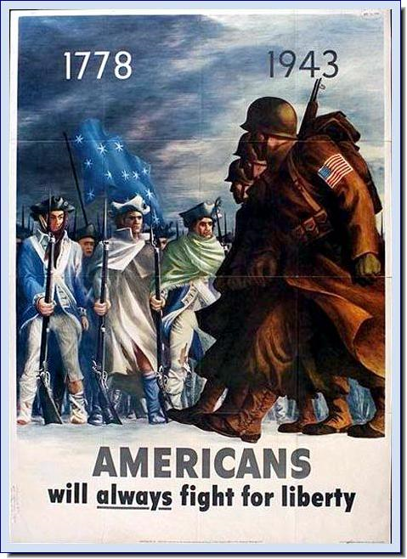
Using your own background knowledge and the following documents, please evaluate the following statement:

“Wartime mobilization was a success due to the use of propaganda during WWII.”
Janet Roberts
jroberts@washoe.k12.nv.us

Historical Background

In 1941, at the dawn of WWII, President Franklin D. Roosevelt signed Executive Order 9182 that established the Office of War Information (OWI). The OWI was in charge of generating products that were meant to be seen by both Americans as well as the rest of the world. Throughout the war the United States government, as well as all other countries, created posters, movies, radio stories, news reels and music for distribution to their people, regardless of their ethnicity, age or gender. The purpose of these this propaganda was twofold. The first was to sway the emotions of the people to support the war. After the people became emotionally invested in the war, the second purpose was mobilizing them.
Document 1: Executive Order 9182
In recognition of the right of the American people and of all other peoples opposing the Axis aggressors to be truthfully informed about the common war effort, and by virtue of the authority vested in me by the Constitution, by the First War Powers Act, 1941, and as President of the United States and Commander in Chief of the Army and Navy, it is hereby ordered as follows:
4. Consistent with the war information policies of the President and with the foreign policy of the United States, and after consultation with the Committee on War Information Policy, the Director shall perform the following functions and duties:
(a) Formulate and carry out, through the use of press, radio, motion picture, and other facilities, information programs designed to facilitate the development of an informed and intelligent understanding, at home and abroad, of the status and progress of the war effort and of the war policies, activities, and aims of the Government.
(b) Coordinate the war informational activities of all Federal departments and agencies for the purpose of assuring an accurate and consistent flow of war information to the public and the world at large.
(c) Obtain, study, and analyze information concerning the war effort and advise the agencies concerned with the dissemination of such information as to the most appropriate and effective means of keeping the public adequately and accurately informed.
(d) Review, clear, and approve all proposed radio and motion picture programs sponsored by Federal departments and agencies; and serve as the central point of clearance and contact for the radio broadcasting and motion-picture industries, respectively, in their relationships with Federal departments and agencies concerning such Government programs.
(e) Maintain liaison with the information agencies of the United Nations for the purpose of relating the Government's informational programs and facilities to those of such Nations.
(f) Perform such other functions and duties relating to war information as the President may from time to time determine.
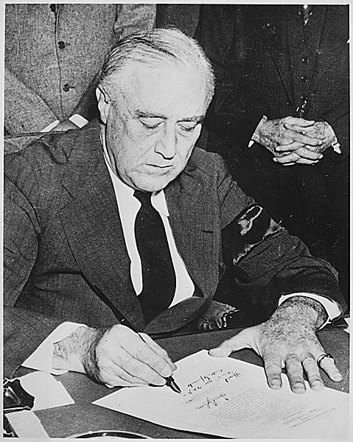
- What are the four areas of media that are addressed in E..O. 9182?

- Aside from Americans, who else was OWI trying to address?

- If the OWI was in char of, “assuring an accurate and consistent flow of war information,” do you think the people were getting the whole story of what was truly occurring at home and abroad? Explain.

- In your own words, why would it be important for the OWI to have a final say in what was distributed to the public?
Document 2:
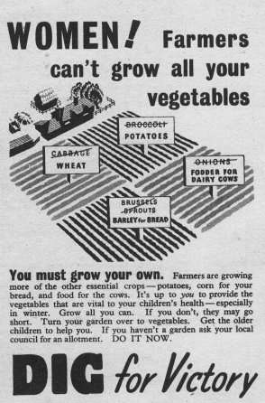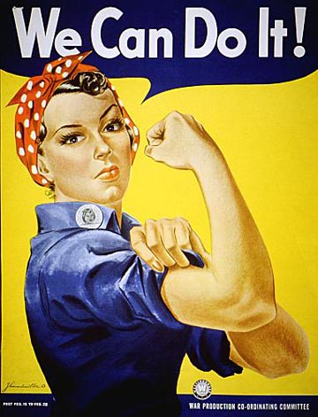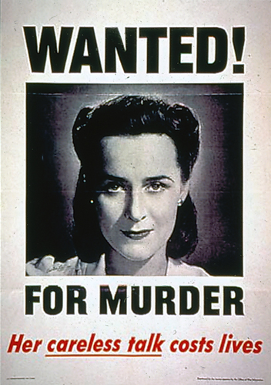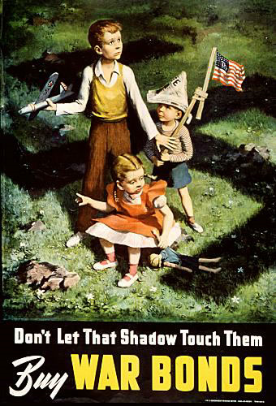

- In what ways were women encouraged to help out on the homefront?

- What emotions were used to mobilize this segment of society?

- Judging by these four posters, how were women depicted in America at this time

- Explain how these posters could help in war production.

Document 3:
“Any Bonds Today”
Written by: Irving Berlin, 1941
Performed by: The Andrew Sisters
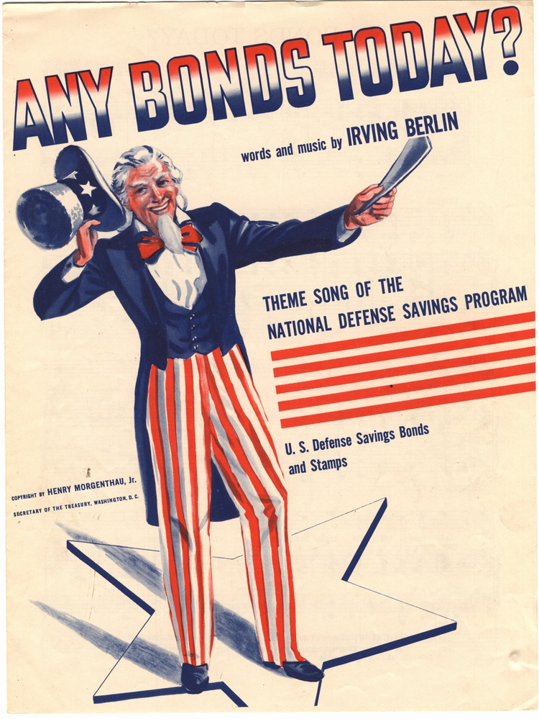
The tall man with the high hat and the whiskers on his chin
Will soon be knocking at your door and you ought to be in
The tall man with the high hat will be coming down your way
Get your savings out when you hear him shout "Any bonds today?"
Any bonds today?
Bonds of freedom
That's what I'm selling
Any bonds today?
Scrape up the most you can
Here comes the freedom an
Asking you to buy a share of freedom today
Any stamps today?
We'll be blessed
If we all invest
In the U.S.A.
Here comes the freedom man
Can't make tomorrow's plan
Not unless you buy a share of freedom today

First came the Czechs and then came the Poles
And then the Norwegians with three million souls
Then came the Dutch, the Belgians and France
Then all of the Balkans with hardly a chance
It's all in the Book if only you look
It's there if you read the text
They fell ev'ry one at the point of a gun
America mustn't be next
Any bonds today?
All you give
Will be spent to live
In the Yankee way
Scrape up the most you can
Here comes the freedom man
Asking you to buy a share of freedom today
Vocabulary: War bonds are debt securities issued by a government for the purpose of financing military operations during times of war. War bonds generate capital for the government and make civilians feel involved in their national militaries
- Who was the, “The tall man with the high hat and the whiskers on his chin?”

- In the fourth set of lines that starts with, “First came the Czechs…” what does it outline?

- What are two major emotions being used to compel people to buy war bonds?

- Although this song was literally trying to sell war bonds to people, what was the real thing that they were selling?

Document 4:
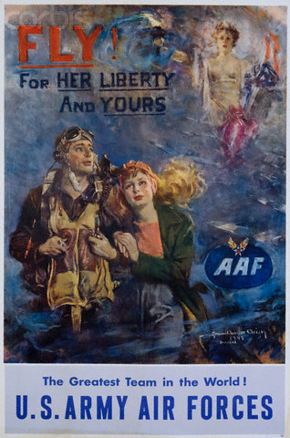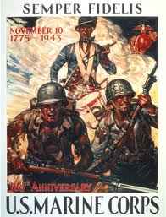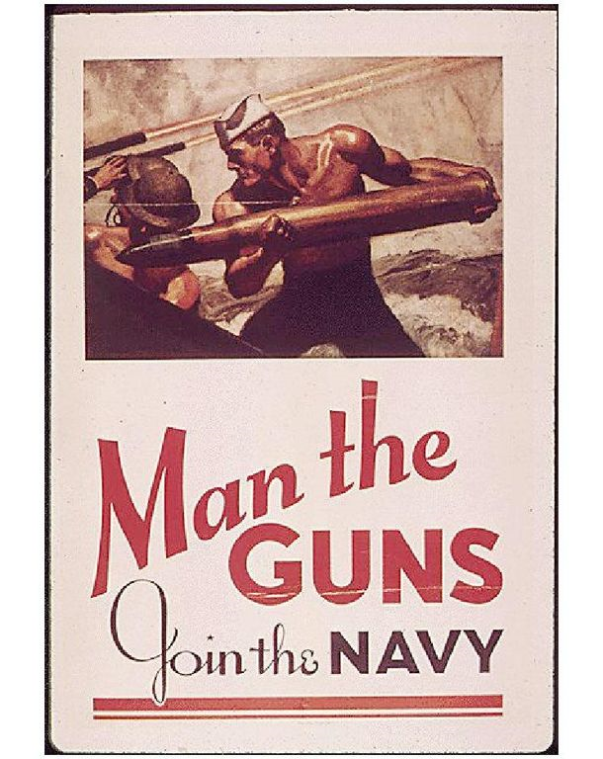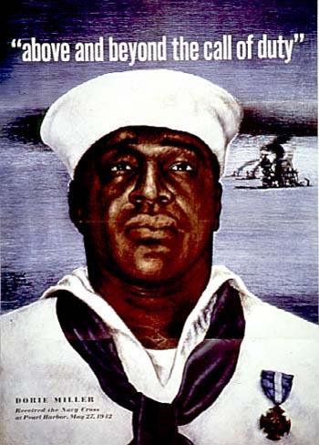

Vocabulary: Dorie Miller- (October 12, 1919 – November 24, 1943) was a cook in the United States Navy noted for his bravery during the attack on Pearl Harbor on December 7, 1941 when he took command of an anti-aircraft gun and began to fire at Japanese planes. He was the first African American to be awarded the Navy Cross, the third highest honor awarded by the US Navy at the time
- Who were these posters meant for?

- Using the men in the bottom and upper right posters, how did the government portray men who joined the service?

- Explain the slogan, “Above and beyond the call of duty.”

- Overall, would you have been inspired to act because of these posters?

Document 5:
Year | Total labor force (*1000) | Armed forces (*1000) | Unemployed (*1000) | Unemployment rate (%)
1939 | 55,588 | 370 | 9,480 | 17.2
1940 | 56,180 | 540 | 8,120 | 14.6
1941 | 57,530 | 1,620 | 5,560 | 9.9
1942 | 60,380 | 3,970 | 2,660 | 4.7
1943 | 64,560 | 9,020 | 1,070 | 1.9
1944 | 66,040 | 11,410 | 670 | 1.2
1945 | 65,290 | 11,430 | 1,040 | 1.9
1946 | 60,970 | 3,450 | 2,270 | 3.9
US Bureau of the Census; Bicentennial edition, Part 2, Chapter D, Labor, Series D 1-10
- What year saw the height of enlisted men in the armed services?

- How many men were in the service during the peak year?

- What event occurred in 1941 that spurred growth in enlistment?

- Explain why the lowest rate of unemployment occurred in 1944.

Document 6:
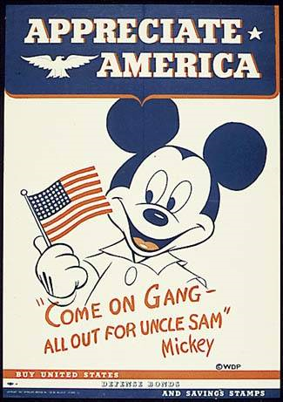
Little Orphan Annie
Jan. 28, 1943 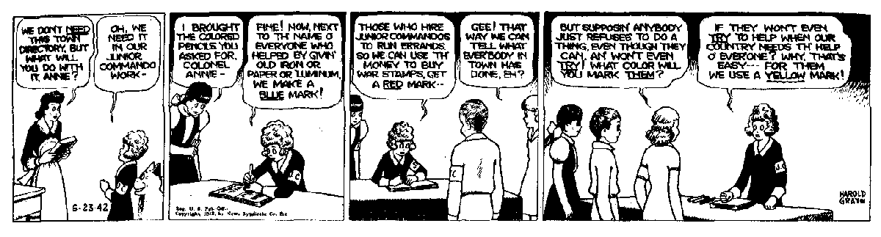

Vocabulary- Junior Commandos- a children’s organization in the popular comic strip “Little Orphan Annie” that sought to fight the Axis Powers and help out on the homefront
- Who was the target audience for these documents?

- Why would the OWI target this segment of society?

- How would you respond if the government was actively targeting this segment of society today?

- Asses why the American government would want to use Mickey Mouse and Little Orphan Annie.

Document 7:
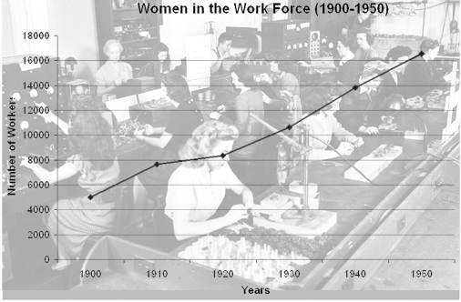
http://history.sandiego.edu
- What is the purpose of this graph?

- What years does it cover?

- Identify why the sudden spike in women joining the work force after 1935.

- State how the government did or did not influence this rate of work.

Document 8:
Vocabulary- Gallup Poll- an opinion poll of randomly chosen persons, used to represent the opinion of the public
Poll #1-
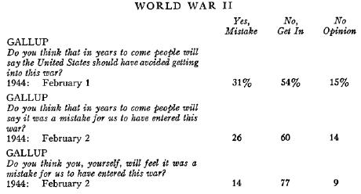
Poll #2-
Systematic polling of public opinion did not begin until the mid-1930s, so no poll of the public's support for World War I was taken during the war. But a Gallup poll conducted just after the Japanese attack on Pearl Harbor found that only 21% of Americans felt it was a mistake for the United States "to enter the last war (1917-18)," while 62% said it was not.
This Gallup Poll was taken before and after a CBS radio broadcast about a bombing and incendiary raid from London to Berlin

Poll #3-
A Gallup poll that was taken after the bombing of Pearl Harbor found that 97% approved of the United States entering the war against Japan. Another Gallup poll conducted two weeks later found Americans said, by 84% to 9%, that President Roosevelt had done everything he should have to prevent war with Japan.
http://www.gallup.com/poll/4954/support-war-terrorism-rivals-support-wwii.aspx

http://www.gallup.com/poll/4954/support-war-terrorism-rivals-support-wwii.aspx

- What was the purpose of the 1st Gallup Poll?

- What event occurred the night of February 1st 1944?

- What was the purpose of the 2nd Gallup Poll?

- There is a 6% increase of people whom feel the US wouldn’t regret getting involved in WWII, how would you account for this change?

- The second Gallup Poll was taken in late 1941; determine why a Gallup Poll would have been taken about WWI when it occurred over twenty years earlier.

- Who is the subject of the 3rd Gallup Poll?

- Provide reasoning as to why in the 3rd Poll the percentage would be so high.

Document 9:
Vocabulary- 5th Column- a group of people who are secretly trying to help out a foreign nation while living inside the foreign enemy’s land.
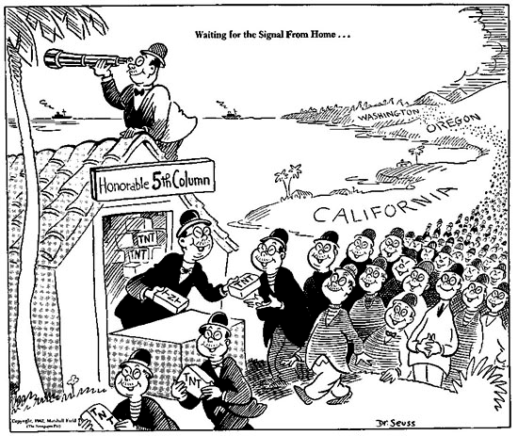
- Who is the negative target of this political cartoon?

- What is the man in the house handing out?

- Determine who the 5th Column is waiting for?

- In your own words, what is this cartoon inferring?

Vocabulary: War bonds- Stocks issued by a government for the purpose of financing military operations during times of war. War bonds generate capital for the government and make civilians feel involved in their national militaries
Document 10:
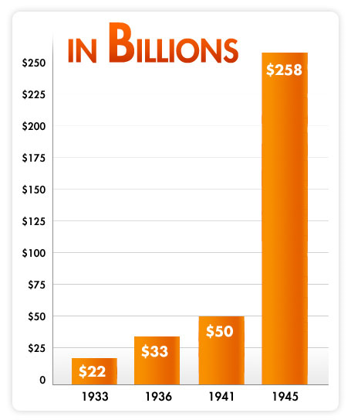
Number of War bonds purchased from 1933-1945
From: http://www.treasurydirect.gov/kids/history/history_ww2.htm
- What is this graph examining?

- What were War Bonds?

- In total, how many bond were sold from the start of WWII to the end of the war?

- Examine what could have caused such a spike in the sale of war bonds in four years.
Document 11:
The Boy Scouts of America wanted to be officially and formally recognized by President Roosevelt as America's main distributor of government information. On February 16, 1943, President Roosevelt signed a letter asking the scouts "to take an important commission as Government Dispatch Bearers for the Office of War Information." The Boy Scouts of America would become the "Official Dispatch Bearers" for the OWI; each scout would receive "a certificate commission for him to carry to the people of the community vital information prepared by the Government." Through this program, the federal government kept 1,600,000 young people working to spread its messages to civilians all across the country.
National Achieves Prolog MagazineSummer 2005, Vol. 37, No. 2
Getting the Message Out: The Poster Boys of World War II, Part 2
By Robert Ellis
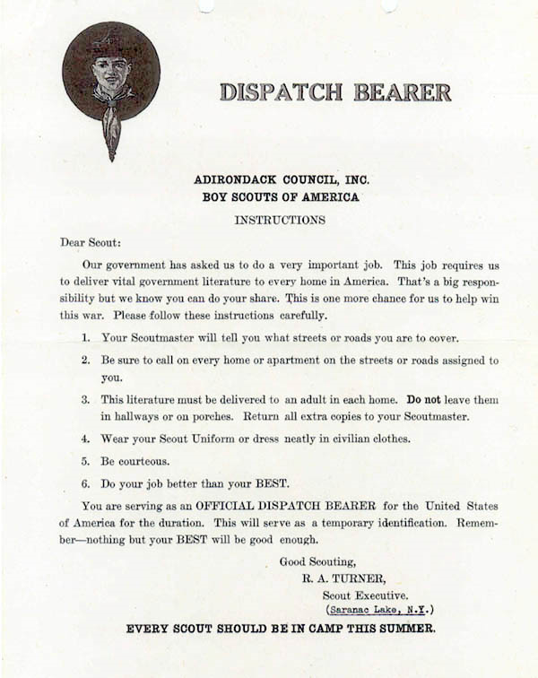

- What was the purpose of the Boy Scouts from 1943 to the end of WWII?

- Who commissioned them for this job?

- How many young boys were involved in this endeavor?

- Interpret how Dispatch Bearers purpose could affect their attitude towards the war.

STUDENT ASSESSMENT SHEET
Document 1:

Document 2:

Document 3:

Document 4:

Document 5:

Document 6:

Document 7:

Document 8:

Document 9:

Document 10:

Document 11:

Document Based Question Rubric
Characteristic | Score 8-9  87 or above | Score 5-7  77 or above | Score 2-4  67 or above | Score 0-1  66 or below
Thesis | Clear, well developed thesis | Contains a clear thesis with limited development | Lacks a thesis, or thesis may be confused or underdeveloped | No thesis
Understanding of the Question | Understands complexity of the question; deals with all parts of the question in depth | Limited or lack of understanding of complexity; may deal with one part of the question in some depth, or in a more general way | Ignores complexity; may deal with one part of the question, or all elements of the question in a superficial way | May simply paraphrase or restate the question
Analysis | Provides effective analysis of the question; some imbalance permissible | Limited analysis, mostly describes | Weak or inappropriate analysis | No analysis
Documentary Evidence | Effectively uses a substantial number of documents. Documents supplement analysis and are balanced with outside information | Effectively uses someof documents; may only restate information found in documents | Poor use of documents with only brief citation or paraphrase; not enough documents used to support analysis | Almost no use of or inappropriate attempts to use documents
Supportive Information | Supports thesis with substantial, relevant information. Outside information is balanced with use of documents in the analysis of the question | Supports thesis with some factual information | Lacks supporting information, or information given is minimal | Incompetent, inappropriate responses
Grammar and Structure | May contain insignificant errors | May contain minor errors that do not detract from overall essay | May contain major errors | Contains many major or minor errors
Organization and Writing Style | Well organized and well written | Clearly organized and written, but not exceptional | Weak organization and writing | Disorganized and poorly written

