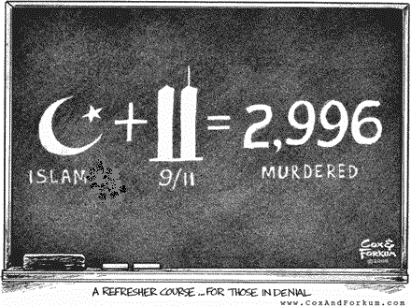
A mosque near Ground Zero:
Which would you support?

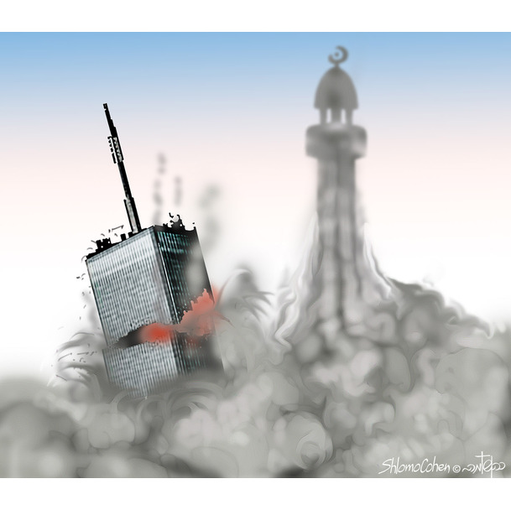
Name: Period: Mr. Lindberg World History

Extended Common Core Social Studies Lesson Plan Template

Lesson Title: A Mosque Near Ground Zero: Which would you support?
2
Author Name: Michael Lindberg

Contact Information: mjlindberg@washoeschools.net

Appropriate for Grade Level(s): 10-12

US History Standard(s)/Applicable CCSS(s):
H2.[9-12].25 Discuss major reasons for tensions and conflicts in the contemporary world and efforts that have been made to address them.
H3.[9-12].15 Explain the impact of the five major world religions on the world‘s political and social fabric.
H3.[9-12].16 Analyze the responses of individuals to restrictive social and political systems.
CCSS.ELA-Literacy.RL.11-12.1 Cite strong and thorough textual evidence to support analysis of what the text says explicitly as well as inferences drawn from the text, including determining where the text leaves matters uncertain.
CCSS.ELA-Literacy.RL.11-12.4 Determine the meaning of words and phrases as they are used in the text, including figurative and connotative meanings; analyze the impact of specific word choices on meaning and tone, including words with multiple meanings or language that is particularly fresh, engaging, or beautiful. (Include Shakespeare as well as other authors.)
CCSS.ELA-Literacy.W.11-12.1 Write arguments to support claims in an analysis of substantive topics or texts, using valid reasoning and relevant and sufficient evidence.
CCSS.ELA-Literacy.W.11-12.1a Introduce precise, knowledgeable claim(s), establish the significance of the claim(s), distinguish the claim(s) from alternate or opposing claims, and create an organization that logically sequences claim(s), counterclaims, reasons, and evidence.
CCSS.ELA-Literacy.W.11-12.1b Develop claim(s) and counterclaims fairly and thoroughly, supplying the most relevant evidence for each while pointing out the strengths and limitations of both in a manner that anticipates the audience’s knowledge level, concerns, values, and possible biases.
Engagement Strategy: DBQ/Fishbowl Discussion/Analytical Writing

Student Readings (list): All information taken from Procon.org

Total Time Needed: 3-4 periods

Lesson Outline:
Time Frame  (e.g. 15 minutes) | What is the teacher doing? | What are students doing?
Day 1
(90 min)
15 min | Teacher poses the following question on the board. What is the first thing that comes to mind when you think of someone who is Muslim? | Students are answering the question on a separate sheet of paper and are discussing their answers with the class.
20 min | Teacher hands out the DBQ and introduces the topic. Teacher then begins the videos in the hook exercise. The teacher then begins a brief discussion on what they saw. | Students are watching the hook exercise videos and responding to the questions afterwards. Students then respond to the videos as a whole class.
20 min | Teacher has students read the background essay and answer the questions independently | Students are reading the background essay and are answering the questions related to the information.
10 min | Teacher works with students to complete document A | Students are analyzing document A and responding to the questions related to the document as a whole class.
25 min | Teacher introduces the jigsaw activity for documents B,C,D,E. Students will be asked to put their packets away, and are assigned one document to complete. They are given the document on a separate sheet of paper. To do this hand out poker cards. (This depends on the class size of course yet I usually use Ace – 8). Students are to find people with the same card (find people with a 2, 3,4, etc.). The group will analyze and respond to all the questions pertaining to that document. Aces and 5’s will get doc B, 2 and 6’s doc C, 3 and 7’s doc D, and 4 and 8’s doc E. They will turn it in and be asked to find people who share the same suite as they do. For example find people who have hearts. To make this work with the numbers have the Ace, 2,3,4 find those who share the same suite and the 5,6,7,8’s as well. Now, each group should have a student who has become a pro at one of the documents. The person who had document B will read the document to the rest of the group and explain the answers. Document c will follow, etc. | Students are completing the jigsaw exercise as initiated by the instructor.
Day 2
(90 min)
25 min | Students are finishing the jigsaw activity as it was probably not finished the class before. | Finishing the jigsaw
20 min | Teacher goes over each document with the class to ensure how the students analyzed the documents was correct. | Students are explaining their analysis of documents B,C,D, and E.
30 min | Teacher assigns the remaining documents to be analyzed by the students in groups. | Students will work together in groups to analyze the remaining documents.
15 min | Teacher reviews each document to ensure understanding. | Students are responding to teacher’s prompts about each document.
Day 3
(90 min)
35 min | Teacher hands out the preparation for a discussion organizer to prepare students for the fish bowl discussion. Teacher posts question which will be asked during the fish bowl discussion to allow students to prepare. | Students are using their DBQ packets to complete the discussion template and prepare their answers to the fish bowl questions.
55 min | Teacher with the help from the students sets up the room for the fish bowl discussion and facilitates it. | Students are participating in the fish bowl discussion.
Day 4  (90 min) | Teacher assigns the Analytical essay. | Students write a four paragraph analytical essay responding to the essential question.

Description of Lesson Assessment: Analytical writing response

How will students reflect on the process and their learning? Analytical writing response

*All answers should be complete sentences completed on a separate sheet of paper, please.
A mosque at Ground Zero: Which would you support?
Trade Center Hook Exercise Videos
http://www.youtube.com/watch?v=Pp4jWMSAahc
http://www.youtube.com/watch?v=HRA0NKQ0k6E

- How do you feel after viewing these video clips?

- Would you support a mosque to be built near Ground Zero?

*All answers should be complete sentences completed on a separate sheet of paper, please.

Background Essay: From History.com
On September 11, 2001, at 8:45 a.m. on a clear Tuesday morning, an American Airlines Boeing 767 loaded with 20,000 gallons of jet fuel crashed into the north tower of the World Trade Center in New York City. The impact left a gaping, burning hole near the 80th floor of the 110-story skyscraper, instantly killing hundreds of people and trapping hundreds more in higher floors. As the evacuation of the tower and its twin got underway, television cameras broadcasted live images of what initially appeared to be a freak accident. Then, 18 minutes after the first plane hit, a second Boeing 767–United Airlines Flight 175–appeared out of the sky, turned sharply toward the World Trade Center and sliced into the south tower near the 60th floor. The collision caused a massive explosion that showered burning debris over surrounding buildings and the streets below. America was under attack.
The attackers were Islamic terrorists from Saudi Arabia and several other Arab nations. Reportedly financed by Saudi fugitive Osama bin Laden's al-Qaeda terrorist organization, they were allegedly acting in retaliation for America's support of Israel, its involvement in the Persian Gulf War and its continued military presence in the Middle East. Some of the terrorists had lived in the United States for more than a year and had taken flying lessons at American commercial flight schools. Others had slipped into the country in the months before September 11 and acted as the "muscle" in the operation. The 19 terrorists easily smuggled box-cutters and knives through security at three East Coast airports and boarded four flights bound for California, chosen because the planes were loaded with fuel for the long transcontinental journey. Soon after takeoff, the terrorists commandeered the four planes and took the controls, transforming ordinary commuter jets into guided missiles.
As millions watched the events unfolding in New York, American Airlines Flight 77 circled over downtown Washington, D.C., and slammed into the west side of the Pentagon military headquarters at 9:45 a.m. Jet fuel from the Boeing 757 caused a devastating inferno that led to the structural collapse of a portion of the giant concrete building. All told, 125 military personnel and civilians were killed in the Pentagon, along with all 64 people aboard the airliner.
Less than 15 minutes after the terrorists struck the nerve center of the U.S. military, the horror in New York took a catastrophic turn for the worse when the south tower of the World Trade Center collapsed in a massive cloud of dust and smoke. The structural steel of the skyscraper, built to withstand winds in excess of 200 miles per hour and a large conventional fire, could not withstand the tremendous heat generated by the burning jet fuel. At 10:30 a.m., the other Trade Center tower collapsed. Close to 3,000 people died in the World Trade Center and its vicinity, including a staggering 343 firefighters and paramedics, 23 New York City police officers and 37 Port Authority police officers who were struggling to complete an evacuation of the buildings and save the office workers trapped on higher floors. Only six people in the World Trade Center towers at the time of their collapse survived. Almost 10,000 others were treated for injuries, many severe.
Background about the Mosque from Procon.org (http://wtcmuslimcenter.procon.org/#background)
The Muslim community center debate traces back to the July 2009 purchase of an empty building (formerly a Burlington Coat Factory) at 45-47 Park Place, New York, NY, for $4.85 million in cash by real estate company Soho Properties. The purchase was led by developer Sharif El-Gamal and backed by an eight-member investment group, which also took over the lease of neighboring 49-51 Park Place for an additional $700,000. El-Gamal has refused to identify his fellow investors except for businessman Hisham Elzanaty, who claims to have provided most of the financing. Elzanaty has come under scrutiny for his 1999 donations to the Holy Land Foundation for Relief and Development, a popular Muslim charity that had its assets frozen by the US and EU governments for providing material support to Hamas.
Formal plans for the project were introduced at a meeting of the Finance Committee of Local Manhattan Community Board No. 1 on May 5, 2010, and approved by a 12-0 vote. Officially titled the Cordoba House, the plans called for demolishing the current buildings at 45-51 Park Place and replacing them with a $100 million facility that would include a mosque, a September 11th memorial, a library, a culinary school, a 500-seat auditorium, and recreation facilities such as a swimming pool, a gym, and a basketball court. The location is approximately one-tenth of a mile from the northern side of the World Trade Center site.
Background Essay Questions:
- Who was responsible for the attack on the World Trade Center?

- Why were the Trade Center buildings attacked?

- How were the terrorists able to accomplish the devastation they set out to create?

- At the end of the event what was the total cost of the attack?

- Explain the condition of the building Sharif El-Gamal purchased? Does the government have the authority to someone from purchasing it?

- Should it cause alarm or suspicion that El-Gamal will not disclose his investors? Why or why not?

- In addition to a mosque, what other facilities will be built at the proposed site?

- Considering the amount of damage the terrorists inflicted on New York City, would you support a mosque being built near the memorial?

*All answers should be complete sentences completed on a separate sheet of paper, please.
A mosque at Ground Zero: Which would you support?

Document A: Leslie Minora, The Village Voice. Sept. 10, 2010. http://blogs.villagevoice.com/runninscared/ground_zero_map090251.jpg

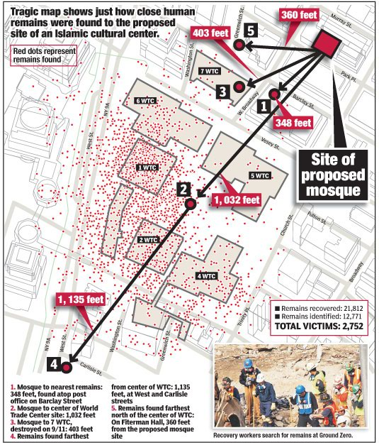

- How far were human remains found from the proposed site?

- How many feet away is the proposed mosque from the nearest WTC building that was destroyed?

- Should Americans consider the proximity of the mosque to Ground Zero a threat? Explain.

*All answers should be complete sentences completed on a separate sheet of paper, please.
A mosque at Ground Zero: Which would you support?

Document B: New York City Mayor Michael Bloomberg, August 3rd, 2010.
Excerpted.
…“Whatever you may think of the proposed mosque and community center, lost in the heat of the debate has been a basic question: Should government attempt to deny private citizens the right to build a house of worship on private property based on their particular religion? That may happen in other countries, but we should never allow it to happen here.
“This nation was founded on the principle that the government must never choose between religions or favor one over another. The World Trade Center site will forever hold a special place in our city, in our hearts. But we would be untrue to the best part of ourselves and who we are as New Yorkers and Americans if we said no to a mosque in lower Manhattan.
“Let us not forget that Muslims were among those murdered on 9/11, and that our Muslim neighbors grieved with us as New Yorkers and as Americans. We would betray our values and play into our enemies' hands if we were to treat Muslims differently than anyone else. In fact, to cave to popular sentiment would be to hand a victory to the terrorists, and we should not stand for that.”

- How would you respond to the question posed by Mayor Bloomberg stating, “Should government attempt to deny private citizens the right to build a house of worship on private property based on their particular religion?” Explain.

- Explain what Mayor Bloomberg means in the first sentence of paragraph two in your own words.

- What is Mayor Bloomberg referring to when he states, “…we would be untrue to the best part of ourselves…”?

- By denying a mosque to be built, how could that be a victory to the terrorists?

Vocabulary: Sentiment- feeling or emotion.
*All answers should be complete sentences completed on a separate sheet of paper, please.
A mosque at Ground Zero: Which would you support?

Document C: Simon Deng is an American citizen from southern Sudan. He is also an escaped slave. He is a leading human rights activist who speaks out about genocide perpetrated against blacks by Arab Muslims in Sudan http://www.lookingattheleft.com/2010/06/stop-the-mosque-at-ground-zero-part-ii/#more-7986

“This is an insult to America and this is an insult to New Yorkers. I’m outraged. I’m so mad and upset because of the insult to those who died here. The last words of the terrorists, it was Allah hu Akhbar when they came to kill us. And they want to build a mosque to say every single minute “Allah hu akbar” every minute here.
- Deng states building a mosque at Ground Zero would be an “insult” to New Yorkers and Americans. Would a mosque at Ground Zero be an insult?

- What bias does Deng have toward Muslims? Is that bias valid? Should it be taken into consideration when answering the essential question?

Vocabulary: Allah the almighty or the greatest.
*All answers should be complete sentences completed on a separate sheet of paper, please.
A mosque at Ground Zero: Which would you support?

Document D: President Barrack Obama speaking to a group of Muslims during an Iftar occurring during the month long Ramadan celebration.
…But let me be clear. As a citizen, and as President, I believe that Muslims have the same right to practice their religion as everyone else in this country. (Applause.) And that includes the right to build a place of worship and a community center on private property in Lower Manhattan, in accordance with local laws and ordinances. This is America. And our commitment to religious freedom must be unshakeable. The principle that people of all faiths are welcome in this country and that they will not be treated differently by their government is essential to who we are. …

- The First Amendment of the U.S. Constitution states Americans have the freedom to worship and follow any religion they choose. To what extent does denying the building of a mosque at Ground Zero violate religious freedom?

- Based upon Obama’s statement, should Muslims be allowed to build a mosque near ground zero?

Vocabulary: Iftar (sunset meal): The name of the meal Muslims have when they break their fast during the day time hours during the month of Ramadan.

*All answers should be complete sentences completed on a separate sheet of paper, please.
A mosque at Ground Zero: Which would you support?

Document E: Vinny Forras is a highly decorated firefighter from Westchester and was one of the first responders. http://www.lookingattheleft.com/2010/06/stop-the-mosque-at-ground-zero-part-ii/#more-7986
We, the people, are still under attack, today. Planes rammed into these buildings on 9/11, but what’s happening here with this mosque is a continuation of the attack on all of us. I liken it to the Twilight Zone, where everything you believe that can’t happen does happen…

I look around and I see the photographs of loved ones lost that appeared in this park when we were here nine years ago. Those families still die a little bit every single day, at the loss of their loved ones. How the hell can we justify more madness right here in our own back yard? I’m telling you now, guys, unless we the people stand up to this insanity, the attacks will continue on all of us. Every American must remember what happened here on this pile not so long ago, and to consider that we have the insane suggestion to build a mosque it is really a mockery on all of you, every one of you. - See more at: http://www.lookingattheleft.com/2010/06/stop-the-mosque-at-ground-zero-part-ii/#more-7986

- How might a mosque at Ground Zero be a continuation of the 9/11 attack?

- In your opinion, would a mosque be a mockery to the victims and the families of the 9/11 attack?

Vocabulary: Twilight Zone- Science Fiction television show from the 1980’s
Mockery- Tease or Taunt.

*All answers should be complete sentences completed on a separate sheet of paper, please.
A mosque at Ground Zero: Which would you support?

Document F: Speaker of the House of Representatives, John Boehner, August 13, 2010.

The decision to build this mosque so close to Ground Zero is deeply troubling, as is the president's decision to endorse it. The American people certainly don't support it.
"The fact that someone has the right to do something doesn't necessarily make it the right thing to do. That is the essence of tolerance, peace and understanding. This is not an issue of law, whether religious freedom or local zoning. This is a basic issue of respect for a tragic moment in our history.
"We can never forget that terrible day, and the heroes who lost their lives - often in the hope that others might live. We honor their memory and their sacrifice, always."
- See more at: http://www.speaker.gov/press-release/boehner-statement-construction-mosque-near-ground-zero#sthash.Q02eTSsh.dpuf

- What does Boehner mean at the beginning of the second paragraph when he states, “The fact that someone has the right to do something doesn’t necessarily make it the right thing to do.”?

- Explain what Boehner is saying in the last sentence of paragraph two.

- Compare and contrast Boehner and Obama’s statements. Who makes a better point about a mosque being built near Ground Zero? Why?

Vocabulary: Essence- the core or heart.

*All answers should be complete sentences completed on a separate sheet of paper, please.
A mosque at Ground Zero: Which would you support?

Document G: CNN Poll Interviews with 1,009 adult Americans, including 935 registered voters, conducted by telephone by the Opinion Research Corporation.

As you may know, a group of Muslims in the U.S. plan to build a mosque two blocks from the site in New York City where the World Trade Center used to stand. Do you favor or oppose this plan?

Aug. 6,2010

Favor 29%

Oppose 68%

No opinion 3%

1. Based upon this poll, what is most important, Constitutional freedoms or the opinion of the people? Explain.

*All answers should be complete sentences completed on a separate sheet of paper, please.
A mosque at Ground Zero: Which would you support?

Document H: Political Cartoons from Adam Zyglis of The Buffalo News 2010 and Matt Wuerker from Politico

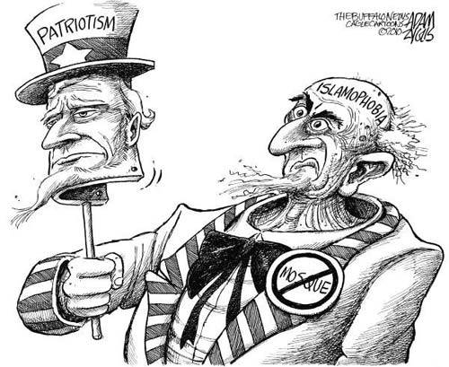
- Who is depicted in the cartoon?

- What is the message of the cartoon?

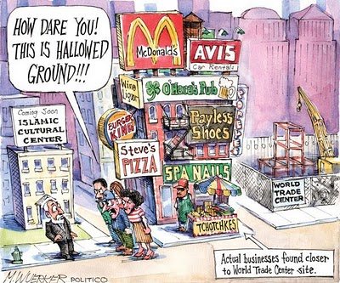

- What does the cartoonist mean by “hallowed ground”?

- What message is the cartoonist trying to make?

- Do you agree or disagree with cartoonists message? Explain.

Fish Bowl Note Taker

Before Discussion
Your Initial stance: (“I Believe…”)

3 Pieces of Evidence:

During Discussion
Rebuttal to someone who disagrees with you: (insert name) brings up an interesting point, because

1 piece of Evidence:

1St Question for others:

2nd Question for others:

After Discussion
Did your opinion change: (Circle One)
Yes or No
Reason: (whether Yes or No)

New Ideas or concepts you hadn’t thought of:

Mosque Discussion Questions
-Which is more important: The rights of private property (building) owners or the rights of the victims and their families?

-Is a mosque two blocks away from the Ground Zero Memorial too close? What would be a sufficient distance? (feeling question)

-Is it fair in this instance to deny American citizens the right to build a place of worship?

-Is a mosque near ground zero an insult and disrespectful to America?

-Is America Islamaphobic? (feeling question)

-If the U.S. does not allow the mosque is America guilty of discrimination?

-Should the opinion of the people outweigh the Constitutional rights of citizens?

“THE FISHBOWL”

CLASS DISCUSSION TECHNIQUE

Place five seats in a a circle in the center of the room.

Push all other seats to the wall for non-participants.

The five students in the circle, the fishbowl, are the only ones allowed to speak in the room. There is to be no conversation outside of the circle. The teacher chooses the first students in the circle, at random.

The students engage in debate on the issue presented, as an open-ended question, by the teacher.

All participants must abide by the rules of civic discussion. These rules are provided in the discussion rubric.

The participants must also operate under the standards of common courtesy. (No yelling, no interrupting, no name-calling, etc.)

Once a student in the circle has spoken, a student from outside the circle may come and tap that student. The student in the circle must then give the one who tapped them their seat and return to the outside observation seats. The new entrant may not be tapped until he or she has spoken at least once.

Students, once removed from the circle, may return at any time. (They may not be tapped until they have spoken again.) The teacher may grant preferential seating to students who have not yet participated in the debate.

The teacher does not participate in the discussion except to provide a new question or to terminate an irrelevant, or inappropriate, line of discussion.

Discussion Rubric (SS100505)

Discussion Rubric | 3 | 2 | 1 | 0
Substantive
States and identifies issues. | Accurately states and identifies issues. | Accurately states an issue. | States a relevant factual, ethical, or definitional issue as a question. | Does not state any issues.
Uses foundational knowledge. | Accurately and expresses completely relevant foundational knowledge pertaining to the issues raised during the discussion. | Accurately expresses mostly relevant foundational knowledge pertaining to issues raised during the discussion. | Accurately expresses somewhat relevant foundational knowledge pertaining to an issue raised by someone else. | Does not express any relevant foundational knowledge.
Elaborates statements with explanations, reasons, or evidence. | Pursues an issue with more than one elaborated statements. | Pursues an issue with one elaborated statement. | Elaborates a statement with an explanation, reasons, or evidence. | Does not elaborate any issues.
Procedural
Invites contributions from, and acknowledges statements of, others. | Engages others in the discussion by inviting their contributions and acknowledging their contributions. | Invites comments from others and does not acknowledge their statements. | Does not invite comments from others but allows others to speak. Does not acknowledge contributions from others. | Does not invite comments from others nor acknowledge their statements.
Challenges the accuracy, logic, relevance, or clarity of statements. | Constructively challenges the accuracy, clarity, relevance, or logic of statements made. | Responds in a civil manner to a statement made by someone else by challenging its accuracy, clarity, relevance, or logic. | Responds in a civil manner but does not challenge the accuracy, clarity, relevance, or logic of statements. | Does not respond in a civil manner in all conversations. Does not challenge the accuracy, clarity, relevance, or logic of statements.

Adapted from Harris, David E. “Assessing Discussion of Public Issues: A Scoring Guide.” In Handbook on Teaching Social Issues, edited by Ronald W. Evans and David Warren Saxe. Washington, D.C.: National Council for the Social Studies, 1996.

Analytical Writing Rubric
Required Essay Elements | Score & Feedback
 | Total Possible |  | Points Identified | Components | Done Well & Suggestions for Improvement
INTRODUCTION
Grabber/Hook | 1 |  |  | Hook ineffective  No Historical background provided  Incorrect information  Super Claim not stated  Super Claim unclear  2 claims not declared  Claims unclear
Historical Background/Context | 2
Restatement of the Question | 1
Super Claim (Thesis Statement) | 4
FIRST ARGUMENT
Claim | 3 |  |  | Claim missing  Reasoning unclear or does not demonstrate link to claim  Document(s) not cited  Evidence doesn’t support claim
Evidence #1 with citation from document or text | 3
Reasoning links evidence/claim | 4
Evidence #2 with citation from document or text | 3
Reasoning links evidence/claim | 4
SECOND ARGUMENT
Claim | 3 |  |  | Claim missing  Reasoning unclear or does not demonstrate link to claim  Document(s) not cited  Evidence doesn’t support claim
Evidence #1 with citation from document or text | 3
Reasoning links evidence/claim | 4
Evidence #2 with citation from document or text | 3
Reasoning links evidence/claim | 4
CLOSING STATEMENT
Restatement of Super Claim |  | 2 |  | No conclusion  Missing super claim  Missing counterclaim  Evidence & reasoning are not Strong
Restatement of Best Evidence/Reasoning |  | 2
Counterclaim (“Although”)/ with Evidence |  | 2
Refute counterclaim |  | 2
TOTAL SCORE (50):

