21 Predictions for 1993 from 1893
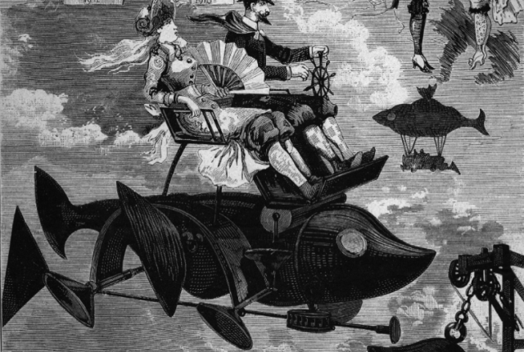
The future just isn’t what it used to be. As a prelude to the 1893 World’s Fair in Chicago, the American Press Association asked 74 of America’s best thinkers to predict what the 1990s would be like. The answers ranged from the grossly wrong to the freakishly prophetic.

1. Mary E. Lease, Political Activist
“Three hours will constitute a long day’s work by the end of the next century.”

2. Thomas De Witt Talmage, Preacher
“Longevity will be so improved that 150 years will be no unusual age to reach.”

3. Asa C. Matthews, Comptroller of the Treasury
“In the 1990s, the United States will be a government of perhaps 60 states, situated in both North and South America.”

4. Nym Crinkle, Critic
“In 100 years Denver will be as big as New York and . . . if the republic remains politically compact and doesn’t fall apart at the Mississippi River, Canada will be either part of it or an independent sovereignty.”

5. Charles B. Lewis, Humorist
“We shall not only restore the dress of our great-grandfathers before we stop, but run the costumes of Adam and Eve a pretty close shave.”

6. Van Buren Denslow, Professor
“Trousers will be relegated to bookkeepers, barbers, pastry bakers, and cripples.”

7. Kate Field, Journalist
“The waist line will be just below the bosom.”

8. Edgar W. Nye, Humorist
“Politically, there will be far less money expended in electing officials, I fancy. And many of our leading politicians out of a job will be living on the island.” [That is, incarcerated].

9. Erastus Wiman, Journalist
“There will be no need of a standing army.”

10. John Habberton, Author
“All marriages will be happy—for the law will put to death any man or woman who assumes conjugal position without the proper physical, mental, and financial qualifications.”

11. Thomas Dixon Jr., Minister
“Law will be simplified and brought within the reach of the common people . . . The occupation of 2/3 of the lawyers will be destroyed.”

12. Felix Oswald, Naturalist
“Transcontinental mail will be forwarded by means of pneumatic tubes.”

13. Samuel Barton, Financier
“Transportation facilities will have so improved that the orange district of Florida will practically furnish the United States all the oranges that it requires.”

14. George F. Kunz, Mineralogist
“We are going to see a wonderful development in the use of jewels in American churches.”

15. E. J. Edwards, Journalist
“By the year 1993, the mechanical work of publishing newspapers may be done entirely by electricity.”

16. Thomas L. James, U.S. Postmaster General
“Postage will be reduced to one cent.”

17. John Clark Ridpath, Editor
“Aluminum will be the shining symbol of that age. The houses and cities of men, built of aluminum, shall flash in the rising sun with surpassing brilliance.”

18. John Ingalls, Lawyer
“Long before 1993, the journey from New York to San Francisco, and from New York to London, will be made between the sunrise and sunset of a summer day. The railway and the steamship will be as obsolete as the stagecoach.”

19. Terence V. Powderly, Union Leader
“Labor organizations will have disappeared, for there will be no longer a necessity for their existence.”

20. Ella Wheeler Wilcox, Poet
"Mesmerism will take the place of anesthetics in surgery. Theosophy—the religion of high thinking and selfless living—will take the place of creeds and dogmas. Clairvoyancy or spiritual insight will be almost universal."

21. James William Sullivan, Editor
“I find that I am unable to prophesy. The future is a fancyland palace whose portals I cannot enter.”

You can find these predictions and more in Dave Walter’s book, Today Then.

