Kids on the Trail West:
Document Based Question
TAH DBQ 2011
Kristin Campbell KCampbell@washoe.k12.nv.us
Drake Elementary School
TAH DBQ 2011
KCampbell@washoe.k12.nv.
Source: http://www.lib.utexas.edu/maps/historical/west_expansion_1803-1807.jpg
Background Essay: Kids on the Trail West
Some forty thousand children participated in the great overland journeys from the banks of the Missouri River to the shores of the Pacific Ocean between the years of 1841 and 1865. (Werner, 1995) It is estimated that one out of every five pioneers was a child. (Bureau of Land Management, 2009) There are a limited number of first-hand accounts from these children, but based on the journal entries, diaries, and other related sources from the children themselves or families they came in contact with, a picture of what life on the trail must have been like for its youngest members begins to unfold. The hardships and adventures are taken together to bring history to life and provide a historical reference from a childhood viewpoint.
In the span of five years, the United States increased its size by a third. It annexed Texas in 1845; negotiated with Britain for half of the Oregon country; and acquired California, Nevada, Utah, and parts of Arizona, Colorado, New Mexico, and Wyoming as a result of a war with Mexico. (Mintz, 2007) Explorer, John C. Fremont’s glowing descriptions of the West as a paradise of plenty captivated the imagination of many Midwestern families who, by the 1840s, were eager for new lands to settle. (Mintz, 2007) As families packed up their possessions and headed toward a better future, the children in these families prepared to leave behind their friends, other family members, and toys to set out on the trail west. The journey often took five to six months.
There were many hardships to traveling more than 2,000 miles – not only did the journey take a long time, but most of the children walked. (Bureau of Land Management, 2009) While riding in the wagon might seem appealing, the wagons were laden with supplies and the trails were uneven and rocky which jostled the contents of the wagon. Children rode in the wagon when they were too tired or too sick to walk. Sickness, disease, and starvation were also hardships on the trail. Many children lost their parents and other family members to death and disease on the long journey and were left orphans or taken in by others traveling on the trail. Often there were accidents that killed the young pioneers or left them injured and unable to walk so they would have to ride in the wagon.
Children also rode in the wagon when the weather was severe. Sometimes there were terrific thunderstorms which scared children and animals, and blew tents down. Dust was a big problem as the pioneers walked along the trail. The dust would get in their eyes and choke their breathing. (Bureau of Land Management, 2009) The children would ride the storm out in the wagon wedged in with all the food and supplies. The jostling of the wagon did manage to churn fresh cream placed in a pail into butter by suppertime. Many pioneers traveled with cows so they children could have fresh milk. Occasionally, the pioneers would hunt or fish for fresh meat, but for the most part the food (when available) was the same day after day –
Sallie Hester (14 years old):
"We live on bacon, ham, rice, dried fruits, molasses, packed butter, bread, coffee, tea and milk as we have our own cows." (Werner, 1995)

Despite the monotony of life on the trail, many children enjoyed the journey. There was time for playing and exploring. The pioneer kids saw many interesting sites along the trail – herds of buffalo, Native Americans, waterfalls, hot springs, and many now famous landmarks like Chimney Rock, Devil’s Gate and Independence Rock. (Werner, 1995) In addition to exploring, children picked flowers, played with animals and their friends. They played games such as London Bridge, run sheep run, leap frog, button-button, prisoner's base, Flying Dutchman, anti-I-over, and pom-pom-pullaway. (Bureau of Land Management, 2009)
Most pioneer children had regular chores while on the trail. The children were often in charge of herding the cattle and milking the cows. Both boys and girls sometimes drove the ox teams that pulled their wagons. Kids also helped with cooking and washing dishes, and watched after younger children. An important job was fetching water, and gathering firewood and "buffalo chips," dried buffalo manure used for campfires when no wood could be found. (Bureau of Land Management, 2009) Although they did chores, most kids set aside their education while on the trail. Some of the children wrote letters and kept diaries while they were traveling. The letters could be sent from military posts or given to someone traveling in the direction of the recipient, but often times the children did not write about their experiences on the trail west until they were adults. There was not a lot of reading material on the journey – like toys, there was not much room for books, but most families had a Bible, and many of the children read from the family Bible to improve their reading skills. Although pioneer kids learned a lot from their adventures on the trail, formal classes often waited until they reached their settlements in the West.
Whether the children’s experience on the trail was a wonderful adventure or a tremendous hardship quite obviously depends upon the outcome of their journey. Providing students an opportunity to draw their own conclusions and support their findings is the basis for this Document Based Question – “Kids on the Trail West.”

Background Essay References
Bureau of Land Management. (2009). Oregon State Office BLM. Retrieved 2011, from Just for Kids - Trail Kids/Oregon: http://www.blm.gov/or/oregontrail/education-kids-trail.php
Mintz, S. (2007). Westward Expansion. Retrieved 2011, from Digital History: http://www.digitalhistory.uh.edu
Werner, E. E. (1995). Pioneer Children on the Journey West. Boulder: Westview Press.

Student Instructions
Use at least 4 of the DBQ documents to create a RAFT response. Your response will be graded according to the attached rubric.

R – Role – You are a pioneer kid traveling west with a wagon train.

A – Audience – Your audience is your future family members – you are leaving a record of your journey.

F – Form – The form your writing will take will be a diary or journal entry.

T – Time – Between the years 1841 – 1846.

Document A

Key Vocabulary
romped: played
oxen: cattle
spite: (in spite of) regardless
fetching: gathering
journeyed: traveled
canvas: thick cotton material
backwoods: country
fording: wading through
stern :back
claim: land
rigged: created
sultry: hot and humid
halted: stopped
unyoked: untied
lolling: sit, stand or lie in a relaxed way

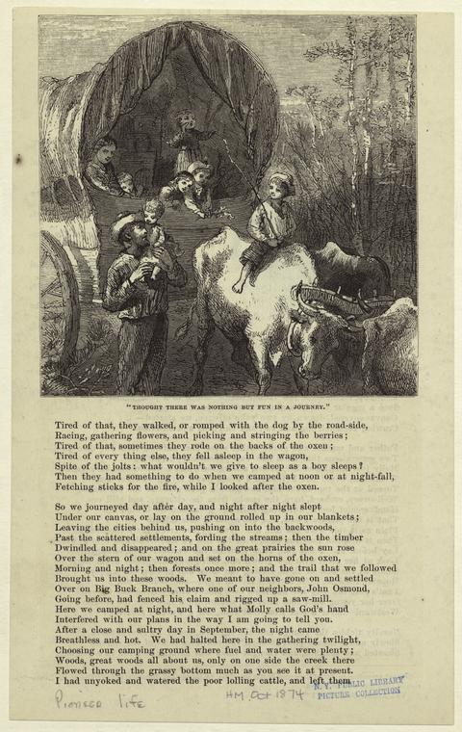
Source Information: “Thought There Was Nothing But Fun in a Journey” created by W. Harry Rogers (Engraver 1825-1873) Originally published in Harper’s magazine (1874)
Document A Questions
- What is the title of the picture?
_________________________________________________
- How many children are pictured? ____________
- Use the first paragraph of the article to summarize 3 things pioneer kids would do on the trail:

- ____________________________________________
- ____________________________________________
- ____________________________________________

- How does the title compare to the content of the article?
The title suggests they thought they would have fun on their trip. The article ____________________________________________
_____________________________________________________
_____________________________________________________
_____________________________________________________
_____________________________________________________
_____________________________________________________
- Use a Post-it note to come up with a prediction for what happened next in the article.
Document B
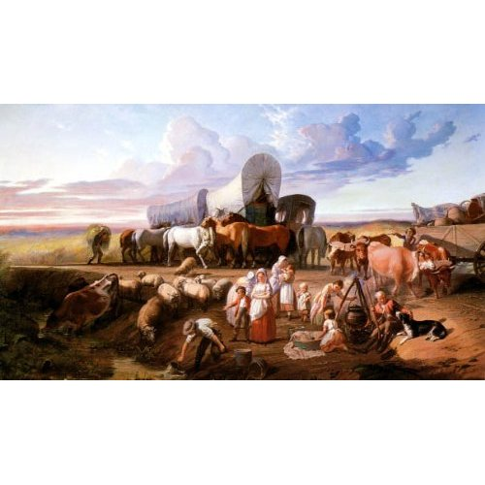
The Emigrant Train Bedding Down for the Night by Benjamin Franklin Reinhart (courtesy The Corcoran Gallery of Art, Washington, D.C.)

Document B Questions
- What is the title of the painting? ____________________
___________________________________________________
- What kinds of activities are pictured in the painting?

- Based on the setting of the picture make the following predictions:
- What time of year do you think it is? Why? ________
_________________________________________________
- Why do you think the group stopped at this location? __
_________________________________________________
_________________________________________________

Document 1C
Source Information: Werner, E. E. (1995). Pioneer Children on the Journey West. Boulder: Westview Press.

Document Note: Benjamin Franklin Bonney was seven when he, his parents, and four sisters and two brothers left Illinois in 1845 headed for Oregon. Later, they changed directions and went to California.
Document
Benjamin Franklin Bonney
The thunder [in Nebraska] seemed almost incessant, and the lightning was so brilliant, you could read by its flashes…. Our tents were blown down as were the covers of our prairie schooners and in less than five minutes we were as drowned rats. Unless you have been through it, you have no idea of the confusion resulting from a storm on the plains, with the oxen bellowing, the children crying and the men shouting…with everything as light as day and the next second as black as the depth of a pit.

Key Vocabulary
incessant: non stopping
schooners: wagons

Document 2C
Source Information: Werner, E. E. (1995). Pioneer Children on the Journey West. Boulder: Westview Press.

Document
Document Note: Sarah Ide was seventeen in 1845 when her family departed from Springfield, Illinois for California.
Sarah Ide
On April 1st we bid our good friends farewell. It was a sad day for us. All our old neighbors came to help us pack our things into our three wagons, and we set off…. We packed our cooking utensils, tin cups, tin plates—with provisions to last six months. Mother, my little brothers—Daniel, aged ten, and Lemuel, aged eight, and Thomas Crafton, all rode in a wagon. Our drove of cattle numbered 165, including 28 working oxen….
Some of our best oxen became poor and unfit for work, and were left on the sandy desert, some 40 miles this way of it, to shirk for themselves; and they probably died, or were “cared for” by the Indians. An ox would lie down in his yoke, and could not be got up; so we would unyoke and leave him.
After passing the 40 mile desert, and crossing the Truckee River thirty two times, we came to Truckee Lake…some of the way being obliged to drive our wagon the edge of the Lake; some of the time the water coming almost to our feet—keeping the women in constant dread of being drowned. It was a fearful time for the timid female passengers, both young and old. At night we camped at the foot of the Sierra Nevada; and were told by the Pilot that we would have to take our wagons to pieces, and haul them up with ropes.
[The men built a road out of stones and dirt.] It took us a long time to go about two miles over our rough, new-made road up the mountain, over the rough rocks, in some places, and so smooth in others, that the oxen would slip and fall on their knees; the blood from their feet and knees staining the rocks they passed over. Mother and I walked, (we were so sorry for the poor, faithful oxen), all those two miles—all our clothing being packed on the horses’ backs. It was a trying time—the men swearing at their teams, and beating them most cruelly, all along the rugged way.
Key Vocabulary
utensils: tools yoke: collar timid: shy or worried
Document 1C and 2C Questions
- What is happening in Document 1C?
____________________________________________________
- Where was Sarah in Document 2C? How do you know?
____________________________________________________
____________________________________________________
- What were some of the hardships and difficulties children faced as they and their families traveled the overland trails?
_____________________________________________________
_____________________________________________________
_____________________________________________________
_____________________________________________________
- Use Documents 1C and 2C to describe 3 ways pioneer or frontier children lives are different from yours.

Document D
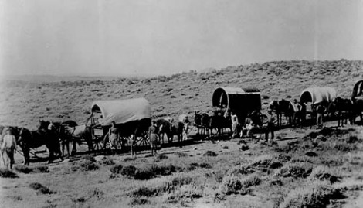
Source Information: Denver Library. U.S. History Document Based Activities Using Primary Sources in the Middle Grades. (2003) Educational Impressions.

Document Note: The following is an excerpt from the memoirs of a woman named Harriet Palmer. They describe the six-month journey she took with her family along the Oregon Trail when she was eleven.

Crossing the Plains

On and on we journeyed – averaging 15 miles a day over cactus, sagebrush, hot sands. Everybody’s shoes gave out and we bartered with Indians for moccasins, but that didn’t help much about prickly pears. One by one the oxen fell by the way…August passed. We were nearing the Cascade Mountains. The oxen were worn out, and the wagons were in poor condition to cross mountains. Some wagons had to be left; some of the oxen were poisoned eating mountain laurel. Our provisions were exhausted by this time, and for three days we had only salal berries and some soup made by thickening water, from flour shaken from the remaining flour sack…
Key Vocabulary
bartered: traded prickly pears: cactus provisions: supplies
Document D
- Based on the picture and the excerpt what kind of terrain was the wagon train crossing?
- Forest
- Plains
- Desert
- Mountains

- What did the pioneers do when their shoes wore out? ____
____________________________________________________
- What were some of the obstacles faced by Harriet Palmer’s family? __________________________________________
_____________________________________________________
_____________________________________________________
- Do you think Harriet Palmer would consider life on the trail as a wonderful adventure? Why or Why not? ____________
_____________________________________________________
_____________________________________________________
_____________________________________________________
_____________________________________
Document E
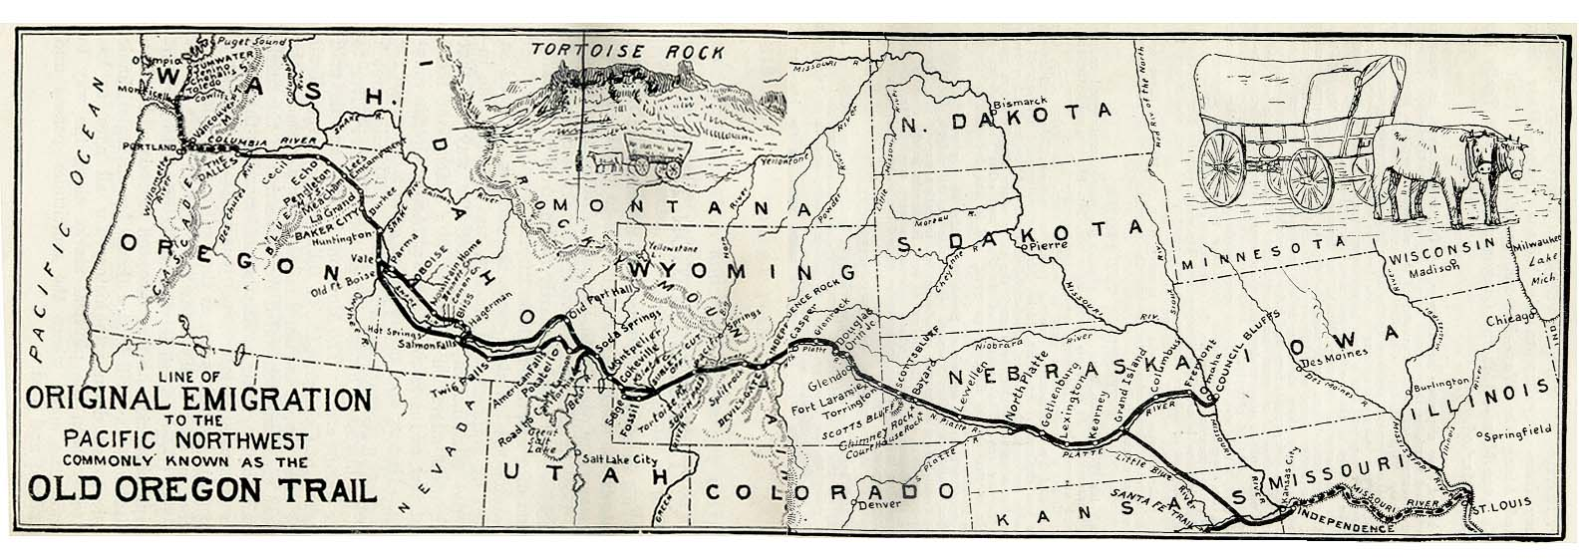
Information Source: Oregon Trail Historical Map (www.lib.utexas.edu)
Document E Questions
- Where does the Old Oregon Trail start?
- Oregon
- Nebraska
- Wyoming
- Missouri

- How many states does the Old Oregon Trail go through? _________

- What map feature is depicted by a sketch? Why do you think the map creator sketched that particular feature? __________________
____________________________________________________________
____________________________________________________________

Document F
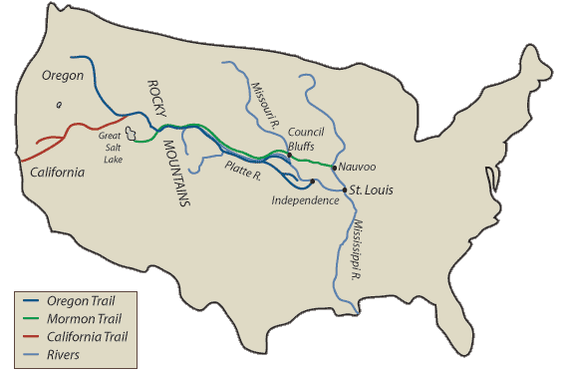
Information Source: http://overlandtrails.lib.byu.edu/trailmap.html
Document F Questions
- Which trails are shown on the map? ____________________________
______________________________________________________________
- Which mountains do all the trails go through? ___________________
- Which trail would you need to take to if you were a pioneer headed to your home? Use map details to support your answer.
______________________________________________________________
______________________________________________________________
______________________________________________________________
Teacher Instructions
http://writingfix.com/wac/RAFT.htm
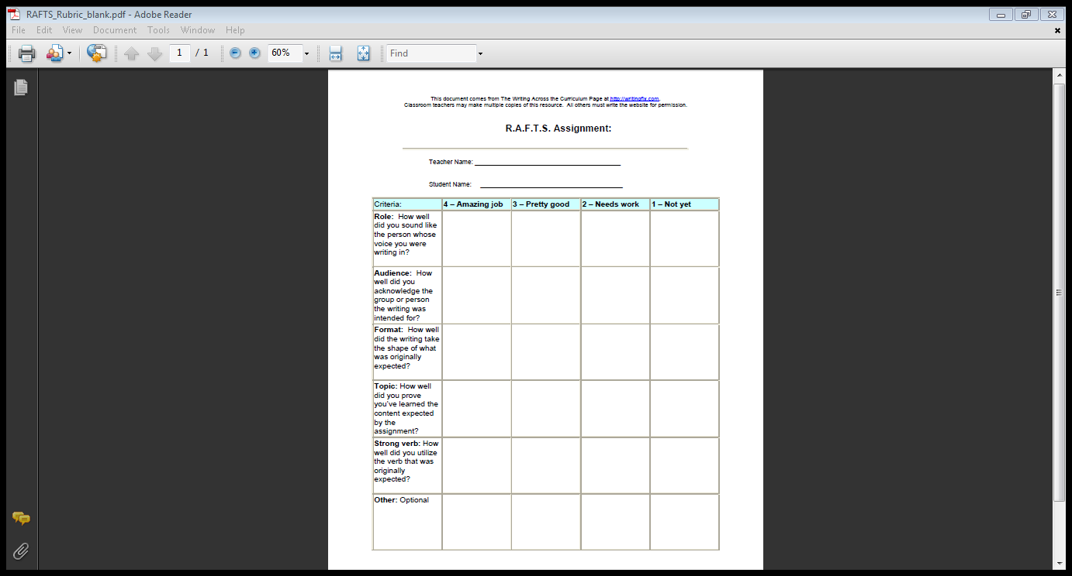
Writing Fix website has an excellent rubric for grading RAFT writing assignments.
Documents A and B should be completed whole group.
Documents 1C, 2C, and D should be completed in small groups or partners.
Documents E and F are meant to be completed independently.
Students should share their RAFT writing responses with their groups or the entire class.
The cumulating activity would be conducted during computer instruction with students playing the “Oregon Trail” computer game.

