Inca Bridges
The difficult terrain within the Inca Empire required that the Inca become superb bridge builders. They constructed many types of bridges—suspension, pontoon, cantilever, and clapper—all of which had their own special names. The generic name for bridge was chaca.
With no wood readily available and with no knowledge of the arch used in cantilever bridges, the Incas perfected the suspension bridge. The most magnificent of these was the bridge spanning the Apurimac River constructed in 1350 CE when the Inca broke out of their traditional territory and had to span the river to move northward. Each main cable was 148 feet long, with an additional 40-foot
length for anchoring the bridge. They were as thick
as a man's body, twisted and plaited, and made
from fibers from the cabuya plant, the same
materials from which modern rope is made. The
cables had to be replaced every two years. The
Apurimac River bridge lasted from 1350 to 1890,
when it was finally abandoned. Without scores
of bridges, the Inca road system would have been
unworkable, and without the roads, the Inca
Empire itself would have been impossible.
Gabriel, Richard A. "Inca bridges." World History: Ancient and Medieval Eras. ABC-CLIO, 2014. Web. 5 May 2014.
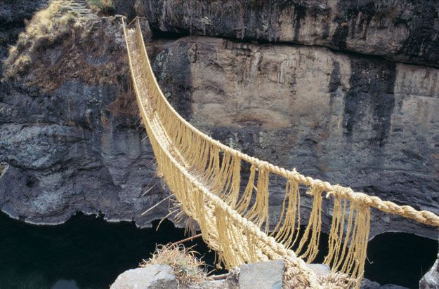 Apurimac River Bridge, Peru
1a. The Latin root “terra” means earth. How does knowing the meaning of the root help you to
understand the words terrain on line 2 and the word territory on line 10? ____________________
________________________________________________________________________________
1b. What other context clues appear near each of these words? Annotate your answer by circling the
word in the text.
2. The word readily appears on line 7. What word could you replace readily with, without changing
the meaning of the sentence? ________________________________________________________
3a. The word suspension on line 8 has many different meanings. Brainstorm different uses of this word.
How is the word used in this context? _________________________________________________
________________________________________________________________________________
3b. How does the photograph support your definition of the word suspension? __________________
_______________________________________________________________________________
4. Why were bridges so important to the Inca Empire? Provide evidence from the text to support
your answer? _____________________________________________________________________
________________________________________________________________________________

