The Emancipation Proclamation (Modified and Excerpted)

On the first day of January, in the year of our Lord one thousand eight hundred and sixty-three, all persons held as slaves within any State in rebellion against the United States, shall be forever free. . .

Now, therefore I, Abraham Lincoln, President of the United States, by virtue of the power in me vested as Commander in-Chief, of the Army and Navy of the United States. . .do order and designate [appoint] the following States as being in rebellion:

Arkansas, Texas, Louisiana, Mississippi, Alabama, Florida, Georgia, South Carolina, North Carolina, and Virginia.

And I hereby call upon the people so declared to be free to abstain [to hold-back] from all violence, unless in necessary self-defense; and I recommend to them that, in all cases when allowed, they labor faithfully for reasonable wages.

And I further declare and make known, that such persons will be received into the armed service of the United States.

And upon this act, sincerely believed to be an act of justice, warranted by the Constitution, upon military necessity, I invoke the considerate judgment of mankind, and the gracious favor of Almighty God.

By the President: ABRAHAM LINCOLN

Historical Note: On September 22, 1862, President Lincoln issued a preliminary proclamation that he would order the emancipation of all slaves in any state (or part of a state) that did not end their rebellion against the Union by January 1, 1863. The Confederate States were outraged with President Lincoln’s proclamation and did not respond. The Emancipation Proclamation went into effect on January 1, 1863.

Emancipation Proclamation
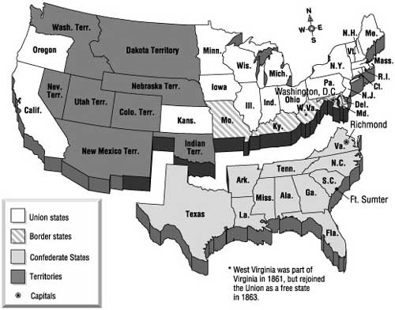

1. Who gave the Emancipation Proclamation? __________________________________
2. What date did the Emancipation Proclamation go into effect? ___________________
3. How do the words persons, slaves, forever, and free in lines 6-7 help you to better
understand the author’s use of the word emancipation in line 3? ________________
______________________________________________________________________
4a. In lines 6-7 it says, “…all persons held as slaves within any State in rebellion against
the United States…” Who or what is the author referring to with this statement?
Provide evidence to support your answer. ___________________________________
______________________________________________________________________
4b. Using the document and the map of the United States during the Civil War, answer
the following question: Are all of the states included? If not, which ones were left
out? Why do you think they were left out? __________________________________
_____________________________________________________________________
5a. In line 17, the phrase call upon the people is used. Who are the people referring to?
Use evidence to support your answer._______________________________________
______________________________________________________________________

5b. What are the people being called upon to do (or not do)? ______________________
_____________________________________________________________________
6. List the four main ideas expressed in the Emancipation Proclamation. Underline and
annotate evidence in the document to support your answer.
1.
2.
3.
4.
7. What justifications does President Lincoln provide for Emancipation in lines 25-27?
Underline and annotate the evidence in the document.

