Background: The Pilgrims left England on a ship called the Mayflower. The ship carried 102 men, women, children
and their belongings, including small animals to the new world. They sailed towards the Virginia Colony, expecting to start a new life there. Instead, after 66 days at sea, they landed farther north in New England and decided to stay there.

The Mayflower Compact
In the name of God, Amen. We whose names are underwritten, the loyal subjects of our dread Sovereign Lord King James, by the Grace of God of Great Britain, France, and Ireland King, Defender of the Faith, etc.
Having undertaken for the Glory of God and advancement of the Christian Faith and Honour of our King and Country, a Voyage to plant the First Colony in the Northern Parts of Virginia, do by these presents solemnly and mutually in the presence of God and one of another, Covenant and Combine ourselves together in a Civil Body Politic, for our better ordering and preservation and furtherance of the ends aforesaid; and by virtue hereof to enact, constitute and frame such just and equal Laws, Ordinances, Acts, Constitutions and Offices from time to time, as shall be thought most meet and convenient for the general good of the Colony, unto which we promise
all due submission and obedience. In witness whereof we have hereunder subscribed our names at Cape Cod, the 11th of November, in the year of the reign of our Sovereign Lord King James, of England, France and Ireland the eighteenth, and of Scotland the fifty-fourth. Anno Domini 1620
John Carver | Edward Tilly | Digery Priest
William Bradford | John Tilly | Thomas Williams
Edward Winslow | Francis Cooke | Gilbert Winslow
William Brewster | Thomas Rogers | Edmund Margeson
Isaac Allerton | Thomas Tinker | Peter Brown
Miles Standish | John Rigdale | Richard Bitteridge
John Alden | Edward Fuller | George Soule
Samuel Fuller | John Turner | Richard Clark
Christopher Martin | Francis Eaton | Richard Gardiner
William Mullins | James Chilton | John Allerton
William White | John Craxton | Thomas English
Richard Warren | John Billington | Edward Doten
John Howland | Moses Fletcher | Edward Leister
Stephen Hopkins | John Goodman
Source: http://www.plimoth.org/learn/just-kids/homework-help/mayflower-and-mayflower-compact
Vocabulary: Dread: highly respected
Sovereign: a supreme ruler
Covenant: a formal agreement made by God and a religious community
Civil Body Politic: a group of citizens acting together as a law making group
Constitute: to establish
Anno Domini: in the year of

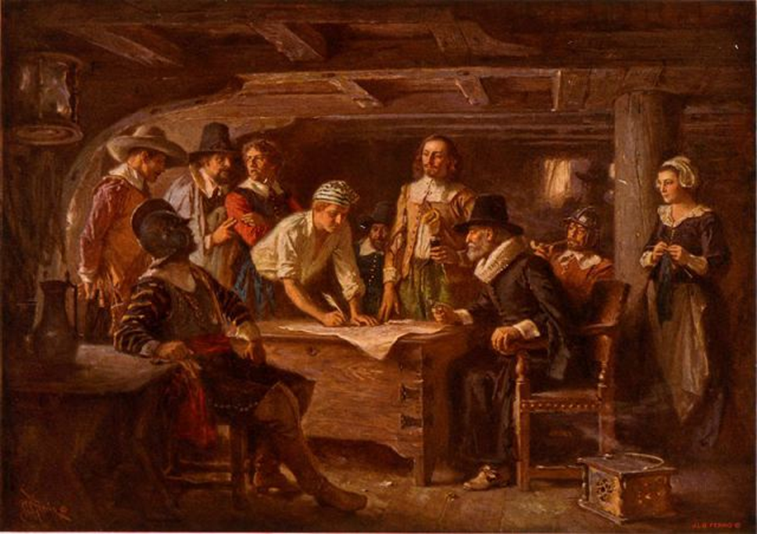
1. When and where was this document created? _________________________________________________
2. The word virtue on line 7 has many meanings. What is meaning of the word in this context?
a. faith b. consideration
c. honor d. credit
3. Who does the We refer to on line 2? __________________________________________________________
4 What do we learn about the relationship between the king and his subjects? __________________________
________________________________________________________________________________________
5. The word enact on line 8 has multiple meanings. What is the meaning of the word in this context?
a. to perform b. to act out on a stage
c. to put into practice d. to create
6. What type of language was used to write this document? In other words, what style was used? Give 3
examples from the text to support your answer. ________________________________________________
7. What is the reason the Pilgrims created this document? ___________________________________________
________________________________________________________________________________________
8. What did the Pilgrims agree to do? ____________________________________________________________
_________________________________________________________________________________________
9. What is the Mayflower Compact? _____________________________________________________________
10. Go back and reread the Background Information and look at the signers of the document. Make and write
a claim about the signers of the Mayflower Compact. _ __________________________________________
_________________________________________________________________________________________
11. What differences do you notice between the document and the painting?____________________________
________________________________________________________________________________________
________________________________________________________________________________________

