Monroe Doctrine
Background Information: In 1823, President James Monroe gave a speech to Congress that established the foundation for U.S. foreign policy.
The occasion has been judged proper for asserting, as a principle in which the rights and interests of the United States are involved, that the American continents, by the free and independent condition which they have assumed and maintain, are henceforth not to be considered as subjects for future colonization by any European powers....
The political system of the allied powers is essentially different… from that of America. We owe it, therefore, to the amicable relations existing between the United States and those powers, to declare, that we should consider any attempt on their part to extend their system to any portion of this hemisphere, as dangerous to our peace and safety. With the existing colonies or dependencies of any European power we have not interfered, and shall not interfere. But with the governments who have declared their independence, and maintained it, and whose independence we have, on great consideration, and on just principles, acknowledged, we could not view any interposition for the purpose of oppressing them, or controlling, in any other manner, their destiny, by any European power in any other light than as the manifestation of an unfriendly disposition towards the United States.
…It is still the true policy of the United States to leave the parties to themselves, in the hope that other powers will pursue the same course.
Source: Excerpt from President James Monroe’s Seventh Annual Message to Congress, December 2, 1823.
Vocabulary: amicable: friendly, interposition: intervention, manifestation: obvious demonstration,
disposition: attitude

1a. When was the Monroe Doctrine created? _____________________________________________
1b. Who is the intended audience of the Monroe Doctrine? _________________________________
2. A doctrine is a set of ___________________________. Circle evidence in the document that
supports your answer.
3. The author uses the word henceforth on line 5. Why is this word important to notice? Use evidence
to explain your answer. ____________________________________________________________
________________________________________________________________________________
4. In line 8, Monroe refers to “allied powers.” What is the antecedent, to what or whom is this
referring to? ______________________________________________________________________
5. The word hemisphere is used on line 9. Which hemisphere is being discussed? Provide 3 pieces of
evidence from the document to support your answer. ___________________________________
_______________________________________________________________________________

6. The Monroe Doctrine has 4 basic points. Underline and annotate evidence in the document to
support each of the following points.
a. The United States would not interfere in the affairs of European nations.
b. The United States would recognize, and not interfere with, European colonies that already
existed in North and South America.
c. The Western Hemisphere was to be off-limits to future colonization by any foreign power.
d. The United States would consider any European power’s attempt to colonize or interfere
with nations in the Western Hemisphere to be a hostile act.
7. What is the purpose of the Monroe Doctrine? __________________________________________
_______________________________________________________________________________
_______________________________________________________________________________
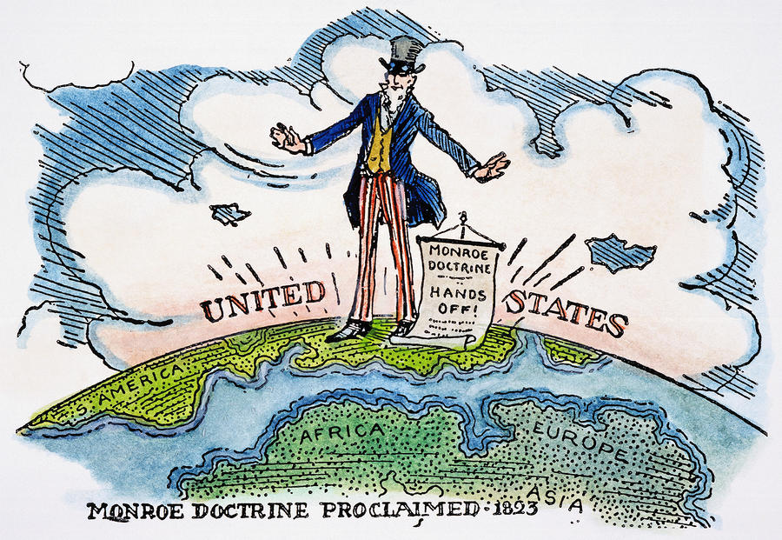
8. What type of primary source is shown? _______________________________________________
9. Which continents are represented? __________________________________________________
10. What do you notice about the way in which the U.S. is characterized? _____________________
_____________________________________________________________________________
11. What is the message of this visual? _________________________________________________
How do you know? Provide evidence in your answer. __________________________________
_____________________________________________________________________________
12. Compare both sources and find two ways in which they are similar. _______________________
______________________________________________________________________________

