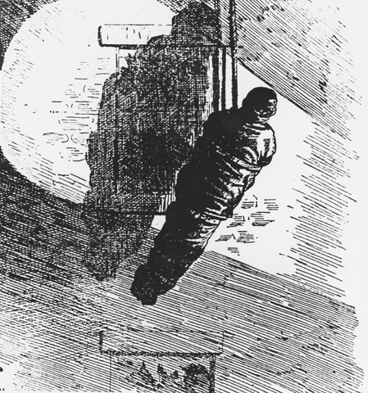
Written by: Shaun Taylor & Donna MacIntyre
Teachers Swope Middle School
sptaylor@washoe.k12.nv.us dmanintyre@washoe.k12.nv.us

Work related death was a daily occurrence during the Second Industrial Revolution until the Triangle Shirtwaist Fire tragedy. From ashes of disaster sparked changes in safety that originated in New York and spread across the nation.
Use the following documents and your knowledge of U.S. History to construct an essay addressing the following question:
DBQ Question: Why was the Triangle Shirtwaist Fire of March 25th 1911 a disaster of epic proportions and how did it create changes in law?

Historical Background:
New York City remembered the hundredth anniversary on March 25, 2011 of the worst disaster in that city’s history until the occurrence of 9/11. On that day, a fire swept through the ninth floor of the Triangle Shirtwaist Factory. One hundred and forty-six young men and women perished in the inferno. The issues of 1911 and today are not that far apart. Labor Unions and safety standards are as important now as they were a hundred years ago.
On that quiet Saturday afternoon in 1911, work safety standards were in their infancy. A six-day work week was a common occurrence during this time in history. “Death was an almost routine workplace hazard in those days. By one estimate, one hundred or more Americans died on the job every day in the booming industrial years around 1911. Mines collapsed on them, ships sank under them, pots of molten steel spilled over their heads, locomotives smashed into them, exposed machinery grabbed them by the arm or leg or hair and pulled them in….Yet workday safety was scarcely regulated and workers’ compensation was considered newfangled or even socialist.”
The Triangle Factory reflected this unsafe work environment, although the factory was as modern as a factory could be during this period. It was said to be located in a fire-proof building, it was a disaster waiting to happen. “Disaster followed disaster, but little changed. The Triangle fire was different because it was more than just a horrific half hour; it was the crucial moment in a potent chain of events---a chain that ultimately forced fundamental reforms from the political machinery of New York, and after New York the whole nation.”
On the day of the fire, approximately 180 people worked on the eighth floor that initially went up in flames. “The rushing, the shouting, and the leaping flames sent panic ripping through them. Those clustered at the Greene Street partition stampeded into the small opening, pushing and shouting and wrestling toward the stairway.” The mass confusion and locked doors prevented the workers from escaping the inferno. If employees were fortunate enough to make it onto an elevator, their rate of survival was increased, but those less fortunate were forced to either perish in the flames or risk the leap from the eighth floor windows. “Many had heard the muffled explosion and looked up to see the puff of smoke coming out of an eighth-floor window. James Cooper, passing by, was one of them. He saw something that looked "like a bale of dark dress goods" come out of a window. "Someone's in there all right. He's trying to save the best cloth," a bystander said to him. Another bundle came flying out of a window. Halfway down, the wind caught it and the bundle opened. It was not a bundle. It was the body of a girl.”
“The most important advantages of the loft factories, compared to the tenement sweatshops, were the high ceilings.” The placement of the workrooms on the highest floors was another preventable element. It focuses on the fact that the height of the ladders used by the New York Fire Department only reached to the sixth floor. If this workroom had been positioned lower, the fire could have possibly been extinguished and the victims could have been reached without performing the death defying “leaps of faith.” Many safety concerns were disregarded by the factory owners because their new-aged building was considered “fireproof.”
Workroom organization was another key component in the tragedy, workrooms had been expanded to provide more workspace but the disposal of garment waste was an ever present hazard in the rooms. “Cotton is even more flammable than paper, explosively so. Those airy scraps of sheer fabric and tissue paper, loosely heaped and full of oxygen, amounted to a virtual fire bomb.”
The tragedy of the Triangle fire is that it could have been prevented. Doors had been locked to prevent workers from stealing. One door was opened at the end of the shift so employees could be searched for possible theft. Yet, at the trial that would take place after the fire, the owners testified:
“Q. Now all the instances when you found goods taken from your factory by the employees, how much in all would you say was the value of the goods that you found had been taken by these employees?
A. You mean goods that were found.
Q. That you found.
A. We find perhaps -- in one year you mean?
Q. In one year.
A Prior to the fire?
Q. Yes.
A. Well, ten dollars or fifteen dollars or twelve dollars or eight dollars, something like that.
Q. You would say it was not over $25, wouldn't you? Between $10 to $25 a month was all that was actually taken.”
The most humanizing aspect of the criminal trial was the fact that owners never considered that locking the doors compromised the safety of all of their employees.
The tragic day ended with a total of 146 men and women deceased, and bystanders who were horrified by the tragic scene as many of the victims leapt from the eighth floor to their death. This day would leave a lasting impression on the entire country. Out of the ashes arose a spirit of reform that cried out for changes. Government action was swift in demanding answers resulting from an extensive investigation led by Francis Perkins who later would become the first women to be a member of a president’s cabinet. “Policies that were enacted because of that fire permeate American workplaces now."
As a result of the ensuing investigation, workplace safety laws were forever changed. “Every factory building over two stories in height in which more than twenty-five persons are employed above the ground floor shall be equipped with a fire alarm signal system with a sufficient number of signals clearly audible to all occupants thereof. In every factory building over two stories In height in which more than twenty-five persons are employed above the ground floor, a fire drill which will conduct all the occupants of such building to a place of safety and in which all the occupants of such building shall participate simultaneously shall be conducted at least once a month. Automatic sprinklers.—In every factory building over seven stories or over ninety feet in height in which wooden flooring or wooden trim is used and more than two hundred people are regularly employed above the seventh floor or more than ninety feet above the ground level of such building, the owner of the building shall install an automatic sprinkler system approved as to form and manner in the city of New York by the fire commissioner of such city, and elsewhere, by the state fire marshal. ”
The issues of 1911 and today are not that far apart. Labor Unions and safety standards are as important now as they were a hundred years ago. Workplace safety and labor laws that were initiated following the Triangle Shirtwaist Fire one hundred years ago are living proof that those 146 souls did not die in vain.

Bibliography

New York (State); New York (State). Dept. of Labor Labor laws and legislation (Albany, J. B. Lyon company printers 1913)
Vol. 3, sec. 7 (pp. 1803-1901). Testimony by workers; and by Isaac Harris, co-defendant/owner http://digitalcommons.ilr.cornell.edu/triangletrans/
KAREN MATTHEWS 100 years after Triangle fire, horror resonates Associated Press http://www.charter.net/news/read.php?rip_id=%3CD9M453100%40news.ap.org%3E&ps=1011&page=1
Von Drehle. Triangle The Fire That Changed America, (Grove Press, 2003)

Part A: The following documents will address various sources examining the Triangle Shirtwaist Fire. Examine each document carefully, and answer the questions that follow.
Source #1: Article excerpt from the New York Times the day after.
Vocabulary:
Waist Company: shirt manufacturing company.
Unionized: Became members of an association that works together for better conditions
Insufficiency: not enough
Strewed: spread out
Apparatus: Fire Trucks/machines

Document Note: This is a New York Times article the day after the disaster describing the scene of the fire and the chaos that ensued.
How the fire started no one knows. On the three upper floors of the building were 600 employees of the waist company, 500 of whom were girls. The victims mostly Italians, Russians, Hungarians, and Germans were girls and men who had been employed by the firm of Harris & Blanck, owners of the Triangle Waist Company, after the strike in which the Jewish girls, formerly employed, had been become unionized and had demanded better working conditions. The building had experienced four recent fires and had been reported by the Fire Department to the Building Department as unsafe in account of the insufficiency of its exits.
The building itself was of the most modern construction and classed as fireproof. What burned so quickly and disastrously for the victims were shirtwaists, hanging on lines above tiers of workers, sewing machines placed so closely together that there was hardly aisle room for the girls between them, and shirtwaist trimmings and cuttings which littered the floors above the eighth and ninth stories.
Girls had begun leaping from the eighth story windows before firemen arrived. The firemen had trouble bringing their apparatus into position because of the bodies which strewed the pavement and sidewalks. While more bodies crashed down among them, they worked with desperation to run their ladders into position and to spread fire nets.
Source: 141 Men and Girls Die in Waist Factory Fire; Trapped High Up in Washington Place Building; Street Strewn with Bodies; Piles of Dead Inside
New York Times, March 26, 1911, p. 1.

PLEASE ANSWER THE FOLLOWING QUESTIONS ABOUT DOCUMENT 1.
1. When and where was the article published?

2. How many employees were present the day of the fire, and of those employees, how many were girls?

3. What were the nationalities of the employees?

4. Before these employees worked at the Shirtwaist Factory, what other nationality worked there? Why does the article say they were no longer there?

5. How was the building classified?

6. What prevented the employees from escaping the building, and what should have prevented this from happening?

Source #2: Article excerpt from New York Times, March 26, 1911,
Document Note: Stories of Survivors. And Witnesses and Rescuers Outside Tell What They Saw

According to several eye witnesses, the flames were pouring from the windows and the girls jumping to the sidewalk for several minutes before the first fire truck with ladders arrived. Benjamin Levy of 995 Freeman Street, the Bronx, one of the first men to arrive at the burning building, says that it was all of ten minutes after the fire started before the first fire engine arrived. Mr. Levy is the junior member of the firm of I. Levy & Son wholesale clothing manufactures just around the corner, at 3 and 5 Waverley Place.
"I was upstairs in our work-room," said he, "when one of the employees who happened to be looking out of the window cried that there was a fire around the corner. I rushed downstairs, and when I reached the sidewalk the girls were already jumping from the windows. None of them moved after they struck the sidewalk. Several men ran up with a net which they got somewhere, and I seized one side of it to help them hold it.
"It was about ten feet square and we managed to catch about fifteen girls. I don't believe we saved over one or two however. The fall was so great that they bounced to the sidewalk after striking the net. Bodies were falling all around us, and two or three of the men with me were knocked down. The girls just leaped wildly out of the windows and turned over and over before reaching the sidewalk.
"I only saw one man jump. All the rest were girls. They stood on the windowsills tearing their hair out in the handfuls and then they jumped.
"One girl held back after all the rest and clung to the window casing until the flames from the window below crept up to her and set her clothing on fire. Then she jumped far over the net and was killed instantly, like all the rest."
One for the policemen who were checking up the bodies as they were being shipped to the Morgue told of one heap in which a girl was found still alive when the others were taken off her. She died before an ambulance doctor could reach her.
Source: Stories of Survivors. And Witnesses and Rescuers Outside Tell What They Saw New York Times, March 26, 1911, P. 4

PLEASE ANSWER THE FOLLOWING QUESTIONS ABOUT DOCUMENT 2.
1. When and where was the article published?

2. Who is the intended audience for this article?

3. Why do you think the author uses such descriptive accounts of the tragedy?

4. What do you think the public’s reaction to this tragedy was after reading the article?

5. Copy three short quotes from the article, that are the most descriptive of the tragedy.

Source #3: Photograph of funeral procession for unidentified fire victims.
Vocabulary:
Hebrew: Jewish decent.

Document Note: In the April 5th funeral procession for the seven unidentified fire victims, members of the United Hebrew Trades of New York and the Ladies Waist and Dressmakers Union Local 25, the local that organized Triangle Waist Company workers, carry banners proclaiming “We Mourn Our Loss.”
Source: Photographer: unknown, April 5, 1911
Kheel Center image identifier: 5780pb39f17d

PLEASE ANSWER THE FOLLOWING QUESTIONS ABOUT DOCUMENT 3.
1. Who is included in the large gathering of people in the photo?

2. In your opinion did protests such as the one in this photo increase public awareness concerning labor and workplace safety laws?

3. Looking back at document 1, what is the significance of the ladies unions’ presence at the funeral?

4. Explain the possible reasons that seven victims of the tragedy were unidentified.

5. Do you think the fact that the majority of deaths were young women increased sympathy towards unions fighting for workers rights?

Source #4: Photograph from local New York City newspaper two days after the disaster.
Vocabulary:
Document Note: For endless hour’s police officers held lanterns to light the bodies while crowds filed past victims laid out in numbered rough-wood coffins. As the dead were identified, the coffin was closed and moved aside for the family to claim.
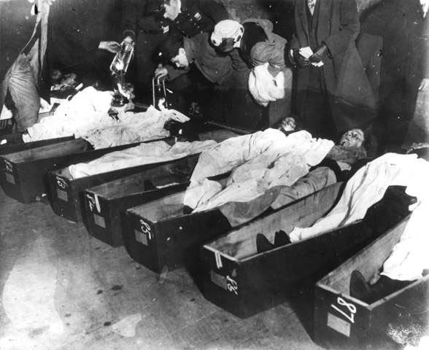

Source: Photographer: Brown Brothers, 1911
Kheel Center image identifier: 5780pb39f20d

PLEASE ANSWER THE FOLLOWING QUESTIONS ABOUT DOCUMENT 4.
1. What are the people standing above the coffins in the photograph doing?

2. What procedure was followed after the body was identified?

3. Why do you think the bodies had to be processed this way?

4. What circumstances made it difficult to identify bodies?

Source #5: Model recreation of the Triangle Shirtwaist Fire Building.
Document Note: This model represents problems that existed before and during the fire that caused so many people to lose their lives on the 9th floor.
Source: http://www.ilr.cornell.edu/trianglefire/supplemental/3Dmodel.html

What Went Wrong?
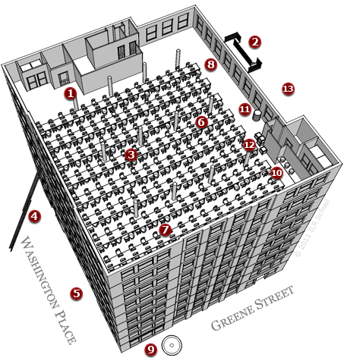

FIRE HAZARDS:
- Locked door to the stair well
- Rusty fire escape that collapsed
- Cluttered work spaces
- Short ladders only reached 6th floor
- Not enough water pressure
- Long wooden tables became obstacles
- Wicker baskets full of scraps
- Oily floors spread the fire quickly
- Fire nets failed to catch jumpers
- No sprinkler system, only pails of water
- Flammable barrel of oil
- Boxes crowding the exit
- Lack of a required third staircase
PLEASE ANSWER THE FOLLOWING QUESTIONS ABOUT DOCUMENT 5.
1. Where was the Triangle Shirtwaist building located?

2. On which floor did the most amount people become trapped in the fire?

3. In your opinion how could some of these fire hazards been corrected?

4. How did a 'fireproof' building become a fire trap?

5. After examining the thirteen “Fire Hazards” in your opinion what were the five most critical causes of the fire?

Source #6
Document Note: In an editorial cartoon, a skeleton surrounded by smoke and flames rises from the burning Asch Building and considers the horrifying events below.
Photographer: Artist unknown, 1911
Kheel Center image identifier: 5780pb39f18i
Image 6 of 14

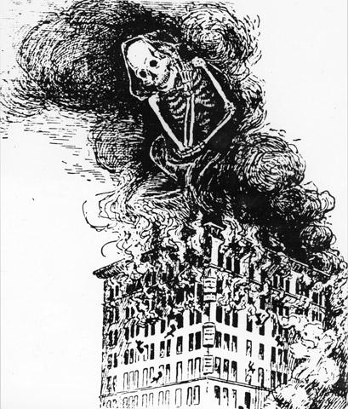
Source: Photographer: Artist unknown, 1911
Kheel Center image identifier: 5780pb39f18i
Image 6 of 14

PLEASE ANSWER THE FOLLOWING QUESTIONS ABOUT DOCUMENT 6.
1. What is the significance of the image rising from the flames?

2. Is this an accurate representation of the disaster?

3. What image do you see in the smoke?

4. What was the role of the media in displaying the tragic events of the Triangle Shirtwaist Fire? Who did the media favor, the factory owners or employees?

Source #7
Vocabulary:
Petty: small
Pocket-books: purse or wallet
Premises: layout of surroundings
Immaterial: doesn’t matter
Rat: hair piece
Incompetent: not capable
Irrelevant: does not matter

Document Note: Vol. 3, sec. 7 (pp. 1803-1901). Testimony by workers; and by Isaac Harris, co-defendant/owner, who describes earlier fires, petty thefts by workers, inspection of pocket-books, layout of premises
THE COURT: Now, Mr. Harris, if you will kindly answer questions so all the
Jury can hear you.
THE WITNESS: Yes, sir.
Q. You are a partner of Blanck’s, aren't you?
A. Yes, sir.
Q. And you have been is partnership with Blanck about how many years?
A. About twelve.
Q. Now we can’t hear you over here.
A. Twelve years.
Q. Mr. Harris, did you ever carry a key to any of the lofts?
A. No, sir.
Q. At no time?
A. Never.
Q. No key to any of the lofts?
A. No, sir.
Q. In getting from one floor to the other, Mr. Harris, did you ever use a key?
A. No, sir.
Q. Did you have anything to do with the locking of the doors Mr. Harris, yourself?
A. No, sir.
Q. Or the locking of the doors at any time?
A. No, sir.
Q. When you had one loft only, Mr. Harris, when you were on the ninth loft, which used to have charge of locking the doors up then?
A. Well, the old man, Mr. Alter, the one that has been here.
Q. The gentleman who was a witness?
A. Yes, sir.
Q. I think there was one witness testified here, Mr. Harris that you and Mr. Blanck used to stand by the door on the Greene Street side on the ninth floor and watch the girls as they went out, and sometimes that you would look into their books. Did you do that?
A. I never done that.
Q. You knew it was done?
A. It was done yes, sir, of course that was done.
Q. That was done by your direction and by Mr. Blanck’s direction?
A. Yes, sir.
Q. But you personally did not do that? A. No, sir; I never done that.
Q. Now where were you Mr. Harris when you first knew that there was any trouble?
A. I was in that time in my office; just had selected some goods from the representative of Krauer and Tynburg.
Q. How did you first know that there was any trouble Mr. Harris?
A. Well, I really could not remember how I find out this, but is that time when I heard all the noise outside, I opened the door from my office and seen four girls running to the Washington elevator place.
Q. The Washington elevator doors?
A. Running to the Washington elevator doors, yes, sir. I came out, I heard the sound of bells and all the noise of course; and I noticed in the back of the room some flames towards the fire escapes, but I could not see the fire —
Q. You say the back of the room. Do you call the place where the fire escape was the back of the room?
A. Yes, sir; I call the front the Washington Place side where was the offices and the back of the room Waverly Place side.
Q. If you can remember, just what you did to tell us, tell us anything that you can remember Mr. Harris.
A. When I came out I have seen the girls and everyone hollered fire, and I have seen there is fire through the windows at that time. The elevator just case up and they went into the elevator; I started to rush all the girls into the elevator. I told them go as quick as you can and come back up as quick as you can. He came up once more and took down another load, and then he took about a minute or a half minute and I waited and I didn’t see him coming up anymore. Somebody started in hollering, somebody in the back, fire, they were hollering in the back, and I heard fire hollered and I ran back to see, they said the fire was in the packing room and so I went back and looked in the packing room and I see that there was fire in the packing room. So I didn’t think of the elevator, I didn't think it would come up any more but which it did afterwards I learned, but I didn’t know there that it was coming again.
Q. Now when the operators went out at night as I understood you to say, the examination of the employees was done under your direction and Mr. Blanck’s direction?
A. Yes.
Q. And you said that you personally had nothing to do with it, never stood there and examined the employee that is their books and bundles as they passed out?
A. No, sir.
Q. Now Mr. Alter performed that duty on the tenth floor didn’t he?
A. Yes, sir.
Q. Now the object of having those watchmen there was to prevent the employees from taking things which did not belong to them was not that so?
A. Of course.
Q. You didn’t want them to take any of your shirtwaists?
A. No, sir, surely not.
Q. And you didn’t want them to take any of your laces, is that not so?
A. Certainly.
Q. Now you had had some experience in having things taken from your factory had you not?
A. Well, enough.
Q. Well, as you say enough, you had had it several times?
A. Yes, we once locked up about six girls and we found in their room, the room of one girl two dozen waists; one girl about three dozen waists; and one girl had in every — in every girl’s house we found so many waists, and we had detectives that went around there and we searched in every house and found from two dozen to three dozen waists that these girls had taken, and there was six girls that we locked up in one night.
Q. About when was that?
A. Well, about three years to my memory, if my memory is good.
Q. After you had these six girls arrested about three years ago you didn’t have any more arrested, you simply discharged them when you found there had been stealing?
A. Yes, we arrested a few of them, and had them fined, a few of the girls and after that they sued us for damages and the only way we could find — we found the best way is to discharge them and not be bothered with them anymore. That is the best way to get quick rid of them.
Q. Do you think there was a great deal of stealing in your factory?
MR. STEUER: I object to that as immaterial.
A. Well as to that I can’t tell.
MR. STEUER: The newspapers will come out with headlines tomorrow that will put us out of business, we won’t get any more employees -~
MR. BOSTWICK: I object to that remark.
THE COURT: I didn’t hear the remark but I sustain the objection.
MR. STEUER: It was not a remark, a reflection upon anybody.
THE COURT: I think that question calls for a conclusion, not for evidence.
Q. During the year 1911, that is from January 1st to March l, 1911, how much worth of goods was stolen from your factory so far as you know?
MR. STRUER: I object to that as immaterial
THE COURT: I will allow it.
A. That we can’t -
MR. STEUER: I except to Your Honor’s ruling.
A. (Continuing) That is pretty hard to find out.
Q. How many times in March -- during the year prior to March 25th, that is from
December 25th -- from March 25th, 1910 to March 25th, 1911 —
A. Yes, sir.
Q. -- the year immediately preceding the fire, how many times did you find people stealing goods from your factory?
MR. STEUER. I object to that as immaterial.
THE COURT: I will allow it.
MR. STEUER: I except.
A. I could not answer it.
Q. Well would you say it was ten times?
A. What do you mean, before the fire?
Q. Yes.
MR. STEUER: He said in the year before the fire.
Q. The year before the fire, the year immediately preceding the fire?
A. Oh, we had a couple of them, the girl with the waists in her rat and about a couple more perhaps, I don't know.
Q. Now all the instances when you found goods taken from your factory by the employees, how much in all would you say was the value of the goods that you found had been taken by these employees?
MR. STEUER: I object to that as incompetent, irrelevant and immaterial.
THE COURT: I will allow it.
MR. STUEUR: I except.
A. You mean goods that were found.
Q. That you found.
A. We find perhaps -- in one year you mean?
Q. In one year.
A Prior to the fire?
Q. Yes.
A. Well, ten dollars or fifteen dollars or twelve dollars or eight dollars, something like that.
Q. You would say it was not over $25, wouldn't you?

(The jury, which retired to deliberate at about 2:55 P.M., returned to the courtroom at 4:45 P. M., and rendered a verdict of not guilty.)

PLEASE ANSWER THE FOLLOWING QUESTIONS ABOUT DOCUMENT 7.
1. What two men owned and operated the Triangle Shirtwaist Company?

2. Did the owners feel responsible for the tragedy?

3. Why were the owners on trial?

4. Explain why the employees were locked in the rooms during the workday? Was the locking of the doors justified?

5. What precautions were taken in the factory to prevent stealing? Which of these contributed to deaths on the day of the fire?

6. Why does the lawyer try to get the defendant to state the amount of goods stolen in the year prior to the fire was less than 25$? To what do you think he is comparing the value of the things stolen?

7. Why do you believe the owners of the factory were declared not guilty when so many lives were lost?
Source 8:
Document Note: New York (State) Laws, statutes, etc, Labor laws of New York State, 1913
Excerpted from Cornell University Digital collection.

§ 83-a. Fire alarm signal systems and fire drills.— 1. Every factory building over two stories in height in which more than twenty-five persons are employed above the ground floor shall be equipped with a fire alarm signal system with a sufficient number of signals clearly audible to all occupants thereof.

2. In every factory building over two stories In height in which more than twenty-five persons are employed above the ground floor, a fire drill which will conduct all the occupants of such building to a place of safety and in which all the occupants of such building shall participate simultaneously shall be conducted at least once a month.

3. In the city of New York the fire commissioner of such city, and elsewhere, the state fire marshal is charged with the duty of enforcing this section. [Added by h. 1912, Ch. 330 and am'd by L. 1913, oh. 203.]
§ 83-b. Automatic sprinklers.—In every factory building over seven stories or over ninety feet in height in which wooden flooring or wooden trim is used and more than two hundred people are regularly employed above the seventh floor or more than ninety feet above the ground level of such building, the owner of the building shall install an automatic sprinkler system approved as to form and manner in the city of New York by the fire commissioner of such city, and elsewhere, by the state fire marshal.

PLEASE ANSWER THE FOLLOWING QUESTIONS ABOUT DOCUMENT 8.
1. What three measures must any business over two stories or more than 25 employees take according to this statue?

2. What types of workers ensure that these laws are being followed?

3. How do you think these laws are related to the Triangle Shirtwaist Factory Fire?

4. List two additional measures we take today to prevent fires or prevent deaths from fires?

5. Evaluate the following opinion “Without tragedies such as the Triangle Shirtwaist Fire, business owners could have continued treating employees like disposable property.”

Name _________________________________ Period _____ Date_________________
Essay Assignment
Part B: Essay: Why was the Triangle Shirtwaist Fire of March 25th 1911 a disaster of epic proportions and how did it create changes in law?
- Using information from the documents in Part A and your class notes, develop a thesis statement that directly answers the document-based question.
Thesis statement: _________________________________________________________________________________________________________________________________________________________________________________________________________
- Please complete the attached outline. The outline will become the blueprint for your essay. Be specific and cite information from the sources in the packet.
- Complete the essay, and use information from the sources. We all have opinions, but using factual information from the time period will enhance your argument greatly.

Use this “chicken foot” to write your answer (thesis) to the essay topic and three main reasons for your answer. (Introductory Paragraph)

_________________________________________
Now, take the top right hand line from above and transfer it to the line below. Give two reasons from the documents/evidence to support your statement. (Paragraph 2)

_________________________________________

Do the same for the second right line from the first chicken foot. (Paragraph 3)

_________________________________________

Do the same for the third right line from the first chicken foot. (Paragraph 4)

_________________________________________

Name ________________________________ Period _____ Date____________________
ESSAY RUBRIC UNIT ESSAY – 8th Social Studies 100pts.

_____ 20pts. Essay Outline
20-17pts. Complete / Well Organized / Facts listed & Topic Sentences
16-13pts. Organized / Facts listed / Main Topic Sentence
12-9pts. Limited Organization / Facts Listed
8-0pts. Poor Organization / No Topic Sentences / Incomplete
_____ 15pts. Introductory Paragraph (Underline thesis statement)
15-13pts. Thesis Statement used / Well Organized / Explains body
12-10pts. Thesis statement used / Organized
9-7pts. Poor thesis statement / Explains major ideas of paper
6-0pts. No thesis statement / Poor Organization
_____ 30pts. Body Paragraphs (At Least 3)
30-27pts. Well written / Organized / Factually supports Topic Sentence
26-23pts. Organized / Supports Topic Sentence
22-19pts. Supports Topic Sentence / Limited Organization
18-0pts. No Organization / No support of thesis
_____ Paragraph 1 _____ Paragraph 2 _____ Paragraph 3
_____ 15pts. Conclusion Paragraph (Underline concluding statement)
15-13pts. Rewrite Topic Sentence / Well Organized /
Restates main ideas / Good conclusion statement
12-10pts. Rewrite Topic Sentence / Organized /
Restates main ideas / Conclusion statement
9-7pts. Restates main ideas / Conclusion statement
6-0pts. No conclusion statement / Poor Organization
_____ 20pts. Answer Accuracy & Historical Understanding
20-17pts. Factually based argument that contains specific facts learned this quarter. Facts are used in an accurate manner and to support the topic sentence. Excellent work and use of facts.
16-13pts. Factual argument based on facts from this quarter. Facts are used to support Topic Sentence.
12-9pts. Facts used. Argument attempts to use facts to support Topic sentence. Limited factual mistakes.
8-0pts. Factual errors and limited to no use of facts to support Topic Sentence.

_____ TOTAL

Von Drehle. Triangle The Fire That Changed America, (Grove Press, 2003), 3
Von Drehle. Triangle The Fire That Changed America, (Grove Press, 2003), 3
Von Drehle. Triangle The Fire That Changed America, (Grove Press, 2003),119-120
Leon Stein, The Triangle Fire (New York: A Carroll & Graf/Quicksilver Book, 1962), pp. 12-14.
Von Drehle. Triangle The Fire That Changed America, (Grove Press, 2003), 47
Von Drehle. Triangle The Fire That Changed America, (Grove Press, 2003), 119
Vol. 3, sec. 7 (pp. 1803-1901). Testimony by workers; and by Isaac Harris, co-defendant/owner http://digitalcommons.ilr.cornell.edu/triangletrans/
KAREN MATTHEWS 100 years after Triangle fire, horror resonates Associated Press http://www.charter.net/news/read.php?rip_id=%3CD9M453100%40news.ap.org%3E&ps=1011&page=1
New York (State); New York (State). Dept. of Labor Labor laws and legislation (Albany, J. B. Lyon company printers 1913) p. 54

