Black Sunday: April 14, 1935
April 14, 1935, dawned clear across the plains. After weeks of dust storms, one near the end of March destroying five million acres of wheat, people grateful to see the sun went outside to do chores, go to church, or to picnic and sun themselves under the blue skies. In mid-afternoon, the temperature dropped and birds began chattering nervously. Suddenly, a huge black cloud appeared on the horizon, approaching fast.
Those on the road had to try to beat the storm home. Some, like Ed and Ada Phillips of Boise City, and their six-year-old daughter, had to stop on their way to seek shelter in an abandoned adobe hut. There they joined ten other people already huddled in the two-room ruin, sitting for four hours in the dark, fearing that they would be smothered. Cattle dealer Raymond Ellsaesser tells how he almost lost his wife when her car was shorted out by electricity and she decided to walk the three-quarters of a mile home. As her daughter ran ahead to get help, Ellsaesser’s wife wandered off the road in the blinding dust. The moving headlights of her husband’s truck, visible as he frantically drove back and forth along the road, eventually led her back
The storm on Black Sunday was the last major dust storm of the year, and
the damage it caused was not calculated for months. Coming on the heels
of a stormy season, the April 14 storm hit as many others had, only harder.
“The impact is like a shovelful of fine sand flung against the face,” Avis D.
Carlson wrote in a New Republic article. “People caught in their own yards
grope for the doorstep. Cars come to a standstill, for no light in the world
can penetrate that swirling murk…. The nightmare is deepest during the
storms. But on the occasional bright day and the usual gray day we cannot
shake from it. We live with the dust, eat it, sleep with it, watch it strip us of
possessions and the hope of possessions. It is becoming Real. The poetic
uplift of spring fades into a phantom of the storied past. The nightmare is
becoming life.”
The Black Sunday dust storm approaching Spearman, Texas on 04/14/1935. Source: The National Archives
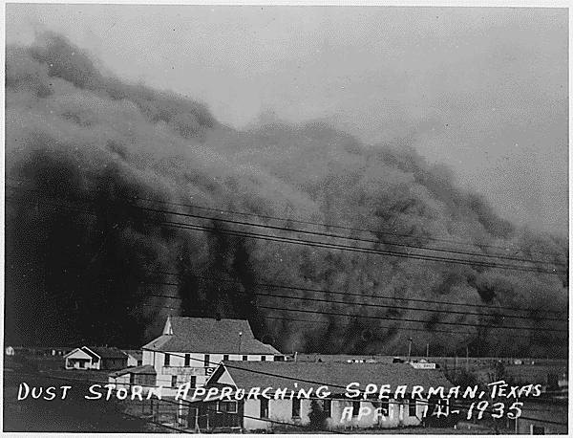
http://www.pbs.org/wgbh/americanexperience/features/general-article/dustbowl-black-sunday/
On Black Sunday
It’s on a Sunday afternoon about six o’clock. And we was gittin’ prepared to go to church and went to church in a team and wagon. And I’d gone out to kinda tend the chickens and stuff and back in the north it was just a little bank, oh, like about eight or ten feet high. We had one of those headers out on each end, you know. And I did a few things there around the chickens and everything and went back in the house and I said, “Dad, we ain’t goin’ to be able to go to church tonight.” And he said, “Why?” And that’s how fast it’s travelin’. And we was livin’ in an old house that was 14 feet wide, 36 foot long, just one room, board and batten with a washed roof on it. It kept gittin’ worse and worse and wind blowin’ harder and harder and it kept gittin’ darker and darker. And the old house was just a-vibratin’ like it was gonna blow away. And I started tryin’ to see my hand. And I kept bringin’ my hand up closer and closer and closer and closer and closer and I finally touched the end of my nose and I still couldn’t see my hand. That’s how black it was. And we burned kerosene lamps and Dad lit an old kerosene lamp, set it on the kitchen table and it was just across the room from me, about — about 14 feet. And I could just barely see that lamp flame across the room. That’s how dark it was and it was six o’clock in the afternoon. It was the 14th of April, 1935. The sun was still up, but it was totally black and that was blackest, worst dust storm, sand storm we had durin’ the whole time.
A lot of people died. A lot of children, especially, died of dust pneumonia. They’d take little kids and cover 'em with sheets and sprinkle water on the sheets to filter the dust out. But we had to haul water. We had a team and we had water barrels. We hauled stock water and household water both. And we didn’t have the water to use for that, so we just had to suffer through it. And lots of mornin’s we’d get up and strain our drinkin’ water like people strain milk, through a cloth, to strain the debris out of it. But then, of course, a lotta grit went through and settled to the bottom of the bucket, but you had have drinkin’ water. And when you got you a little dipper of water, you drink it. You didn’t take a sip and throw it away, because it was a very precious thing to us because we had to haul it.
Source: excerpt from an interview with Melt White, from Surviving the Dustbowl http://www.pbs.org/wgbh/americanexperience/features/interview/dustbowl-witness-white/
Answer the following questions:
1. The word ruin is used on line 8. It has multiple meanings. What does the word mean in this context?
a. to destroy b. to harm
c. remains of a building d. to demolish a building
2. On lines 8-9 it states, “…fearing that they would be smothered.” What are they worried about being
smothered by? Find evidence in the text to support your answer. ____________________________
_________________________________________________________________________________
3. What words and phrases in lines 13-24 help you to understand the meaning of the word murk?
_________________________________________________________________________________
_________________________________________________________________________________
4. On lines 23-24 it says, “The nightmare is becoming life.” What is the meaning of this statement?
Provide evidence from the text to support your answer. ___________________________________
________________________________________________________________________________
5. In lines 34-40, Melt White discusses the darkness of the dust storm. Why do you think that was
important to him? Include evidence form the text in your answer. __________________________
________________________________________________________________________________
________________________________________________________________________________
6. Why was water so precious to Melt White and his family? _________________________________
________________________________________________________________________________
7. Which dust storm was the worst one? _________________________________________________
8. According to the texts, what are some problems caused by the dust storm? ___________________
_________________________________________________________________________________
_________________________________________________________________________________
9. Why was this dust storm referred to as Black Sunday? ____________________________________
________________________________________________________________________________

