Migrant Mother, 1936

Lange had just completed a month-long photographic assignment and was driving back home in a wind-driven rain when she came upon a sign for the camp. Something beckoned her to postpone her journey home and enter the camp. She was immediately drawn to the woman and took a series of six shots - the only photos she took that day. The woman was the mother of seven children and on the brink of starvation.

In 1960, Lange described her experience in an interview with the magazine Popular Photography.   
  
"It was raining, the camera bags were packed, and I had on the seat beside me in the car the results of my long trip, the box containing all those rolls and packs of exposed film ready to mail back to Washington. It was a time of relief. Sixty-five miles an hour for seven hours would get me home to my family that night, and my eyes were glued to the wet and gleaming highway that stretched out ahead. I felt freed, for I could lift my mind off my job and think of home.

I was on my way and barely saw a crude sign with pointing arrow which flashed by at the side of the road, saying PEA-PICKERS CAMP. But out of the corner of my eye I did see it I didn't want to stop, and didn't. I didn't want to remember that I had seen it, so I drove on and ignored the summons. Then, accompanied by the rhythmic hum of the windshield wipers, arose an inner argument:

*Dorothea, how about that camp back there? What is the situation back there?*

*Are you going back?*

*Nobody could ask this of you, now could they?*

*To turn back certainly is not necessary. Haven't you plenty if negatives already on this subject? Isn't this just one more if the same? Besides, if you take a camera out in this rain, you're just asking for trouble. Now be reasonable, etc. etc., etc.*

Having well convinced myself for 20 miles that I could continue on, I did the opposite. Almost without realizing what I was doing I made a U-turn on the empty highway. I went back those 20 miles and turned off the highway at that sign, PEA-PICKERS CAMP.

I was following instinct, not reason; I drove into that wet and soggy camp and parked my car like a homing pigeon.

I saw and approached the hungry and desperate mother, as if drawn by a magnet. I do not remember how I explained my presence or my camera to her but I do remember she asked me no questions. I made five exposures, working closer and closer from the same direction. I did not ask her name or her history. She told me her age, that she was 32. She said that they had been living on frozen vegetables from the surrounding fields, and birds that the children killed. She had just sold the tires from her car to buy food. There she sat in that lean-to tent with her children huddled around her, and seemed to know that my pictures might help her, and so she helped me. There was a sort of equality about it.

The pea crop at Nipomo had frozen and there was no work for anybody. But I did not approach the tents and shelters of other stranded pea-pickers. It was not necessary; I knew I had recorded the essence of my assignment."

References: Lange, Dorothea, "The Assignment I'll Never Forget: Migrant Mother," Popular Photography (February 1960); Curtis, James. Mind's Eye, Mind's Truth: FSA Photography Reconsidered. (1989).   
"Migrant Mother, 1936," EyeWitness to History, www.eyewitnesstohistory.com (2005).

Answer the following questions based on the primary sources you have read and annotated.

1. What types of primary sources did you read and annotate? _________________________________

2. Who is the author of these sources? ____________________________________________________

3. What is happening in the United States during this time period? _____________________________

4. What type of a camp is it? Provide evidence from both sources to support your answer. __________  
 __________________________________________________________________________________

5a. A *summons* is a call to go somewhere. Who or what is making the summons. __________________  
 __________________________________________________________________________________  
5b. Underline and annotate the evidence in the text.

6. What was life like for workers in the camp? Provide evidence from both sources to support your   
 answer. ___________________________________________________________________________  
 __________________________________________________________________________________  
 __________________________________________________________________________________

7. What does the word *negatives,* on line 23,mean in the context of this document? _______________  
 What words or phrases help you to understand the meaning of the word? _____________________  
 __________________________________________________________________________________

8. How might Dorothea Lange’s photographs help the woman? ________________________________  
 _________________________________________________________________________________

9. The word *essence* on line 39 has multiple meanings. How is the word used in this context?  
 a. character b. a smell or scent  
 c. basis d. important ingredient

10. What is the mood of the camp? Provide evidence from both sources to support your answer.  
 _________________________________________________________________________________  
 _________________________________________________________________________________

11. On line 39, Lange states, “… I knew I had recorded the essence of my assignment.” What did she   
 mean when she said that? ___________________________________________________________  
 _________________________________________________________________________________  
 _________________________________________________________________________________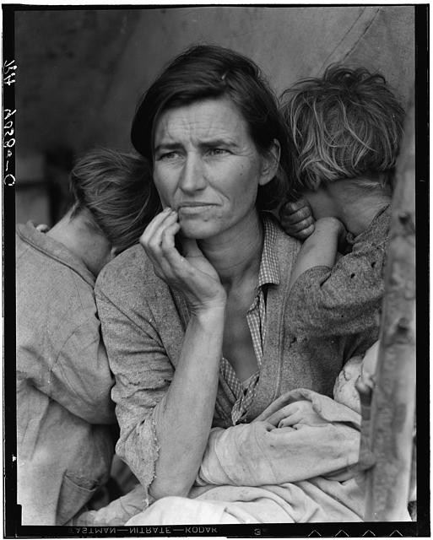

Migrant Mother

**[Type the sidebar content. A sidebar is a standalone supplement to the main document. It is often aligned on the left or right of the page, or located at the top or bottom. Use the Drawing Tools tab to change the formatting of the sidebar text box.]**



**Source:** Photographs were taken in   
March 1936 by Dorothea Lange. They  
were taken about 175 miles outside of  
Los Angeles, in Nipomo, California.  
They were part of a series of   
photographs taken at a camp for   
seasonal agricultural workers.

|  |  |
| --- | --- |
|  |  |