Teacher Notes on History Mysteries

- Unlike a close read or DBQ, this activity does not require that students gain an understanding of all of the vocabulary involved or have deep comprehension of the documents. Acknowledge that the documents/clues are highly difficult, and thus, that the case has been difficult to solve up until this point! Encourage students to skip over what they don’t understand and pick out clues from what they do understand.
- Place students in heterogeneous groups of detectives. Give them more explicit “jobs” within the group if you believe it will increase engagement by all learners.
- A History Mystery is a hook. It should pique student interest in a topic on which you will spend additional time. Do not spend a ton of time immersed in the mystery. Sustain student energy and interest in order to introduce another aspect of the unit. Students should refer back to the clues as they learn more information in the unit.
- A History Mystery is set up so that new pieces of vital information are released gradually throughout the clues. The first clue might leave students wondering what’s going on or in a bit of confusion. But they should begin putting the pieces together as they investigate the next clues.
- Play with the materials. Put them in an envelope marked top secret. Give students magnifying glasses and/or detective or agent badges.

TO: Nevada History Detectives
FROM: TOP SECRET History Mystery Department
REGARDING: History Mystery #173

In this dossier [fancy word for file of evidence], you will find all the clues found so far in Case #173, a History Mystery Cold Case that has been left unsolved to this point. We have asked several teams of detectives to give this case a second look and try to figure out exactly what was happening at this time in history.

You will investigate the following pieces of evidence and keep track of your thoughts and understanding as the case progresses. Look for details that stand out and help tell a story. Look for information that changes the way you thought about what you had learned from previous clues.
Clue A | Segments of a Federal Government Report, 1928
Clue B | Additional Segments of a Federal Government Report, 1928
Clue C | Quotes from Interviews of Adults Involved in an Earlier Investigation
Clue D | Photographs of Students
Clue E | Interviews done by National Public Radio in 2008

Clue A

Segments of a Federal Government Report, 1928

"The diet is deficient in quantity, quality, and variety. At a few, very few, schools, the farm and the dairy are sufficiently productive to be a highly important factor in raising the standard of the diet, but even at the best schools these sources do not fully meet the requirements for the health and development of the children. At the worst schools, the situation is serious in the extreme.
The toilet facilities have in many cases not been increased proportionately to the increase in pupils, and they are fairly frequently not properly maintained or conveniently located. The supply of soap and towels has been inadequate.”

Clue A Evidence Collection
Source the document (type of evidence, year, author if known).

Make a list of all of the important evidence/details you see.

Based on this evidence, what do you think this case is about?

Clue B

Additional Segments of a Federal Government Report, 1928

"In nearly every boarding school one will find children of 10, 11, and 12 spending four hours a day in more or less heavy industrial work—dairy, kitchen work, laundry, shop. The work is bad for children of this age, especially children not physically well-nourished; most of it is in no sense educational since the operations are large-scale and bear little relation to either home or industrial life outside.”
"…we should hardly have children from the smallest to the largest of both sexes lined up in military formation; and we would certainly find a better way of handling boys and girls than to lock the door to the fire-escape of the girls' dormitory.”

Clue B Evidence Collection
What do you learn from these further clues from the same government report?

Make a claim. What is this report concerned about?

Clue C

Quotes from Interviews of Adults Involved in an Earlier Investigation

"It was deemed necessary to establish during the year a stricter system of discipline than heretofore prevailed. A cadet battalion organization of five companies broke up the tribal associations."
— Arthur Grabowski, Superintendent, Haskell Institute, 1886

"The parents of these children are ignorant, and know nothing of the value of education, and there are no elevating circumstances in the home circle to arouse the ambition of the children."
— John S. Ward, United States Indian Agent, Mission Agency, California, 1886

Clue C Evidence Collection
Source both quotes. Who said it? What was their role? What year did they say it?
Quote 1 | Quote 2

What new information do we learn?

Circle the words and phrases in the evidence that are the most important to solving this case.

Make a new claim – What is this case about?

Clue D

Photographs of students at the beginning of their time in the boarding schools and after their time in the boarding schools in Pennsylvania and in Colorado

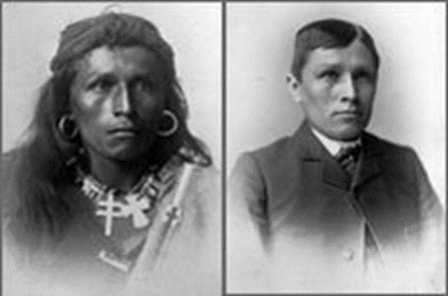
Clue D Evidence Collection
Make a list of all of the details you notice in these before and after photographs.

Make a claim based on what you have learned from the evidence so far as well as your investigation of these photographs.

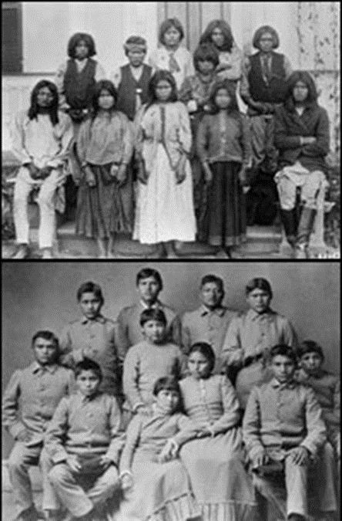

Clue E

Interviews of adults who were children at the Indian Boarding Schools done by National Public Radio in 2008

In 1945, Bill Wright, a Pattwin Indian, was sent to the Stewart Indian School in Nevada. He was just 6 years old. Wright remembers matrons bathing him in kerosene and shaving his head. Students at federal boarding schools were forbidden to express their culture — everything from wearing long hair to speaking even a single Indian word. Wright said he lost not only his language, but also his American Indian name.
"I remember coming home and my grandma asked me to talk Indian to her and I said, 'Grandma, I don't understand you,' " Wright says. "She said, 'Then who are you?' "
Wright says he told her his name was Billy. " 'Your name's not Billy. Your name's 'TAH-rruhm,' " she told him. "And I went, 'That's not what they told me.' "
Wright also remembers an adviser hitting a student.
"Busted his head open and blood got all over," Wright recalls. "I had to take him to the hospital, and they told me to tell them he ran into the wall and I better not tell them what really happened."
~~~~~~~~~~~~~~~~~~~~~~~~~~~~~~~~~~~~~~~~~~~~~~~~~~~~~~~
"It wasn't really about education," says Lucy Toledo, a Navajo who went to Sherman Institute in the 1950s. Toledo says students didn't learn basic concepts in math or English, such as parts of speech or grammar.
She also remembers some unsettling free-time activities.
"Saturday night we had a movie," says Toledo. "Do you know what the movie was about? Cowboys and Indians. Cowboys and Indians. Here we're getting all our people killed, and that's the kind of stuff they showed us."

Clue D Evidence Collection
What is the most important evidence in this clue?

With your group of investigators, construct a paragraph that describes this History Mystery. What happened at Indian Boarding Schools? Use evidence from each source in your paragraph. Be prepared to share your thoughts on Case #173 with the other investigators at our Top Secret Meeting.
________________________________________________________________________________________________________________________________________________________________________________________________________________________________________________________________________________________________________________________________________________________________________________________________________________________________________________________________________________________________________________________________________________________________________________________________________________________________________________________________________________________________________________________________________________

