How the 2 Americas Spend Their Time
By Jordan Weissmann Jul 12 2012
A story of class, culture, and men who watch a shocking amount of television.
There was an era in the United States where most people, regardless of how well educated they were or what they made, had roughly the same amount of free time. But since the mid-1980s, just as we've experienced a surge of income inequality, we've also experienced a rise in "leisure inequality."
Today, the higher your degree, the fewer hours you have to relax.
Economists Erik Hurst of the University* of Chicago and Mark Aguiar of Princeton documented this trend a few years back in a paper that looked at time use surveys from 1985 and from 2003 to 2005. Their findings, much of which I've rendered here in graph form, tell us a few beautifully condensed stories about the changing nature about work, gender, home life, and class in America.
Before we begin unpacking those issues, though, let's talk about what counts as leisure. It's a tricky question. After all, one parent might count making a big pot of marinara sauce with their kid as bonding time. Another might see it as one more chore on the to-do list. Augiar and Hurst restrict leisure to a fairly narrow category that excludes house work, child care, shopping, car repair, cooking, and other tasks that some people might count as part of their R&R. So we're talking about activities like reading for fun, watching TV, eating, sleeping, and exercising, among a few others. In a world of imperfect definitions, it's a fair one.
With that out of the way, let's discuss the trends, starting with women. Across all education levels -- which are one of the best proxies we have for economic class -- females in the last decade had less time for themselves than they did in the 80s. The reason, according to Hurst and Aguiar, was simple enough: They went to work in greater numbers than ever before. Moreover, women with higher degrees made the most career progress, and so their leisure hours dropped the most drastically.
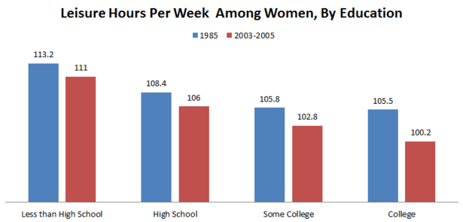
For men, the story has been a bit more complicated. It starts with the changing demand for male labor. The last thirty years have seen the decimation of low-skill domestic industries that favored men, such as manufacturing. Unsurprisingly, as males with a high school degree or below began working less, they relaxed more. But that's only part of the picture. As Aguiar and Hurst write, employment differences only explain about 30 percent of the growing gap between educated men and the rest. Males who have at least some college are also working a couple hours less each week than in the past. And, when the researchers looked solely at men who were employed, they noticed that those with less schooling were only spending an hour less on the job than their college educated peers. And yet, they were still managing four more hours of free time.
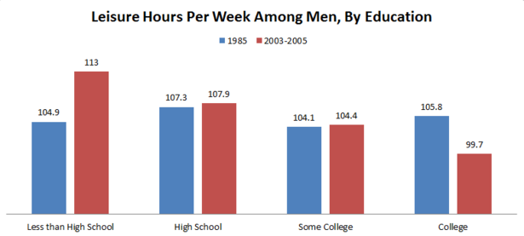
This is where culture comes into play. Employed, college-educated males not only clock in on the job for an additional hour each week, but they also do more at home and in their communities.
The two graphs below, which track how the average employed man in Aguiar and Hurst's study spent their weeks, look extremely similar on first blush. Regardless of class, they devoted most of their time eating, sleeping, working, and watching ungodly amounts of TV. But there are important, subtle differences. Men with at least some college chip in more on child care, shopping, and other chores, and are more engaged in civic and religious activities. They spend a little less time caring for other adults or repairing their houses and cars.
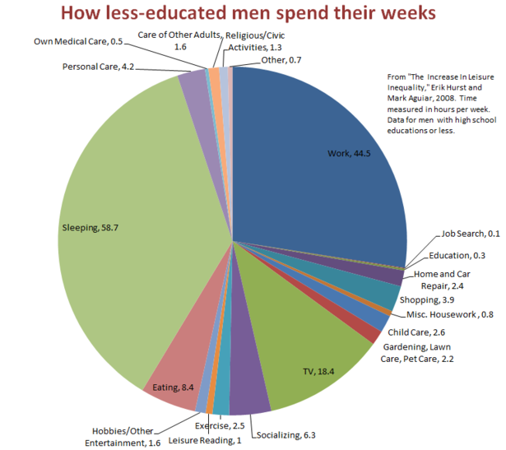
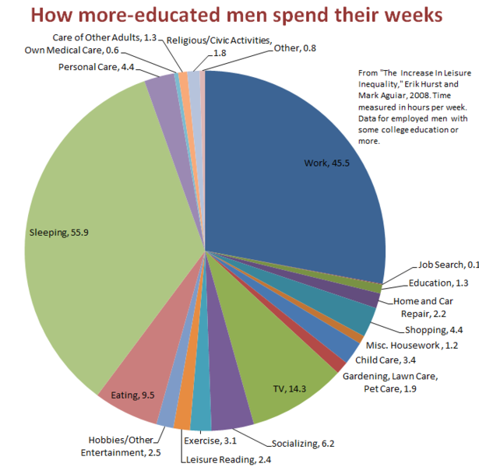

Educated men today, it appears, do more to support their educated, career-oriented wives and their communities. Lower class men reserve more time for themselves. It's one more bit of evidence of how the country is splitting culturally as it splits economically.

