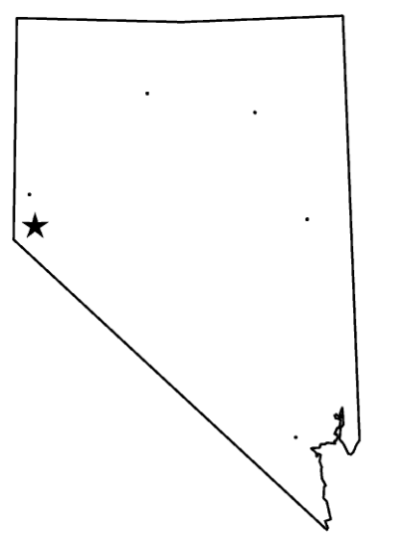

Make an appointment for learning with 6  
different people in class. Make sure that   
both of you have written the appointment  
on your Nevada maps. Only make the   
appointment if there is a space available on both of your maps. You may only make  
an appointment with another student 1   
time.

Elko  
__________

Winnemucca  
__________

Reno  
__________

Carson City  
___________

Las Vegas  
__________

Ely  
__________

**Nevada Learning Buddies**