What if we wonder?
Question Formulation Technique
"American Colonies"
Essential Questions: How do physical geography and natural resources affect the settlement of people and the development of culture? What does it mean to be an American?
Historical Thinking Skills: Sourcing, Corroboration, Close Reading

Teachers’ Notes:
This lesson is designed to teach students how to analyze documents and become proficient investigators of visual source content. As an introductory lesson in the Colonial America Unit, students should be able to access these documents with little to no background knowledge of the time period. Through pair analysis and question writing, students will practice critical thinking and problem solving skills while building knowledge at the same time.
Step 1: For each document, provide a colored copy to a pair/threesome of students and/or project the document. Ask students to engage in “quiet looking” for at least 30 seconds. Then, while the document is still projected provide students with one minute to write as many questions as they can in the graphic organizer. They will then talk with a partner and add to their list of questions. You can ask students to share some questions aloud to the whole group. But do not engage in answering the questions. Have students number their questions as they develop them. Continue this process for the four documents.
Steps 2-3: Ask students to work with a partner to choose a set of questions for one of the documents (A-D) and categorize their questions as closed or open-ended. They will then discuss what the advantages and disadvantages are of both open and closed-ended questions. Finally, they will choose one open-ended question and change it to a closed-ended question and vice-versa.
Step 4: Have students prioritize their questions. They should re-write three of their favorite questions on a sheet of paper that will remain handy during the unit. During the unit they will see if their question is answered in any of the lesson activities or if they need to do further research.
Step 5: Encourage a whole class reflection. What did they learn simply by asking questions? How can asking questions/inquiring support learning as much or more than answering someone else’s questions?
Step 6: Have students begin filling out the P.L.A.C.E.S organizer for the American colonies based on what they learned by questioning the documents. Remind students to go back to their questions throughout the unit. Encourage students to let the class know when one of their prioritized questions was answered during the unit.

What if we wonder?
Question Formulation Technique
"American Colonies"
Essential Questions: How do physical geography and natural resources affect the settlement of people and the development of culture? What does it mean to be an American?
Historical Thinking Skills: Sourcing, Corroboration, Close Reading

Student Guide:
- Produce Your Questions.
  - Base your questions on the focus word, phrase, or statement.
  - Number the questions you develop for each source.

- Categorize Your Questions as C or O.
  - Closed-ended questions (C) can be answered with “yes” or “no” or with one word.
  - Open-ended questions (O) require an explanation and cannot be answered with yes” or “no” or with one word.

- Name Advantages and Disadvantages of Types of Questions.
  - Change one closed-ended question into an open-ended, and change one open-ended question into a closed-ended one.

- Prioritize Your Questions.
- Choose the three most important questions from your list. Mark them with an “X” or highlight them.
- Discuss your reasons for selecting those three questions.
- What are the numbers of your priority questions?

- Reflect.
- Did your questions represent historical thinking skills? Why or why not?
- What did you learn? What value does it have?

- Do something to extend your learning on the focus and to answer your priority questions. Research to find out answers and to develop further questions.

What if we wonder?
Question Formulation Technique Focus: American Colonies
Rules for Producing Questions
- Ask as many questions as you can.
- Do not stop to discuss, judge or answer the questions.
- Write down every question exactly as it is stated.
- Change any statement into a question.

Document A | Document B
What if we wonder?
Question Formulation Technique Focus: American Colonies
Rules for Producing Questions
- Ask as many questions as you can.
- Do not stop to discuss, judge or answer the questions.
- Write down every question exactly as it is stated.
- Change any statement into a question.

Document C | Document D

Document A: English Colonies in America Prior to 1763
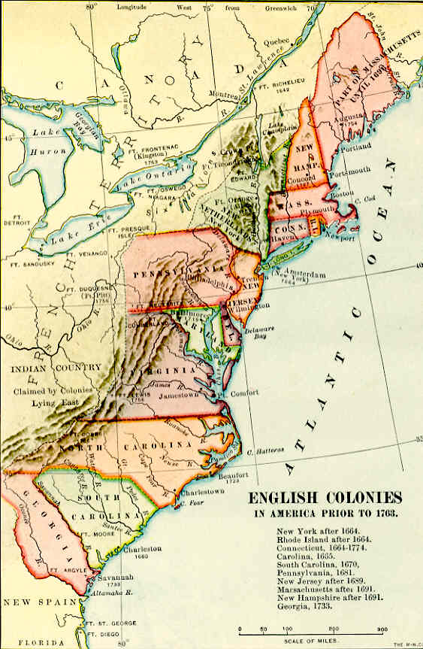

Document B: Settlement of Ethnic Groups in American Colonies by 1755
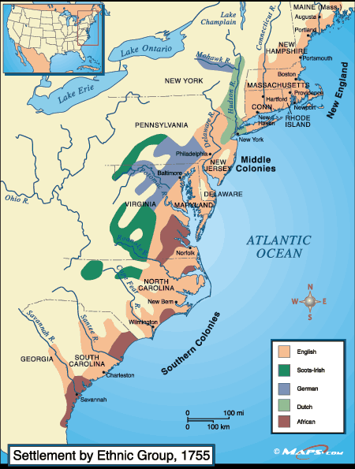

Document C: Colonial America Major Products, 1770
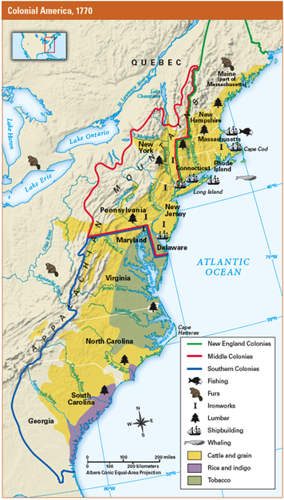
Document D: White and Black Population of the Colonies in 1750
