Don’t let her witty charm fool you! She is the leader of a gang of superheroes who regularly risk their lives in the great Jungle of Primary Sources!
It’s a bird! It’s a plane! IT’S SUPER ANNOTATOR!
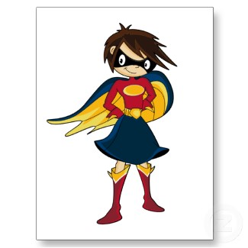
She can analyze, synthesize, evaluate!
But most of all, she can ANNOTATE!

Huddle up superheroes! It’s time to super-annotate!

Common Core Anchor Standard | Annotation Guide  (If different colors help you organize your thoughts, please use them!)
Interpret words and phrases as they are used in a text, including determining technical, connotative, and figurative meanings. | Circle words that are unknown or that might need explanation to others. Double circle words that might have a unique connotation or meaning. If necessary, comment in the margins.
Read closely to determine what the text says explicitly and make inferences from it. | Consider this the “huh, what?” section. Put a ?next to areas where you say, “huh, what?” and write a brief description of your inference in the margin.
Determine central ideas of a text and summarize the key details and ideas. | 1) At the top, write down a two-six word “central idea” of the document.  2) At the bottom, write a short summary explaining the main idea of the document (no more than two sentences).
Delineate and evaluate the argument and specific claims in a text, including the validity of the reasoning as well as the relevancy and sufficiency of the evidence. | Underline each specific argument or claim in the text. Is the argument or claim valid and relevant? On a scale of 1-3 (one is very relevant and valid and three is not relevant or valid), rate the evidence and explain. (e.g. V = 1, very historically accurate and persuasive)
Assess how point of view or purposes shapes the content and style of a text. | When a word or phrase helps you understand the author’s point of view, draw a talking bubble in the margin and write a few words to describe the point of view.
Analyze how two or more texts address similar themes or topics in order to compare the approaches of the authors. | 1) Does this relate to something else you know? If so, place a next to the section and write the connection in the margin.  2) Draw arrows between your two documents when there is a connection. Write a phrase that describes the connection.

Accountability & Shared Knowledge
When the annotation process is complete, group will exchange materials with another group (so that each group is now looking at an unfamiliar text). Ask each group to compare the annotated version with the original, and then in discussion consider the following questions:
- How much difference did the annotations make to the comprehensibility of the text? What insights were possible with the annotated version that was not possible with the original?
- What kinds of annotations were most helpful? Which ones were least helpful? What is the overall effect of the annotation on the text? How does it alter your impression of the text?

