“Timber for the Comstock”
By Thomas J. Straka
Published in the journal Forest History Today, 2007
(excerpt)

After the initial gold strike in 1850, as prospectors dug for gold in Gold Canyon, bluish mud clung to their shovels and picks. In the summer of 1859, someone had the “blue stuff” assayed in California. It turned out to be silver, worth $3,876 to the ton at a time when anything over $100 a ton was a good mining prospect, the value being one-fourth gold and three-fourths silver. To the prospectors’ surprise, the silver was worth more than the gold they had been panning for the last decade. This area became the Ophir mine, part of the Comstock Lode. The silver rush was on.
The Ophir mine was the first to encounter problems with the loose, crumbly ore body. At a depth of 50 feet, the tunnel was 10 to 12 feet wide, but by the time it reached the 180-foot level, it was 40 to 50 feet wide. Local pine was limited, and timber from the short, scrubby trees, spliced together with iron bolts and bars, could not with- stand the pressure of the constantly shifting earth. Soon the mine was too unsafe to operate: though it contained vast treasure, the superincumbent “blue stuff” had rendered the mine shafts unstable and dangerous.
In 1860 a German engineer, Philip Deidesheimer, was brought in to solve the problem. Inspired by the honeybee’s comb, he invented square-set timbering, a framing system that used interlocking rectangular timber sets to support the unstable rocks. These cubes could be filled with waste rock to form support pillars, and the finished structure resembled a honeycomb. So much wood was used in its construction that is was said “a forest of under- ground timbers of enormous dimensions” lay under Virginia City.
Eventually, the constant pressure of moving earth would compress even the strongest timbers. Wood that was originally fourteen inches thick was squeezed to a thick- ness of two to three inches. The tremendous pressure made it “as easy to cut as if it were so much iron,” and locals call it petrified wood.
Stable, square-set timbering required huge amounts of timber. Over the next twenty years, the Comstock Lode consumed 600 million board feet of lumber for the mines and 2 million cords of firewood for running the steam engines in the mines and mills. William Wright’s firsthand account of the timber situation on the Comstock in 1876 painted a bleak picture:
“The Comstock Lode may truthfully be said to be the tomb of the forest of the Sierra. Millions upon millions of feet of lumber are annually buried in the mines, nevermore to be resurrected....The pine forests of the Sierra Nevada Mountains are drawn upon for everything in the shape of wood or lumber, and have been upon for many years. For a distance of 50 or 60 miles all the hills of the eastern slope of the Sierra have been to a great extent denuded of trees of every kind—those suitable only for wood as well as those fit for the manufacture of lumber for use in the mines.”
With little timber near Virginia City, miners quickly turned to the “unlimited” timber resources of the nearby Sierra Nevada. Trees on the lower slopes of the Sierra Nevada were harvested first. Deidesheimer’s square-set timbering could make the mines safe, but it would take a second major invention to get the wood out of the mountains. Loggers constructed gravitation flumes that operated without the aid of water in some very steep places. The logs slid down straight chutes faster than speeding trains, sometimes leaving a trail of fire and smoke. These flumes ended at a lake so that the logs would not be “shivered to pieces.” On occasion a daring logger would ride a log down the chute, ending with a “wild leap of twenty or thirty feet into the lake”—if the logger was lucky.
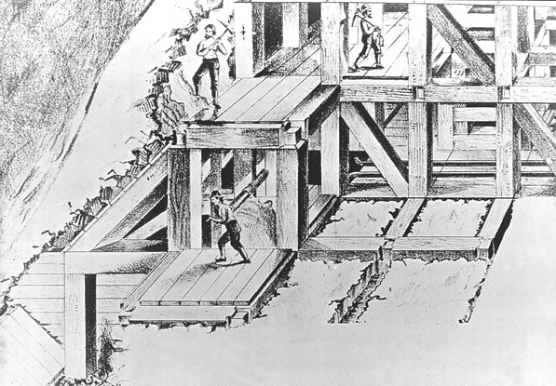
Figure 2: Drawing of a square set timber structure of the Comstock.
Teacher Instructions for Leading Students to Understanding of the Text
This text should be followed by a writing task. If possible, complete the reading, visit the NMA’s Tahoe exhibit, and then create a short task that asks students to synthesize the learning from this piece with what they learned from one or more images from the exhibit.
Depending on the particular needs of your class, have students read the text individually and then read it aloud to them (or read it aloud first).
Say to students: Because this is a complex text with a lot of important vocabulary, please complete a vocabulary scan: Before you read, which words are unfamiliar to you? Highlight those words. (Model/think aloud this process with the first paragraph if your students are not yet accustomed to this strategy.) As we read through this document together, circle the highlighted words that you were able to figure out from our close reading. (Go back to this at the end. What words from the text are still unknown to students? Where appropriate, either have some students explain how they figured that particular word out, or explain that sometimes good readers skip a difficult word in a text if they can figure out the meaning of the sentence or paragraph without understanding the definition.)
Make sure that students know what “timber” and “ore” mean before beginning. You might provide pictorial support for this, if necessary.
From this point on, have one question at a time appear on your SmartBoard. Have small groups (2 or 3 students) work together to find answers. Call on students randomly after a short time to share their evidence and reasoning for answers. Annotate the text on the SmartBoard as they provide answers to model annotation.
When possible, connect this reading to your instruction of NGSS: 4-PS3, 4-ESS3, and 3-5 –ETS1.
Questions | Possible Answers/Textual Support
Let’s source the document! What do we learn about this source from lines 1-4?  (Follow up question, if necessary: What might we infer about the author’s type of work?) | This is a sourcing question that orients students to the text. Students should note the title and see that this is about wood and the Virginia City area. They should also note the author. The journal should provide a clue that the author is likely a historian of some sort. They should also recognize that this is simply a part of the article (excerpt).
There are two clues in the first paragraph to help us figure out how long prospectors/miners were digging for gold in the Comstock/Gold Canyon. Find these two clues in the text. Approximately how long were miners focused on searching for gold? | Unlike less complex texts that might say “Miners/prospectors were searching for gold for 9-10 years,” this text requires students to pay attention to dates and academic language. The clues appear on lines 6/7: “strike in 1850” and “summer of 1859” & in line 11 “last decade.”
The word “assayed” is used in in line 7. Now reread the sentence that follows (lines 7-9), what clues can you find for what “assayed” means? | Clues include: “turned out to be silver,” “worth $3876 to the ton,” “the value being one-fourth gold and three-fourths silver.” Assayed means to determine the content, quality, and worth of an ore.
The final sentence of the first paragraph states, “The silver rush was on.” Why had silver become more important than gold? | “Anything over $100 a ton was a good mining prospect,” and this ore was worth “$3876 to the ton”. There was more silver (3/4 to ¼ gold) available. It was worth more than gold and there was more of it.
The silver Ophir mine had three problems. Using paragraph two (lines 12-17), work with your group to explain the problems in your own words in a phrase. Then, quickly make a sketch of the three problems. | - The silver was crumbly.  - The deeper the tunnels were dug, the wider they had to be.  - Pine was scarce and the short trees could not hold up the moving earth.  This led to the main problem that the silver “had rendered the mine shafts unstable and dangerous.”  Because this text describes things in a visual way, it will be important to let students demonstrate their understanding with simple sketches.
Describe how engineer, Philip Deidesheimer, solved these problems.  - What was his inspiration?  - Does the picture on page two of the reading help you visualize his plan? Why or why not? | He was inspired by the honeybee’s comb (line 21). He invented square set timbering which framed the tunnels to support the unstable rocks above. Each of the cubes created for the tunnel was set next to another that was filled with waste rock which kept the ceiling of the tunnel up.  Again, the visuals are meant to support student learning.
The quote on lines 28-29 can be a bit confusing because it is worded differently than we might say it today.  - Discuss what the quote means with your partner(s).  - Rewrite the quote to make more sense to you.  - Underline the clues in the text that help you know you understood the quote. | Quotes: “as easy to cut as if it were so much iron”  This quote captures the idea that the constant pressure upon the wood compressed it to a density and hardness that were near iron like. But students might struggle with the fact that the quote starts with “as easy to cut”. This is a place to slow down and make sure students understand the intent of the author using context clues like the words and phrases like: “compress even the strongest timbers,” “squeezed to a thickness of two or three inches,” “as if it were so much iron,” “petrified wood.”
Ask the whole class: What additional information would be helpful to you in understanding the amount of timber discussed in lines 31-32? (You may want to provide pictorial support. Also, encourage students to use their resources when reading to find similar visual supports.)
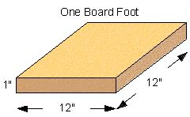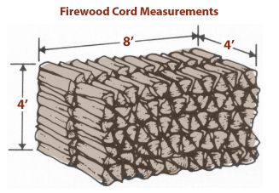
When students are reading dense informational texts about an unknown topic, they should know that good readers consult outside sources to make meaning. There is nothing wrong with finding out how large a cord of wood is as you are reading.
How does William Wright’s (quote in italics) use of words and phrases shape his meaning?  - If students need further probing and support, direct them to: “tomb of the forest,” “buried,” and “nevermore to be resurrected.”  - You might also ask students to infer the meaning of the word “denuded” from the text. The root “nude” is helpful as is the prefix “de,” but you do not need these to understand that it means completely stripped. | Students should begin to recognize that when quotes are used in informational texts, they are often used sparingly and for effect. The word choice in this quote demonstrates that logging created the effect of a tomb. Tomb has the connotation of death and killing.
Why is the word “unlimited” on line 41 in quotations? How does the quotation prior this this line help you understand the use of quotation marks around this word? | Authors place words in italics or quote sometimes to demonstrate a strong tone. In this case, “unlimited” was, of course, untrue. Although the people stripping the forests saw them as vast and full, soon, the entire Tahoe basin was stripped of its forests.
Depending on what students have learned from NGSS, use the final paragraph to delve deeper. You might also consider using the images that follow and/or students’ personal experiences on log/water rides at amusement parks.
Use evidence to construct an explanation relating the speed of an object to the energy of that object.
Make observations to provide evidence that energy can be transferred from place to place by sound, light, heat, and electric currents.
Ask questions and predict outcomes about the changes in energy that occur when objects collide.

Images to help students understand flumes/chutes:
