OUT Teacher Tips

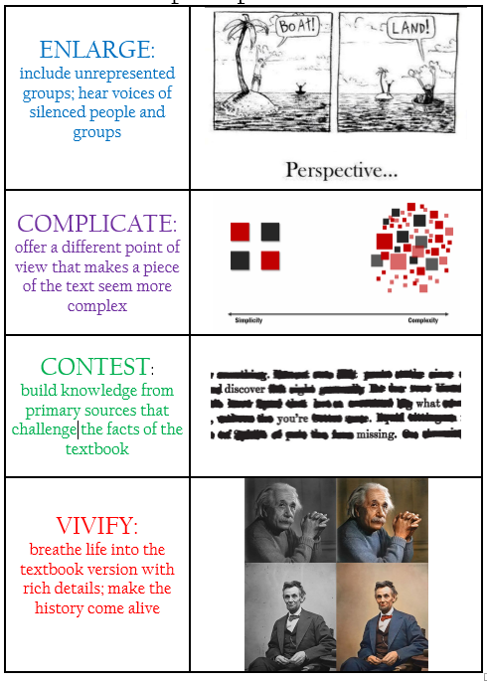
Teacher Tips:

- Model document analysis with students.

- Ensure that students stay on task in their small groups. Stop regularly to check for understanding and have groups report out on their findings.

      - At the end of each document analysis, have students answer the question: Does this document enlarge, complicate, contest, or vivify the textbook? How?

