How to Guide a Student Mininquiry (Mini + Inquiry)
75-90 minutes of student-focused questioning, research, communication and reflection

- Why didn’t it happen like that? (Template p.1) Provide three solid blocks of evidence to build a narrative wherein a trend develops towards a specific outcome but, in fact, occurs differently. For example:

- Unequal pay for women following the decades after WWII  - Decline of great empires following long periods of advancements (Islamic, China)  - Unforeseen turning points in conflict/wars  - A growth in federal power suddenly restricted in favor of states’ rights  - 1900-29 Economic growth, then stock market crash  - Passage of civil rights legislation but lagging inequality  - The election of 2016 | 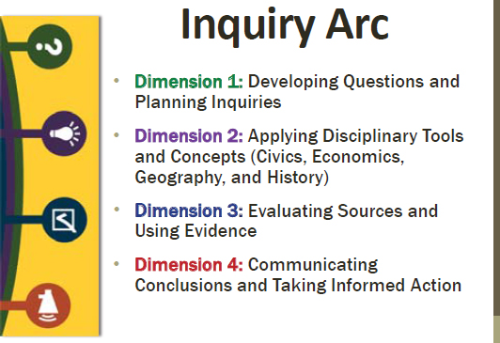

- So Then…
  - The Assumption: Describe the assumed outcome to the historical issue based on preceding evidence.
  - But, The Reality: Present conclusive evidence illuminating a different and surprising outcome.

- Why Might this Be? Turn the real outcome into a compelling question. Then, ask students in small groups to frame supporting questions that would help them research a better understanding of the actual outcome of the problem. Students should spend time writing questions individually and then share questions in their small group.

- Steps to Consider in Planning Your Mininquiry: Teachers facilitate small groups as they collaboratively plan their research using questions 1-4 of this section. Here you can assist them in organizing question themes in their groups, identifying key search terms, providing them with specific websites or databases for searching (WCSD Library Databases), and determine parameters for number 4.

- Doing Research: Provide 10-20 minutes for students to research their topics. Students should record answers next to their research questions on the template or elsewhere.
  - Note: It is okay for student questions and search query to take them to a new place in the broader topic. They should note this new knowledge and include it in their search results. Remember, that in the real world a person is not assigned a research task with the “answer’ already known.

- Communicating Conclusions: Working in small groups students will attend to the first three questions. Check for understanding along the way to illuminate multiple answers to the inquiry and the experience of the research process. Explain that part of researching is discovering new information and going off on tangents. For question 4, decide how groups will present their information. A google slide or PowerPoint slide is suggested.

- What did I learn from other group’s mininquiries? Students record interesting information during small group presentations. The teacher has an opportunity to clarify or add to the discussion.

- What new questions do I have? Based on shared information, each student will craft new questions describing what information they would still like to know.

- Mininquiry Reflection: Provide students with time to reflect on their work and the process of the mininquiry. Foster an awareness of what students learned, what they did well, and what the need to work on next time.

