First Grade DBQ – Core Knowledge – Early World Civilizations

A DBQ (Document Based Question) is an authentic assessment where students interact with historical texts. Document Based Questions were first used in high school AP classes. But after several years of using DBQs in grades 4-12 in WCSD for all students, it was determined that the same skills could be practiced with students in K-3. A DBQ asks students to read and analyze historical records, gather information and fill in short scaffolding response questions, assimilate and synthesize information from several documents, and then respond in writing to an assigned task, by using information gleaned from the documents, as well as, their own knowledge. For grades K-3, these tasks have been refined to include pictures and text from the Core Knowledge units of study. In this way, students who have been immersed in a unit of literacy study are able to demonstrate their knowledge of the unit while also practicing the skills used in social studies in later grades with a DBQ.
This DBQ is aligned with the Core Knowledge Listening and Learning domain, Early World Civilizations. It is meant to follow the unit so that students have already been exposed to the knowledge and vocabulary gained from the read alouds. You may need to take some time to build an understanding of the important components of a civilization.
With prompting, scaffolding, and support, the students will review the series of pictures and text to determine the important components of early world civilizations. After reviewing the documents, students will write to the prompt independently.
Helpful Vocabulary:
river | symbols | religion | leader
trade | cuneiform | gods | pharaoh
farming | hieroglyphs | goddesses | tradition

Writing Task:
Civilization is the culture and way of life of people who live together in an area. Civilization has components like farming, religion, traditions, and writing. Please choose to write about the Mesopotamian civilization or the ancient Egyptian civilization. Then, using evidence found in the following documents, your knowledge of our readings, and at least four of the vocabulary words from above, describe the important components of the Mesopotamian or the ancient Egyptian civilization.
Teacher Notes:
- Students should be given the opportunity to discuss the documents with partners and/or small groups. You may also choose to have the students work through the documents orally and keep a class chart of the written answers. Students should not be expected to work through the documents independently. The teacher should monitor their understanding of the documents through whole group discussion before moving on to the independent writing task.
- As a teacher, you know your students and where they are on the developmental spectrum in writing. After the students have a solid understanding of the documents, the students are expected to tackle the writing piece independently. However, please scaffold and support this writing as needed by your students. For example, you could provide additional support through shared writing beforehand as an example, or provide additional graphic organizers as needed.
- Allow for several class sessions to complete this DBQ.

Name _____________________

First Grade DBQ – Core Knowledge – Early World Civilizations

Helpful Vocabulary:
river | symbols | religion | leader
trade | cuneiform | gods | pharaoh
farming | hieroglyphs | goddesses | tradition

Writing Task:
Civilization is the culture and way of life of people who live together in an area. Civilization has components like farming, religion, traditions, and writing. Please choose to write about the Mesopotamian civilization or the ancient Egyptian civilization. Then, using evidence found in the following documents, your knowledge of our readings, and at least four of the vocabulary words from above, describe the important components of the Mesopotamian or the ancient Egyptian civilization.

Document A
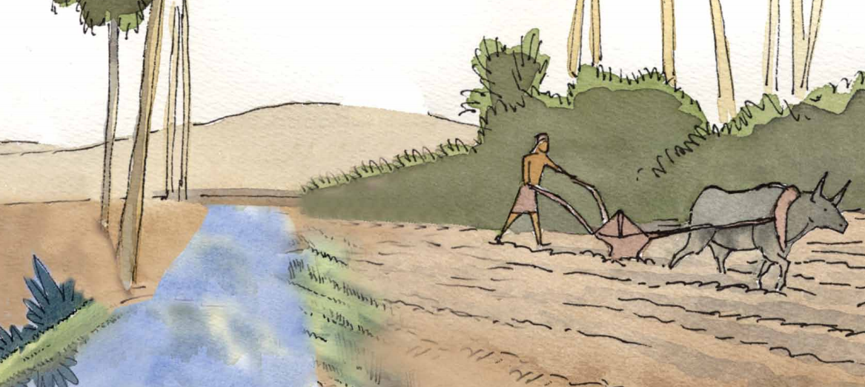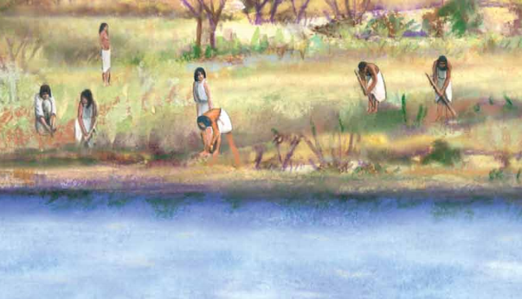
The first people who lived along this river realized that the land surrounding the river had rich soil for planting crops, like wheat and barley for bread. So, these people built their homes along the river so that they could grow crops to feed themselves and their families.
- Make a list of everything you see in the two pictures.
People | Objects | Actions

- Read the caption carefully. What did the land surrounding the river have that the people of Mesopotamia and Egypt needed?

- How did this rich soil help the people?

- How does this document help to explain an important component of the civilizations of Mesopotamia and Egypt?

Document B
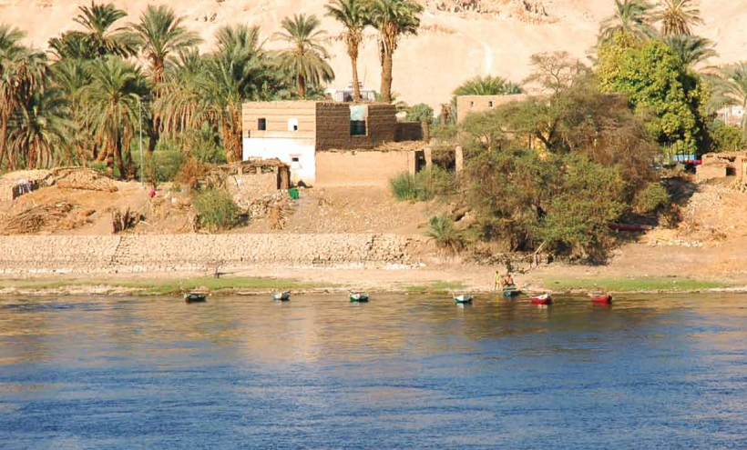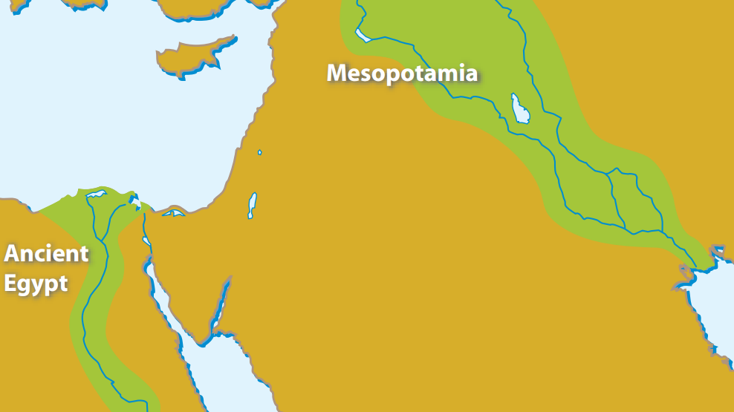
If this river did not flow, there would be no palaces, no gardens, not even any houses. Many people came and settled up and down the river, forming other towns and cities. Soon, they realized they could use the river for more than just growing food. They could travel up and down the river to trade with people from other cities.
- Make a list of everything you see in the two pictures.

- What do both of the pictures have in them?

- What connections can you make between Document A and Document B?

- Why were cities built around the rivers?

- How does this document help to explain an important component of the civilizations of Mesopotamia and Egypt?
Document C
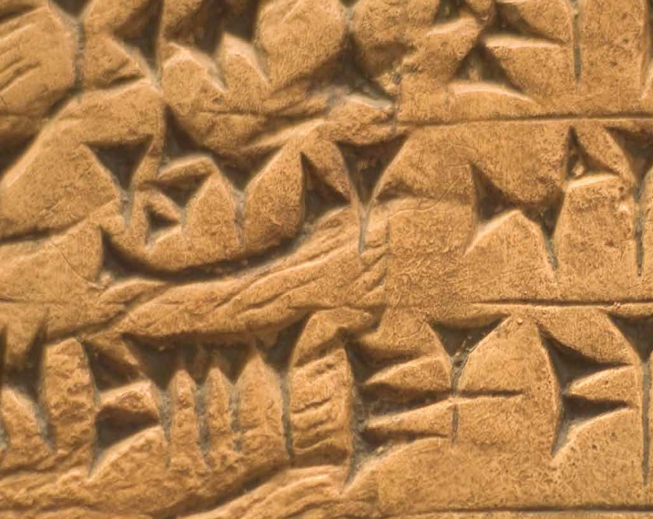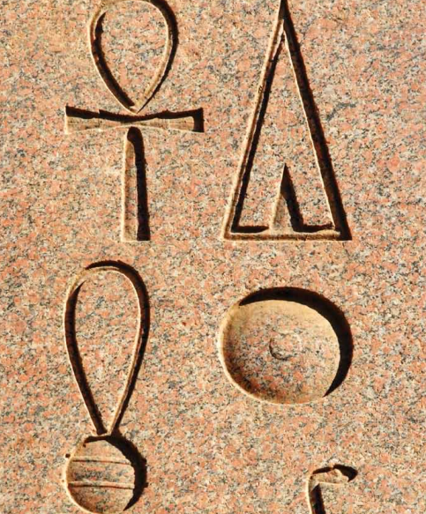
In Mesopotamia, wedge-shaped symbols were pressed into clay. This sort of writing is called cuneiform. In Egypt, the people drew symbols called hieroglyphs that represented the words they said. Both forms of writing helped the people remember the messages and information accurately, so they would not get forgotten or mixed up.

- Read the caption carefully. What was the writing in Mesopotamia called? What was the writing in Egypt called?

- Why was it important to write the messages or information down?

- How does this document help to explain an important component of the civilizations of Mesopotamia and Egypt?

Document D
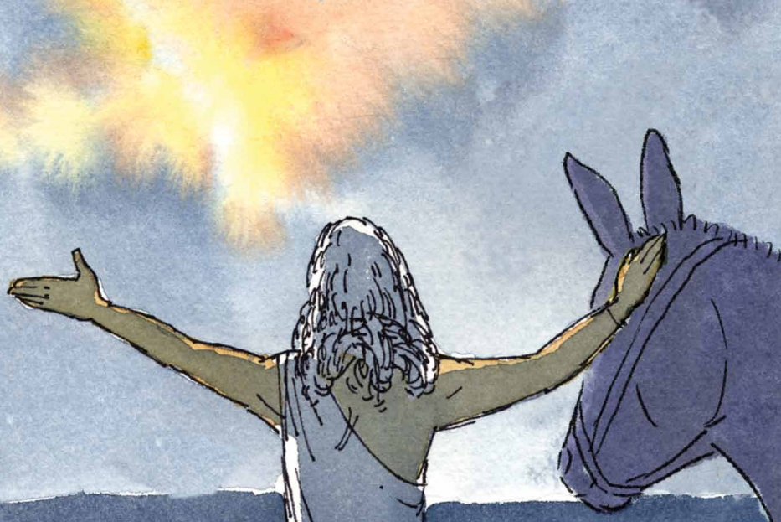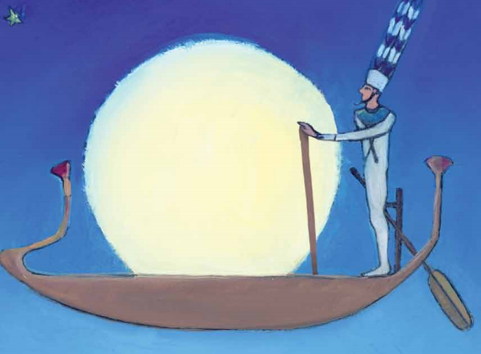
The people of Mesopotamia and Egypt wondered about nearly everything and didn’t have many answers yet. One explanation they came up with was that the world was planned and created by powerful beings called gods and goddesses. In Mesopotamia, they believed that many gods and goddesses had powers over the universe. In Egypt, they believed that one of their gods, Amon-Ra was powerful enough to bring the sun to the sky in a boat.
- Make a list of everything you see in the two pictures.
People | Objects | Actions
- Is there anything similar in the two pictures?

- Read the caption carefully. What was one way the people of Mesopotamia explained things they wondered about? What was one way the people of Egypt explained things they wondered about?

- How does this document help to explain an important component of the civilizations of Mesopotamia and Egypt?

Document E

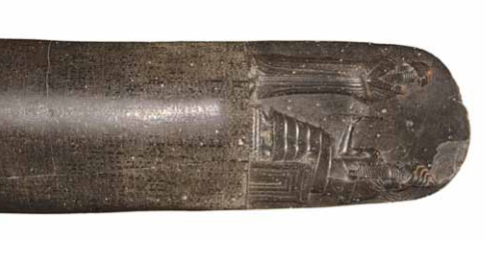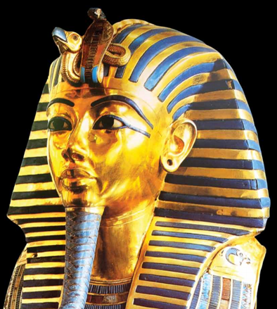
Both the Mesopotamians and the Egyptians had leaders to rule over their civilizations. King Hammurabi of Mesopotamia was so powerful that he made up a set of rules, or laws, for people to live by, so that they would know how to behave in different situations. This set of laws is called the Code of Hammurabi. The 282 laws were written down so that everyone would remember and follow them. The kings of Egypt were called pharaohs. The people of Egypt thought the pharaoh was not just a man; they thought he was a god. King Tut, or Pharoah Tutankhamun was a young pharaoh in Egypt. He died very young and was buried in a tomb in the Valley of the Kings.

- Who was King Hammurabi? What did he contribute to the Mesopotamians?

- What did the Egyptians call their kings? What did they think about their kings?

- Who was King Tut?

- How does this document help to explain an important component of the civilizations of Mesopotamia and Egypt?

Name: _______________________________________
Writing Task: In one paragraph, choose either the Mesopotamian or ancient Egyptian civilization and describe the important components of that civilization.
Remember to use an introductory sentence.
- Use at least one piece of evidence from each document. After a piece of evidence from a document, put the document letter in parentheses. For example, “George Washington was the top army general for the Continental Army (Doc. B).”
- Correctly use at least four of the vocabulary terms from this DBQ in your paragraph.
______________________________________________________________________________________________________________________________________________________________________________________________________________________________________________________________________________________________________________________________________________________________________________________________________________________________________________________________________________________________________________________________________________________________________________________________________________________________________________________________________
______________________________________________________________________________________________________________________________________________________________________________________________________________________________________________________________________________________________________________________________________________________________________________________________________________________________________________________________________________________________________________________________________________________________________________________________________________________________________________________________________
__________________________________________________________________________________________________________________

