Second Grade DBQ – Core Knowledge – Greek Myths

A Document Based Question (DBQ) is an authentic assessment whereby students interact with historical texts. A DBQ asks students to read and analyze historical records, gather information and fill in short scaffolding response questions, assimilate and synthesize information from several documents, and then respond (usually as a written essay) to an assigned task, by using information gleaned from the documents as well as their own outside information.
This second grade (primary level) DBQ is aligned with the Core Knowledge Listening and Learning domain, Greek Myths. It is meant to follow the unit so that students have already been exposed to the knowledge and vocabulary gained from the read alouds.
With prompting, support, and scaffolding as needed for your class, the students will review the series of pictures and text to determine how some Greek myths explain events in nature. After reviewing the documents in small groups with teacher support, students will write to the task independently. You will notice that there are a few sentences below each visual source. These sentences come from the Core Knowledge read-alouds.
Helpful Vocabulary:
immortal | humans | pine | arachnid
mortal | despair | underworld | flattered
ridiculous | retrieve | Earth | weave

Writing Task:
Using evidence found in the following documents, your knowledge of our readings, and at least four of the vocabulary words from above, please describe how Greek myths explained events that occur in nature.

Teacher Notes:
- Students should be given the opportunity to discuss the documents with partners and/or small groups. Students should not be expected to work through the documents independently. The teacher should monitor their understanding of the documents through whole group discussion and individual group monitoring before moving on to the independent writing task.
- As a teacher, you know your students and where they are on the developmental spectrum in writing. After the students have a solid understanding of the documents, the students are expected to tackle the writing piece independently. However, please scaffold and support this writing as needed by your students. For example, you could provide additional support through shared writing beforehand as an example, or provide additional graphic organizers as needed.
- Allow for several class sessions to complete this DBQ.

Name _____________________

Second Grade DBQ – Core Knowledge – Greek Myths

Helpful Vocabulary:
immortal | humans | pine | arachnid
mortal | despair | underworld | flattered
ridiculous | retrieve | Earth | weave

Writing Task:
Using evidence found in the following documents, your knowledge of our readings, and at least four of the vocabulary words from above, please describe how Greek myths explained events that occur in nature.

Document A.1
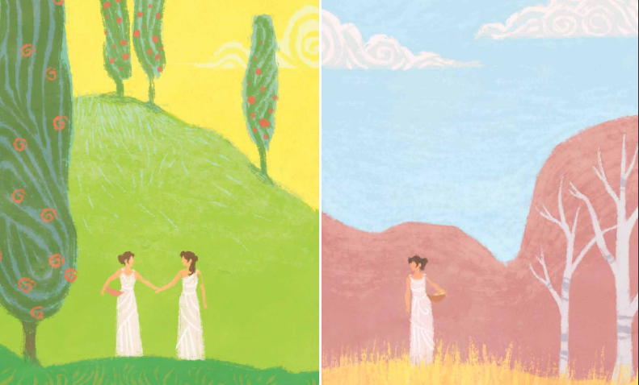
Document A.2
During the six months that Persephone lived in the underworld, however, Demeter would ignore all the crops on Earth and would pine for her daughter. The leaves would fall off the trees in autumn and would be bare in winter, while Demeter longed for her daughter. Once Persephone was returned to Demeter, it would be spring again.
- Look carefully at the two pictures. Make a list of what you see in each picture.
Picture 1 | Picture 2

- What season is represented in each picture? How can you tell?

- Based on what you know about this Greek myth and Document A.2, who is in the first picture? Who is in the second picture? What happened to Persephone?

- How do these documents help to show how a Greek myth explained an event that occurs in nature?

Document B.1
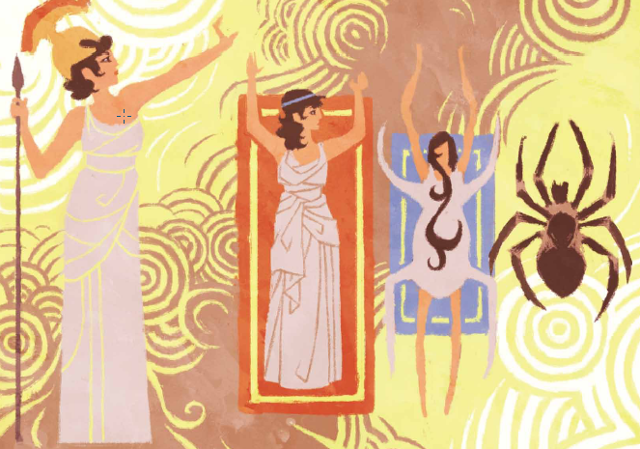
Document B.2
Athena reached out and touched Arachne’s shoulder with the tip of one finger. Instantly, Arachne began to change shape. After about five minutes, Arachne became the first spider in the world. Today we call all members of the spider family arachnids, and that is why some people say all spiders are the children of Arachne the Weaver.

- Make a list of everything you see in the picture.
People | Creatures | Actions

- Based on what you know about this Greek myth, who is the woman on the left side of the picture? What is she doing in the picture? What caused her actions?

- Based on what you know about this Greek myth, who is the woman on the first rectangle? What is happening to her in the second rectangle? Why is this happening?

- How do these documents help to show how a Greek myth explained an event that occurs in nature?
Document C

Prometheus felt sorry for the humans, though. They had no fur to keep them warm, nothing to light the darkness, and nothing with which to cook their food. Humans needed fire, especially if they were to prove themselves. He asked Zeus for this gift for the humans, but Zeus refused. “Fire,” he said, “is just for the gods.”
Prometheus knew the humans needed fire. “With fire,” he thought to himself, “they can soften metal and bend it into a shape to make tools. With these tools they can plow fields, fish and hunt for food, cook that food, and build shelters in which to live. With fire, humans can also honor the gods with sacrifices. Human beings need fire, but getting it for them will be very dangerous.”
Prometheus knew that up on Mount Olympus, where most of the gods lived, there was one carefully guarded fire. The gods and goddesses used this fire to cook their food. From this same fire, however, came the dangerous lightning bolts that Zeus would fling through the sky. In fact, all fire came from this one source.
Zeus had said, “Fire is too dangerous for these ridiculous humans to use wisely. Only we gods and goddesses shall have it.” Yet Prometheus was determined to bring fire to humans, even if it meant disobeying the king of the gods.
Prometheus picked a stalk of fennel and carried it up to Mount Olympus. When no one was looking, he dropped a burning coal from the fire into the plant’s hollow center, where no one could see it. Then he carried the plant, with the fire hidden inside, down to the earth.

- Why did Prometheus feel sorry for the humans?

- Why did Prometheus think the humans needed fire?

- Why didn’t Zeus want the humans to have fire?

- In your own words, describe how Prometheus brought fire to the humans.

- How does this document help to show how Greek myths explained an event that occurs in nature?

Name: _______________________________________
Writing Task: In one paragraph, describe how Greek myths explained events that occur in nature.
- Use at least one piece of evidence from each document. After a piece of evidence from a document, put the document letter in parentheses. For example, “George Washington was the top army general for the Continental Army (Doc. B).” Explain how your evidence shows how Greek myths explained events in nature.
- Correctly use at least four of the vocabulary terms from this DBQ in your paragraph.
______________________________________________________________________________________________________________________________________________________________________________________________________________________________________________________________________________________________________________________________________________________________________________________________________________________________________________________________________________________________________________________________________________________________________________________________________________________________________________________________________
______________________________________________________________________________________________________________________________________________________________________________________________________________________________________________________________________________________________________________________________________________________________________________________________________________________________________________________________________________________________________________________________________________________________________________________________________________________________________________________________________
__________________________________________________________________________________________________________________

